MEMORANDUM

To: UW-Whitewater Faculty, Deans, and Department Chairs

From: Susan Elrod, Provost & Executive Vice Chancellor for Academic Affairs
James Hartwick, Chair, Faculty Senate
Patricia Fragola, Chair, Academic Staff Assembly

Subject: Posting Syllabi - Faculty Senate Resolution 945-12 and Academic Staff Assembly ASAR 1516.8

Date: January 4, 2017

In accordance with the UW-Whitewater Faculty Senate (Resolution 945-12) and Academic Staff Assembly (ASAR 1516.8), instructors of every course are required to submit an updated syllabus every semester. Syllabi need to be uploaded as PDF files using the Online Syllabus Database or submitted directly to Andersen Library in paper form. PDF (Portable Document Format) files are the only format supported by the Online Syllabus Database.

Instructors may choose one of the following options when submitting a syllabus and making it available:
- digitally, but limited to users with UW-Whitewater Net-ID (the default option);
- digitally to the public-at-large (choose “make this syllabus public” option); or
- in the library, and limited to users with UW-Whitewater Net-ID (choose “paper copy only” option).

As such, syllabi will be accessible only to users with a UW-Whitewater Net-ID, unless explicitly marked "public" by the instructor. However, please be aware that any and all syllabi may be released in response to a public records request.

For all three options above, go to http://courses.uww.edu/Syllabi/Manage to upload digital syllabi or to indicate that you will submit a syllabus to the library.

Questions regarding syllabus uploading and website issues can be directed to the Help Desk by emailing helpdesk@uww.edu or calling EXT.: 4357.

Questions or issues regarding the “paper copy only” option can be directed to the Andersen Library Circulation Desk at circdesk@uww.edu or calling EXT.: 5511.

- How to use the system: The Online Syllabus Database is easy to use. Go to courses.uww.edu, login using your UW-Whitewater Net-ID, and click "Log On" as shown below

- After logging in, click on SYLLABI, as shown below:

- On the ensuing page, select the option “Upload by Instructor”:

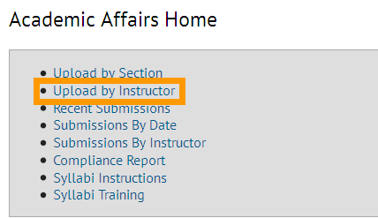

- Enter your name in the “Instructor Search” field and click the “Search” button:

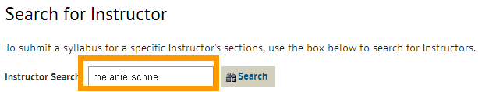

- The result will be displayed as shown in the screen below. Click on “View Sections” link:

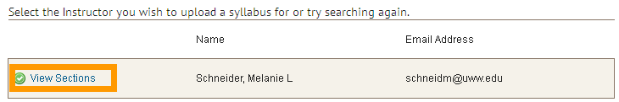

- The screenshot below displays all the sections where you are an instructor. Select the section you wish to upload the Syllabus for and click “Continue.” The syllabus on the next page will be uploaded for all of the courses you selected.

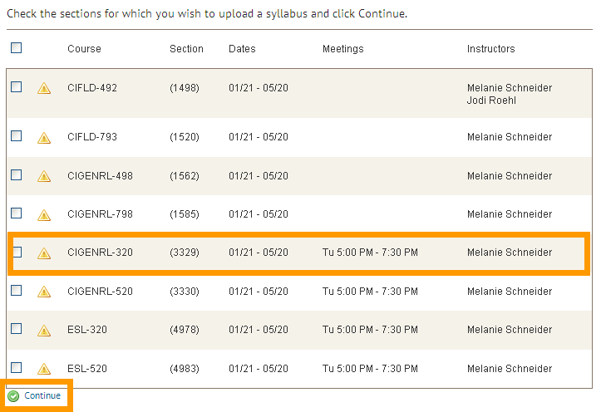

- Select the file you want to upload by clicking the “Browse” button and browsing to the file on your computer. Once selected, click the “Save” button.

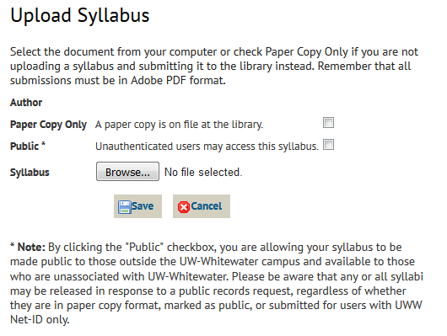
Result of User Clicking the Paper Copy Only is shown below

