Entering your timesheet – Classified (Exempt)
- Log into portal (my.wisconsin.edu)
- Scroll down to Time and Absence box
- If you are reporting leave without pay, military leave, sabbatical, personal holiday, vacation, sick leave this pay period, select ENTER ABSENCE
- Each day must a separate entry (example: going on vacation the week of July 9 – July 13, report vacation on July 9, report vacation on July 10, report vacation on July 11, report vacation on July 12, report vacation on July 13.) Start date MUST be the same as the end date. Entry type is “hours per day” and the bottom two boxes must match and be the number of hours requesting. Please note that your current balance appears when you enter leave time. DO NOT ENTER LEGAL HOLIDAY, this will automatically populate on your timesheet.
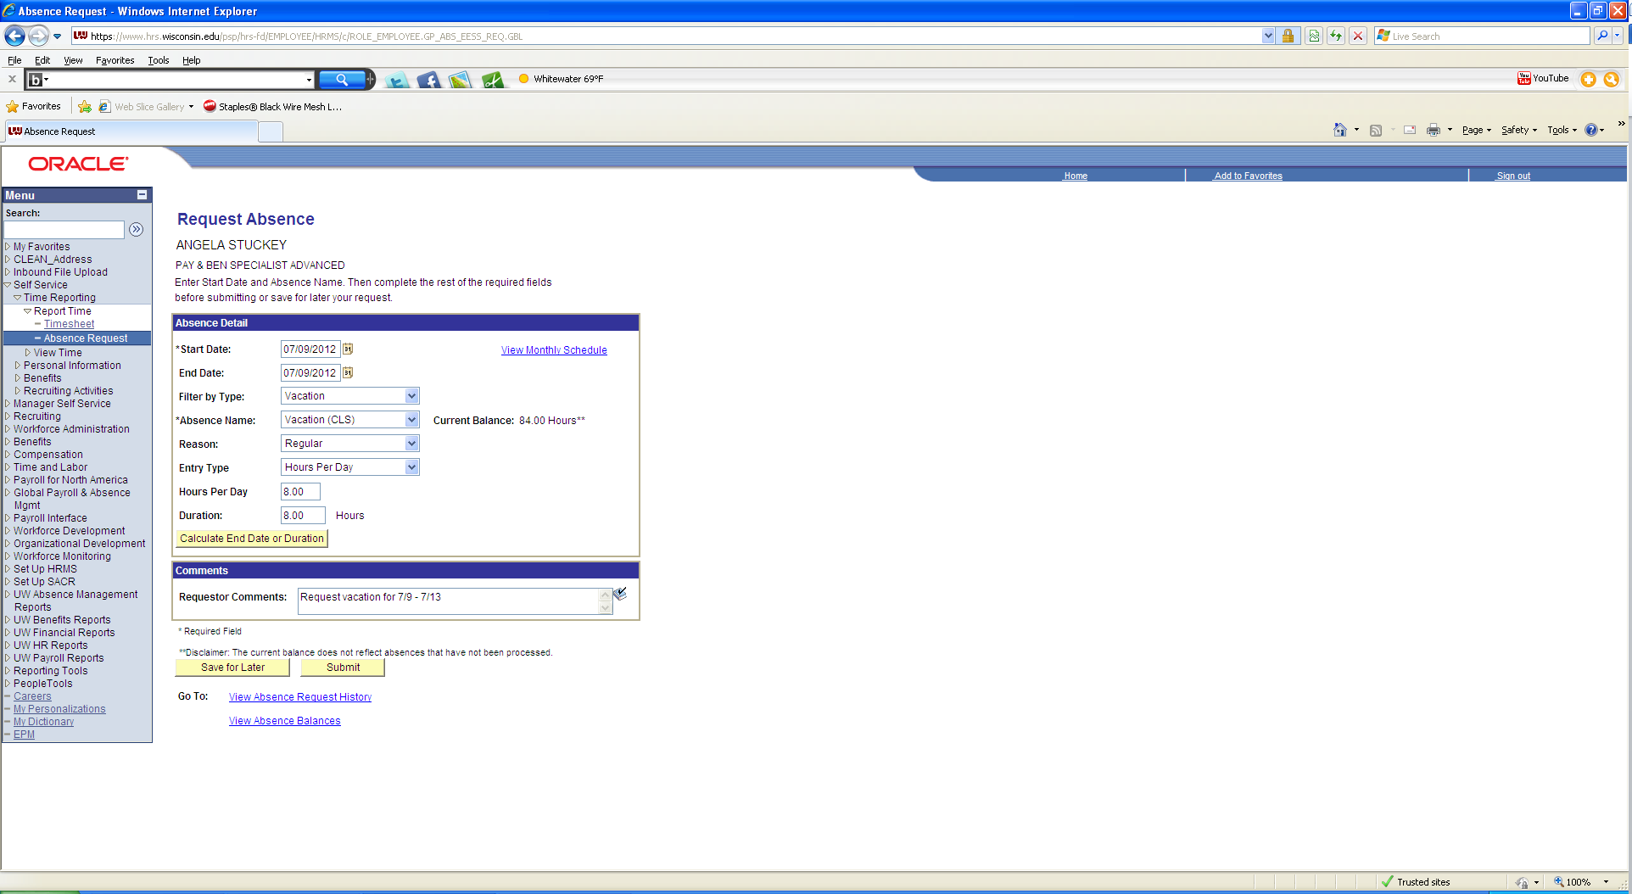
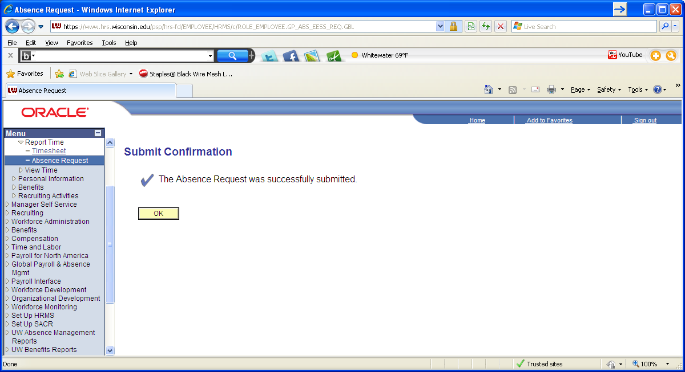
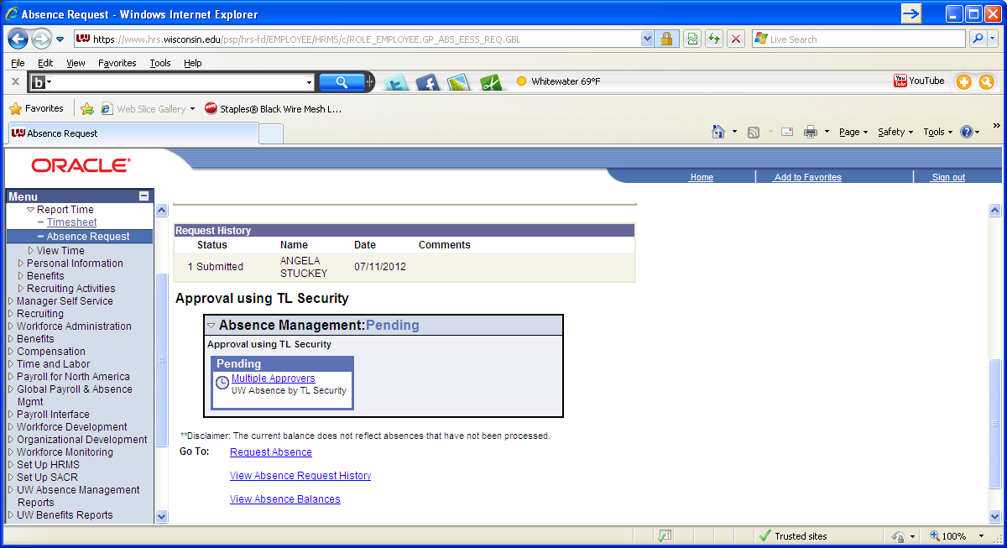
If you need to add additional absence, select request absence.
- After submitting, sign out and close window and return to portal.
- Select TIMESHEET from Time and Absence box.
- Enter the number of hours worked each day during that pay period
- Make sure the Time Reporting Code column is blank
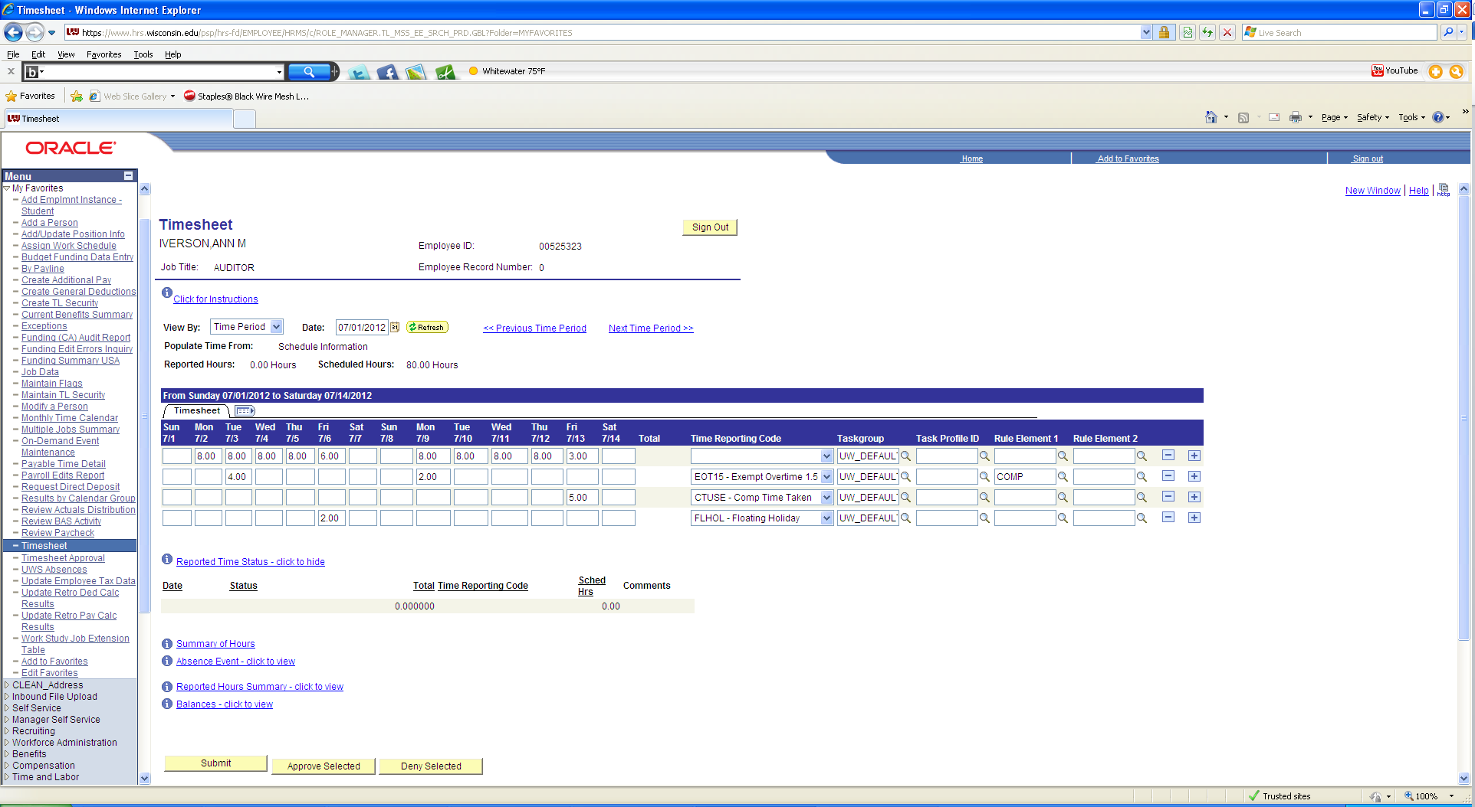
- Hit Submit on bottom.
- After submitting, sign out and close window.
- Sign out of portal.

SPECIAL NOTES:
Legal Holidays –
DO NOT ENTER, once time is submitted on your timesheet the legal holiday will auto populate
If you worked on a holiday, please enter your time and select NOHOL – No Legal Holiday from the Time Reporting code column
Overtime/Comp Time –
Overtime – add a row and select EOT15 – Exempt overtime from the time reporting column and put the quantity on each day. Please see yellow box on timesheet
Earning comp time: If you would like to earn comp time for OT rather than cash, please select go to Rule Element 1 column for the day you would like to earn the CT, select magnifying glass and select comp. Please see yellow box on timesheet.
Using comp time: If you would like to earn comp time, go to the Time Report Code column, select drop down and select CT use. Then, go to quantity column and enter the number of comp hours you would like to use. Please see yellow box on timesheet.
Floating Holidays -
To report the use of Floating Holiday hours, go to Time Reporting code column, select FLHOL – Floating Holiday and then list quantity of floating holiday hours you would like to use under each day. Please see yellow box on timesheet
Standby Hours –
To report standby hours, go to the plus sign on the farthest right side and add a row for each day you are reporting standby hours. Go to the new row, go to Time Reporting Code Column, select SD225 – Standby (2.25 hour) and put the number of hours for each day this applies

