Entering your timesheet – Classified/Project (Non Exempt)
- Log into portal (my.wisconsin.edu)
- Scroll down to Time and Absence box
- If you are reporting leave without pay, military leave, sabbatical, personal holiday, vacation, sick leave this pay period, select ENTER ABSENCE
- Each day must a separate entry (example: going on vacation the week of July 9 – July 13, report vacation on July 9, report vacation on July 10, report vacation on July 11, report vacation on July 12, report vacation on July 13.) Start date MUST be the same as the end date. Entry type need to be hours per day and the bottom two boxes needs to have the number of hours you are requesting off. Please note that your current balance appears when you enter leave time. DO NOT ENTER LEGAL HOLIDAY, this will automatically populate on your timesheet.
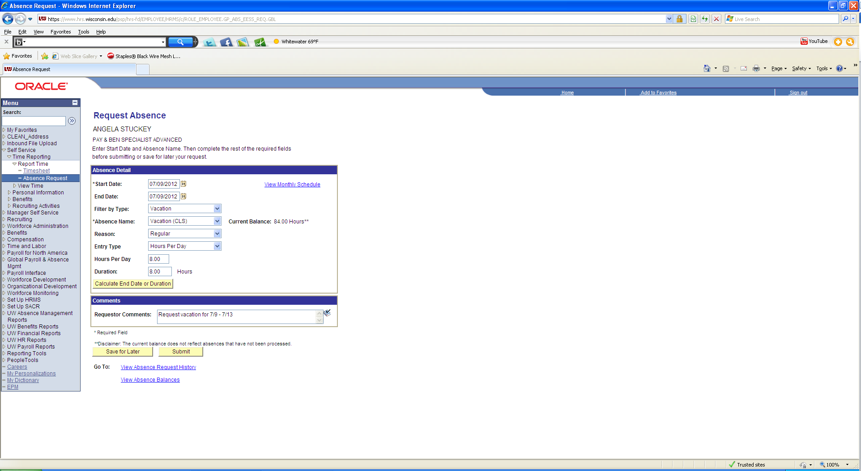
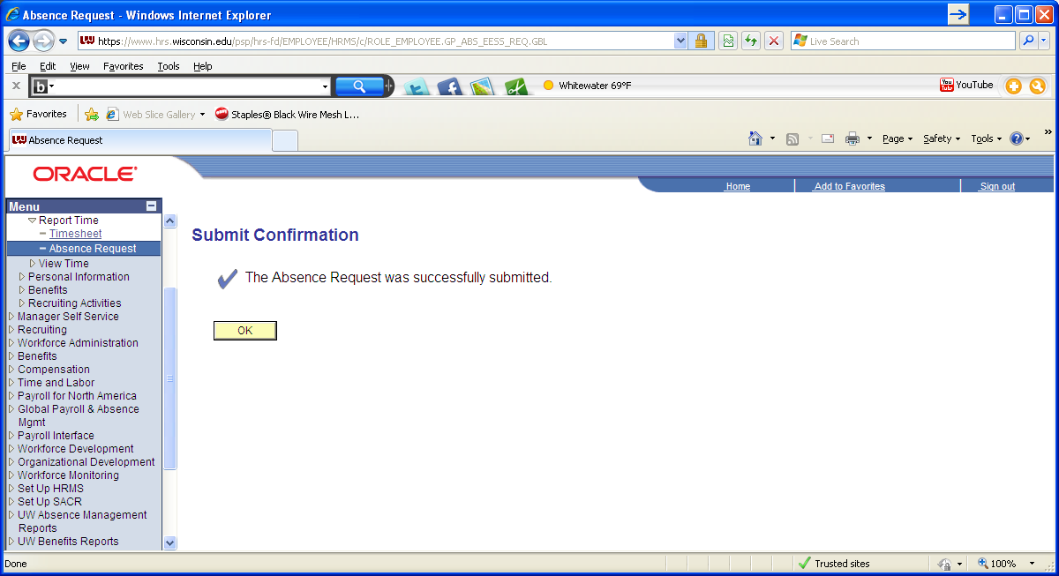
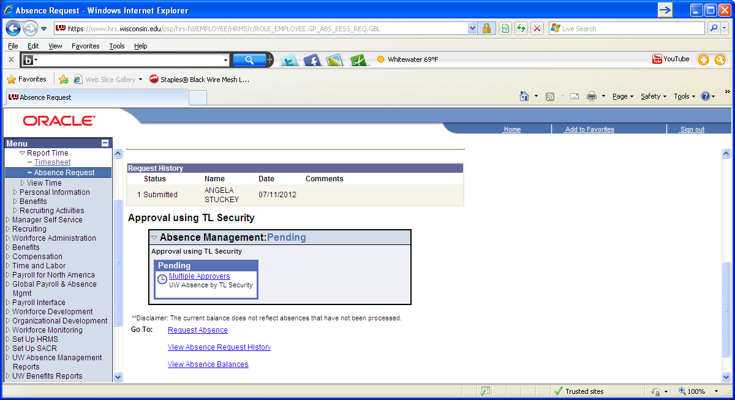
If you need to add additional absence, select request absence.
- After submitting, sign out and close window and return to portal.
- Select TIMESHEET from Time and Absence box.
- Enter your time worked for during that pay period
- IF YOU DID NOT TAKE A LUNCH, DO NOT REPORT TIME IN THE MIDDLE OUT/IN COLUMNS. This will create an exception/error on your timesheet.
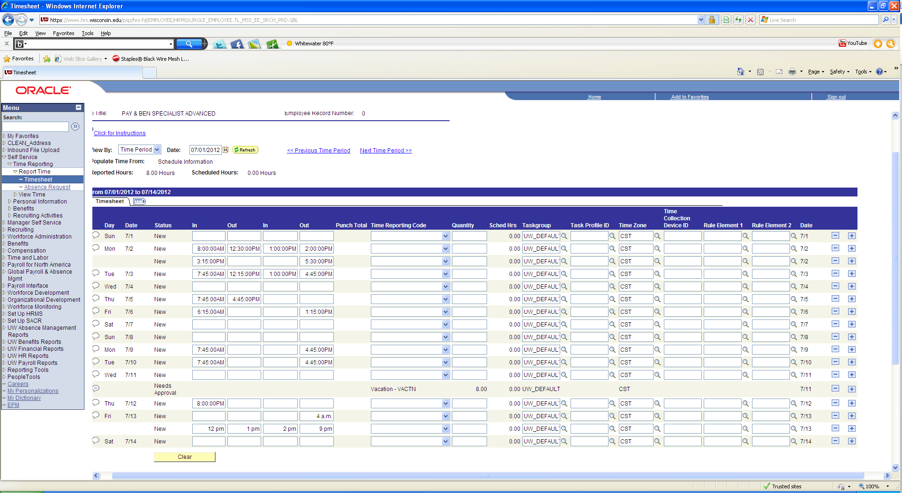
- For overnight shift add a row on the next day by hitting the + sign and put out time in farthest right column.
- Hit Submit on bottom.
SPECIAL NOTES:
Legal Holidays –
DO NOT ENTER, once time is submitted on your timesheet the legal holiday will auto populate
If you worked on a holiday, please enter your time and select NOHOL – No Legal Holiday from the Time Reporting code column
Overtime/Comp Time –
Overtime – The system will calculate OT for you, NEVER sumbit OT codes from the Time Reporting Code column.
Earning comp time: If you would like to earn comp time for OT rather than cash, please select go to Rule Element 1 column for the day you would like to earn the CT, select magnifying glass and select comp.
Using comp time: If you would like to earn comp time, go to the Time Report Code column, select drop down and select CT use. Then, go to quantity column and enter the number of comp hours you would like to use
Floating Holidays -
To report the use of Floating Holiday hours, go to Time Reporting code column, select FLHOL – Floating Holiday and then move to Quantity column and list the number of floating holiday hours you would like to use.
Standby Hours –
To report standby hours, go to the plus sign on the farthest right side and add a row for each day you are reporting standby hours. Go to the new row, go to Time Reporting Code Column, select SD225 – Standby (2.25 hour) and put the number of hours in the quantity column
Rounding –
HRS rounds to the nearest quarter hour. Please refer to the chart below for rounding.
00 – 7.5 | 00
7.5 – 22.5 | .25
22.5 – 37.5 | .50
37.5 – 52.5 | .75
52.5 - 60 | 1.0

