University of Wisconsin-Whitewater

Curriculum Proposal Form #3

## New Course

**Effective Term:**

**Subject Area - Course Number: FILM 485**

(See Note #1 below)

**Course Title:** (Limited to 65 characters) Film Theory

**25-Character Abbreviation:** Film Theory

**Sponsor(s):** Donald Jellerson

**Department(s):** Languages and Literatures

**College(s):**

# **Consultation took place**: NA Yes (please see Film Studies proposal)

**Programs Affected: Languages and Literatures: Film Studies**

**Is paperwork complete for those programs?** (Use "Form 2" for Catalog & Academic Report updates)

NA  Yes  will be at future meeting

**Prerequisites:** 9 units from: COMM 236, COMM 249, ENGLISH 266, FILM 350, FILM 352, FILM 354; or consent of the instructor

**Grade Basis:**  Conventional Letter  S/NC or Pass/Fail

**Course will be offered:**  Part of Load  Above Load

On Campus  Off Campus - Location

**College:** **Dept/Area(s):** Film Studies

**Instructor:** Donald Jellerson

**Check if the Course is to Meet Any of the Following:**

Technological Literacy Requirement  Writing Requirement

Diversity  General Education Option:

**Credit/Contact Hours:** (per semester)

Total lab hours:       Total lecture hours: 48

Number of credits: 3 Total contact hours: 48

**Can course be taken more than once for credit? (Repeatability)**  No  Yes

**Note:** Film 485, *Film Theory*, will serve as the capstone to the minor. Donald Jellerson will teach the course in the spring semester as an overload (beginning in 2015) until such time as enrollments in the Film Studies minor warrant a regular offering.

**Course justification:**

This course will serve the proposed minor in Film Studies. The minor is designed to enable students in various majors to understand cinema, the foundation for today’s visual media, as an art form and a social force. *Film Theory* will serve as the capstone to the minor, enabling students to learn major theoretical approaches to the study of film**.**

Film Theory will enable students in the Film Studies minor to understand the historical scope and development of theoretical approaches to film over the last several decades. It will also select three to four theoretical approaches for closer analysis. The syllabus example included here, for instance, focuses on feminist, marxist, psychoanalytic, and queer theory approaches. Students will be expected to read a significant number of secondary texts typifying the selected theoretical approaches, then apply that learning in analyzing a group of films. Instructors may choose films based on the kinds of theoretical approaches they wish to emphasize.

Since *Film Theory* carries a prerequisite of three film courses, students will be expected to bring well-developed skill sets in film analysis with them. The course will challenge students to deploy their skill sets throughout the semester as they encounter complex theoretical lenses for film analysis. This will allow students to exercise and improve their critical reading and writing skills.

As a capstone, *Film Theory* will remain attentive to all six of the learning outcomes for the Film Studies minor. While the question of which learning objectives will receive emphasis must remain the province of the instructor, all iterations of the course will be expected to provide explicit instruction, to greater or lesser degrees, in each of the six learning objectives.

**Short Course Description:**

In this course, students will learn how film theory developed, study the work of major film theorists, and analyze specific films using sophisticated theoretical lenses. Topics will vary.

**Budgetary impact:** This course will be taught by Donald Jellerson as an overload (starting in 2015) until such time as the minor has enrolled enough students to warrant a regularly scheduled capstone course. The associated expense will therefore be negligible for the next several years.

**Relationship to program assessment objectives:** Film 485 will serve the proposed Student Learning Outcomes (SLOs) for the Film Studies minor.



**Course objectives:**

* apply theoretical paradigms in oral and written analyses (SLO 1, 4)
* gain an understanding of the historical scope and development of film theory (SLO 2)
* deploy film analysis skill sets learned in previous film courses (SLO 3)
* deploy analyses based on three to four major theoretical approaches (SLO 4)
* enhance ability to contextualize ethical and aesthetic judgments (SLO 5)
* practice creating specific and complex interpretations of cinematic conventions (SLO 6)

tentative syllabus:

**English 485: Film Theory Donald Jellerson**

**email:** [jellersd@uww.edu](mailto:jellersd@uww.edu)

**“Genderqueer Cinema” office:** Laurentide 3217 **phone:** 472-1979

Spring, 2015 • MW 12:30–1:45 • HE 213 **hours:** MW 2:30–3:30; TR 4:00–5:00

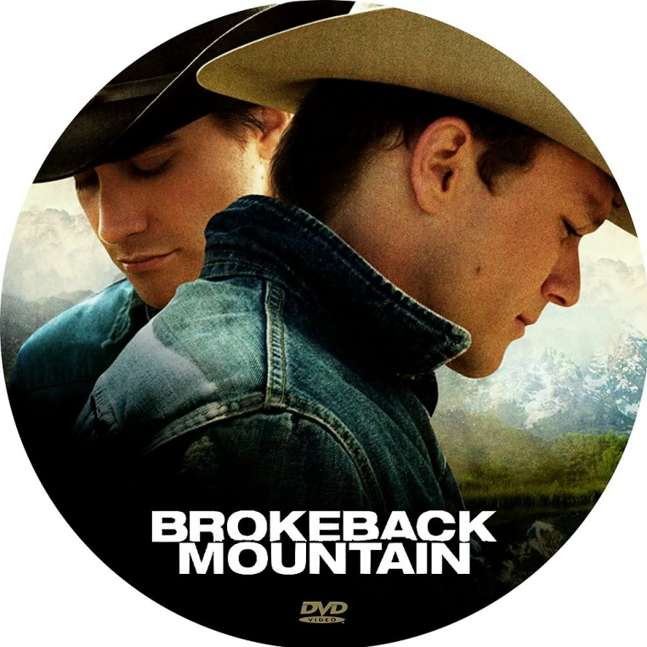texts:  
*Film Theory: An Introduction.* Stam (2000)

*Queer Theory: An Introduction.* Jagose (1997)

*Selected Essays* (provided)

films:  
*Brokeback Mountain.* Ang Lee (2005)

*The Crying Game.* Neil Jordan (1992)

*Imagine Me and You*. Oliver Parker (2005)

*Paris is Burning*. Jennie Livingston (1990)

*Rocky Horror Picture Show*. Sharman (1975)

*Hedwig and the Angry Inch*. Mitchell (2000)

*Rebecca*. Alfred Hitchcock (1940)

*Letter from an Unknown Woman*. Max Ophuls (1948)

course description:

In this course, you will learn terms and concepts in film theory so you can analyze film through established theoretical lenses such as feminism, Marxism, queer theory, and psychoanalysis. We will begin by pursuing a definition of genderqueer cinema.

According to the Gay-Straight Alliance, the term “genderqueer” refers to a gender identity position and/or sexual orientation outside of culturally prescribed binary systems ([www.gsanetwork.org](http://www.gsanetwork.org)). This course is interested in what it might mean to describe certain films as *genderqueer*. Such films could be distinguished from what has come to be known as “queer” cinema—films by, about, or for gay and lesbian audiences. *Genderqueer* films could also be distinguished from bi-curious comedies (e.g. *Some Like It Hot*) or sex/gender orientation tragedies (e.g. *Boys Don’t Cry*). What if, on the other hand, a *genderqueer* film is one that reflects upon and critiques stabilizing labels such as masculine, feminine, gay, and straight—a film like, say, *Brokeback Mountain*?

course goals:

* Learn and deploy theoretical approaches to cinematic texts
* Investigate a research question that demands theoretical and methodological innovation
* Reconsider the historical contingency of cinematic objects in relation to claims of universality

grade breakdown: Group Projects 25% Participation 20%

Short Analyses 25% Final Paper 30%

grade scale:

A = 93–100 A- = 90–92 B+ = 87–89 B = 83–86 B- = 80–82

C+ = 77–79 C = 73–76 C- = 70–72 D = 60–69 F = < 60

University Policy Statement: The University of Wisconsin-Whitewater is dedicated to a safe, supportive and non-discriminatory learning environment. It is the responsibility of all undergraduate and graduate students to familiarize themselves with University policies regarding Special Accommodations, Misconduct, Religious Beliefs Accommodation, Discrimination and Absence for University Sponsored Events. (For details please refer to the Undergraduate and Graduate Timetables; the "Rights and Responsibilities" section of the Undergraduate Bulletin; the Academic Requirements and Policies and the Facilities and Services sections of the Graduate Bulletin; and the "Student Academic Disciplinary Procedures" [UWS Chapter 14], and the "Student Nonacademic Disciplinary Procedures" [UWS Chapter 17]).

readings / **viewings** assignments

Week One ***Rebecca* (1940)**

Week Two Stam, “Film Theory”; Dyer, “Queer Noir”

Week Three ***Letter from an Unknown Woman* (1948)** short analysis

Week Four Doane, “The Woman’s Film”; Cavell, “Melodrama of the Unknown Woman”

Week Five ***Imagine Me and You* (2005)** short analysis

Week Six Metz, *The Imaginary Signifier* (selections)

Week Seven ***Paris is Burning* (1990)** short analysis

Week Eight Butler, “Gender is Burning”; Butler, *Gender Trouble* (selections)

Week Nine***Rocky Horror Picture Show* (1975)**group analyses

Week Ten ***Hedwig and the Angry Inch* (2000)** group analyses

Week Eleven Jagose, *Queer Theory* (selections)

Week Twelve ***The Crying Game* (1992)** short analysis

Week Thirteen Aaron, *New Queer Cinema* (selections)

Week Fourteen ***Brokeback Mountain* (2005)** short analysis

Week Fifteen Hanson, *Essays on Queer Theory* (selections)

Week Sixteen review; presentations final paper

**Bibliography:**

Aaron, Michelle. Ed. *New Queer Cinema: A Critical Reader*. Rutgers (2004)

Andrew, Dudley. *Concepts in Film Theory* (New York: Oxford University Press, 1984)

Barthes, Roland. *Elements of Semiology*, Lavers & Smith, trans. (New York: Hill & Wang, 1967).

Bazin, Andre. *What is Cinema?* Hugh Gray, trans & ed. (Berkeley: University of California Press, 1967)

Bellour, Raymond. *The Analysis of Film* (Bloomington & Indianapolis: Indiana University Press, 2000)

Butler, Judith. “Gender is Burning.” *Feminist Film Theory: A Reader*. Edinburgh UP (1999)

Butler, Judith. *Gender Trouble*. Routledge (2006)

Cavell, Stanley. “Psychoanalysis and Cinema: The Melodrama of the Unknown Woman.” *The Trial(s) of Psychoanalysis*. Ed. Francoise Meltzer. Chicago: U Chicago P (1988)

Corrigan, Timothy et al. *Critical Visions in Film Theory*. Bedford (2010)

Doane, Mary Ann, “The ‘Woman’s Film’.” *Re-Vision: Essays in Feminist Film Criticism*. Frederick, MD: University Publications of America (1984)

Dyer, Richard. “Queer Noir.” *Queer Cinema: The Film Reader*. New York: Routledge, 2004. 89-104.

Eisenstein, Sergei. *Toward a Theory of Montage* (Bloomington: Indiana University Press, 1992).

Hanson, Ellis. Ed. *Out Takes: Essays on Queer Theory and Film*. Duke (1999)

Jagose, Annamarie. *Queer Theory: An Introduction*. NYU (1997)

Metz, Christian. *The Imaginary Signifier: Psychoanalysis and the Cinema*. Indiana UP (1982)

Mulvey, Laura. *Visual and Other Pleasures* (Bloomington: Indiana University Press, 1989)