Looking for Willie Warhawk!

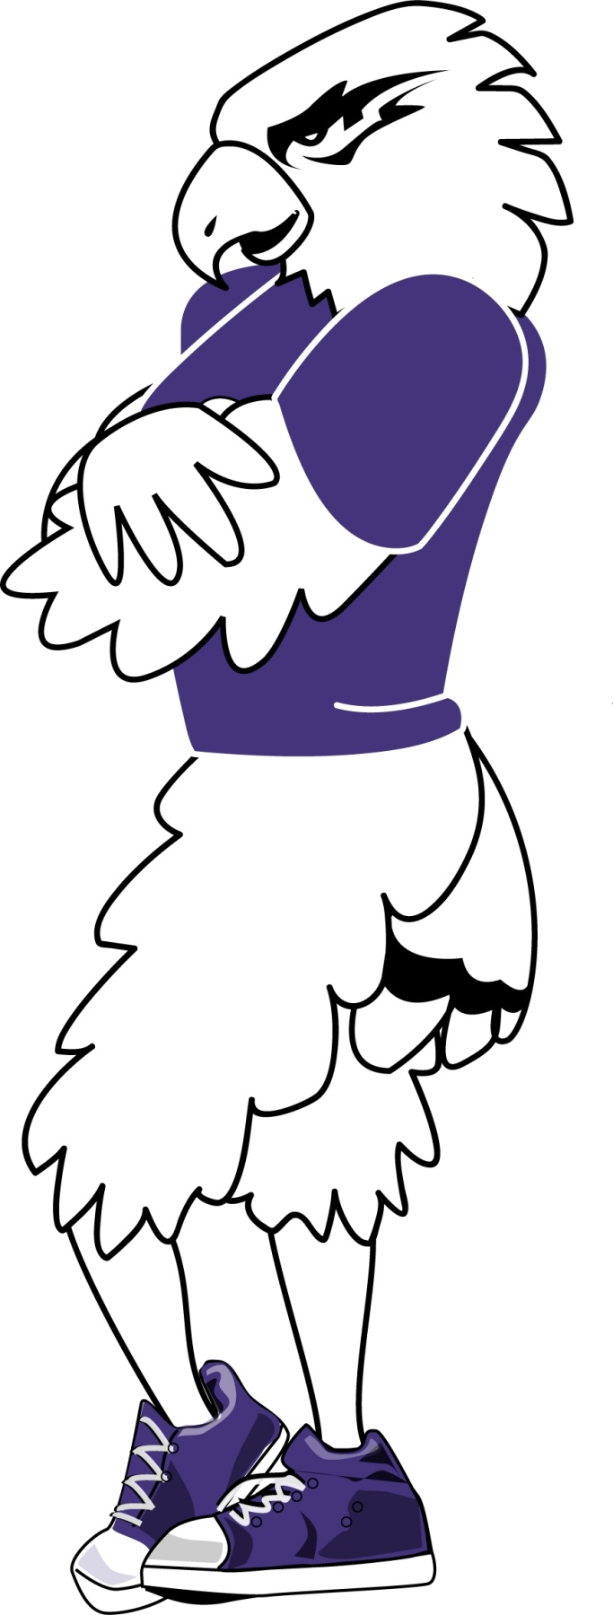
Could it be you?

Work Study preferred.

Job responsibilities Include performing at athletic events, university events, and community events.

Evening and weekend availability is required.

Must be outgoing and have tremendous Warhawk Spirit!

Contact Therese Kennedy if interested at 472.1145 or kennedyt@uww.edu

