ACCOMMODATIONS FOR TESTING

IMPORTANT NOTES:
- 2 STEPS

  - ALTERNATIVE TESTING CONTRACTS
  - ALTERNATIVE TESTING REQUESTS

- Requests cannot be submitted until a contract has been completed for the course

- Contracts should be completed with the instructor, if at all possible

- CONTRACTS AND REQUESTS DO NOT NEED TO BE COMPLETED FOR CLASSES WITH ONLY ONLINE TESTS

- A REQUEST DOES NOT NEED TO BE COMPLETED IF YOU ARE TAKING YOUR TEST WITH YOUR INSTRUCTOR

ALTERNATIVE TESTING CONTRACT
- Click on “Alternative Testing” in the left menu
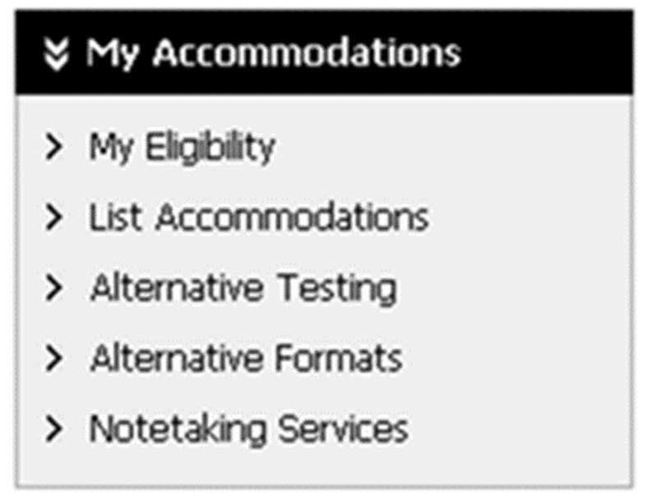

- Click on “Submit Alternative Testing Contract” in the upper right (above the white arrow in the red square)
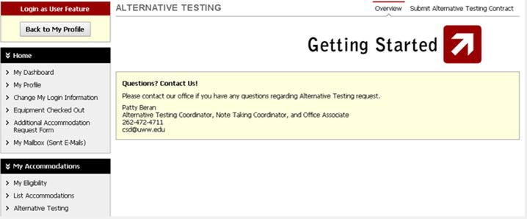

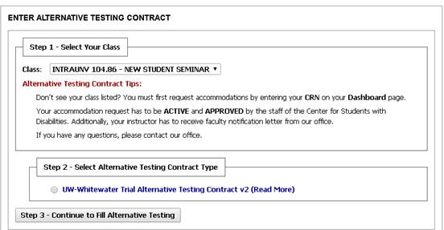
- Select the class from the dropdown menu

- Check off the UW – Whitewater Alternative Testing Contract

- The first part of the contract consists of a description of the contract and directions for the instructor completing the contract with you

- Answer the questions on the contract with your instructor

- Enter the amount of time the CLASS will have for each test type used

  - The time you enter should NOT include your extra time

  - If you get time and a half (1.5x) as an accommodation, enter the time allowed for the final into the “Final – Time and a half” field; if you get double time (2x) as an accommodation, enter the time allowed for the final into the “Final – Double Time” field

  - Any test types not used in the class can be left blank; you will NOT be able to select them when making an Alternative Testing Request
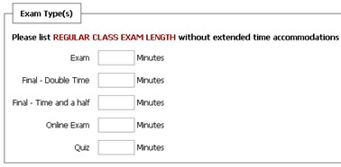

- Enter in the instructor’s phone number, and any additional information about the test CSD should know (i.e., two parts, calculator on half only, etc.)
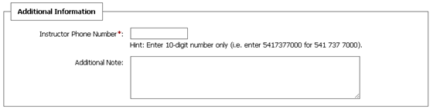

- Review your responsibilities as a student, checking them off as you do so

- Click “Submit Alternative Testing”

ALTERNATIVE TESTING REQUEST
- Click “Alternative Testing” (NOTE: if you just completed the Alternative Testing Contract, it will automatically bring you to the Alternative Testing Request screen)
- Select your class from the dropdown menu and click “Schedule an Exam”
  - NOTE: Any classes for which you have not completed a Contract will NOT appear in the dropdown menu
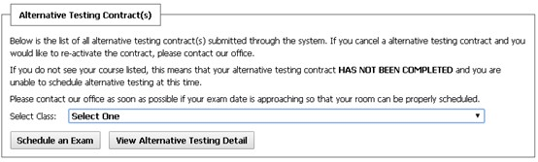

- Select the exam type from the dropdown menu, and enter the date and START time of the test
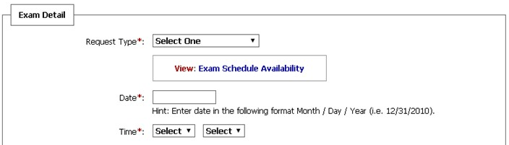

- Check off the accommodations you would like for the test
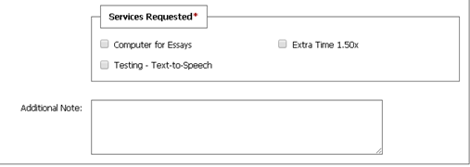

- In “Additional Note”, include anything you are allowed to use on the test (that was not on the Contract), and/or anything else CSD should know about the exam

- Review and check off the “Terms and Conditions”, then click “Add Exam Request”
