UW-Whitewater
Financial Training Manual
Financial Services 2018
Table of contents
Policies and Procedures
University Funding String Overview
Fund Accounting 5
Funding String Structure 5
Funding String Maintenance 9
Funding String Authorized Signers 9

Accessing Financial Information
WISDM 10
WISER 12
ImageNow 13
Access Forms 14
Data Security 14

Budgeting
Timeline 15
Corrections 16

Revenue
Types of Revenue 17
Tuition / Rates 17
Other Department Charges 18
Services Provided to Others 18
Sales / Sales Tax 19
Grants 20
Foundation 20
Chargebacks 20

Purchasing
P-Card 21
Shop@UW 22
State and UW Purchasing Contracts 23
Badger State Institute (BSI) 23
Printing Orders 23
Purchase Requisitions 23
Printing Services 25
Central Stores 25
Computers 25

Payments
Direct Payments (Quick Orders) 26
On purchase orders 27
PIRs / Contracts 27
Travel 28
Sponsored Events / Hosting 33

Payroll 34
Payroll Encumbrances 34
Independent Contractors 34
Emergency Paychecks 34

Accounting Forms
Expenditure Correction or Transfer=Non-Salary 35
Expenditure Correction or Transfer – Salary 35
Revenue Correction or Transfer 36
Department Chargebacks 36
Work Order Chargeback 37
Interunit Journal (IUJ) 38
Other forms 39
Prize Approval, Food Checklist, Off-Campus Events,
Equipment Disposal/Relocation

Depositing Revenue
State Receipts 39
Deferred Revenue 40
Student Faculty Organization Funds 41
Change Funds 41

Department/Division/College Monitoring of Finances 42
Fiscal Year End 42
Attestation of Effective Internal Controls 42

Training 44

Policies and Procedures
Policies provide structure for those who work or study at UW-Whitewater. They help ensure that decisions and transactions are made in uniform and authorized ways. Policies communicate the university expected actions and provide the authority needed to ensure compliance.
UW-Whitewater is governed by policies developed at several levels. They include federal law and policies, Wisconsin Statutes and Administrative Code, Board of Regents' and UW System Administration policies, and policies developed at UW-Whitewater. To comply with a federal, State, System, or campus policy, UW-Whitewater has also developed procedures to implement certain policies. This training manual will give you many of the policies and procedures you need to know, but the websites of these entities should be reviewed for specific requirements.

Frequently Used Policy Sources
UW System Policies
Located at: https://www.wisconsin.edu/uw-policies/uw-system-administrative-policies/
UW Whitewater Administrative Policies
Located at: http://www.uww.edu/adminaffairs
UW Whitewater Financial Services Accounting Policies and Procedures
Located at: http://www.uww.edu/adminaffairs/finance/accounting-services

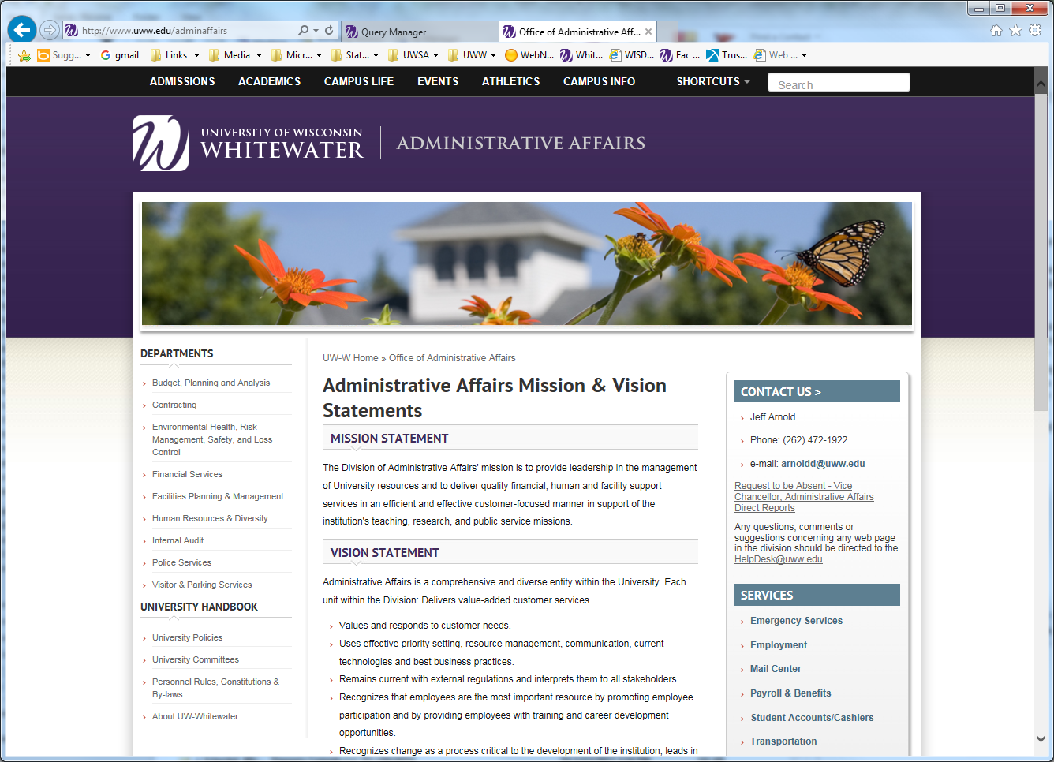
University Funding String Overview
Fund accounting
This is an accounting system emphasizing accountability rather than profitability, used by non-profit organizations and governments. In this system, a fund is a way to separate budget/revenue and other resources into categories based on the source of the fund. Each fund is an independent accounting entity, where accounts are maintained to make sure that the funds are used for their intended purposes.
The University of Wisconsin System uses fund accounting to track money related to a specific project or purpose in accordance with laws and regulations or special restrictions and limitations.
SFS is the Shared Financial System of the University of Wisconsin System (PeopleSoft Financials). This single integrated financial system enables each institution to execute its core business processes in a streamlined and flexible environment that meets users' needs.
Funding String Structure
The financial system structure, consist of six components: Fund, Program, Department ID, Account, Project and Class. Fund, Program and Account are uniform for the University of Wisconsin System. Department ID, Project, and Class are managed at the institution level.
The combinations of these components are referred to as a funding string.
Example of University funding string: 128 – 8 – 304004 – 9200 – PRJ0001 - 00000
Fund Prog Dept ID Account Project Class
Fund: The Fund (also called Appropriation) tells us about the source of money. Field size of the fund code is 3 digits. The two main types of funds are General Purpose Revenue Funds (GPR) and Program Revenue Funds (PR).
GPR - This revenue is tax payer dollars received from the State of Wisconsin in the form of budget rather than actual cash. Unused budget at year end reverts back to the institution. Commonly used GPR funds are:
102 - General Program Operations
109 - Energy Costs
402 - Minority program funding
403 - State aid program

PR - These Revenues are self-sustaining, meaning these activities generate their own revenue. The revenue is anything earned by the campus or earned from a source other than the State or Federal Government. Revenue sources include student fees, sales, and user charges. Cash balances remaining at year end stay with the department. Some of these funds earn interest on positive/pay interest on negative balances. Commonly used PR funds are:
128 - Auxiliary Services
131 - Academic Student Fees
133 - Non-Federal Grants & contracts
136 - General Operations
189 - Extension Student Fees
233 - Gifts

FED - These revenues are received from the federal government for support of grants or financial aid. Commonly Used FED funds are:
144 - Federal Aid – Special Projects
145 - 149 Federal Aid – Work-study, SEOG, Perkins Loans, Pell Grants, Direct Loans
150 - Federal Indirect Cost Reimbursement

Example of University funding string: 128 – 8 – 304004 – 9200 – PRJ0001 - 00000
Fund Prog Dept ID Account Project Class

Program: Program code tells us the purpose of funds being spent or collected. It is additional information to the accounting structure. Much of UW-Whitewater’s and the University of Wisconsin System’s financial reporting to external entities is done at the program level. The field size of program code is one digit. There are ten different program codes defined by UW System.

0 - Student Services
1 - Institutional Support
2 - Instruction
3 - Hospitals - Not used at Whitewater
4 - Research
5 - Public Service
6 - Academic Support
7 - Physical Plant
8 - Auxiliary Enterprises
9 - Financial Aid
Most academic areas will use program code 2 or 6. Auxiliaries will generally use code 8. Administrative areas generally use code 1. When requesting new funding to be set up, a program code will be determined based on the program revenues and expenses being tracked.
Further definition of each code is available at http://www.uww.edu/adminaffairs/finance/accounting-services
Look for “Program Code Information”

Example of University funding string: 128 – 8 – 304004 – 9200 – PRJ0001 - 00000
Fund Prog Dept ID Account Project Class
Department ID: Department ID (often referred to as Org Code) is used to identify the division, major unit, sub unit, and departments of the university. The field size of Dept ID is six digits. The first two digits represent the division, and the next two, the department within the division. The remaining digits have no specific meaning. Some examples:
1010xx- General Admin - Chancellor
2510xx- Graduate Studies & Continuing Ed Division - Dean
3030xx- Admin Affairs Division – Human Resources
4085xx- Student Affairs Division – University Housing
98xxxx- University Wide

For example, the code 408541 is a department ID for Housing Facilities.
First two digits 40 describe the division of campus, which is Student Affairs.
Third and fourth digits 85 identify the major unit, which is University Housing.
The fifth and sixth digits 41 identify the specific department, which is Housing Facilities.
A list of active and inactive funding strings is available for UW-Whitewater at: http://www.uww.edu/adminaffairs/finance/accounting-services
Look for “Department Code Listing”
This excel spreadsheet contains a listing of all Department codes and Project codes by major unit. The spreadsheet includes a filter which allows you to sort to meet your needs.

Example of University funding string: 128 – 8 – 304004 – 9200 – PRJ0001 - 00000
Fund Prog Dept ID Account Project Class

Account: Provides detail to a transaction. Field size of account code is four digits. There are different groups of account codes. All accounts and their definitions are listed in the chart of accounts found on the UW System website.
1xxx - Wages & Fringes
2xxx - Services Expense
28xx - Travel Expenses
3xxx - Supplies Expenses
4xxx - Capital Expenses
5xxx - Special Expenses
6xxx, 7xxx, 8xxx - Balance Sheet Accounts
9xxx - Revenue
Accounts and their definitions: http://www.uww.edu/adminaffairs/finance/accounting-services
Look for “Account Codes”

Example of University funding string: 128 – 8 – 304004 – 9200 – PRJ0001 - 00000
Fund Prog Dept ID Account Project Class

Project: Optional field; field size of project is seven digits. The first 3 digits are letters and the last 4 numerical digits, all are assigned at random (currently no logic at this level). Project numbers can be found on the list of department codes. Project codes are often used to track grants, specific years of a program, or for other specific purposes.
Class: This is an optional field; field size 5 digits. Class digits can be alpha, numeric or a combination. There is limited use of this field, but it is currently used to track revenue in some Dept IDs, or to identify buildings.

Funding String Maintenance
To request, close/inactivate or change authorized signers, the following form is used. https://www.uww.edu/adminaffairs/finance/accounting-services/forms/
Look for “Dept(org) Code Request/Change Form”.
The completed form is routed to Financial Services.
Authorized Signers
Financial Services delegates funding string management responsibilities to Department Managers. Authorized signors are designated for specific departments by the Department Manager. The Department Manager can designate any number of authorized signors for a department code, keeping in mind that any authorized signer can spend funds, make changes via expense or revenue transfers, etc. Financial Services maintains a current listing of department and project codes, their manager, and authorized signers on our website.

The Authorized signor list is available at: http://www.uww.edu/adminaffairs/finance/accounting-services
Look for “Department Code Listing”
Changes to the Manager shown in WISDM or to authorized signers must be made using the Dept Code Request/Change form (shown above). Multiple changes can be made on one form.

Accessing Financial Information
The tools used in accessing financial information are WISDM, WISER, and ImageNow.
WISDM
Wisconsin Data Mart (WISDM) is the university’s data warehouse for PeopleSoft financials. A user ID and password are required; to get access to WISDM, the employee’s supervisor needs to send an access request form to the help desk. Periodic training is provided for new users and is found at the site: https://my.uww.edu
WISDM is accessed from a quick link on the UW-W website. Go to UW-W website, select faculty/staff, and find the quick link shown:
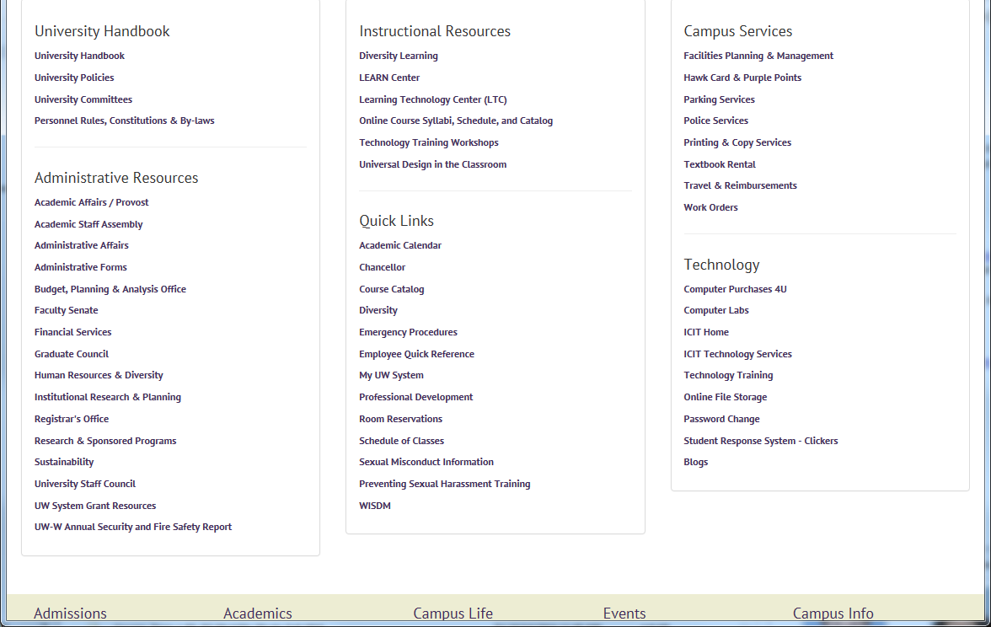

Select Whitewater
Login using your network ID and password.

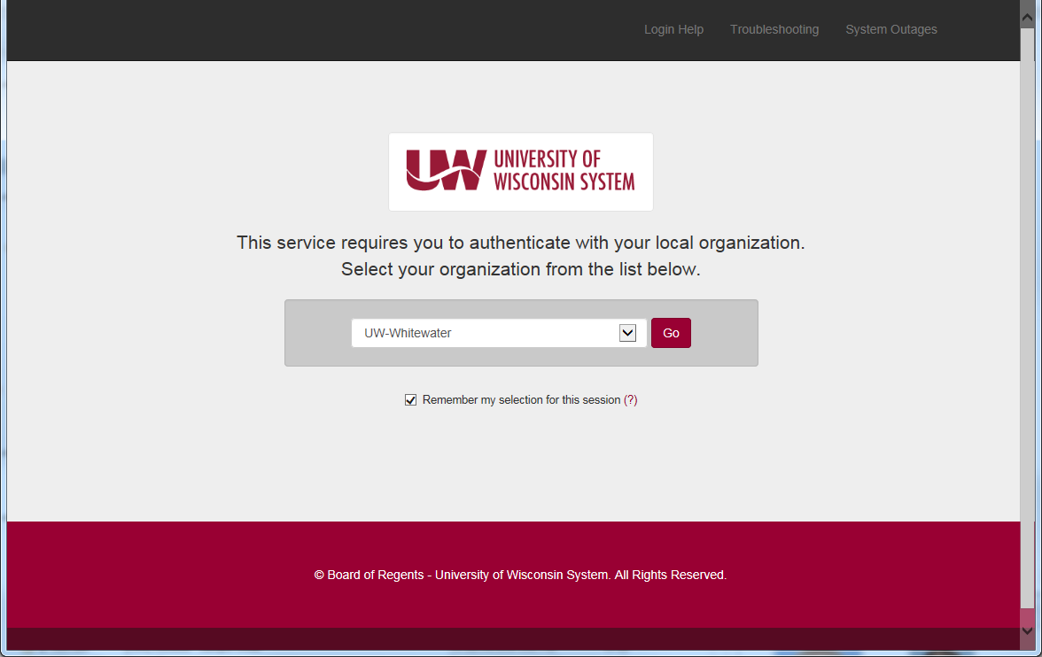
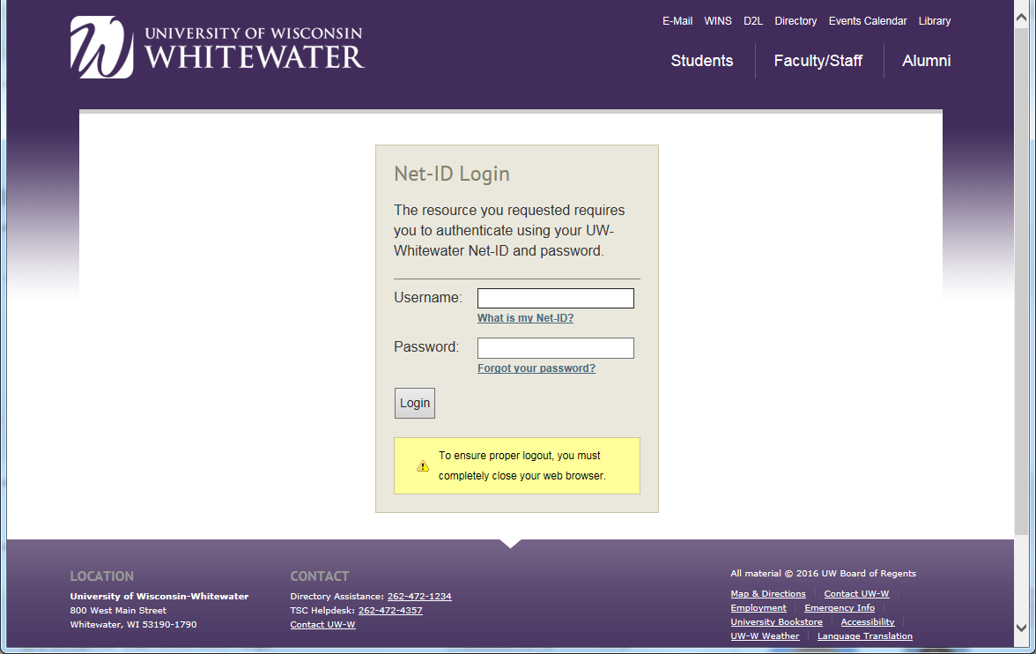

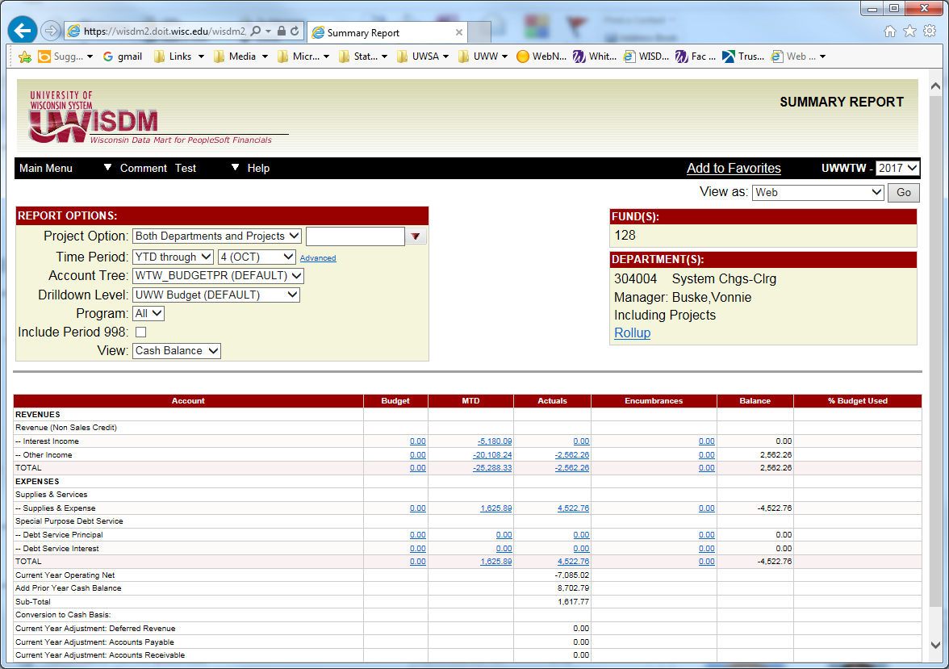

The summary by department code shown here will be the most useful tool for business managers, but other query tools are available within the system. General Ledger months close on the 8th day of the following month, so there could be minor changes if you are looking at month end data prior to that day. New users should attend a WISDM training class to for navigation and tips to get the most efficient use from this tool.
For more information on WISDM you can find the WISDM manual on the Financial Services website. http://www.uww.edu/adminaffairs/finance/accounting-services/
Look for “WISDM Manual”

WISER
Within the WISDM drop down menu is another tool called WISER. WISER provides the ability to easily roll up information for a department across multiple funds. It will provide a year to year comparison and more or less detail on the components of the summary reports seen in WISDM. This tool also provides a YTD comparison for a point in time last year to this year or for multiple years. As with WISDM, drilldown capabilities exist to get to very detailed level of the transactions.

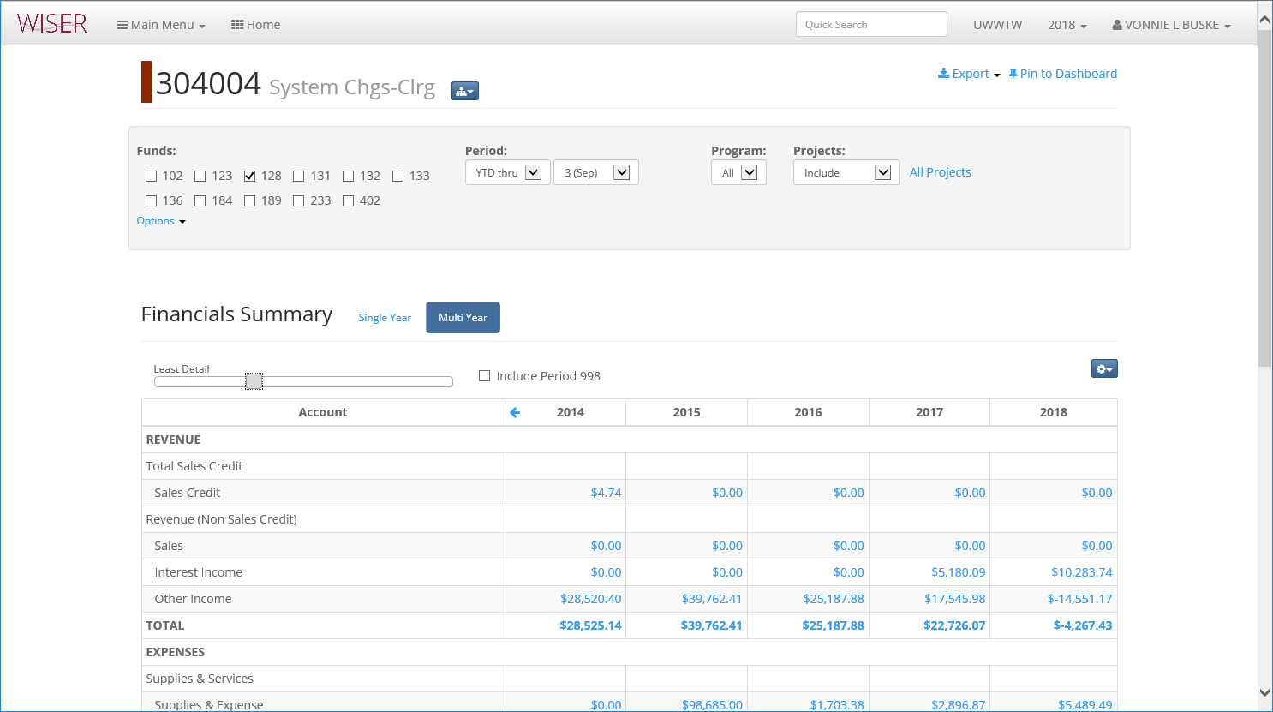

ImageNow
A Perceptive Software imaging application is utilized by the University. This software enables employees to workflow and store documents electronically. Once imported (captured), files can be efficiently routed, processed and stored in this paperless system. Many departments are using this software for their own purposes, so contact your Campus Business Rep (CBR) for your department to determine if you need this access. If your department is not currently a user, it may be that a workflow does not exist for any process you currently use in the department. Each department determines if they will utilize this software for their needs.
If you are a CBR, access to the Webnow version of this software is recommended. Financial Services uses Imagenow for processing and storing documents for the University. Images of the invoices, journals, etc are typically made available to CBRs via Webnow. In WISDM, if there is a stored image of a processed document, you will see a “View Image” column indicated on that transaction line in the department level transactions. Clicking on this link will take you to the stored image, if available. NOTE: Use internet Explorer for Webnow, and Java version must be level 8 or lower.

Access
The campus has purchased a number of licenses for Webnow access, so should this access be needed, the user should contact the help desk. They will contact Financial Services to grant access to the Webnow images stored.

To sign-in
Select Webnow from your computer’s programs or from your menu bar. https:/webnow.uww.edu/webnow/
Sign in with your campus login and password.
Locating Documents
Stored documents may be located by selecting the Documents tab. Users may search using the All Documents folder or by specific document type such as PO number, number, voucher ID etc (note these are labeled Field1, Field2, etc). If you are unable to locate a document, contact Financial Services for assistance.

Access Forms
Access to software utilized by Financial Services is obtained by submitting the Computer Access Request and Authorization form. Along with the form, the user will need to complete the Compliance Form. Completed forms are sent to the help desk (HR if a new employee).
Both forms are available on the Financial Services website:
http://www.uww.edu/adminaffairs/finance/accounting-services/forms
Look for “Computer Access and Authorization Request” form and “Compliance Form”

Data Security
Access to Shared Financials, WINS, and HR may require additional training and use of a “fob”. If required, the helpdesk will assist in obtaining the needed items. Additionally, departments that handle confidential information should ensure the confidentiality agreement is completed and FERPA and red flag rules are explained to all employees.

Budgeting
The University budgeting process for departments largely occurs between December and March. Budget related information such as deadlines, target sheets and summaries are located on the Budget Office web page. The budget is often referred to as the REDBOOK (historically the budget was printed with a red cover).
The Budget Office sends instructions and spreadsheets to the divisions who then distribute to departments. The division sends this information to the departments with their own instructions for timelines, if applicable.
Budget Development Timeline

July & August | Determine ability to fund new positions and what those positions will be (staffing plan).  Funding is not added permanently until we have generated that level consistently for over a year.
December | Budget instructions and spreadsheets (salary/summary) are developed and distributed.
January & February | Divisions and departments update their budget spreadsheets and return to the budget office. Budget office staff meets with units as requested.  Departments are provided a budget target for FTE, salary and non-salary items.  Within the target, funds may be moved between departments, colleges and divisions based on consultation with Chancellor, Provost, Deans, Department Chairs.  The submission must reconcile back to the target for GPR/Fee funds (102, 402, 131).  Funding should not shift between salary and non-salary categories but can move within the categories.  Auxiliary budgets are reviewed for fee increases as well as changes to FTE. Program revenue budgets do not need to reconcile to initial budget targets.
March | Allocation information is received from UW System.
March & April | Budget office reviews, enters and reconciles budgets. Completed budget is submitted to UW System.
May | UW System Budget Office reviews submission and presents to Vice President of Finance and Assoc. Vice President of Budget.
June | Board of Regents acts on promotions and status changes.
July | Board of Regents enacts annual budget
August | Budget Office works with Human Resources to verify salaries and funding.
August & September | Budget extract is verified and exported to the financial system.

Budget Transfers/Corrections
- Transfers can be made between departments and campus units, as well as, between budget line classifications
- During the fiscal year, transfers between salary and service and supply are allowed
  - These are not allowed in the budget process without prior approval from budget office
  - Transfers onto the student help line are allowed in the budget process, but not off
- Budget may not be transferred between Program Revenue (131, 136, 128) and GPR (102, 402)
- Budget transfers may be requested using the Budget Transfer form found on the Budget Office website:

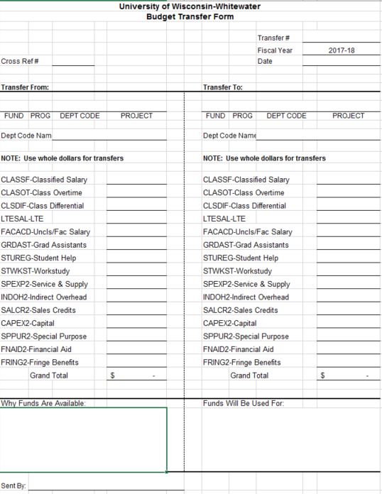

Department Monitoring of Budget
- At the start of a new fiscal year and during the year, departments should be reviewing their budgets, verifying funding of staff being paid by their dept codes, reviewing expenses, monitoring budget overdrafts, etc, and making needed corrections as early as possible.
- At the end of the fiscal year, departments are provided with the timelines for year-end processing and chargeback distributions. Departments should be closely reviewing dept code activity, budget and cash balances.

Revenue
Types of Revenue
As indicated in the funding structure section, some types of revenue determine the fund in which they can be deposited. Auxiliary revenue, for example (housing, dining, parking, bookstore) is deposited to fund 128. Revenue received as a gift is deposited to fund 233.
All funds received in departments on campus are deposited to campus accounts via a deposit form and are brought to the Cashiers office for deposit to the bank. See Cash Handling section for discussion of how processing of revenue is completed. Any activity that uses University resources to be generated, or is sponsored by the University to generate revenue will be deposited into a University account. Generally, deposits are made to the same account in which expenses for the cost of service or items used are charged (matching revenue and expense). When this is not the case, it should be explained on the deposit so that a reviewer can match the revenue and expense if needed.

Tuition Revenue
UW-Whitewater has the authority to charge three types of tuition including:
Standard Tuition: Academic student fees and tuition for instruction set by the Board of Regents in adopting the annual operating budget. These are traditional type courses offered in-person. If offered on-line, outside of the College of Business, an additional Distance Ed fee is charged per credit to cover the added cost of on-line technology. Whitewater utilizes a tuition plateau approach for pricing. Students taking 12-18 credits are charged the same amount for tuition and fees. Credits above or below this range are charged per credit.
Differential Tuition: Any tuition rate that is different than the standard tuition set by the Board of Regents. This tuition at Whitewater was developed to provide additional advising services to all students and targeted programing for students in their first two years.
On-line Program Tuition: Authority to charge market rates for specially designed or customized programs or certificates; driven by market demand and delivered to professionals. The courses are offered at alternate time frames and may be in person, at a distance – on or off campus. Student credit hours and tuition revenue generated will be outside of the typical tuition plateau.
Fund 131 is used for all tuition revenue deposits. All tuition charges are placed on the student bill and invoiced (billed) to the students, with payments collected through Financial Services, Student Accounts and Cashiers unit.
Tuition Rates
Rates for differential tuition and on-line programs are presented to the Board of Regents for approval. Standard tuition rates are established by the Board of Regents annually.

Segregated Fees
Segregated fees are collected from each student attending courses that charge standard tuition. Seg fees are reviewed each year and submitted for Chancellor and Board of Regents approval.
Student Organizations and campus departments heavily utilized by students seek operating funding for the next year by submitting a request to the SUFAC student group for review and approval. The SUFAC funding process is described here http://www.uww.edu/sufac/student-org-sufac Budget office staff assist the SUFAC group in deriving the amount an approved budget increase or decrease will have on the seg fees for the next year.
Departments with capital projects for which student financial support is sought will submit a request to the SUFAC group for their commitment to the project. Commitments are formally approved in writing and funding strings are set up to track revenue as it is generated toward the commitment.

Other Department Charges on a Student Account
Some departments provide services to students and are permitted to charge their services or fees to the student’s account with the University. These include housing and meals, purple points, health center charges, parking, bookstore, etc. Not all departments charge to the student’s account, and not all students desire the charges to go on their student accounts. Departments can collect for their services at the time of sale if desired, or if the student prefers to pay at the time of services.
Departments who prefer to charge the student account avoid the hassle of handling money in their office, or collecting from the students. Only those departments who maintain adequate records of the transactions to be placed on the student’s account will be permitted to do so. Departments who desire to place charges on a student account should contact Financial Services for a review of their process and documentation supporting the charges. Once approved for being able to add charges to a student’s account, the department must follow the timelines established for the timely posting of charges so as not to hinder the billing and collection of student account balances. Charges will only be posted for the current term, no prior term charges will be posted, as student collections activity operates on set timelines for collection and referral to collection agencies.

Services Provided to Others
Departments who provide items or services to others charge fees for their services. This revenue may be in the form of sales, as in a certain price is charged for an item, ie. a transcript, or a fee for services provided, ie transportation. Charges for these sales can be collected at the time of sale and deposited with the Cashier’s office. Some charges are billed to the customer receiving the service. Sage 50 / Peachtree Quantum software is used to bill external customers for services provided by departments or staff of the university. Departments are NOT permitted to develop their own invoices or utilize other billing systems for University sales or services. If you have a unique request, you MUST contact Financial Services BEFORE implementing any other process.
Documentation for invoices prepared in the Sage/Peachtree software is maintained by the billing departments for the required accounting record retention period, with periodic review by Financial Services. Statements for unpaid invoices are mailed out to customers monthly by Financial Services. Payments on invoices go directly to the Cashier’s office, so it is important that the correct coding is used on the invoice for the deposit of funds. Wire transfers for the invoice amount can be sent to a specific bank account used by the Cashier’s office for this purpose. Contact the Cashier’s office if this information is needed. Collection of past due amounts is the responsibility of the department. If attempts have been made to collect without results, the department needs to request assistance from Financial Services to send the debt to a collection agency.
Departments request access to the billing software via the computer access form found on the Financial Services website and forwarded to iCIT for software access. iCIT will request approval for access on behalf of the user. Once approved, iCIT will install the software for use. Financial Services will inform the user of the login ID for access. Departments are assigned a login for the department use, and staff and backups use that login, so passwords may already be established by another department user. If there has been turnover and there is no other user, Financial Services will reset the password for the new user. Personalized training is available for use of the software from Financial Services staff. Before departments can use the software, they must be set up in the software so funding strings and invoice templates are available to them.

Sales Tax Related to Department Sales
The University holds a sellers permit for all sales tax reportable items sold on campus. Student organizations may use the University sellers permit for sales they hold, but funds must be deposited in university accounts to ensure all sales tax is reported.

Financial Services, Cashiers Office unit collects information for all sales on campus that are required to collect and report sales tax. Electronic deposit forms calculate the sales tax on the deposits to be made, providing assistance to the preparer in completing the form. The deposit form should be accessed from the website to ensure the most up to date form is used. Departments who wish to customize the form for their revenue strings may do so, but cannot change the format and formulas within the form.

Grants
Grants provided to the University may come from federal, State, UW System, or other institution funds. Typically, faculty or staff from UWW write grants requesting funding for a specific purpose, research project, foreign travel, etc. The UWW Pre-Award office in Research and Sponsored Programs assists the writers in this effort and helps put together the documents needed to apply for grants. If a grant is funded, the award is typically transitioned to the Post Award unit in Financial Services to assist with the set-up of payroll, p-cards, etc for spending and reporting on the grant. Some grants from UW System are monitored by the Pre-award office, all others are monitored by the Post Award Office in Financial Services. The Pre-Award office will assist the grant writer (Principle Investigator or “PI”) in the transition process to the correct office for post award activity.

Foundation
Foundation funds are often available for specific use within a department or college, depending on the donor’s instructions. Funds to be received from the foundation will follow the same process as other spending at the University, but will be coded to a fund 233 funding string. If the department has been provided with permission to spend Foundation funds, they will spend as needed and the Foundation will send the funds to cover expenses for which they have committed. If the Foundation is fundraising for a specific project or purchase, the department must coordinate with the Foundation to plan for the timing of the purchase and transfer of funds. No Foundation funds may be spent without first getting confirmation from the Foundation that they agree to fund the purchase.

Foundation principles for spending were updated in July 2017 and are available here.
http://www.uww.edu/adminaffairs/finance/accounting-services/campus-financial-polices

Chargebacks
UW-Whitewater departments establish rate/fee schedules for goods and/or services they render, especially goods and services offered in a recurring manner. Departments that have an automated process provide uploads to Financial Services with the charges for their customers, which are loaded into the ledger and displayed in WISDM monthly. Departments that do not have an automated process use the Sage 50 (Peachtree) software to prepare internal billings for their customers. The customer receives the invoice to review, and if any issues, contacts the service provider to modify the invoice. They have at least a week to complete the review. Financial Services pulls all internal billings weekly on Fridays to upload the file of chargebacks. Once the chargeback file is loaded, any changes will need to be processed as expense corrections.

Purchasing
As a State agency, UW-Whitewater purchases must be in compliance with all State and UW System purchasing regulations and contracts. We purchase things in one of four ways: 1 - Purchasing Cards, 2 - Shop at UW, 3 - State and UW contracts, and 4 - Bidding. Regardless of the method used, the University is tax exempt, so you should not pay sales tax on a purchase. Tax exempt cards are available from Financial Services.
Purchasing Cards (P-cards)
Purchasing cards should be used to make supply or equipment purchases under $1,500 to expedite the receipt of necessary products. The use of the P-card is a time saving tool for cardholders and financial staff. It allows for reduced processing times for purchase requisitions, purchase orders, and invoices. All Campus Business Reps (CBRs) should have a P-card for their department. There may be multiple P-cards in the department to accommodate different funding sources. A P-card holder is responsible for any activity on their assigned cards, and MUST obtain receipts and prepare logs and required reports.
Specific limitations of the p-card: The P-card cannot be used to purchase gift cards. Amazon PRIME memberships are not permitted. Use of a p-card for Amazon purchases requires a specific tax exempt set up for the account, please contact purchasing if this is applicable to your department.
P-card manual
Location: https://www.wisconsin.edu/financial-administration/special-topics/purchasing-cards/
Look for “UW System Purchasing Card Policy & Procedure Manual”

P-card applications
Location: https://www.wisconsin.edu/financial-administration/special-topics/purchasing-cards/
Look for “System Electronic Purchasing Card Application and User Agreement”
After the application is submitted, UWW Purchasing staff will notify you when the card is available for pick up.

P-card training
Training needs to be completed before a P-card is provided to you. Annual training updates will be required.

P-card log and receipts
As you make purchases with your p-card, log all of the purchases on the p-card log. Indicate the items purchased and the business purpose of the items. Verify the receipts for the items are accurate, and that you were not charged sales tax. If sales tax was charged, it is your responsibility to request a refund from the vendor. Inappropriate charges made on a p-card will require the cardholder to return funds to the UWW.
Attach receipts to the p-card log. At the end of each cycle, compare your logged transactions to those posted in WISDM. If not accurate, contact the vendor, or p-card administrator to identify remedies.

P-card Statements
Statements are received by the card holder from US Bank biweekly (every other week). Reconcile your statement by matching charges on the statement to your p-card log and receipts. Sign and forward the statement, log and receipts to your supervisor for review and signature.
Once signed by supervisor, send documents and receipts to Purchasing; these records will be imaged and reviewed by the Purchasing office.
The purchasing card billing cycle can be located at:
https://www.wisconsin.edu/financial-administration/special-topics/purchasing-cards/
Look for “Purchasing Card Billing Cycle”

P-card Charges
Charges are automatically assigned to the funding string identified for the card and account code 3100 – Supplies for standard purchasing cards. If charges are not for that funding string or are not supplies, these charges may be reallocated to the correct account(s). Contact Financial Services to inquire about access to the transaction file for making regular changes to p-card activity.

Shop@UW
Most department purchases will fall under the Office Supplies contract and need to be purchased through vendors in Shop@UW. Related expenses are then charged directly to the department’s funding designated on the application to access the system.
To access Shop@UW, you will need to set-up an account. Your supervisor should complete the Shop@UW account set-up form available at: http://www.bussvc.wisc.edu/shopuw/account.html
Once set up, you will have access to make purchases in the storefront. The system will process a chargeback to the funding information for your account. Purchases need to be logged as they are made, and when charged back, are approved just like those purchases on the p-card.
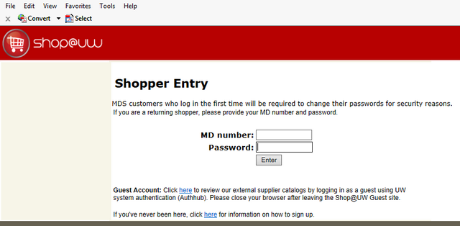
If you would like to view tutorials on using the Shop@UW online, please go to http://bussvc.wisc.edu/shopuw/tutorials.html

State and UW Purchasing Contracts
The State and UW System contract with a number of vendors for regularly used commodities. When making purchases for specific commodities for which vendors have been identified as MANDATORY contract providers, those vendors MUST be used. Examples include travel services and office equipment. Some mandatory contracts have been developed that include multiple providers, so utilization of any provider in the contract is permitted.

UW campuses also contract with vendors for commodities often used by them. These contracts are not required, but provide a benefit to the user, as the vendors are familiar with the UW needs, and save time in identifying vendors for the needed product or service. Use of these vendors is permitted if “piggybacking” on the contract is allowed by the vendor. Some vendors will not allow this, as some are not in the area of other campuses, or perhaps they gave an exclusive price to the one campus. If a contract has a list of possible vendors, the purchaser should contact providers for quotes for their purchase to get the best possible price.

If you are seeking to make a purchase that will exceed $5,000 or one year of service, contact the Purchasing Office first to ensure there is no mandatory contract for the commodity, and to ensure you follow the rules related to that type of purchase. You may also search here for contracts https://www.wisconsin.edu/procurement/contracts/ but navigating the contracts can be confusing. ALL printing orders require a purchase order, so you MUST contact Printing Services to coordinate that purchase.

If you are not sure if you need a Purchase Order, contact the Purchasing Office to discuss.

Badger State Industries (BSI)
Use of Badger State Industries is mandatory for some items – generally office furniture, office equipment, modular systems, desk lifts, etc. Before any purchases can be made with another vendor, a waiver MUST be obtained from BSI if they will not be used. Contact Purchasing BEFORE proceeding with this type of purchase.

Printing Orders
The State requires all printing orders to be processed on a purchase order regardless of dollar amount. To ensure you follow the required process, you must work with Printing Services to start the process. The purchase requisition should be sent to Printing Services for processing.

Purchase Requisition (Non-Printing Orders)
If you need to order an item or service that cost more than $5,000, you will need to identify the specifications to be provided to each vendor, obtain quotes using those specifications, prepare the quote summary, and prepare a purchase requisition form with the pertinent information for review by the Purchasing Office. Once the Purchasing Office has reviewed and approved your request, staff will prepare the Purchase Order (this is the official order for the goods or services) and send it to the vendor to place the order. No order for goods or services can be placed prior to obtaining approval, which is the Purchase Order, so submitting an invoice and purchase requisition means you have not followed correct procedures.
Inappropriate purchases made by an employee are the responsibility of the employee to pay, so it is imperative that you are following all procurement rules to avoid taking personal liability for an inappropriate purchase.
Purchases exceeding $25,000 for the item or one year of service must be reviewed and approved by the UW System Purchasing Office, so more time is needed in advance of the desired purchase. Contact should be made with the UWW Purchasing Office well in advance of this type of purchase.
Purchases for service that will cover more than one year may be considered for contract purposes, HOWEVER, payments will be made in annual installments, such as for a copier lease, or software.
If you make regular purchases throughout the year with the same vendor, the Purchasing Office can create a Blanket Order. Blanket Orders expire at the end of the fiscal year and need to be resubmitted annually if the expense is ongoing.
The Purchasing requisition form is found here http://www.uww.edu/adminaffairs/finance/accounting-services/forms

It is important to ensure that the form provides the funding information for the items being ordered. Any comments included on the form will be added to the purchase order when prepared. The form must be authorized by an authorized signor for the dept funding being used. The completed form, quote summary, and quotes should be forwarded to the Purchasing Office, or can be scanned and sent to purchasing@uww.edu Please send OR scan, but not both to avoid duplicate entries.

The completed purchase order commits the funds to cover the cost of the purchase. This commitment is called an encumbrance. In WISDM you will see all funds committed in this way in a separate column. The encumbrances will be liquidated when the actual payment is made to the vendor. If you know you will be committing funds for a specific purchase, it is important to do this as early as possible in the year so the funds will not be unintentionally spent. The purchasing office will prepare all purchase orders for copier leases at the start of each year of an active lease. If you will be discontinuing a copier lease, please let purchasing know.

Printing Services
Printing Services provides planning, management, production coordination and print buying services in accordance with the University Printing Policy. Printing related purchases are regulated by Wisconsin Statutes Chapter 16 and the State constitution.
A Purchase Requisition is required for all print jobs. Information on the various services and items that can be ordered can be found on the website: http://www.uww.edu/umc/identity-standards/printing
Business cards, letterhead and stationery can be ordered online.

Central Stores
Central Stores purchases and stores commonly used office paper items in bulk. Items available through Central Stores include: letter and legal size white paper and color paper. Items can be ordered by completing the supply order form:
http://www.uww.edu/adminaffairs/fpm/forms
Look for “Central Supply Order Form”

Computers
Computer purchases should be coordinated through iCIT. They maintain a stock of computers, or have regular buying cycles for computers, and will receive and set up computers for department use. Specialized needs and software should be discussed with them before buying. http://www.uww.edu/icit/services/tech-purchasing

Payments
Financial Services processes all payments to vendors, other than p-card purchases, and all reimbursements to employees. No payments are permitted from revenue collected at a department.

By statute, the UWW must pay its vendors within 30 days of the invoice date or file a notice of dispute with the vendor within that time. Invoices that are delayed in the department and are submitted late may be charged late fees/interest by the vendor. Should this happen, Financial Services is required to annually report all late fees paid, the reason for them, along with submitting a corrective action plan. Should this be needed, the department will be required to identify the reason for the tardiness and the actions it will take to prevent this from happening again.

Direct Payment (Quick Order)
This form is used to make individual payments to vendors not requiring a purchase order. All purchases submitted on a Quick Order form must comply with the UWW’s purchasing and accounting policies and procedures, and with extramural funding agency restrictions. Some examples would be: registrations, memberships and subscriptions. This authorized form along with the appropriate documentation should be sent to Financial Services for processing.
Payment on Purchase Orders
Invoices for items purchased on a purchase order should be sent directly to Financial Services by the vendor. Invoices received will be set up for automatic payment. An e-mail will be sent to the person identified on the purchase order indicating that the invoice has arrived and the amount, and that payment will be made in 7 days, allowing time for the purchaser to verify that the purchased item was received and the payment should be made. If the payment should be made, the purchaser needs to do nothing as the invoice will automatically be paid. If there was a problem with the purchase, the purchaser must notify Financial Services that the payment should not be made, and the problem with the invoice. Financial Services will file a notice of dispute with the vendor.

Payment to Individual Report (PIR)
This form is used to pay non-employees for their services. Campus Business Reps should determine if the person from which services are requested should be employed or contracted for service. If the services to be performed are like that of an employee, the provider should be placed on payroll, not contracted in this way. A checklist of questions is included as instructions to the Payment to Individuals form that would help in making that determination.
If it is determined that contracting is appropriate, send this completed form to Continuing Education for review, along with any necessary backup and approvals prior to the start of the service. All contracts need to be approved in advance of the start of the service being provided, so please submit at least a week in advance of a start date for review.
http://www.uww.edu/adminaffairs/finance/accounting-services/forms
Look for “Payments to Individuals Form” and “Instructions”

Travel
Travel Policies and regulations are set by the UW System and are maintained on a website called TravelWIse. All travel arrangements must follow prescribed travel policies. Non-compliance with policies may result in non-reimbursement, so travelers should read the policies before making travel arrangements.
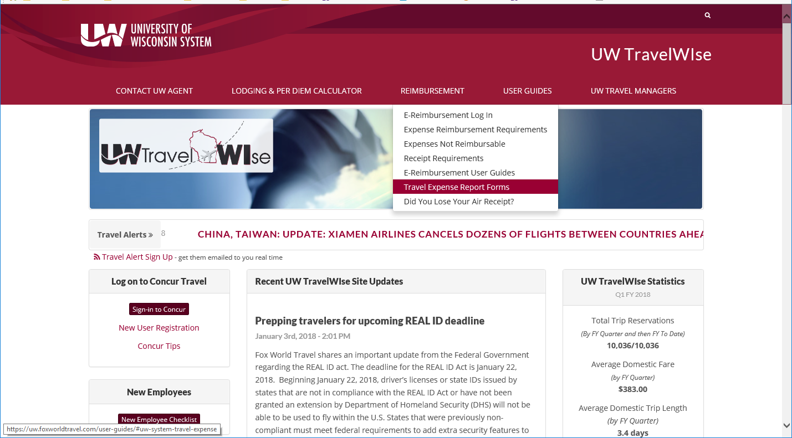

The General Travel and Expense Policy found here will provide a basic introduction to Travel at UWW.
https://www.wisconsin.edu/uw-policies/uw-system-administrative-policies/travel-and-expense-general-travel-expense-policy/
All UW System travel policies are found here https://uw.foxworldtravel.com/policies-and-procedures/
The site includes a number of other aids for travelers, including a new employee checklist, training videos, lodging and meal calculator, Concur system tips, contact info for Fox World Travel and the UWW travel office, links for Concur booking tool and e-reimbursement, etc.
UW Whitewater contracts with UW System for a Regional Travel Manager who provides staff orientation to travel, the Concur system, and interpretation of travel policies and applicability. New travelers should attend an orientation session and review the Basic Guide for New travelers found on our website http://www.uww.edu/adminaffairs/finance/accounting-services/travel
Please contact Alma Ramirez for orientation information or questions regarding travel at 414-345-7553 or aramirez@uwsa.edu
Booking system - Concur
Most travel arrangements will be made within the Concur travel system. Access to the system must be set up prior to attempting to use the system. Contact the Regional Travel Manager for assistance with access. Once set up in the tool, you will need to load your profile for travel preferences, and payment information. A link to the system is found on the Travel WIse site.
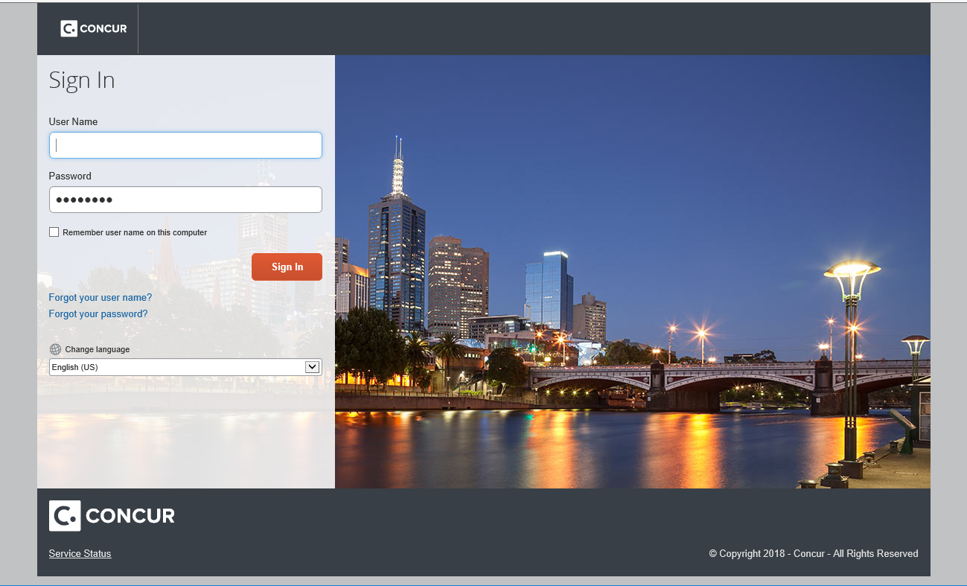
The link will take you through the login screen to get you into the Concur tool where you will be able to book airfare, hotels, and car rentals.
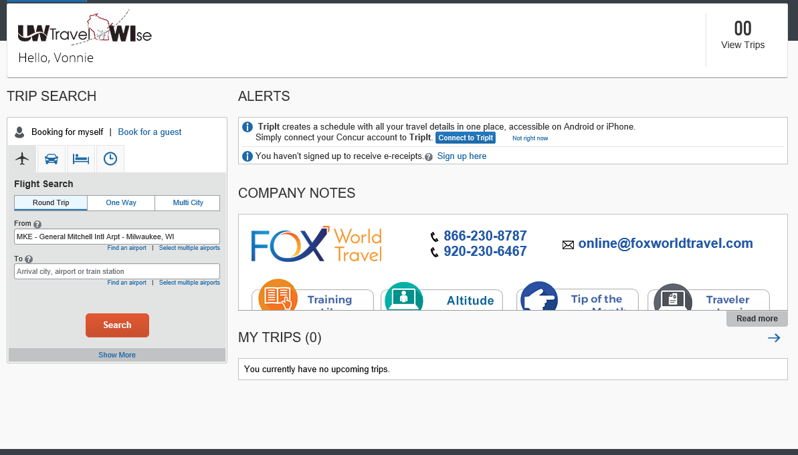

Travel Expense Reports
Travel reports are required for all travel on behalf of the University. ALL expenses incurred for a trip need to be documented on a single travel report for the traveler.
Expenses on a p-card, personal card, corporate card, etc are documented on one report for the entire trip for the traveler. The report is required to be submitted within 90 days of the end of the trip. If a travel advance was provided for a faculty/staff lead group of students, excess funds need to be returned to the Cashiers office for deposit back to department funding the advance, and the travel report is due within 30 days of the end of the trip.
Even if the traveler is not claiming a reimbursement, they have spent university funds for travel, so a travel expense report must be filed to bring all the expenses together for review and approval.
Specific university policies also exist for some areas of travel, such as interview candidate arrangements, travel authorizations, payment methods, etc. These are found on the university travel website: http://www.uww.edu/adminaffairs/finance/accounting-services/travel
All UW campuses utilize electronic reporting of travel expenses through a Peoplesoft system module called e-reimbursement. Access for this system is provided as part of the employee being added to payroll, so no specific access needs to be requested.

E- Reimbursement
This is the web-based tool used to reimburse UW-Whitewater employees and non-employees for expenses incurred while traveling or conducting business for the University, and for other reimbursements. New users to the tool may want to attend provided training, as there are several nuances with the system that are not obvious to the user.
All travel for the UW needs to be authorized in advance of the trip for risk management purposes. New travelers need to consult with their department about the process used for travel authorizations, as this can vary by department or college. Authorizations should be entered in the system as soon as possible to allow ample time for approval. Approved authorizations are used to “load” the expense lines in a travel expense report. Authorizations that are not approved PRIOR to departure date cannot be approved, and will require the traveler to re-enter the expenses in a travel expense report.
To create Travel Authorizations and Expense Reports go to the link found on the UW travel website, or on the Travel WIse site that will take you to the login screen. The login screens are similar to those used for other UW applications and you will end up here:
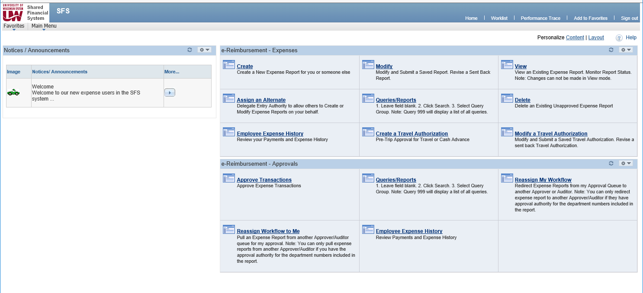
Basically, you will start by Creating your travel authorization well in advance of your trip, and before making travel arrangements. If the authorization is approved, you can proceed with making arrangements. To create a new authorization you will select the type of trip you will be taking, as this will help guide you by populating expected expenses for that type of trip. Here is an example of an instate conference authorization request.
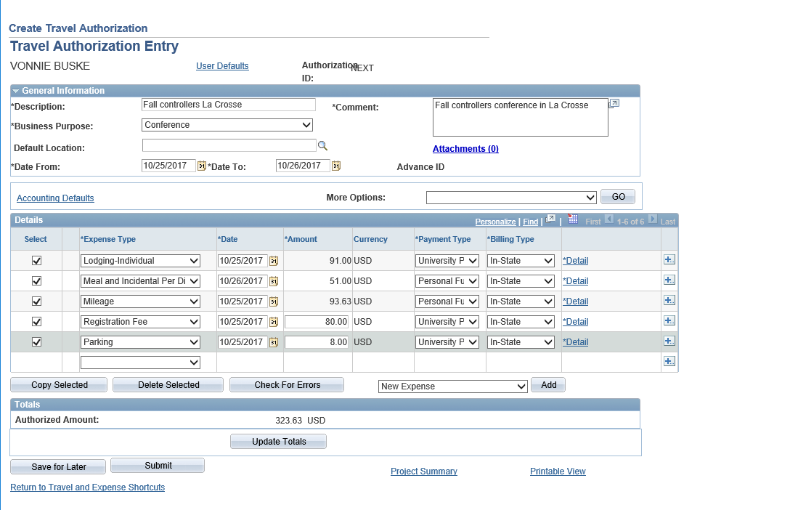

In order to complete a travel authorization, the traveler will need to identify the allowed lodging and meals for the destination. The Travel WIse site includes a calculator that identifies the maximum per diems allowed by policy.
https://uw.foxworldtravel.com/rate-calculator/
The traveler will enter information about their trip, and identify any provided meals. The calculator will then produce the amounts needed to be included in the travel authorization.
Here is the calculator for the example authorization above:
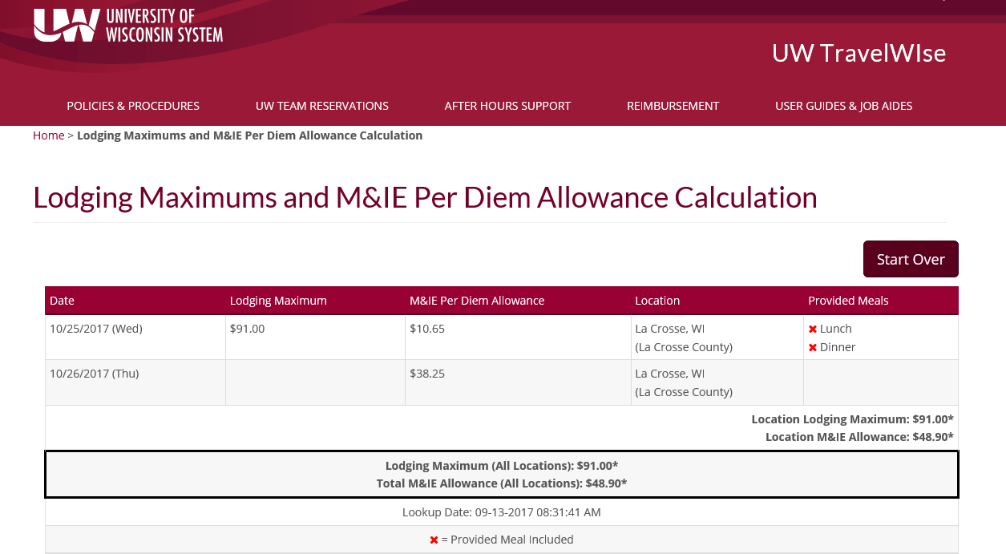

Certain types of travel are required to be paid for on a travel procurement card or a US Bank Corporate card. These are: airfare, hotels, and car rentals. New employees should talk to their Campus Business Rep about obtaining these cards.
UW System maintains reciprocity agreements with some states for exempting the university from sales tax related to hotel rooms. See the TravelWIse site to identify which states have this agreement, and follow the process shown to request the exemption. https://uw.foxworldtravel.com/sales-tax-exemption-from-other-states/

Sponsored Events / Hosting
Events held on campus are coordinated through the Camps and Conferences office. They will assist in processing registrations, obtaining parking permits, arranging for rooms, charging back a promoter of an event, etc. Scheduling should be arranged with them to ensure facilities will be available for the event.
Expenses related to hosting an event on or off campus are generally covered in the Headquarter City and UW System Sponsored Events policy 435 https://www.wisconsin.edu/uw-policies/uw-system-administrative-policies/headquarter-city-uw-system-sponsored-events-policy/
This policy covers all hosted events for conditions that allow food, price limitations, and documentation requirements.
Requirements for meals related to hosting an interview candidate is covered by this policy. Additionally a specific document guiding interview candidate search and screens is available on the travel site: http://www.uww.edu/adminaffairs/finance/accounting-services/travel
See “Interview Candidates Travel Guidelines”

Payroll
All employee wage payments are made through the payroll system. An employee’s funding code is designated at the time of hire, or at the time of job change. If specific payments to employees are funded by another funding source, the funding must be provided on the request for additional payment. Once a payroll is processed, if a correction is needed, a Change of Status form is needed to correct the transaction(s). Corrections are processed by Financial Services since the payroll transactions have already posted to the accounting system.
As employees are hired, and at the start of each new fiscal year, all payroll funding for employees should be reviewed to ensure employees are paid under the correct coding. If coding for employees is changed as part of the budget process, it should roll into the new year correctly, HOWEVER, this needs to be reviewed. Errors at this time are less complicated to fix than if delayed into the fiscal year. Corrections late in the year require Financial Services to separately touch each payroll transaction that was processed incorrectly, which is very labor intensive. Delays in correcting coding create a lot more work!
Payroll Encumbrances
Payroll encumbrances are created when an employee is hired, or at the start of a new year for all permanent staff. The encumbrance represents the amount of salary expected to be paid to the employee over the course of the fiscal year. As payrolls are paid, the encumbrance is reduced. Encumbrances that remain should an employee leave, are zeroed at the last payroll for the employee. Wages for LTEs, project employees, graduate assistants, and students will not be encumbered.
The encumbrance is shown in the WISDM department summary. These funds are committed funds, since payroll will need to be paid. If a negative budget balance results from this encumbrance on the salary line, the CBR needs to address the problem.
Independent Contractors
Guest speakers, consultants, referees are all examples of independent contracts who may be utilized on an occasional basis for specific tasks. If the tasks are typically performed by employees, and there is an employer/employee relationship, in that the university directs the work, then these providers may need to be treated as employees and paid on payroll. If you have questions about how to pay someone, contact Human Resources & Diversity to talk through the intended services to be provided, so as not to delay getting required paperwork BEFORE services are provided.
Emergency Paychecks
On an occasional basis an employee may forget to submit a timesheet, or a supervisor may forget to approve it. Emergency checks can be made available in some unique hardship situations. Ample reminders are provided to employees and supervisors to prevent these situations, so when they occur, a true hardship must be present.
HR determines when an emergency check is appropriate.

Accounting Forms
A list of the forms utilized by Accounting Services is available on line at http://www.uww.edu/adminaffairs/finance/accounting-services/forms
The primary forms utilized by the department staff in processing transactions are covered here. Please note that when using these forms, supporting documents and explanations are required. If the reviewer can’t tell what the transaction is attempting to do and why, they will return the document to the sender.
Expense Correction – Non Salary
This form allows the transfer of expenses between departments, account codes or funds. Instructions are included on the form. Route this completed form with supporting documentation to Financial Services. Forms may be e-mailed to finsrv@uww.edu by authorized signors.
Expense Correction - Salary
Salary corrections are made through the payroll office. You will need to contact them to obtain access to the Change of Status system. Change of Status forms are routed via electronic workflow for signatures and for processing. To obtain access, call 262-472-1024.

Revenue Correction or Transfer Form
This form allows the transfer of revenue between departments or funds. Instructions are included on the form. Route this completed form with supporting documents to Financial Services. Forms may be e-mailed to finsrv@uww.edu by authorized signors.

Department Chargebacks
Sage 50 / Peachtree software is also used by internal departments that provide services to campus to bill for their services. Rather than preparing journal entries, if billing departments do not have automated capabilities for creating a file for uploading to ledger, they create invoices in this software for their department customers. Customers provide the funding string to be charged for the service at the time they order the service, and the billing department uses that funding to bill for the service. Invoices are e-mailed to the department purchasing the service for review, and Financial Services extracts billings for upload to the general ledger. Examples of departments who use this form for billing: printing services, iCIT, Royal Purple.
Documentation for invoices is maintained by the billing departments for the required accounting record retention period.

Workorder Chargebacks
Chargebacks or progress on projects being done by FPM can be reviewed in the workorder system found here: https://fpmtma.uww.edu:444/home.html

To look up a workorder for which you have been charged, enter the PC-XXXX number from WISDM in the Search by Number field.

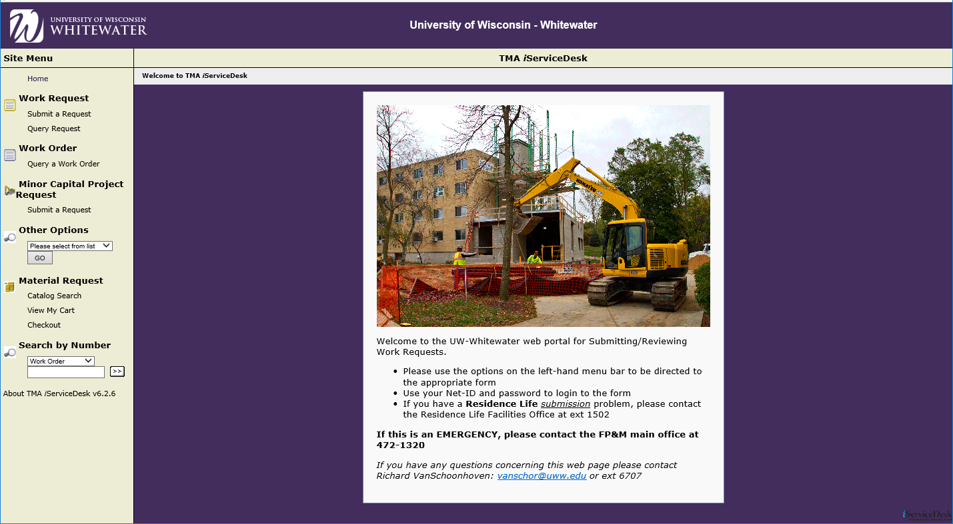

You will then see the detail of the workorder, and can change the screen to see all of the charges

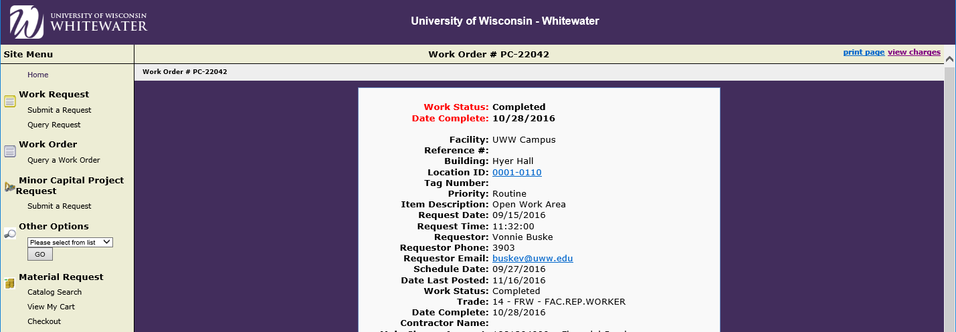

Inter Unit Journals
These are chargebacks that institutions within the UW System can do rather than pay each other with a check. When you attend a conference at another UW institution, or are provided a service and they want to charge you directly, they will request chargeback coding so they can submit an IUJ to process the chargeback. The coding to provide is the same coding you would use to process a quick order. These will show up in WISDM transactions with a GL Jrnl ID starting with “IUJ”.

Other Forms
As a university employee there are other forms that are important for you to be aware of. A central list of all financial services forms can be found at: http://www.uww.edu/adminaffairs/finance/accounting-services/forms. Due to the changing nature of forms, DO NOT SAVE forms to your computer, use the form from the website. Instructions for forms are generally included on the form, or found at a reference policy site.
Some of these forms include:
Prizes, Awards, Gifts Approval – Required approval form
Prize Tax Acknowledgement – Prize recipients must complete when value is more than $25
Food Checklist – Required for any hosted meal
Request for Off Campus Event – Required when an event will be held off campus and will incur expenses
Disposal / Relocation of Equipment – Items with an initial cost of $5,000 or more are inventoried. Disposal or relocation of any capital asset must be done per the procedures here: http://www.uww.edu/adminaffairs/fpm/forms/disposaldeclarationform
http://www.uww.edu/adminaffairs/fpm/forms/property-location-change

Depositing Revenue
“Cash handling” is the term used to refer to all the tasks inherent to the acceptance, receipt, storage, transportation, and depositing of coin, currency, checks, money orders, negotiable instruments and charges on behalf of UW-Whitewater and/or the State of Wisconsin. Due to the associated risks, cash handling activities are highly regulated and closely monitored. Internal controls are utilized to safeguard assets against loss/theft and to prevent mishandling of funds. A strong internal control program defines responsibilities and procedures and serves to protect employees from inappropriate charges.

The Department Cash handling manual should be reviewed thoroughly to understand the requirements. http://www.uww.edu/adminaffairs/finance/accounting-services/campus-financial-polices
Look for: UWW Cash Handling Manual

Supervisors of departments that accept revenues on behalf of the University must be knowledgeable regarding internal controls and are responsible for establishing and maintaining the proper environment, procedures and training. Supervisors are also responsible for monitoring their department’s cash handling activities on an ongoing basis and conducting periodic reviews to ensure the internal controls are being followed and are effective.

Statutory Requirements
The Legislature uses Chapter 20 of the statutes to cover a broad range of issues under the title of “Appropriations and Budget Management.” Included in Chapter 20 is a very specific guideline on the frequency of deposits and the penalties for failure to observe the guidelines: Wisconsin Statutes 20.906 Receipts and Deposits of Money
“(1) Frequency of Deposits. Unless otherwise provided by law, all monies collected or received by any state agency for or on behalf of the State treasury shall be deposited in or transmitted to the State treasury at least once a week…..”
“(4) Penalties. If any State agency fails to make such deposits of money, or to make such reports as are required by this section, the Department of Administration, with approval of the governor, shall withhold all monies due such State agency until this section is complied with; and upon such failure to make such deposits of money, the officer or employee so failing shall be liable to the State treasurer for an amount equal to the interest upon the monies so withheld; and such interest shall be a charge against the officer or employee and shall be deducted from his compensation.”
The Cashiers Office makes all deposits on behalf of the University, and is the holder of the ONLY bank accounts authorized for the University. Departments are not authorized to establish a bank account on behalf of the University, nor to deposit University funds into an unauthorized bank account.

State Receipts
State receipts are “all monies collected or received by any State agency for or on behalf of the State….” This includes all fees (resident, non-resident, and segregated) for credit and non-credit programs, user fees, contract proceeds, fines, assessments, service fees, grants, gifts and other miscellaneous revenues.
State receipts are distinguished from other receipts by the source of authority for their collection and assessment. Only fees authorized by the Board of Regents, the Wisconsin Statutes, or by an official UW-Policy paper may be collected. Conversely, no individual, department, or entity may create or cause a fee to be assessed unless authorized to do so by the Regents, the Statutes or by UW Policy. Special course fees are permitted only under the parameters of System Policy 825 Special Course Fees.
The Cashiers Office is responsible for receipting and depositing all university revenues or recovery of expenses. In addition, the Office reports State and County sales tax collections to the Department of Revenue. Inquiries about the taxability of goods or services provided by the University may be directed to the Cashiers Office. The Cashiers Office also offers checking account services for Student/Faculty organizations. They provide instructions and the necessary forms for State and Student/Faculty account transactions.
Departments collecting University revenue must deposit all funds with the Cashiers Office. No University funds may be diverted to the Foundation or other accounts or used to direct pay expenses.
The Cashier Office does not provide check cashing services for the general public. Local banks should be contacted if this service is needed.
For specific cash handling policies, staff should review the University Cash Handling for Departments Manual found on the website, as noted above.

Deferred Revenue
Revenue received in one fiscal year that will be “earned” in the next fiscal year will be deposited as Deferred Revenue. This revenue is refundable until it is earned, so it cannot be treated as “earned” when received. This type of revenue is typical toward the end of the fiscal year, but funds could be received much earlier in the year depending on the type of revenue. For example, funds for camp registrations or theatre tickets could be received in February for a camp or performance that takes place in August. The revenue is refundable until the event takes place, so the revenue is deposited as “deferred” revenue. In the new year, the “deferred” revenue will be recorded as “earned” in one lump sum transaction.
Summer session tuition and fees are always treated as deferred revenue when received before June 30, as the entire summer session is recorded in the new fiscal year.
The Deferred Revenue Balance shown in WISDM is the “change” in Deferred Revenue from one year to the next. So if you deposited $1,000 of deferred revenue for the first time in 2017, the Deferred Revenue in 2018 will show ($1,000), since that amount was taken out of Deferred and put into “earned” revenue in 2018. When you start depositing the deferred revenue again in 2018, it will offset against this deferred amount to show you only the net value of Deferred Revenue. This can be very confusing. If you want to know your true value of revenue deposits that have been deferred, you will need to look at the transactions, rather than the WISDM “Balance”.

Student / Faculty / Organization Receipts
The deposit of student or faculty organization receipts into Student / Faculty / Organization (SFO) accounts is permitted. SFOs may collect funds as part of the operation of their organization, and utilize the University bank account provided for this purpose. Because these funds are under the protection of the University, the University federal ID number is used for the maintenance of the account. No student or faculty organization may use this ID number to open separate checking or other bank accounts.

Change Funds
When departments on campus are hosting an event and will sell tickets, t-shirts, etc. and need a way to make change, the Cashiers Office can provide “change banks” for this use. Change banks can be requested via an on-line form, and turned in to the Cashiers Office in advance of the event. The change bank must be returned to the Cashiers Office after the event, along with the deposit of funds.

Permanent change funds can be established if a department has a need for constant access to funds to make change. In this case a department custodian can request a change bank, and take ownership of safeguarding that bank for department use. Periodic cash counts and internal control reviews will be done by the custodian, as well as cashier staff or internal auditors. The banks are only available if there is a regular need, not periodic needs, so as to minimize the risk of loss or theft over time. As turnover occurs, the custodian must return the bank to the Cashiers Office, and a new custodian can then check out a new bank in their name. Contact the Cashiers Office with questions 262-472-1378.

Department/Division/College Monitoring of Finances
At the start of a new fiscal year and during the year, departments should be reviewing their budgets, verifying funding of staff being paid by their dept codes, reviewing expenses, monitoring cash and budget overdrafts, etc, and making needed corrections as soon as possible.
Questions on activity they see in WISDM or other Peoplesoft systems should be directed to the department most able to assist - Budget, HR, or Financial Services.

Fiscal Year End
The fiscal year for the University is July 1 to June 30. Each year a calendar of critical dates is prepared well in advance of year end, communicating the cut off dates that will apply to closing the accounting records for the fiscal year. This calendar is shared with the CBRs in March, for them to share with their departments, so they can plan accordingly for their own processes to meet the deadlines.
CBRs and administrators should be closely reviewing their dept code activity, budget, and cash balances as we close the year. Once closed, no corrections can be made.
A list of typical activities for review and monitoring follows – this is not intended to be an all-inclusive list, as departments may have unique needs for which they monitor other things:
- Professional Development Plan (PDP) transfers complete
- Payroll charged to correct dept for staff and students
- Outstanding Invoices in Sage/Peachtree – contact customer to collect funds
- Travel expense reports submitted
- Quick orders submitted for payment
- Payment to Individuals (PIRs) signed and ready for processing
- P-card and Shop@UW transaction dates – consider when to order based on posting dates
- Purchase Order Balances – POs should be closed if goods received and paid
- Chargebacks to other Depts are complete
- UWSA charges and insurance allocations are complete and correctly charged
- Negative cash balances are cleared up

As we approach the end of the fiscal year, Financial Services (accounting, cashiers and purchasing) all get busy with year-end processing and clean up, which is particularly heavy in May and June. Transactions, purchases, and vendor payment requests from departments will take longer to process. Every effort should be made to allow ample time for transactions or payments to be processed before due dates. What normally takes a few days can be expected to take at least a week, maybe more.

Attestation of Effective Internal Financial Controls
Each year Department/Division/College Heads and CBRs will be attesting to their implementation of appropriate internal controls for their operations. This includes an adequate monitoring system for finances and related transactions. This attestation will be used to ensure administrators are aware of their responsibility for the activity within their control and are knowledgeable about the transactions they are producing.
Part of the attestation document includes the review and updating of internal controls. It is critical for the administrators to ensure the controls they have put in place are operating as expected. In the event of a problem, the administrators will need to report the issue to the Vice Chancellor for Admin Affairs, and to work with Financial Services to redesign the controls to prevent future problems.

Training
Training on the systems used by Financial Services is provided on an on-going basis. Regular sessions are scheduled for
WISDM, Purchasing, Travel Orientation, E-Reimbursement, etc. Peachtree training is provided on an individual basis by appointment.

All training registration is available through the campus training site my.uww.edu

