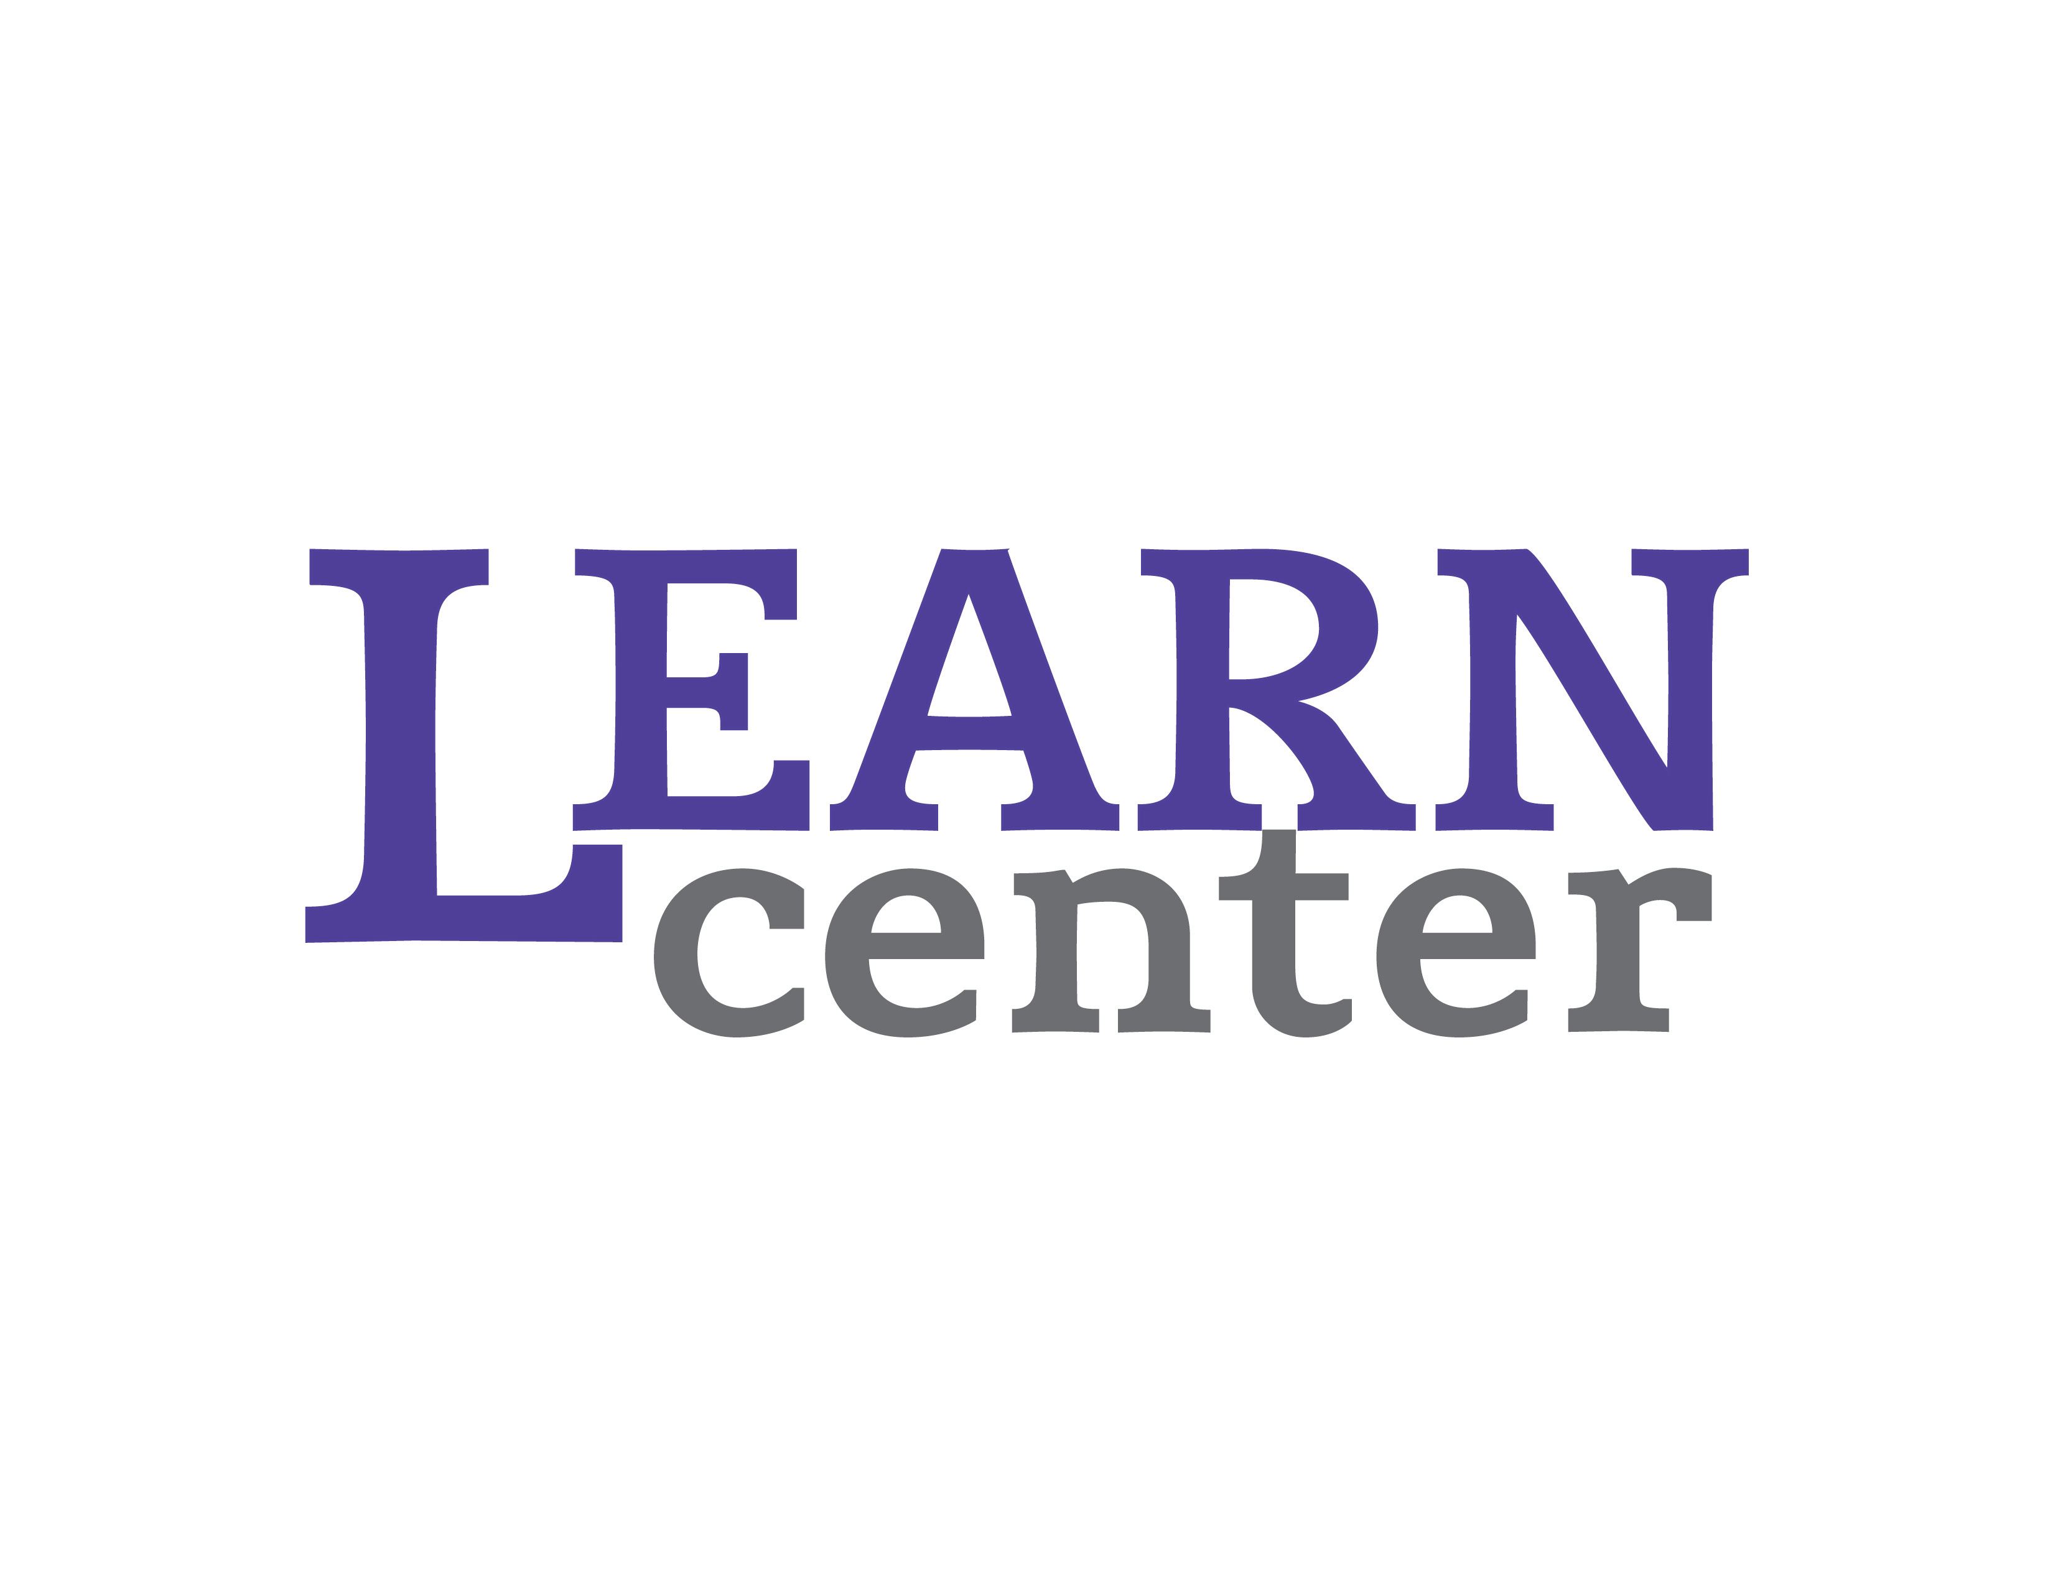

Roseman Building Telephone: 472-5242
Room 2013 FAX: 472-5027
cbl@uww.edu

“Optimizing student learning through the professional development of faculty and staff.

October 31, 2016

From: Jodie Parys, Community Based Learning Coordinator
Seth Meisel, Interim Dean, School of Graduate Studies & Continuing Education

Re: Invitation to apply to the Community Based Learning Fellows

Your chair or Dean Meisel has recommended that I invite you to apply for our new UW-Whitewater Community Based Learning Fellows program. This is a year-long faculty development program that provides a structured and collegial environment for a group of 10 faculty and academic teaching staff from across campus to explore best practices in community based learning and to undertake a substantial revision of an existing course that is scheduled to be taught during the Fall 2017 semester to develop a new service-learning or community based research component in that course. Please consider this your invitation to apply to participate.

Community based learning holds great promise to embed civic engagement in the curriculum. AACU, in its recent report A Crucible Moment: College Learning and Democracy’s Future (2012) argues that higher education is uniquely poised to “offer an intellectual and public commons where it is possible not only to theorize about what education for democratic citizenship might require in a diverse society, but also to rehearse that citizenship daily in the fertile, roiling context of pedagogic inquiry and hands on experience” (p. 2). As one of the LEAP high impact practices, service learning aligns with the LEAP ELO of personal and social responsibility, fostering civic knowledge and engagement. Well-designed community based learning courses can contribute to this civic learning. Some of the learning outcomes include “increasing students’ sense of social responsibility and citizenship skills such as religious and racial tolerance, prosocial decision making, and exploring the intersections between identify and privilege...” as well as improving “complexity of understanding, problem analysis, critical thinking and cognitive development” (60-61).

The two most common forms of community based learning are:

- Service-Learning: a teaching and learning strategy that integrates meaningful community service with instruction and reflection to enrich the learning experience, teach civic responsibility, and strengthen communities. Through service-learning, students use what they learn in the classroom to solve real-life problems. They not only learn the practical applications of their studies, they become actively contributing citizens and community members through the service they perform.

- Community based research: is research that begins with a research topic of practical relevance to the community and is carried out in community settings. It is collaborative in design and implementation as community members and researchers equitably share control of the research agenda through active and reciprocal involvement and the results of the research help make positive social change.

This Community Based Learning Fellows program follows the successful model of the Teaching Scholars Program, which has proven to be a popular program among previous participants. It is based on regular seminar meetings providing a venue for a sustained conversation with faculty and academic teaching staff from across campus who are committed to teaching excellence. In addition to the regular seminars, the program provides support for building a community partner relationship for your service learning or community based research course project and assistance to complete significant assignment and assessment redesign for the selected course. The program begins in January 2017 and continues throughout the 2017 calendar year.

Program Design
The 2017 Community Based Learning Fellows Program has four principal components.

1.Introduction
The program will convene during the beginning of the Spring 2017 semester. We will meet as a group on Friday, January 13, 2017 from 10 am – 2pm. Please be certain you will be available to attend this orientation as it will provide an introduction to the program and participants, an exploration of key concepts of community based learning and its relationship to civic engagement, and some careful consideration of the promise and challenges of working with community partners.

2. Fellows Seminars
Participants will meet in a seminar twice per month from 1:15-2:30 pm on Wednesdays during the Spring 2017 semester. Seminars will focus on a discussion of readings from the literature relevant to the program theme.
Those unable to commit to regular meetings at this time should not apply to the program.
(Applicants should arrange with their department chairs to be certain they will not be scheduled for a class or other responsibilities during this time for the entire year. Participants missing seminar meetings or other program components will have their stipends adjusted accordingly.)

3. Community or Regional Partner Agency Consultation
This is an opportunity to work with our CBL coordinator and graduate assistants to explore possible community partners for the proposed course and initiate a discussion about areas of collaboration on a service-learning or community based research project.

4. Course & Assessment Redesign Project
Following our discussion of the broader goals of community based learning and civic engagement, participants will be given the opportunity to examine best practices and successful models of service learning and community based research courses and guidance in integrating these experiences into their proposed course. In addition, participants will consider how their courses contribute to the LEAP “Personal and Social Responsibility” essential learning outcome and how to assess student learning by using either the AACU VALUE rubrics or the Teagle Consortium’s Community Based Learning Scorecard, available through Campus Compact.
Participants will be expected to present a draft of their course redesign in the spring seminar; participate in a 1-day Summer 2017 workshop to report on redesign progress and to meet with community partners; as well as report on results of the redesign to the LEARN Center after the course has been offered in Fall 2017. Furthermore, participants are encouraged to disseminate their results more widely after the completion of the Fellows Program through participation in on-campus community based learning events, regional or national community based learning conferences, or other similar opportunities that allow participants to contribute to UWW goals related to civic engagement and assessment of learning outcomes.

Program Objectives
While participants will likely find their own motives for engaging in the program, in general, the Community Based Learning Fellows Program is designed to have participants:
- explore best practices in community based learning course design;
- help define how the campus can best support community based learning instruction;
- complete a course redesign project intended to enhance civic engagement while also integrating at least one of the following thematic strands assessing student learning outcomes:
- Civic Engagement
- Diversity Learning
- E-Portfolios
- Community Based Learning Scorecards
- make a contribution toward a campus and UW System priority; and
- develop more collegial relationships among faculty from across campus.

Timeline
Spring 2017 semester
Note: Meetings will be held every other Wednesday from 1:00 – 2:15 pm, starting Wednesday, January 25, 2017.
- Seminars with discussion of readings on civic engagement and student
development
- Individual consultation meetings to develop community based
learning project ideas
- Sharing best practices, models for course design and assessment, Community Based Learning scorecards and e-portfolios
- Community or Regional Partner Agency Consultation
Summer 2017
- 1-day workshop to report on redesign progress. Date will be determined in
consultation with program participants prior to the conclusion of the Spring 2017 semester.
- Regular meetings with Community or Regional Partners
- Individual consultation meetings to refine community based learning project ideas
- Completion of course and assessment redesign
Fall 2017 semester
Note: Meetings will be held monthly on Wednesdays from 1:00 - 2:15pm.
- Launch redesigned course and discuss progress
- Report on integration of one of the thematic strands into the course redesign
- Monthly seminars will focus on:
  - Problem solving surrounding any issues that arise
  - CBL professional development and publication opportunities
  - Community Based Learning Resources
  - How to Scale and Sustain Community Based Learning Courses
  - Working collaboratively to plan activities to disseminate information (i.e. Assessment Day, LEARN Center workshops, LEAP presentations, etc.)
- By the conclusion of the Fall 2017 semester, each participant is required to submit a detailed report on their course redesign and assessment activities to the following venues:
  - https://spaces.uww.edu/display/CSLServiceLearning/Outreach+Experiences+Home
  - https://orgsync.com/132489/chapter
Spring 2018 Semester (Optional, but strongly encouraged)
- Disseminate results through a presentation at a local, regional, or national Community Based Learning event. (An additional $500 stipend will be provided to support this activity)
- Take on a leadership role in some area of community based learning and assist the campus in efforts to share and scale successful project models and design.

Participant Support
The Office of Continuing Education will provide each participant in the 2017 program with a $5500 stipend (an additional $500 stipend is also available to support Spring 2018 dissemination activities). The stipend will be paid as follows:
- $2000 will be paid upon successful completion of the Spring 2017 seminars and submission of a draft course redesign plan.
- $2000 will be paid upon successful completion of the Summer 2017 workshop and related community partner meetings, as well as submission of the completed course redesign plan and all related documents (syllabus, assessments, etc.).
- $1500 will be paid upon successful completion of the Fall 2017 seminars and submission of project summary, assessment, and reflection. Furthermore, you must indicate how you and your department are committed to integrating this redesigned course into the curriculum beyond the pilot semester.
- Each participant will also be eligible to receive an additional $500 stipend (paid in Spring 2018) to offset the costs related to conference attendance to present this project.

Program Leader
Jodie Parys is the Coordinator of the Community Based Learning Program. In addition to being a practitioner of community based learning throughout her career as a Spanish professor, she also participated in a university task force charged with designing strategies for deepening the engagement of UW-Whitewater’s academic programs with the region.

To Inquire/Apply
If you have questions, please contact Jodie Parys (472-5070; parysj@uww.edu).

Please indicate your interest in participating by, in the space of 1-2 pages, addressing the following:
- Indicate your name, department, college teaching experience and what knowledge, if any, you have of community based learning practices.
- Describe the course in which you propose to integrate a service learning or community based research project and how this approach will contribute to your goals for student learning in this course. Note: This course must be on the Fall 2017 course rotation or you must show how you will complete the required curricular changes to offer your proposed course during the Fall 2017 semester.
- Describe how this course will contribute to the curriculum for your department and how it will be integrated into the curriculum beyond the pilot semester.
- Detail how your proposed course redesign will meet campus and/or system strategic priorities.

Applications will be reviewed by a panel representing the Community Based Learning Program and the LEARN Center. Selection of Community Based Learning Fellows will be based on quality of applications and other considerations (e.g., representation from various departments across campus, potential to develop model community based learning courses, interdisciplinary course redesign proposals, commitment to participate in leadership and/or dissemination activities, etc.) Final selection will be made by early December. Applicants will be notified at that time.

Please forward your letter of application to the LEARN Center (Roseman 2013; fax, 262.472.5027; email, <learn@ uww.edu>) by noon on Monday, November 28, 2016.

