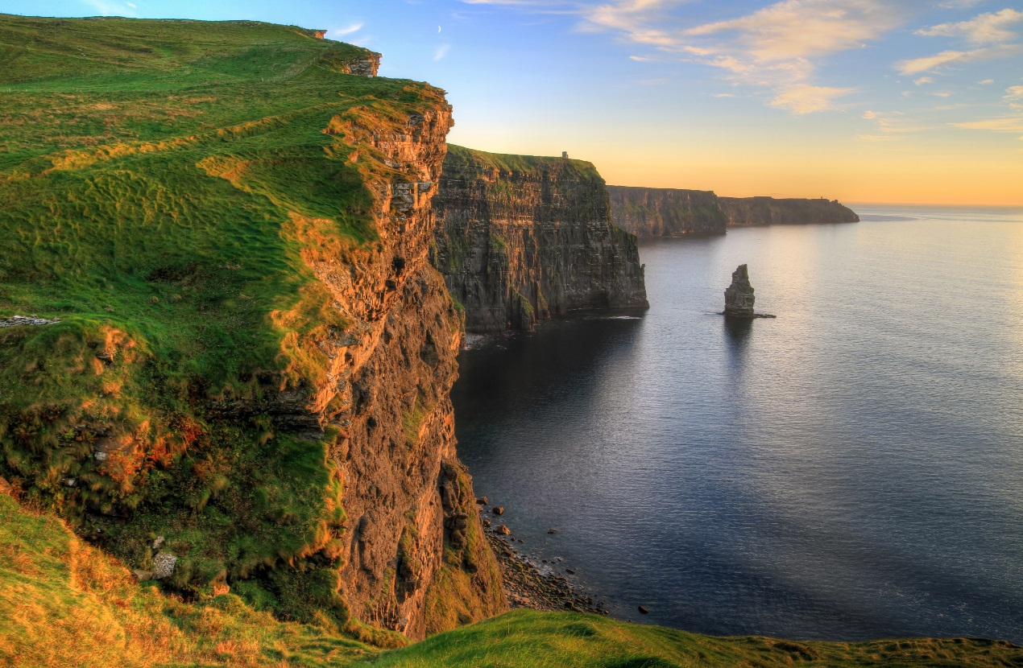

|  |  |  |  |  |
| --- | --- | --- | --- | --- |
|  |  | |  | | --- | | Ireland  **COMM / JOURNALISM 491** | | C:\Users\studyabroad\Desktop\Flag_of_Ireland.svg.pngUW-Whitewater | |
|  |  |  |
| 3 credit Faculty-Led Travel study |  | Application |

**LOCATION**

Dublin, Derry, Galway, Cork

**DURATION**

Spring 2018 (Program)

May 21 – June 9 2018

(Tentative travel)

**REQUIREMENTS**

Minimum of 2.5 GPA, at least second semester freshman status, & good disciplinary standing.

**LANGUAGE OF INSTRUCTION:** English

**Course Selection:** COMM/JOURNALISM 491

**Apply Online:** *www.uww.edu/international*

**Application deadline:**

Friday, December 4th, 2017

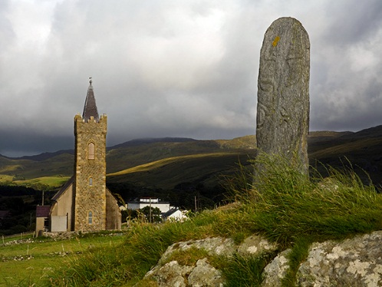

**THE PROGRAM**

The goal of this course is to provide students with understanding of intercultural communication practices through study of Irish culture and immersion experiences in Ireland. The course will be offered at UW-Whitewater during the spring semester, followed by mandatory three-week travel component to Ireland and Northern Ireland.

<http://www.south-africa-tours-and-travel.com/images/university-witwatersrand-sat-studyabroadinsouthafrica.jpg>

**FACULTY CONTACTS**

Professor Ksobiech: ksobieck@uww.edu

Professor Davis: davisc@uww.edu

**COORDINATOR CONTACT**

Dan Colleran: collerad@uww.edu

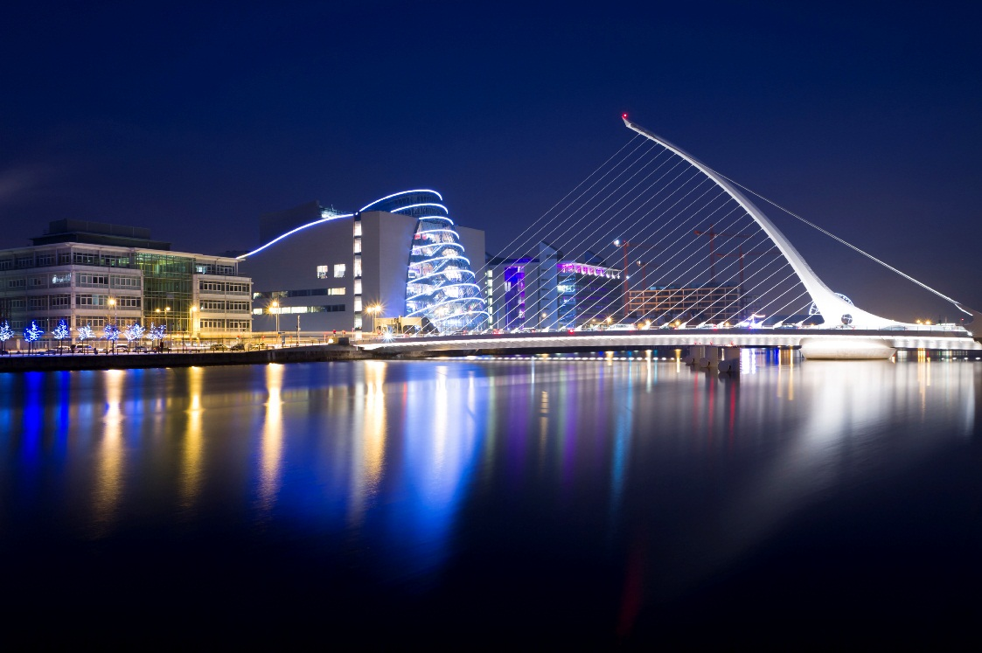

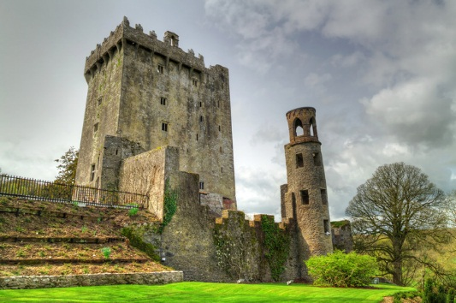

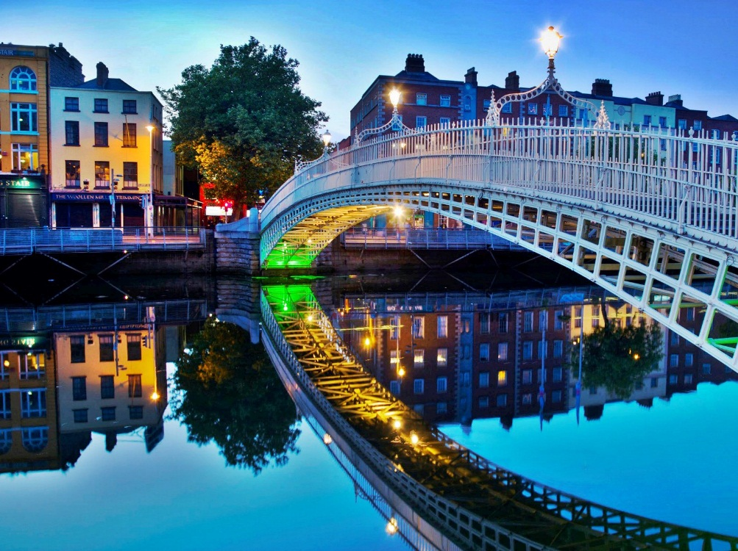

|  |  |  |
| --- | --- | --- |
| C:\Users\studyabroad\Desktop\Flag_of_Ireland.svg.png  Ireland    UW-Whitewater |  |  |
| Fees and Expenses |  | THE TENTATIVE TRAVEL ITINERARY |

02Jun: Travel from Galway to Dingle

03Jun: Travel from Dingle to Cork

Walking tour of Cork City

04Jun: Day trip to Kinsale

Visit Charles Fort

05Jun: Day trip to Cobh

Stop at Middleton Distillery

06Jun: Travel back to Dublin

Stop at Blarney Castle / Glendalough

07Jun: Lecture at University of Dublin

08Jun: Free Day

09Jun: Flight back to Chicago

21May: Depart for Dublin

22May: Bus tour of Dublin

Group tour of Kilmainham

23May: Trinity College / Book of Kells Tour

24May: Trim Castle/Travel to Belfast

25May: Black Taxi Tour of Belfast

26May: Travel to Ballintoy

Visit Giant’s Causeway-A-Reade Rope Bridge

Visit Dunluce Castle

27May: Walking tour of Derry City Walls

Tour of Protestant and Catholic areas of Derry

28May: Visit Ulster Folk Museum

Travel to Glencolumcille

29May: Free Day to explore folk village and beach

30May: Travel to Galway

Group dinner at Monroes’s

31May: Tour Galway City

01Jun: Ferry to Inis Mor and a one night stay on the Island

**Estimated Program Fee:** TBD

**FEES INCLUDE:**

* Airfare and local transportation
* Local Tours/ accommodations
* Indicated group meals
* UW System academic abroad insurance

*\*The estimated program fee is based on 14 paying participants. The actual program fee will be established mid-term when all participants have obtained legal travel documents.*

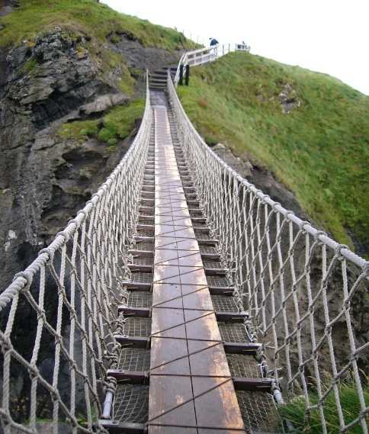

**Center for Global Education**

Hyland Hall Suite 1227

Phone: 262-472-5759

www.uww.edu/international

