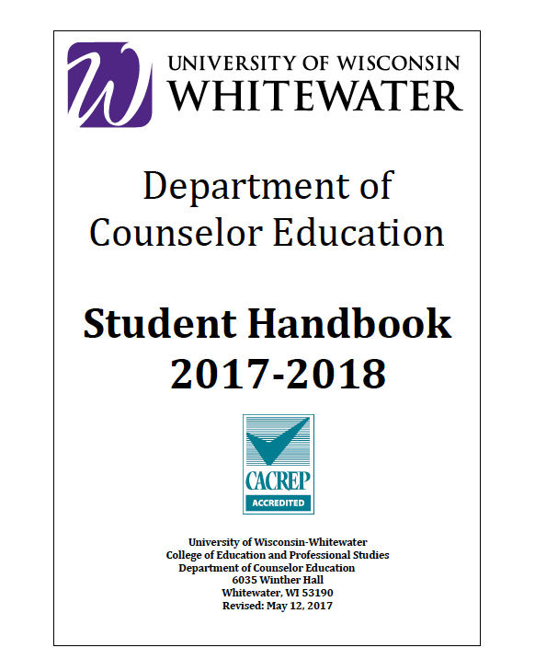
Internship Handbook
2018-2019

Internship
The Supervised Internship in Counseling is an opportunity for students to apply concepts and skills in field counseling settings. Students are placed in field settings that are compatible with the individual student's experiences, competencies, and career goals. Students work with clients under the supervision of a qualified field staff member in the setting and the university counselor education staff.

Objectives
Although specific objectives vary among settings, the primary objectives of the Supervised Internship in Counseling are:
- Students know and understand the services or programs provided to clients.
- Students know and understand the counseling needs of the client population.
- Students design, develop, and implement appropriate services or programs.
- Students establish and maintain ethical and effective working relationships with staff and clients.
- Students implement effective individual and small group counseling strategies and processes.
- Students effectively utilize counseling tools or resources such as information systems, appraisal data and referral sources.
- Students consult with persons in the setting, community or client's immediate environment.
- Students implement research strategies to assess programs or services.
- Students identify their professional competencies and plan appropriate educational or career goals.
- Increase self-awareness of values, biases, attitudes, and belief systems when working with clients from different backgrounds and addressing these in supervision.

General Requirements

General requirements that apply to all students enrolled in internship are outlined below. Because of differences in client populations, or counseling objectives and procedures used among settings, specific objectives consistent with all settings cannot be identified in these guidelines. The specific activities in which a student participates will be determined by the nature of the setting, activities initiated by the student, and assignments by field or university supervisors.
The supervised internship is an academic yearlong (fall-spring) experience. Students earn three graduate credits on a pass-fail basis for each semester satisfactorily completed. Thus, students
must earn a minimum total of six credits in internship in order to be granted the Master of Science in Counseling. Students seeking a post-master’s certificate can complete a one-semester 20-hour-per-week internship (3 credit hours) or a two semester 10-hour-per-week internship (1.5 credit hours/semester).

The counselor education staff concludes that internship should encompass two major areas of learning. First, it should provide students an opportunity to work directly with individuals and small groups of clients. Second, it should enable students to participate in significant activities related to the total counseling function of the field setting. Therefore, although the counselor education staff believes that working with clients is the foundation of internship, students are expected to participate in other appropriate activities as well. These activities will be defined collaboratively by students and supervisors.

The counselor education staff places students in actual field settings upon the approval of appropriate professional personnel within the specific setting. Students are to spend 20 hours per week in the setting for the duration of the academic year for 30 weeks (at minimum, a total of 600 hours). Students are required to work directly with clients providing individual and small group counseling. The time spent in such activities is called contact hours. Students are required to gain experience in a minimum of 240 contact hours during the year. Students should complete a minimum of 100 hours during the first semester. Students are required to make audio and/or video recordings of counseling sessions for supervisory purposes. These recordings will be made in a manner that is legally and ethically appropriate and agreed upon by the field supervisor.

Students are also expected to participate in other counseling related activities (e.g., staff meetings, research, progress notes). The time spent in such activities is not to be regarded as contact hours in terms of the 240-hour requirement.

While all students will participate with direct and indirect service totaling 600 hours during the academic year, specific requirements should also be noted for several groups.
- Students seeking Licensed Marriage and Family Therapy (LMFT) status are required to have a minimum of 300 contact hours, to include practicum and internship, working with individuals, couples, groups, families, and partnerships.
- Students seeking licensure as a school counselor have a primary placement at one level and are required to have substantial experience at other level(s). The primary placement and substantial experience are determined collaboratively by the faculty supervisor and student.

The internship should enable the student to obtain an overall perspective and understanding of the role and functions of the counselor in the specific settings. Therefore, students are expected to participate in activities related to informational services, appraisal programs, research procedures, conferences or staff meetings, and other appropriate activities. These activities combined with the time spent in either consultative activities or counseling contacts would comprise the 20 hours per week. Internship is an academic year experience, beginning in September and ending in May for all students in the program. Post-master’s students have the option of a one-semester or an academic-year internship as mentioned above.
The counselor education staff members serve as on-campus supervisors. These staff members organize and conduct weekly on-campus classes, which students must attend. Students may be requested to participate in individual on-campus conferences with their university supervisor. University supervisors make periodic visits to the setting in order to consult with the student and field supervisor. Additional conferences within the field setting may be arranged at the request of the student or field supervisor.

Field supervisors are able to perform significant educational and supervisory functions. Therefore, each student will work with a supervisor in the setting who has earned a master's degree in counseling or a related field and is able to provide effective assistance. Field supervisors must be employed in the setting and must perform duties enabling them to provide effective supervision. Therefore, if an approved supervisor is not available, the setting will not be approved.

Application and Admission

The number of students enrolled for a given year is limited; therefore, any change regarding enrollment must be approved by the internship committee. Students should follow these procedures for admission:
- Students will need to complete the internship application by the specified date during the fall semester one year prior to the internship. The completed form will be returned to the department chairperson.
- A typed resume must accompany the application.
- Students must have satisfactorily completed all courses as outlined in their program of study prior to the internship. A 3.0 grade point average is required at the end of the semester preceding internship. If this is in doubt, the placement will not be finalized until the 3.0 is verified.
- Students employed fulltime (more than 21 hours per week) may not take additional course work concurrently with internship.
- Full-time students that are not employed fulltime (20 hours or less/week) may be scheduled for one additional 3-credit course per internship semester.

A committee composed of counselor education faculty reviews and approves the applications. This committee determines admission to internship and the nature of the actual placement. The committee will give priority to those students who have not implemented a program change. Students may request to meet with the committee for review of committee actions. If the conclusions of the committee are found to be unsatisfactory, the student will be informed of possible additional appeal procedures.

Placement

The internship committee is responsible for the placement of students in appropriate settings. Students are encouraged to consult with staff to explore possible future employment and possible settings. Students are not to make their own commitments regarding settings. The only exception to this policy is for students employed in the setting in which they plan to take internship.
Placement will take into account available sites, availability of qualified supervisors, existing programs in specific settings, and competencies of the individual student. Students are to be

aware that admission to the counselor education program does not guarantee a specific internship placement in terms of type of setting or location of the setting. Internship placements must meet the location requirements that align with the placement policies outlined by the COEPS Field Experiences Office (see map in Appendix). Students must be prepared to make travel arrangements if necessary. Students who wish to pursue a placement outside of the map placement area must apply for an out of area placement exception.

The setting must provide opportunities for students to participate in an established program. In order for a setting to be considered, an on-going or structured program must be in existence at the time of placement in that setting. The setting must be served by a qualified counselor, i.e., one who has earned a master’s degree in counseling or a related field, assigned at least one-half time to counseling.

Internship Conduct

Interns are to model professional and ethical behavior (e.g., confidentiality and limits to confidentiality, recognition of qualifications and limitations, record keeping, dual relationships, self-awareness and monitoring, etc.). Interns need to be aware and behave in accordance with the American Counseling Association Code of Ethics (and other relevant codes) and discuss with their supervisor(s) (site and academic) any ethical guidelines/codes specific to their work. Interns are expected to exhibit professional behavior at their site. Unethical or inappropriate behavior demonstrated by internship counselors may result in suspension or termination of client work, and may result in dismissal from the program. Due process will be implemented in any decision rendered.

Eligibility for Clinical Experience (Practicum and Internship)

Practicum and Internship Background Checks and TB test

All students must have a TB test and submit a criminal background check via The Office of Field Experiences in the College of Education prior to the practicum. All verification needs to be given to the Clinical Coordinator before the student will be able to provide any counseling. As suggested above, students are required to purchase individual liability coverage prior to their practicum semester.

On the first day of internship class, students will need to sign an affidavit that their TB test is still current (TB tests are usually valid for 1 year though some school districts may request annual tests), that they have personal liability coverage for the duration of internship and that no criminal behavior has occurred since the previous background check. If criminal behavior has occurred, another background check will be required. (Note: schools and/or agencies may require a background check despite no change in legal status).

If background checks indicate any concern, department faculty will consult and determine the appropriate intervention (see requirements below). The individual’s advisor will meet with the student and discuss the concerns and eligibility for the clinical experience.

State Law and Implications of Background Checks

As of October 1, 1998, the law requires criminal and regulatory background checks of all persons responsible for the care and safety of children and vulnerable adults working in or having access to clients being served under programs regulated by the state. Individuals wishing to provide counseling services in the school or in state-certified mental health agencies must submit to a background check.

Since there has been an increased concern regarding the potential for physical and emotional abuse of vulnerable citizens by persons who have been convicted of serious crimes or have a history of other improper behavior, Wisconsin has identified specific crimes and offenses that will permanently disqualify individuals from being licensed or employed in caregiving settings. For less serious crimes and acts, the law allows persons to demonstrate rehabilitation by submitting clear and convincing evidence of rehabilitation. The Counselor Education Department requires a background check prior to involvement with practicum. If a student has committed crimes and offenses that would permanently disqualify him/her from licensure, the student would not be able to participate in practicum and would not be able to complete their master’s degree. If less serious crimes/acts have been committed, the clinical director will meet with the student to develop a rehabilitation plan. This plan will need to be approved by the department faculty.

Student Malpractice Insurance Coverage

All practicum and internship students are required to obtain professional liability/malpractice insurance.

Proof of insurance is required on or before your first day of internship class. You may forward an electronic copy of proof of confirmation to your faculty supervisor or send a photocopy of your proof of insurance via regular mail, or bring a photocopy on the first day of class.

There are several insurance companies that offer insurance to student trainees at discounted rates. The American Counseling Association (ACA) Insurance Trust offers student rates through HSPO. See the ACA site for more information, or go to hpso.com/support/faq/student. You can also obtain professional liability insurance free as part of your student ACA membership which is a cost-effective way to get all ACA membership benefits. Students who are pursuing a school counseling emphasis can obtain professional liability insurance free as part of their student ASCA membership. Additional information about liability/malpractice insurance options will be made available at the information sessions required for enrollment in practicum and internship.

It is important to note that if you have licensure (e.g., SAC, SAC-IT, LPC) you cannot acquire liability insurance at the student rate and you must obtain liability/malpractice insurance at the professional rate related to your highest level of licensure. If you carry a license and obtain only a student rate you will not be fully covered and will be out of compliance with Wisconsin state statutes.

