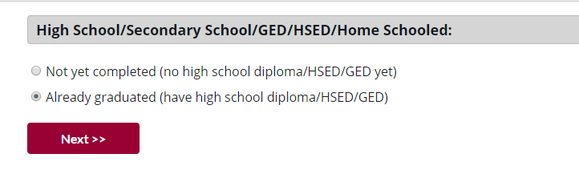
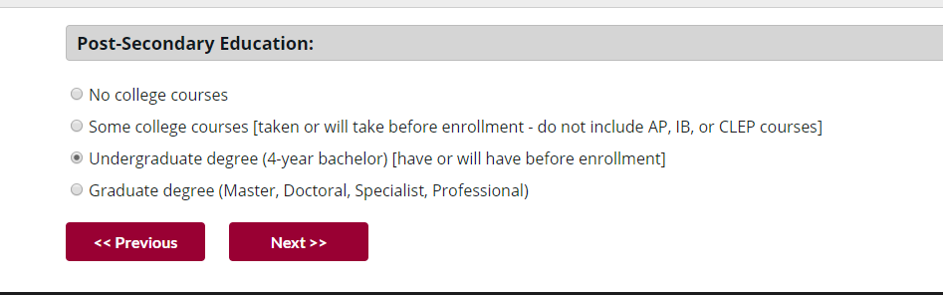

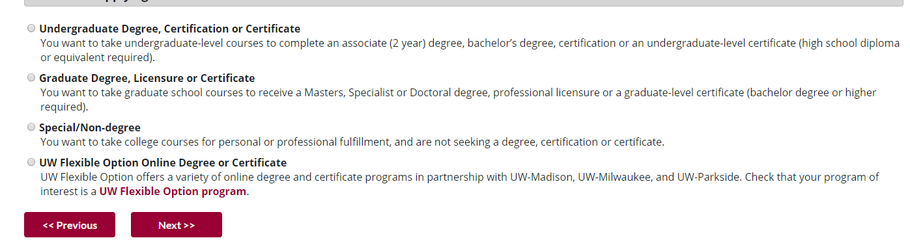
Here- select either Undergraduate Degree, Certification or Certificate regardless of status. If the student already has a degree, we want them to select this option as well.

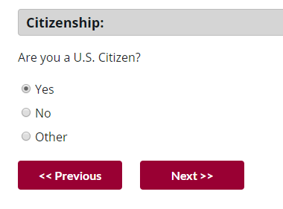

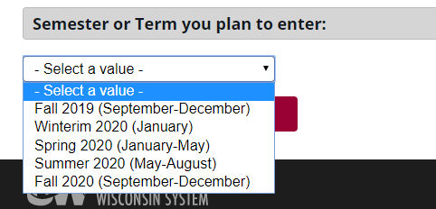

Select the proper term

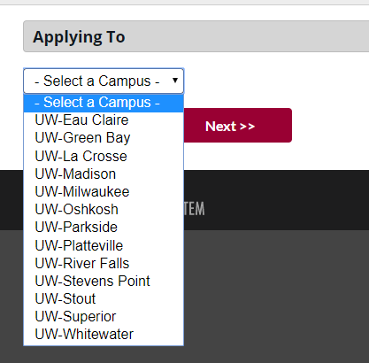

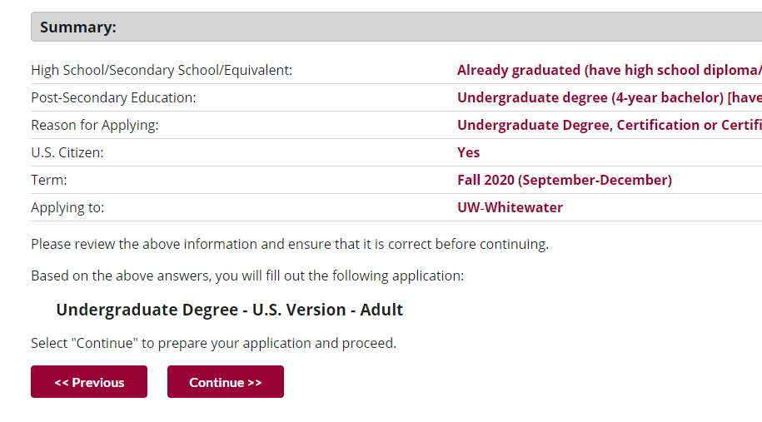
Click Continue

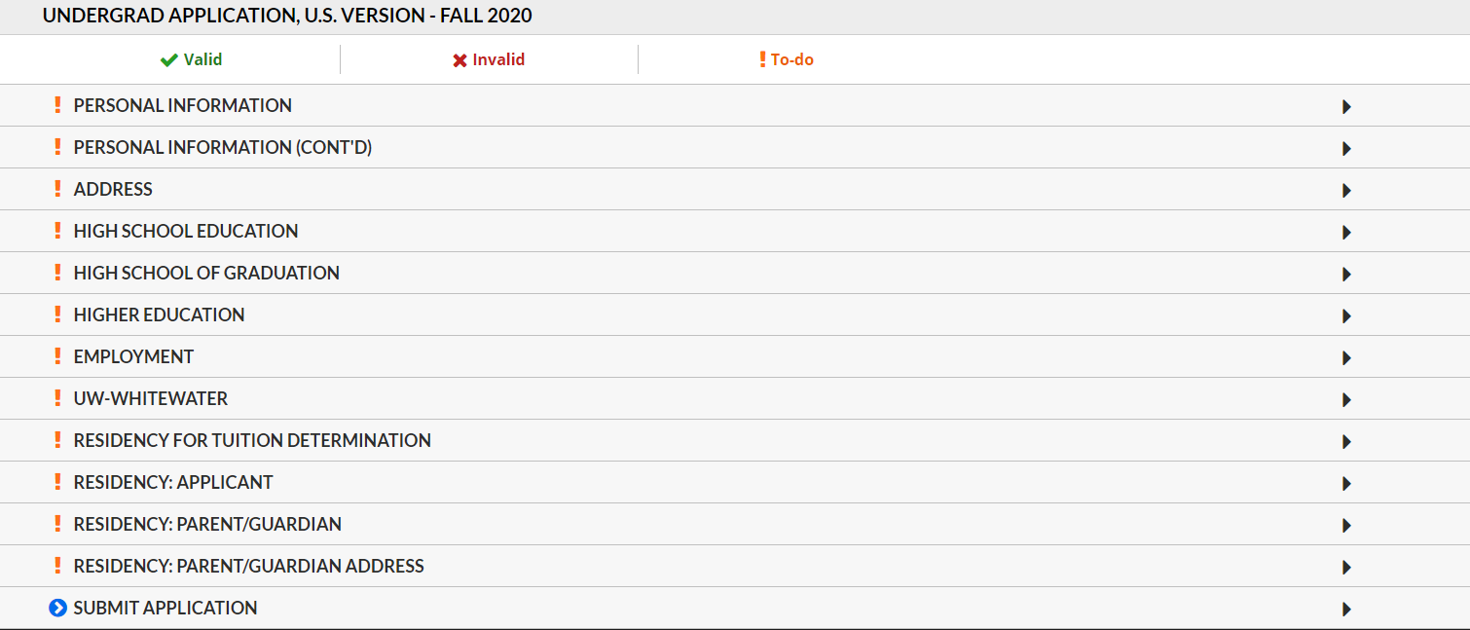
Select “UW-Whitewater”

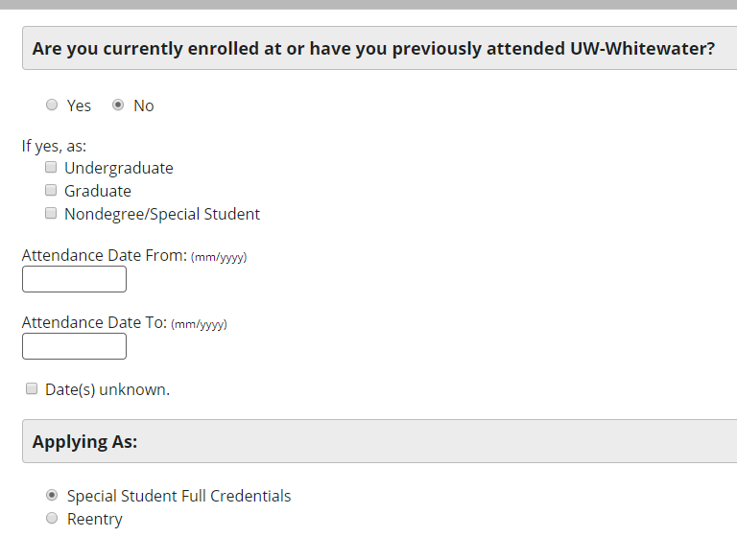
If you are student who already has a degree- be sure to select “Special Student Full Credentials”

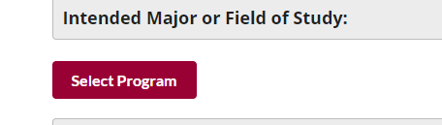
Click “Select Program”
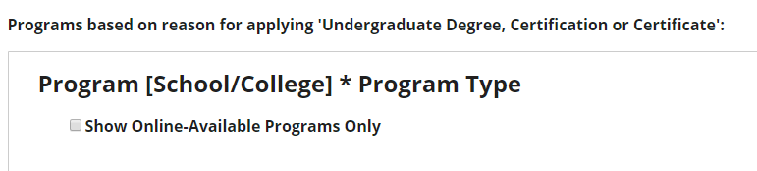
Check the box stating “show online-available programs only”

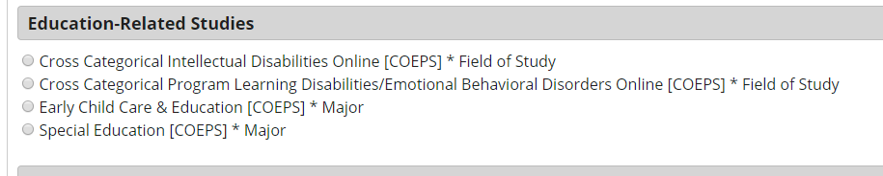
Select either “Cross-Categorical Intellectual Disabilities Online [COEPS] OR
“Cross-Categorical Program Learning Disabilities/Emotional Behavioral Disorders Online [COEPS]

Then complete the remainder of the application.

