Registering to be a notetaker
- Go to the CSD webpage and click on the square labeled ARP (Accommodation Request Portal)
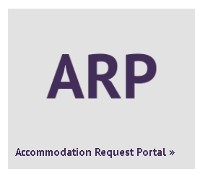
- Click “Sign In to ARP”
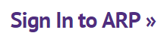
- Click the link for “Sign Up as a Notetaker”.

- Enter in the information it requests and click “Step 2”
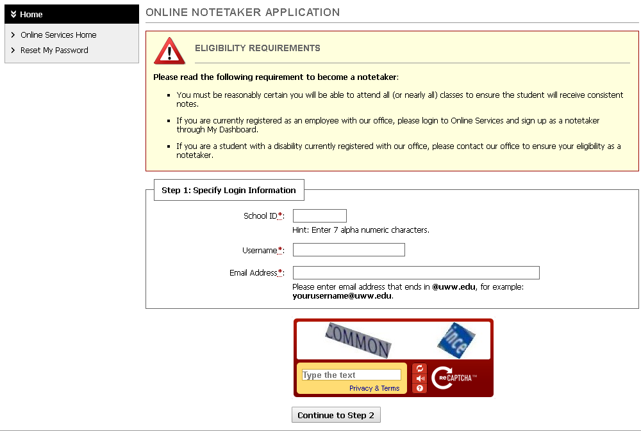
- Enter the requested information and click “Register as a Notetaker”
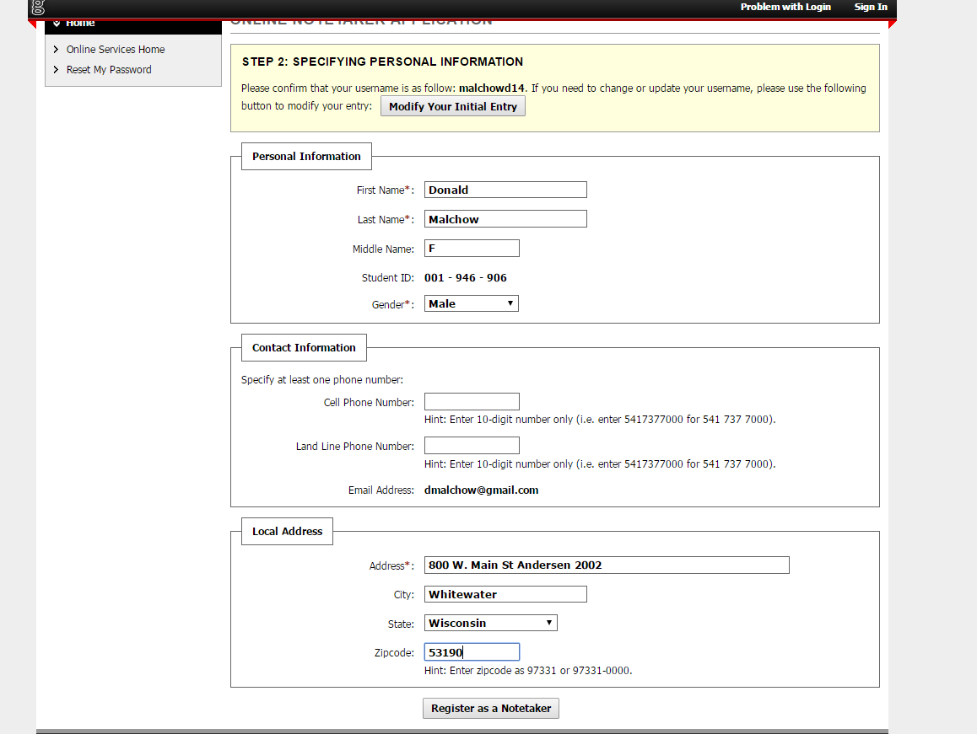

- Find your classes and click “Continue to Verify Your Classes”
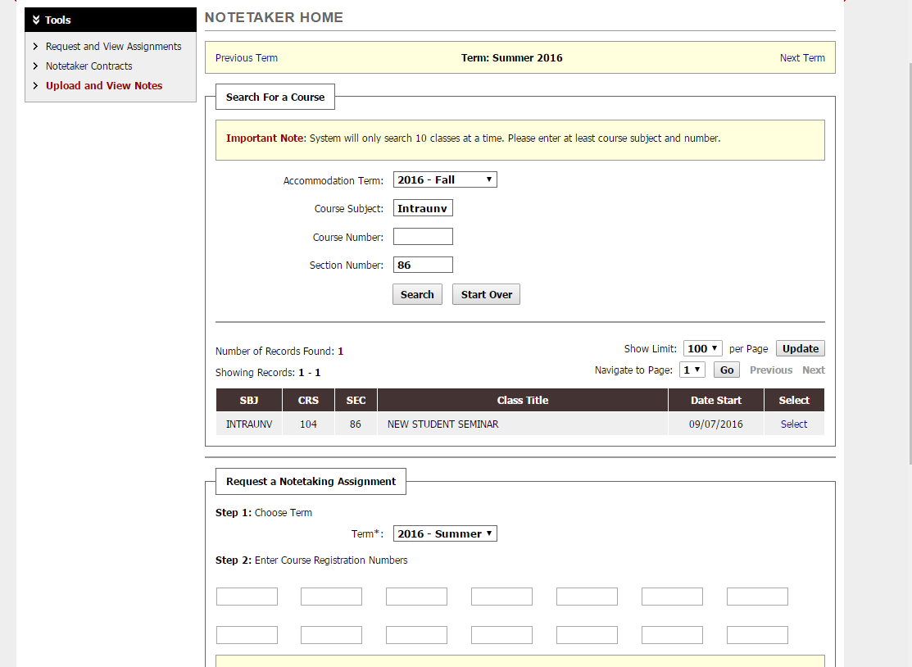
- Make sure the correct classes are listed; for each one that is correct, click the box on the left (so you need to check off each class), and click “Submit Your Class Schedule”
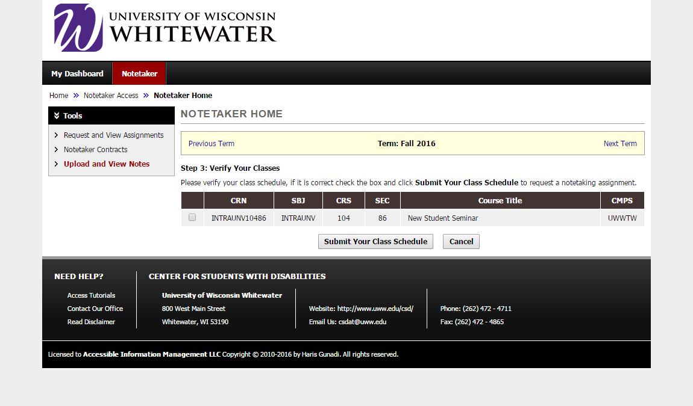

- Review the Notetaker Agreement and then type your name as your signature
- Click Submit Your Notetaker Contract
When you are paired with a student, you will receive an email with their name and email address. Please reach out to them and introduce yourself! They will also receive an email with your name and email address

