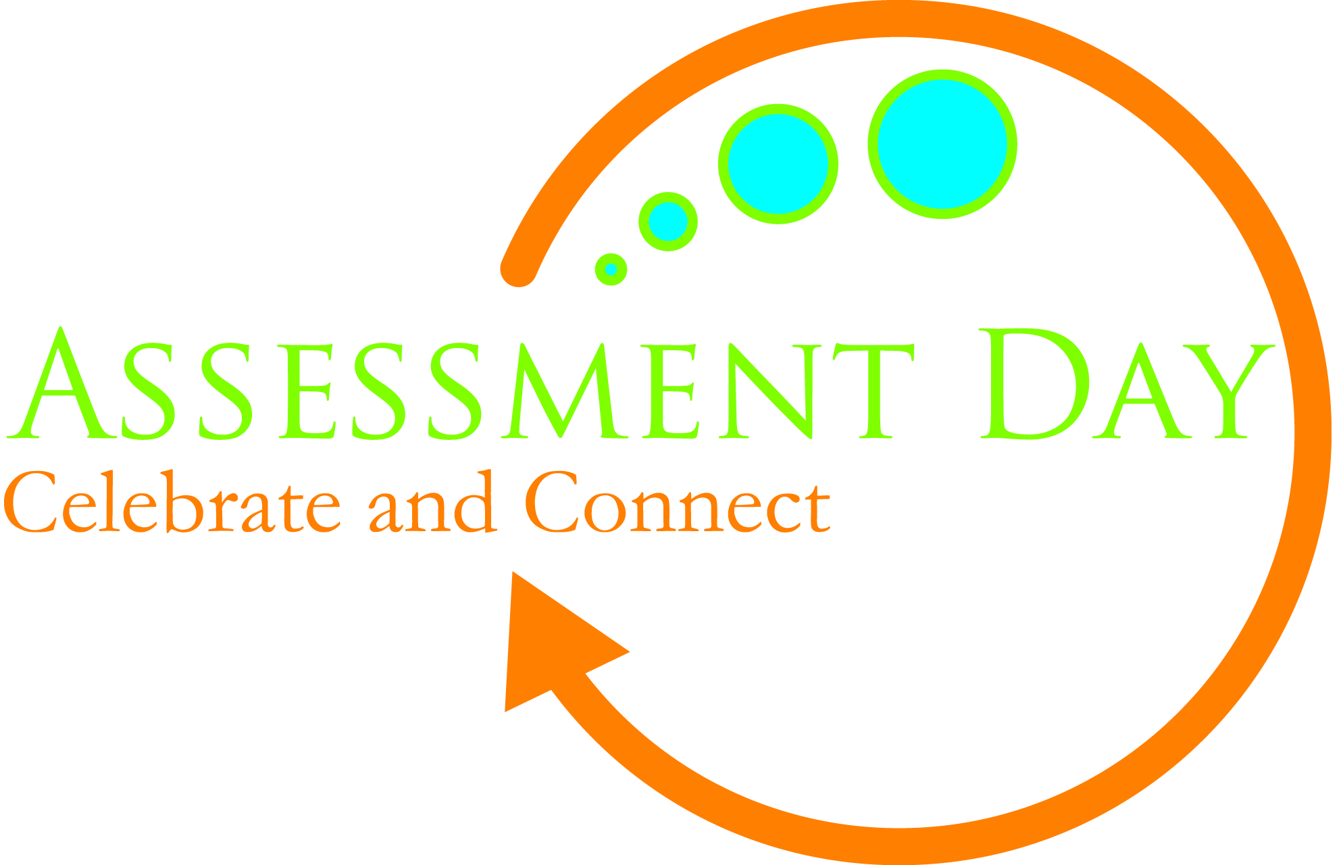

ASSESSMENT DAY, 2015
Whitewater, Wisconsin
Wednesday February 25
12:15-4:30pm

Join us in the University Center for UW-Whitewater’s Annual Assessment Day!

Celebrate all the interesting assessment projects going on across our campus. Connect with others to learn about different approaches, specific tools for assessment, and what these projects are telling us about student learning.

Keynote Address by Dean John Stone
    - “A Visit from the In-Laws":
    - What Will the HLC Look for and Say about UWW's Academic Assessment Work

NEW THIS YEAR—Prizes for outstanding posters, selected by those attending
    - Hamilton Room open from 10am-4:30pm for viewing posters & voting on awards

Go to Assessment Day, 2015 (http://www.uww.edu/acadaff/assessment/aday)
for the full program and to register for lunch.

