Film Studies Minor Proposal

12 February 2013

Film

Studies



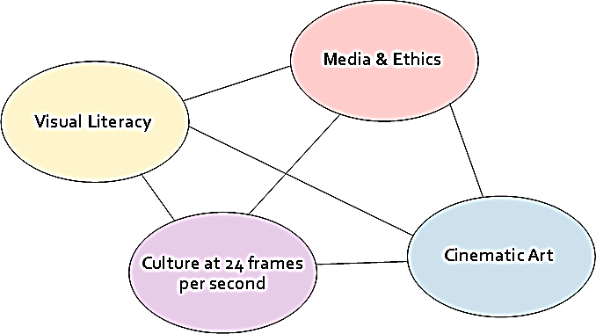

University of Wisconsin-Whitewater

Curriculum Proposal Form #1

## New Degree, Major, or Submajor

**Effective Term**:

**Degree**:

**Program Title**: Film Studies

**GPA Required in the Major/Submajor**: 2.5

Spo**nsor(s):**  Donald Jellerson, John McGuigan, Holly Wilson, Janine Tobeck, Elena Levy-Navarro, Marilyn Durham

**Department(s):** Languages and Literatures

College(s):

# **Consultation took place:** NA Yes (list departments and attach consultation sheet)

Departments: Communication, History

*Check if:*

# New Degree: Intent to Plan *

# New Degree: Final Proposal

# New Major: Intent to Plan *

# New Major: Final Proposal

# New Submajor: Minor

# New Submajor: Emphasis/Track

# New Submajor: Certificate Program

# Module: Intent to Plan

# Module: Final Proposal

# Other (list):

**Note:** This document proposes an interdisciplinary Film Studies minor that draws on subject areas in the College of Letters and Sciences and the College of Arts and Communication. Though interdisciplinary in scope, the minor will be housed in the Languages and Literatures Department in the College of Letters and Sciences. Dr. Donald Jellerson will serve as Coordinator.

* **Catalog description of the program**

The Film Studies minor offers students the opportunity to study the medium of film in an interdisciplinary setting. Students will learn methods of film analysis that take into account the history and conventions of filmmaking. They will learn about the social impact of film—its uses for reflecting, shaping, and critiquing culture—while improving their ability to formulate and express cogent interpretations of this important and influential medium. Students will emerge with the ability to critically view and interpret films, becoming discerning analysts and consumers of national and international cinema.

* **Student Learning Objectives of the program (what a student should know/be able to do upon completing the program)**

Students emerging from the Film Studies minor will be able to:

1. critically interpret films and clearly express those interpretations orally and in writing
2. demonstrate knowledge of the historical development and cultural impact of film as an art form
3. demonstrate a familiarity with the collaborative processes through which films are constructed
4. employ the specialized vocabularies and methodologies used by Film Studies scholars
5. engage with questions of ethics and social justice through representations of culture on film
6. analyze a range of cinematic visual styles, narrative conventions, and generic trends

* **Correlation with LEAP Outcomes**

These learning objectives correlate with the LEAP initiative in several ways. (For how specific course groupings intersect with LEAP, please see the chart on page 6.)

Objectives 2 and 5 in particular respond to the LEAP learning objective, “Knowledge of Human Cultures.”

Objectives 1, 3, 4, and 6 respond to the category, “Intellectual and Practical Skills” (critical thinking, analysis, written and oral communication, and information literacy).

Objective 5 aligns with LEAP’s “Personal and Social Responsibility” mandate (intercultural knowledge, ethical reasoning).

Through a series of courses working in tandem across disciplines, Film Studies seeks to provide students an experience in what LEAP calls “Integrative Learning” (“synthesis across general and specialized studies”). Overall, the Film Studies minor aims to provide, in LEAP language, “foundations and skills for lifelong learning,” given the ubiquitous presence of cinema and its legacy, visual media, in modern-day culture.

* **List of courses to be included in the program (include course titles), with a brief rationale for each course; new courses must be submitted for approval prior to or together with the final proposal for the program**

Currently Offered

**HISTRY 110** *History through Film*

introduces students to the process of culturally situating cinematic works

**COMM 236** *Introduction to Cinema*

introduces students to the vocabularies and methods of film analysis

**COMM 249** *Great Moments in Cinema* [cross-listing: **JOURNLSM 249**]

introduces students to the history of cinema, the evolution of its technology and forms

**ENGLISH 266** *Gender in Film*

analyzes gendered representations in films and the cultural contexts from which they emerge

**COMM 346** *Sound and Image* [cross-listing: **MUSC 346**]

explores how and to what effect visual media combine images with sound and music

**ENGLISH 376** *Screenwriting*

provides experience in the theory and practice of writing scripts for cinema

Proposed

**FILM 350** *Film Genre*

examines the conventions, development, and cultural contexts of a rotating selection of film genres

**FILM 352** *Literature on Film* [cross-listing: **ENGLISH 352**]

examines cinematic adaptations of literary texts through analysis of changing historical contexts, narrative strategies, and representations of culture

**FILM 354**  *Shakespeare on Film* [cross-listing: **ENGLISH 354**]

examines the conventions and cultural contexts of cinematic adaptations of Shakespeare’s plays, with a focus on the generic (tragedy, comedy, history) and the formal (stage, page, and screen)

**FILM 356** *Text and Image*

analyzes how language and image combine to produce narrative effects

**FILM 485** *Film Theory*

capstone providing instruction in theoretical lenses through which scholars view film

* **List of the required courses (do not include titles) in a format appropriate for the catalog and advising report**

MINOR – 24 UNITS

1. HISTRY 110
2. COMM 236 or COMM 249
3. **CULTURE:** ENGLISH 266 or FILM 352
4. **GENRE:** FILM 350 or FILM 354
5. SELECT 9 CREDITS **ELECTIVES** FROM:

COMM 236, COMM 249, ENGLISH 266, FILM 350, FILM 352, FILM 354, FILM 356, COMM 346, ENGLISH 376

1. FILM 485

**NOTE:** No course can fulfill more than one requirement in the minor with the exception of FILM 350 and FILM 352, which may be repeated as electives with a change in topic.

* **The new prefix, “FILM”**

Our program seeks to emphasize the distinct skill sets, knowledge domains, and pedagogical goals shared by those scholars and students who study cinematic texts. As a discipline, film studies enjoys a distinct identity, yet it plays a role in many larger fields, including Literary Studies, Communication, Theatre, Art History, and others. By labeling our new courses “Film” instead of “English,” “Communication,” or something else, we seek to provide our film studies program with the autonomy to shape itself according to its own unique methods. Using the title “Film” instead of an existing prefix will also underpin and encourage an interdisciplinary growth model that need not necessarily serve the larger agenda of any one department. We therefore suggest that the film studies minor should be available to all interested students, whatever their home discipline, including English and Communication majors.

Despite the new prefix, however, the program would remain under the larger administrative umbrella of Languages and Literatures. The Languages and Literatures Department Chair would schedule film courses with the minor coordinator consulting.

* **Proposed Rotation**



* **Student Learning Objectives (SLOs) by Course**



**All:** Every course will feature instruction in film analysis and its oral and/or written expression (SLO 1).

**Requirement #1:** HISTRY 110 introduces students to how film represents cultural groups and historical events, allowing students to situate national and international cinemas in cultural contexts (SLOs 2 & 5).

**Requirement #2:** COMM 236 or COMM 249. In addition to film analysis and its oral and written expression (SLO 1), these courses introduce the skill sets that enable the remaining five learning objectives, including techniques for analyzing the historical development and cultural impact of film (SLO 2), technologies that determine cinematic form (SLO 3), terms and methods used to analyze film (SLO 4), how film represents culture (SLO 5), and cinematic conventions, styles, and genres (SLO 6).

**Requirement #3:** ENGLISH 266 or FILM 352. English 266 repeats the goals of requirement #2 with an emphasis on gender in cultural context. Both courses offer intermediate instruction in the historical context and cultural impact of film (SLO 2) and how film represents culture (SLO 5).

**Requirement #4:** FILM 350 or FILM 354. In addition to film analysis and its oral and written expression (SLO 1), these courses offer intermediate instruction in the historical context and cultural impact of film (SLO 2) and how film represents culture (SLO 5) with an emphasis on cinematic narrative conventions, styles, and genres (SLO 6).

**Requirement #5:** ELECTIVES. The elective category allows students additional practice in the six learning objectives with emphases they select.

**Requirement #6:** FILM 485. The Film Theory course will carry a prerequisite: students will have fulfilled requirements 2–4, at a minimum. The course will offer advanced instruction in all six learning objectives through students’ appropriation and use of theoretical perspectives on film analysis.



* **Resources needed to support the program (staffing, equipment, library materials, etc.)**

1. **Facilities:** UWW has adequate existing facilities to implement the program. The support mechanisms are in place to digitize and present films through D2L, and those classrooms already equipped with computer and projection capability will serve the needs of the courses described here.
2. **Materials:** Individual instructors may request that DVD copies of films be kept on reserve at the library for students. The Languages and Literatures Department also owns a selection of DVDs (including a substantial selection of Shakespeare films) that could be usefully employed and augmented. In light of these contingencies, we recommend that the film studies program be assigned a small budget for film purchasing. Films purchased will be kept with the existing collection in the Languages and Literatures offices. Films not in use for current courses will go to the library for wider circulation at the end of each academic year. We recommend a budget of $300 per year (enough for between 10 and 20 DVDs). Dr. Jellerson will work with Dr. McGuigan to augment and formalize the Department’s existing, informal faculty lending system.
3. **Staffing:** As the minor grows, it will seek out and incorporate the participation of a wider circle of faculty members. The newly proposed courses may be offered by the following faculty members:

**FILM 350** *Film Genre* Holly Wilson / Donald Jellerson

**FILM 352** *Literature on Film* John McGuigan / English Literature Faculty

**FILM 354** *Shakespeare on Film* Elena Levy-Navarro / Donald Jellerson

**FILM 356** *Text and Image* Janine Tobeck / Professional Writing Faculty

**FILM 485** *Film Theory* Donald Jellerson / Linda Robinson

The program will seek to foster the links with Communications, Women’s Studies, Race and Ethnic Studies, Languages, and other departments that would expand course offerings along with the pool of participating faculty members. As the program grows, new hires in Languages and Literatures may be sought who have secondary experience in film and media studies. The program plan does not as yet anticipate hiring instructors whose primary field is film studies. Such hiring would not become necessary or advisable unless the minor program grows to the point at which a new major should be considered. To accommodate the initial instruction needs of the new courses, the program recommends shifting faculty from English 101 and 102 courses and employing an academic staff instructor to teach the necessary sections of introductory writing.

**Associated Expense:** The rotation plan above (p. 5) represents several courses that are already running, for which no change in faculty teaching loads are necessary. We envision no change in the rate at which these courses run. Of the new courses proposed here, four would require shifting faculty members in Languages and Literatures from their duties teaching Freshman English. (The fifth, FILM 485, would be taught as an overload.) Given the rotation, this suggests that four sections per year (two per semester) of Freshman English would need to be covered, which suggests that Languages and Literatures would need the equivalent of a .44 FTE increase in academic staff coverage.

**Coordinator**: The start-up and ongoing duties of the coordinator will be…

* 1. work with Marketing and Media Relations to develop a brochure for the program and oversee production—such a brochure will be used to 1) encourage enrollments, and 2) add a supplementary recruitment tool for the University
  2. visit existing introductory film courses to advertise the new minor
  3. work with the Web Support Team to develop a Film Studies website to serve as a hub for information about the program and a point of contact between students and faculty
  4. liaise with other departments (History, Communication, and others), including reporting assessment results, discussing learning objective overlaps and gaps, and course planning
  5. schedule annual (at a minimum) meetings of the faculty members teaching in the minor to share best practices, discuss assessment results, and plan the growth of the minor
  6. implement assessment program and facilitate sustainable assessment practices
  7. schedule and host yearly gatherings of students and faculty and facilitate ongoing opportunities for student–faculty contact
  8. develop curriculum—track enrollments to determine demand, vet new course proposals, ensure continued alignment of course offerings and learning objectives
  9. advise students in the minor—Languages and Literatures would shift the coordinator’s advising load from English to Film Studies students

**Flyer Design Example:** triptych, glossy, color, 2000 copies

**Outside Panels:________________________________________________________________**

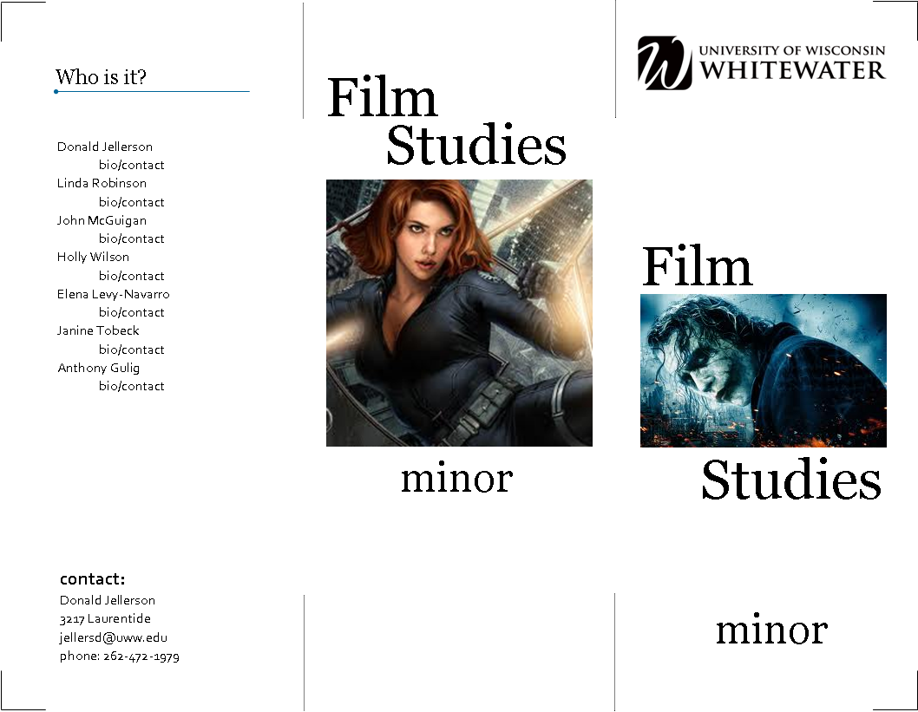

**Inside Panels:________________________________________________________________**

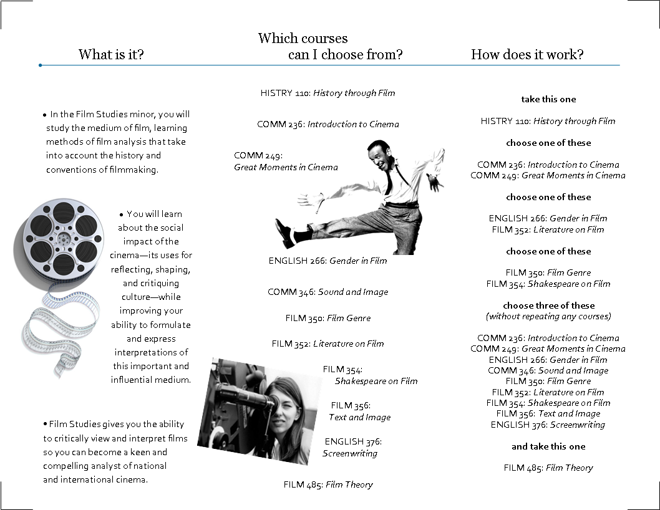

* **One-sheet Flyer**

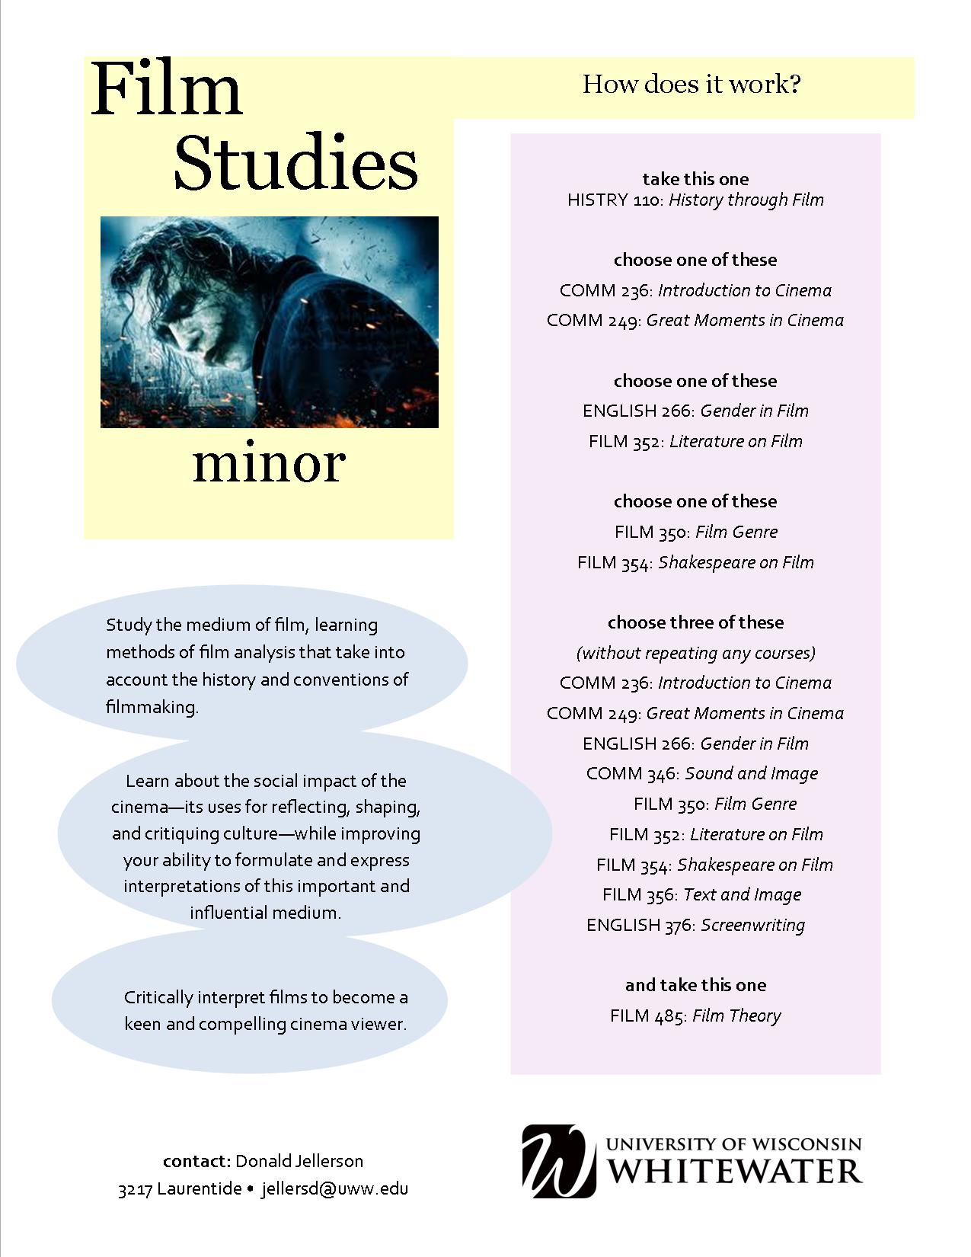

* **Student need/demand for the program**

The success of the film courses we currently offer suggests a strong demand for the subject. The Department of Languages and Literatures is currently offering a pilot Special Topics course in Film Studies (English 300). The course is over-enrolled (36 students), which gives it the largest enrollment of any Special Topics course the Department has offered to date. The History Department’s extremely successful film course (HISTRY 110) enrolls 80-90 students every semester (WINS). Linda Robinson’s *Introduction to Cinema* course (COMM 236) regularly enrolls 40-50 students. Robinson’s *Great Moments in Cinema* (COMM 249) was fully enrolled in Spring 2012, the second semester in which it was offered. Understood as a measure of demand, the enrollments in these introductory courses are a positive indicator for the success of a Film Studies minor.

Our experience at other institutions also suggests that Film Studies can be a popular and useful subject area. Linda Robinson has taught at Northwestern University and the University of Wisconsin Oshkosh, whose Communication departments offer popular Radio-Film-Television degrees. Donald Jellerson has worked at Vanderbilt University and Rhodes College, both of which housed successful Film Studies programs within their English departments. Looking at UW Whitewater’s neighboring institutions and drawing on our past experience, we can confidently predict a solid and growing demand for the film studies minor.

As a truly interdisciplinary subject area, we expect that Film Studies will become a popular and useful minor for students in several departments, including Communication, English, MAGD, Women’s Studies, Sociology, History, and Theatre. Film Studies relies on methodologies developed in literary studies, sociology, psychology, and art history, to name a few. Students can thus use the study of film to create intellectual links between their major subject area and related disciplines. A Journalism student, for instance, can explore the possibilities for writing about (and within) various media. An Art History student can draw connections between fine art, photography, literature, and film—arts that have evolved in strong relation to each other over the last century. Literature students can explore in depth how the medium in which a text is presented transforms and determines linguistic meaning. Education students could benefit, since classrooms rely increasingly on media, and teaching media literacy skills has become a priority. Moreover, a Film Studies minor will be an excellent complement to such degrees as Electronic Media (Communication Department) and MAGD, in which students learn to produce visual narratives, as it will deepen students’ understanding and knowledge of the moving visual image.

More broadly speaking, media saturation has transformed culture in significant ways over the last several decades, a process that continues at an ever-increasing pace. Higher education has changed, and must continue to change, along with culture. Students now have a growing range of career choices related to film, television, and other media. While the Film Studies minor does not currently propose preparation in specific career paths, a general familiarity with cinema, the foundation for all present-day uses of the moving image, will serve students in many other careers they may choose. For instance, the degree in Broadcast/Print/Web Journalism is designed to prepare future journalists to be proficient, as they must be, in visual as well as text-based story-telling. The same need to be media savvy exists in such careers as advertising and marketing, to name just two.

Furthermore, a Film Studies minor will open doors for future expansion. The program will continue to forge interdisciplinary links within the broader category of media studies, paving the way to a possible major program that would respond more fully and practically to our increasingly media-saturated culture.

Even if we put future developments and career fields aside, however, a Film Studies minor as this proposal envisions it will provide what the LEAP initiative calls “foundations…for lifelong learning.” Responsible and productive leaders who must thrive in our current and future media culture do well to think critically about the effects of visual media on interpersonal and group dynamics, ethics, gender, race, class structures, commerce, and so on. Film Studies will serve to foster that critical thinking, creating informed consumers and, more importantly, producers of culture.

* **Relation of the program to other programs on campus, in the UW System, and in the region**

Many universities and colleges in our area have successful Film Studies programs. Both UW Madison and UW Milwaukee offer advanced degrees in Film Studies: Madison offers a PhD in the subject through its Communication Department, and Milwaukee offers a master’s-level degree through its English Department. UW Parkside offers a certificate program in Film Studies, and UW Oshkosh offers a practice-based bachelor’s degree in “Radio-TV-Film.” UW River Falls offers a minor in the subject through Communication Studies. Marquette University in Milwaukee offers an interdisciplinary Film Studies minor. Looking across our southern border (but leaving aside Chicago), Northern Illinois University offers an undergraduate degree in Media Studies that includes film, and Western Illinois University offers a minor in Film Studies through its English (and Journalism) program. Going a little further afield, Eastern Michigan University’s Communication, Media Arts and Theatre Department offers a degree in Electronic Media and Film Studies, and Michigan State University offers a Film Studies degree in its English department, as well as an interdisciplinary and interdepartmental undergraduate specialization elective in film studies administered by the College of Arts and Letters.

We are comparatively disadvantaged as an institution without a film studies program. Progress in this direction will open up interdisciplinary links within our University and serve students focused on a growing range of careers in which working understandings of cinematic media are becoming more and more necessary.

* **An assessment plan for the program (to be submitted after program approval to the University Assessment Committee for review)**

**Coordinator:** Donald Jellerson

**Annual Meeting in May**

With the assistance of faculty members teaching in the program, the coordinator will conduct direct and indirect assessment measures (see below). The coordinator will recommend *at least one* action item for program improvement during the following academic year.

**Annual Meeting in September**

At the beginning of the academic year, the coordinator will host at least one meeting of faculty members currently teaching courses in the minor. The coordinator will share assessment results and encourage feedback from faculty members. The group will decide on the action item(s) for the year. The intent will be to make the meetings brief and informative, allowing involved faculty members the opportunity to share in directing the minor.

**Direct Measure:**

The program coordinator will conduct an annual sampling of essays produced by students who have declared the minor. These essays will be drawn from three levels within the minor: the genre component, the cultural component, and the theory capstone. The coordinator will assemble a small group of evaluators—one or two faculty members teaching in the minor that year—to conduct the assessment, which should take no more than one day. Evaluators will use specially designed rubrics to analyze the benchmark essays in genre (with emphasis on learning objective six) and cultural codes (with emphasis on learning objective five) for evidence of progress. The evaluators will measure the capstone essays for evidence of mastery of learning objectives one through four.

**Method of Essay Collection:**

Faculty members teaching the relevant courses will collect final papers in electronic form (e.g. D2L dropbox) and provide access to the Coordinator (e.g. by granting the Coordinator guest instructor status on D2L). The Coordinator will generate random samples of twenty student papers in each category, without regard to particular courses or instructors. Identifying marks will be deleted or obscured so that samples can be used to evaluate learning outcomes within categories rather than measure the success of particular courses, instructors, or students.

**Rubrics for Assessment**







**Indirect Measure:**

Students in the capstone course will measure their learning in the form of a survey. The survey will ask students to measure their learning in the six master learning objectives. In the following sample survey, each master objective is reflected in two forms (the first and second categories below reflect learning objective 1, the third and fourth respond to objective 2, and so on).

