Depending on the student’s specific visual impairment and specific assistive technology it will alter how you convert documents. It is important to discuss with the student what type of file format they prefer. Some file formats are not accessible in specific technologies that students with disabilities commonly utilize.
PowerPoint:
The easiest way to save a PowerPoint to an accessible format for a student utilizing a Braille Note [Apex] is to do the following:
FILE > SAVE AS > Click the drop down menu SAVE AS TYPE > Select either RTF or TXT
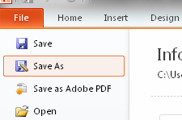
If the student is requesting enlarged print often times students can print the Powerpoints with one slide per page. If enlargement is requested after you have converted to RTF/TXT you can select all and enlarge the font to the appropriate size.
IMPORTANT: Images will not be copied. It is imperative that there is a caption for the photo describing the image embedded on the slide.

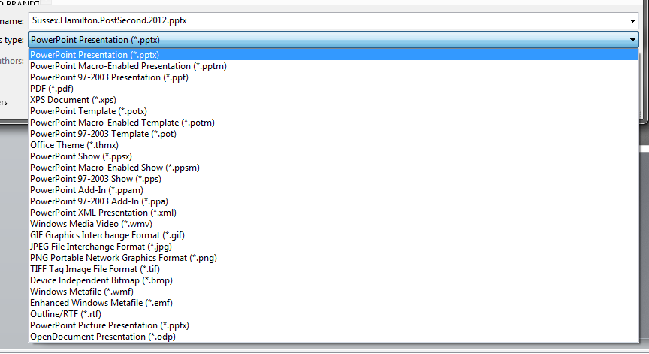

Portable Document Format [PDF]:
If files are saved as PDF’s they are typically not accessible if the accessible options in Adobe are not activated. Most screen readers and other assistive devices will see a PDF as an image and will not be able to read any of the text.
To create an accessible PDF please utilize this Wiki from the Learning Technology Center at UW-W: https://wiki.uww.edu/dept/instructional/index.php/Acrobat:_Creating_Accessible_PDF
To convert a PDF to an accessible file and it is not a Locked PDF and you do NOT have Adobe Professional do the following:
To Order Adobe Professional:
http://www.uww.edu/icit/services/tdc/purchase.html

EDIT > SECLECT ALL > RIGHT CLICK [on selection] > COPY > Open Microsoft Word > Create new document > Right CLICK > PASTE
- Then save the document like the PowerPoint in RTF or TXT [See above]
If it is a locked PDF of you have Adobe professional follow these simple steps:
FILE > SAVE AS > Microsoft Word > Word 97-2003 Document
- Then save the document like the PowerPoint in RTF or TXT [See above]
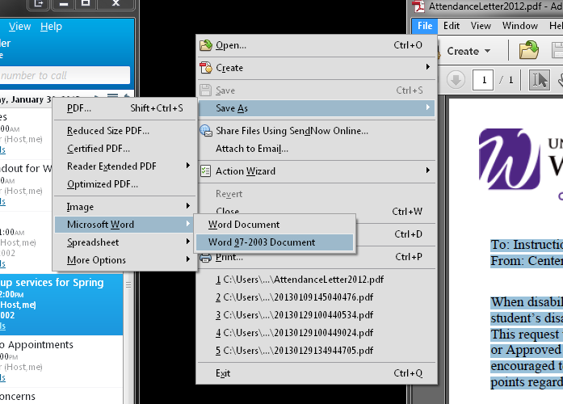

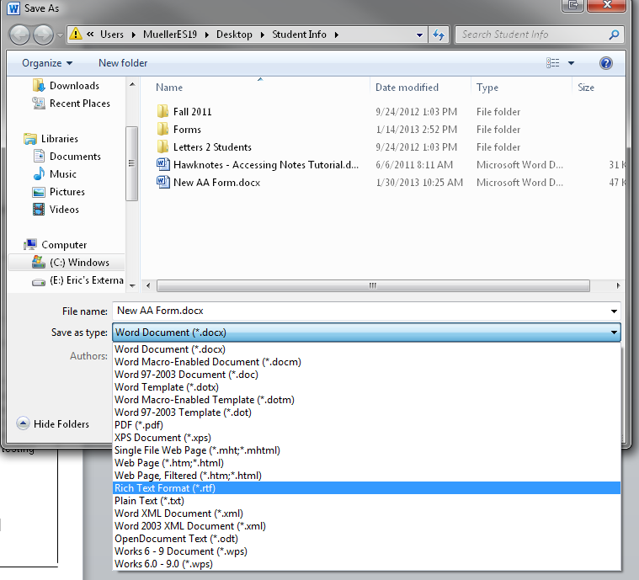
Microsoft Word:
FILE > SAVE AS > Click the drop down menu
SAVE AS TYPE > Select either RTF or TXT

The Center for Universal Design in Education
http://goo.gl/Rydq6
Copyright © 2002-2006 by University of Washington-AccessIT

