GETTING NOTES
AFTER HAVING CHECKED OFF “NOTETAKING” AS AN ACCOMMODATION
- Click on “Notetaking Services” in the left menu
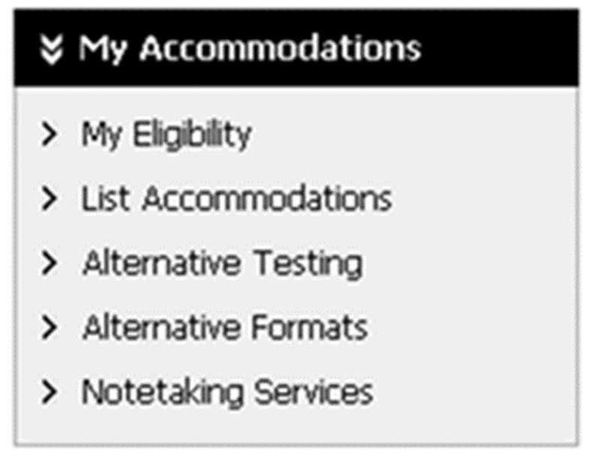
- Click “Confirm Now” for each class in which you want a notetaker
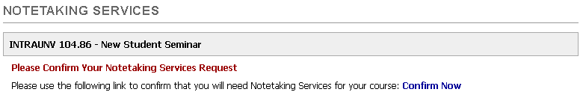
- Once a notetaker has been found and signed up in ARP, they will upload notes; those notes will appear in the “Notetaking Services” section, organized by class
