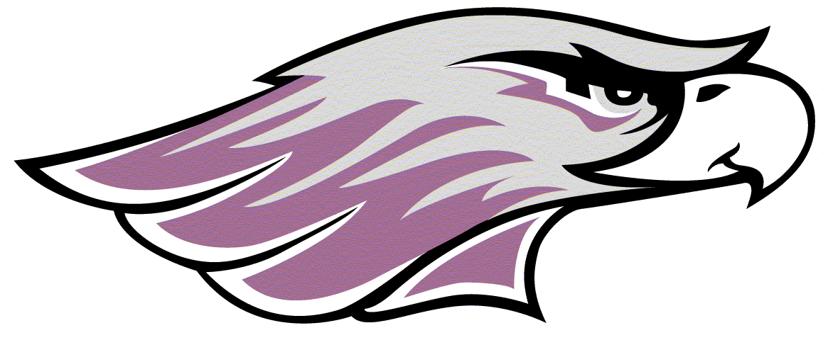WILLIAMS CENTER/KACHEL FIELDHOUSE

FACILITY OPEN HOURS & WEEKLY EVENT SCHEDULE

November 13 - 19, 2023

|  |  |  |  |  |  |  |  |
| --- | --- | --- | --- | --- | --- | --- | --- |
| Date | **November 13** | **November 14** | **November 15** | **November 16** | **November 17** | **November 18** | **November 19** |
| Monday | Tuesday | Wednesday | Thursday | Friday | Saturday | Sunday |
| **Kachel Fieldhouse** | 8 am – 2 pm | 8 am – 2 pm | 8 am – 2 pm | 8 am – 2 pm  9 – 11 pm (1 ct) | 8 am – 2 pm  7 – 9 pm | 8 am – 5 pm | Noon – 4 pm  7 – 11 pm (1 ct) |
| **Kachel**  **Track** | 8 am – 2 pm  7 – 11 pm | 8 am – 2 pm  7 – 11 pm | 8 am – 2 pm  7 – 11 pm | 8 am – 2 pm  7 – 11 pm | 8 am – 2 pm  7 – 9 pm | 8 am – 5 pm | Noon – 11 pm |
| **DLK Gym (Main)** | 8:30 – 10:30 am | 8:30 – 9:30 am  10:30 am – 2 pm  6 – 11 pm | 8:30 – 11 am | 8:30 – 9:30 am  10:30 am – 2 pm | 8: 30 am – Noon | No Open Recreation | Noon – 11 pm |
| **Russell Volleyball Arena** | 8 am – 2 pm | 8 – 9:30 am  11 am – 12:30 pm  9:30 – 11 pm | 8 am – 2 pm | 8 – 9:30 am  11 am – 12:30 pm | No Open Recreation | No Open Recreation | Noon – 7 pm |
| **Weight Room/**  **Cardio Center** | 6 am – 11 pm | 6 am – 11 pm | 6 am – 11 pm | 6 am – 11 pm | 6 am – 9 pm | 8 am – 5 pm | Noon – 10 pm |
| **Racquetball**  **Courts**  **(Rsv. Req.)** | 8 am – 11 pm | 8 am – 11 pm | 8 am – 11 pm | 8 am – 11 pm | 8 am – 9 pm | 8 am – 5 pm | Noon – 11 pm |
| **Pool** | 11 am – 1 pm  7 – 9 pm | 7:45 – 8:45am  11 am – 1 pm  7 – 9 pm | 11 am – 1 pm  7 – 9 pm | 7:45 – 8:45am  11 am – 1 pm  7 – 9 pm | 11 am – 1 pm  7 – 9 pm | CLOSED | 7 – 9 pm |
| **University Fitness**  **(Wells Hall)** | 12:30 – 11 pm | 7 – 9 am  12:30 – 11 pm | 7 – 9 am  12:30 – 11 pm | 7 – 9 am  12:30 – 9 pm | 7 – 9 am  12:30 – 7 pm | CLOSED | 3 – 9 pm |
| **Events at Williams Center/**  **Athletic Complex** |  |  | -Women’s Basketball vs. Ripon (5:30pm, DLK Gym)  -Men’s Basketball vs. Carroll (7:30pm, DLK Gym) | -Possible NCAA Women’s Volleyball Tournament (TBA) | -Possible NCAA Women’s Volleyball Tournament (TBA) | -Swim Meet vs. UW-Stevens Point (1pm)  -Women’s Basketball vs. Carroll (6pm, DLK Gym)  -Possible NCAA Women’s Volleyball Tournament (TBA)  -Possible NCAA Football Playoff (TBA) |  |

**Hotlines – 472-1400 Website: http://www.uww.edu/recsports/**

**Call 472-1384 For Racquetball and Indoor Tennis Reservations An ATM is located on Williams Center 2nd floor for your convenience!**

NOTES: Equipment Check-Out Is Available During The Same Hours As The Racquetball Court Reservation Times Listed Above.