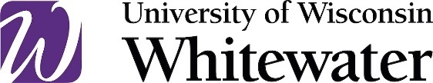

Open Meetings Practice Directive

Division:
Administrative Affairs
Department:
Administrative Affairs
Contact Information:
Vice Chancellor of Administrative Affairs / Taryn Carothers / (262) 472-1922 / carothet@uww.edu
Effective Date:
07/01/2021
Revised Date:
07/21/2024

Authority:
UW System Administrative Policy: UPS Operational Policy: HR 15, Open Meetings Law
Wisconsin State Statute: Wis. Stat. 19.81-19.98

Objective:
The purpose of this Practice Directive, and its corresponding Procedure, is to provide guidance in complying with Wisconsin’s Open Meetings Law.

Statement:
Wisconsin's Open Meetings Law requires “governmental bodies” to conduct official business in open session and post in advance public notices of the meetings.

Procedures:
Open Meetings Procedure
Agenda Template

Searchable Words:
Wisconsin Open Meetings Law, WOML, Open Meetings Law, Open Meetings, Meeting Agendas, Governing Bodies, Governing Body, Government Bodies, Government Body, Closed Session, Open Session, Public Notice, Agenda Posting, Newspaper Notice, Virtual Meetings, Open Access Meetings.

