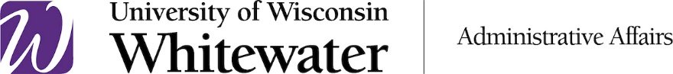
Warhawks Do
The Right Thing!

Reporting Waste, Fraud and Abuse

The University of Wisconsin System is committed to
encouraging an environment where open, honest
communications are the expectation, not the exception.

We want you to feel comfortable in approaching your supervisor or
management in instances where you believe violations of policies
or standards have occurred.

If you believe there may be an incident of waste, fraud or
abuse happening on our campus, you are encouraged to
report it via one of the following options.

What Are My Reporting Options?

INTERNAL UNIVERSITY CONTACT INFORMATION
- Ethics Officer and Vice Chancellor of Administrative Affairs Taryn Carothers.
Taryn can be reached by telephone at (262) 472-1922 or email at carothet@uww.edu.
- Chief Human Resources Officer Janelle Crowley.
Janelle can be reached by telephone at (262) 472-1024 or email at crowleyj@uww.edu.

EXTERNAL CONTACT INFORMATION
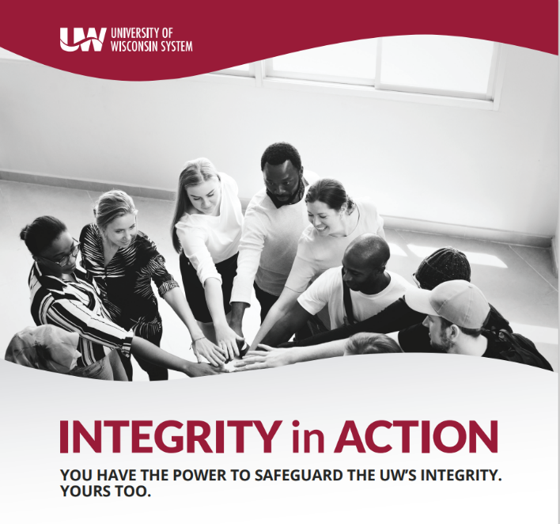 | You have the power to safeguard the UW’s Integrity. Yours Too.  If you have a concern about misconduct, abuse, fraud, illegal activity, or if you fear retaliation for speaking out, discuss with a manager, supervisor or HR representative listed above.  Or contact Navex Global online at: www.secure.ethicspoint.com or call 855-827-4950 anytime. You can remain anonymous.

