**FACULTY and ACADEMIC STAFF – ABSENCE ENTRY**

Log into the MyUW portal; see the link below. Choose Whitewater from drop-down box.

<http://my.wisconsin.edu>

Click "Launch full app" on the Time and Absence tile.

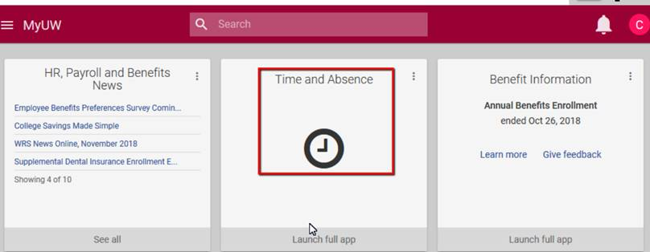

On the top left, choose Request Absence.

Select "No Leave Taken" in the drop-down box. The start and end dates should be the

same. Submit your request.

**OR,** select an Absence Name (i.e. Sick Leave) in the drop-down box. The start and end

dates should be the same. Enter the "Hours Per Day" (4 or 8). Submit your request.

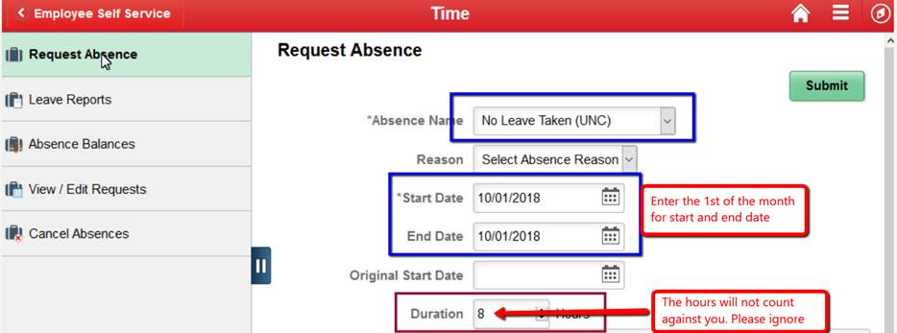

To watch a short video, please click on the link below. It is the first tab called Employee

Self Service. The video is on the upper right hand side, "Absences for Monthly Employees."

<https://uwservice.wisconsin.edu/help/time-absence>

(Please copy/paste this link into your browser.)

