**UW - Whitewater**

**SFS Web Based Financial Reporting System**

**User’s Manual**

****

MP00640_**BS00580_**

[**https://wisdm2.doit.wisc.edu/wisdm2**](https://wisdm2.doit.wisc.edu/wisdm)

10/17/17

*Table of Contents*

*Page*

*Accessing WISDM 3*

*Main Menu 4*

*Department Search 6*

*Summary Report Navigation 7*

*Department Rollup 11*

*Project Search 14*

*Purchase Order Search 16*

*Encumbrance Search 18*

*Voucher Search 20*

*Vendor Search 23*

*Payroll Encumbrance Search 24*

*Salary/Fringe Search 26*

*Journal Search 27*

*Transaction Search 28*

*WISER 29*

*My Favorites 32*

*My Profile 33*

*Help 35*SFS Web Inquiry System (WISDM)

**Access:**

The system is accessible at the following address <https://wisdm2.doit.wisc.edu/wisdm2/>

**Browsers:**

The system will run on Microsoft Internet Explorer, Chrome or Firefox.

**Logon Screen:**

Entry to the website will be through the UW System authentication hub page shown below. If you will make frequent visits to the page, set up a bookmark for the WISDM login screen. You will need to select your institution, then you will see the login page below:

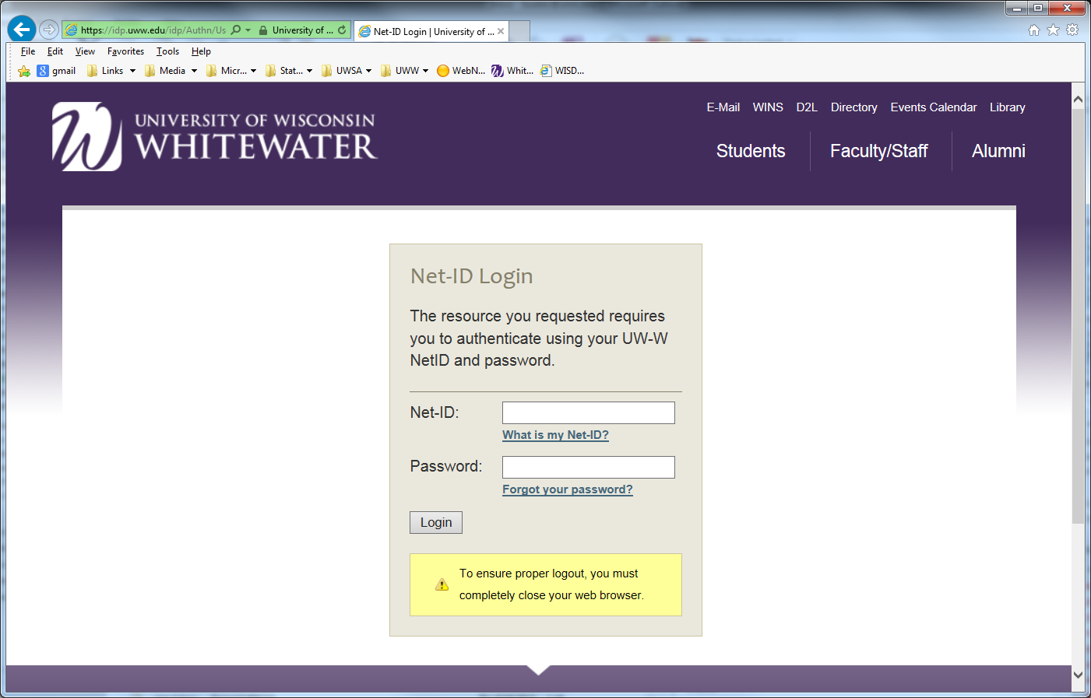

Login will require a Username and a Password. The Username is the same login you use for all access for UW-Whitewater applications.

Type in the password and then click the **LOGIN** button.

**Main Menu**

Once you login, you will be at the Main Menu screen. This screen can be accessed from any of the screens by clicking on the words **Main Menu** at the top left side of the screen.

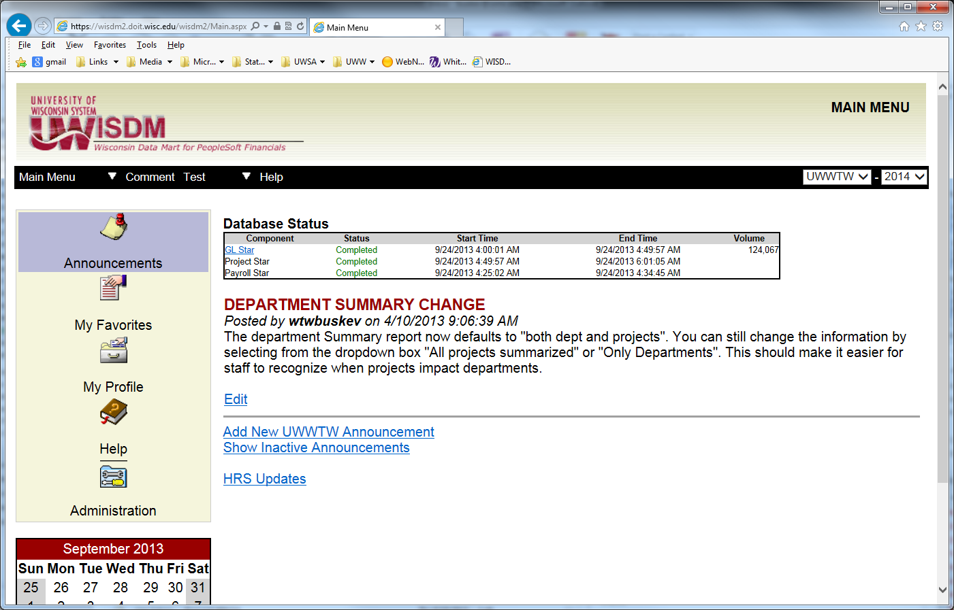

From this menu, you will be able to select a task to perform from the navigation menu that drops down when you move the mouse to the main menu:

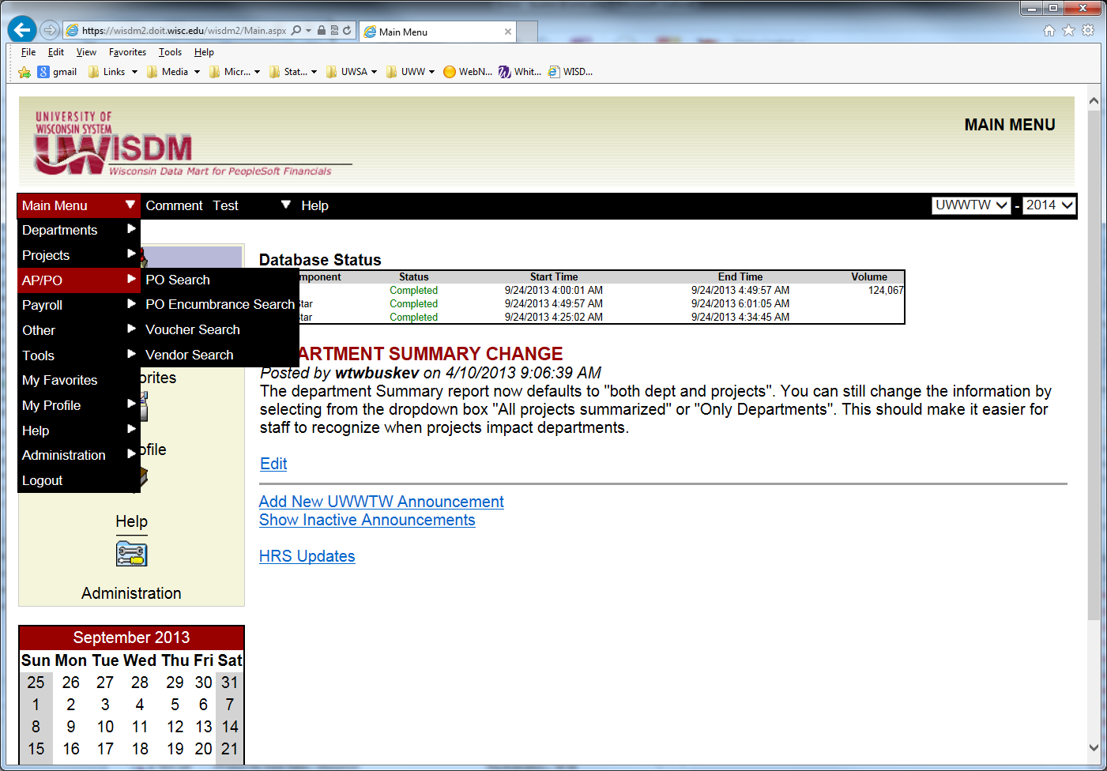

* **Departments (Organizations)** 
  + Search – allows you to search for organization codes using specific criteria
  + Rollup – provides summary information at various levels
* **WISER Departments**
* **Projects**
  + Search – allows you to search for projects using specific criteria
* **AP/PO Searches**
  + PO
  + PO Encumbrance
  + Voucher
  + Vendor
* **Payroll**
  + - Encumbrance
    - Salary/Fringe search
* **Other Searches**
  + Journal
  + Transaction
  + Custom
* **Tools**
* Budget Control Report
* **My Favorites**
* **My Profile**
* **Help**

# Department Search

Under **Department**, the **Search** navigation menu lets you query for a fund, specific department code (org code) or find a list of departments meeting the criteria you enter. That criteria can consist of the Fund, Department, Description, or Manager, or any combination of them, and can be a whole entry or just the starting information. The drop down arrow allows you to select “starts with”. Type in the criteria you want to view, then click **Submit**.

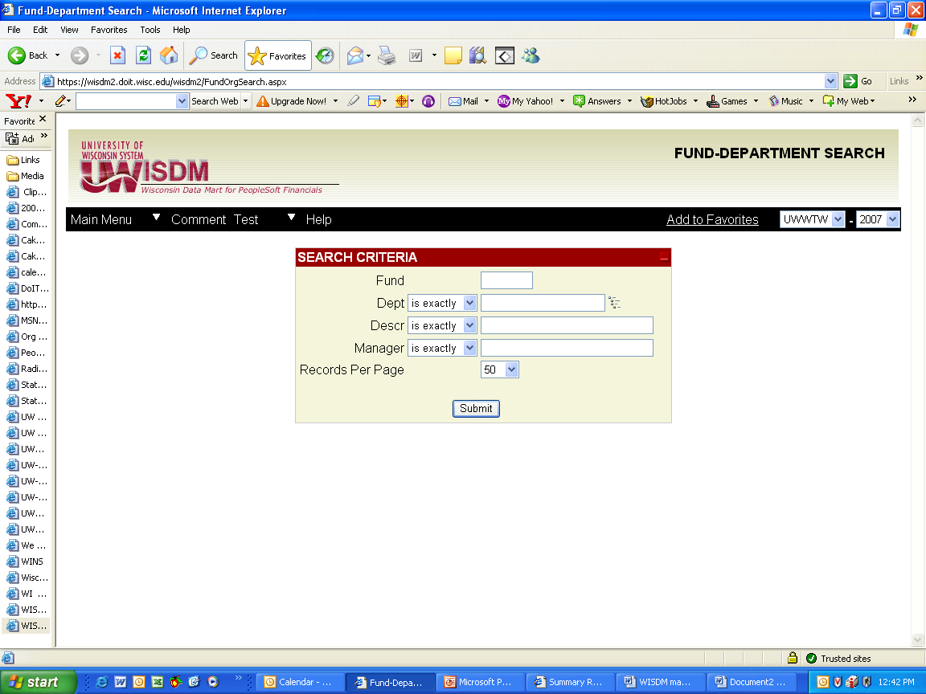

If you do not know the department number, you can use the dropdown list to find it. By clicking on the icon at the end of the Dept field. You will have a pop us screen that will allow you to open more detail by clicking on the plus sign. You can continue to open more detail until you find what you need.

You can also just put in the fund, click on submit, and all depts for the fund will be listed. If you put in the starting number or a portion of the dept name or manager name, you can change the fields to indicate “starts with”, or “contains” to give you more options.

Once you have selected the correct dept, click on **Submit.** The **Summary Report** for the department code selected will appear. If this department code does not use projects, this is the total for the department, but if projects are used, it is the total for all projects and department transactions. If project codes are used, you can view just by changing the **Project Option** box to see the project **Summary Report**, or the combined department and project **Summary Report**.

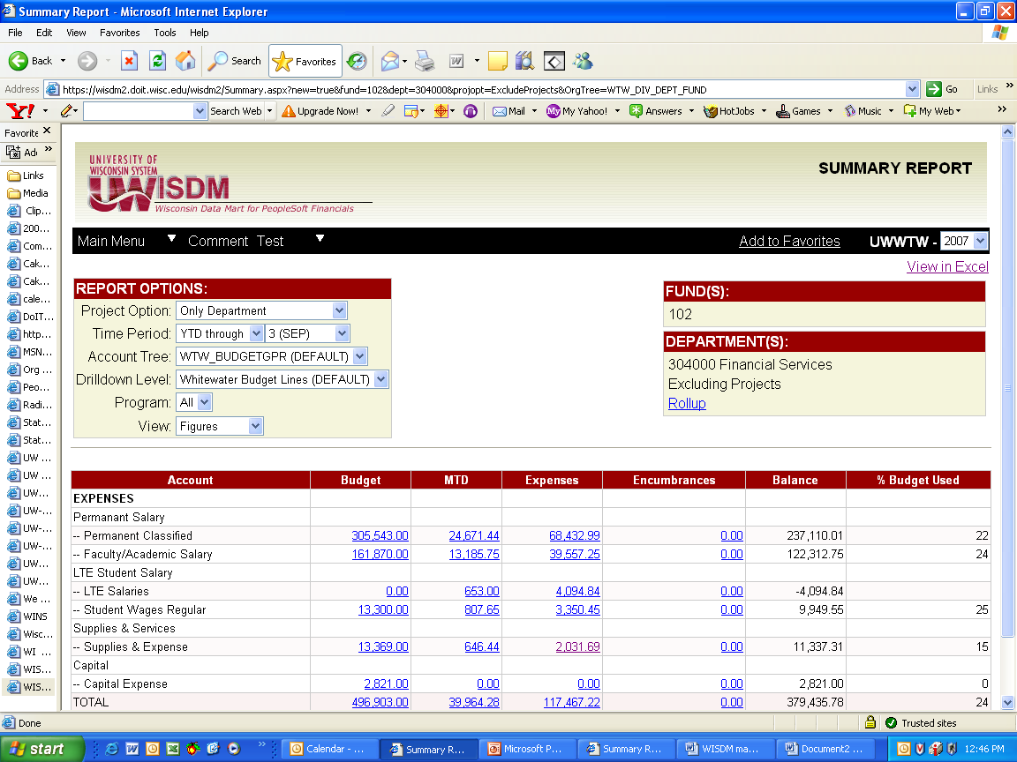

**Summary Report Navigation**

From the **Department** or **Project** **Search** navigation menu you will be running a **Summary Report** for your selection. You will see the following screen from which to select the type of transaction information.



The next screen shows the selection of department 304007:

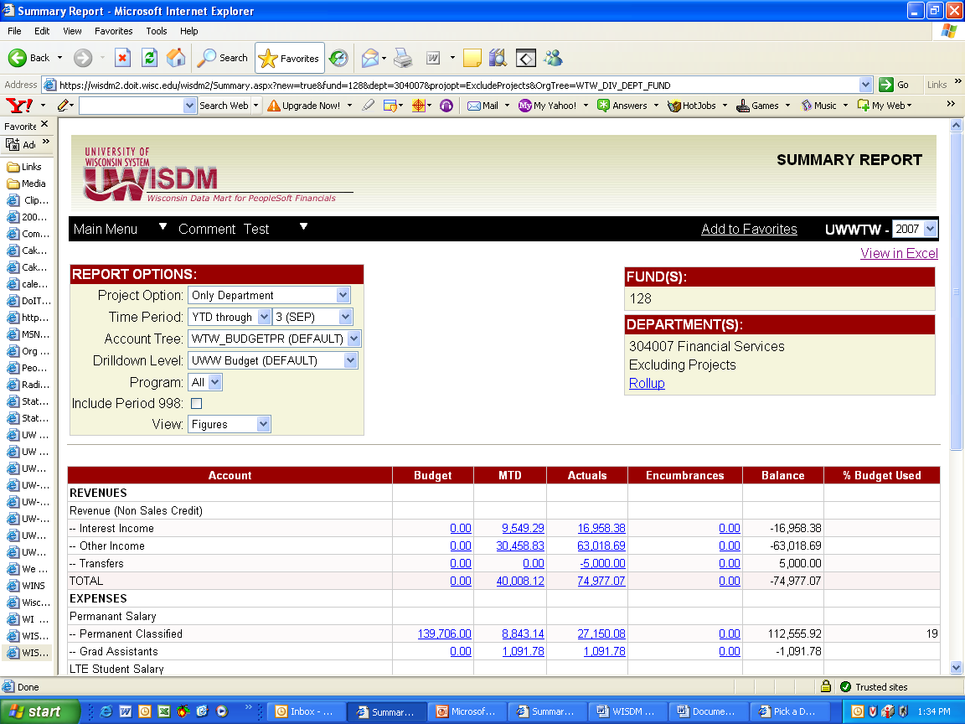

This screen shows the information based on the defaults set up for UWW users. Defaults for GPR depts and PR depts have been set up differently for the specific needs of the funds. The level of detail default for UWW has been set to provide the most detail when the reports are brought up. You can change your specific settings to maintain the level of detail you want to see when a report is selected. This will be covered later in the **Edit Profile** section. You always have the option to select a different detail setting while in this screen. You can change selections in the any of the fields with down arrows next to them:

* Fiscal year (information going back to 2000 is available),
* Accounting Period (default shows YTD, but you can select a specific month or quarter), info cannot be selected to a specific date,
* Account Tree (you should leave this default as is),
* Drilldown Level (to get more/less detailed level of summarization).

Each change will make the screen refresh to show that change.

In the screen below, the fiscal year has been changed to “2002” and the detail level has been changed to “Redbook” simply by selecting from the dropdown menus.

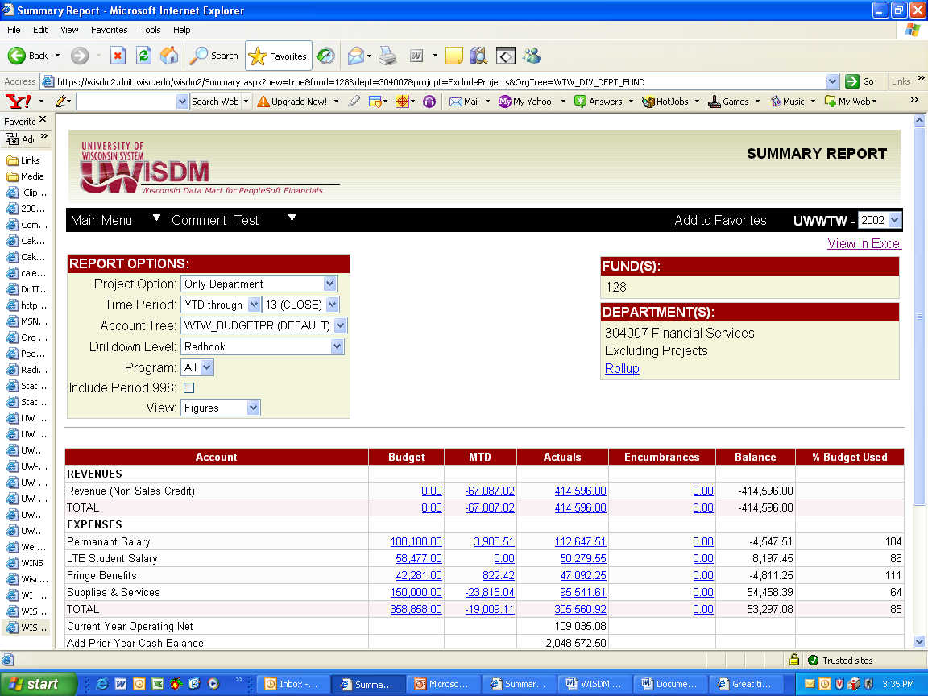

Amounts shown in blue and underlined can be drilled down on to see more detail. Simply click on the item once, and the system will drilldown to the next level of detail. You may be able to drilldown further on some items in the drilldown screen. See the next screenshot for the drilldown on supplies and services.

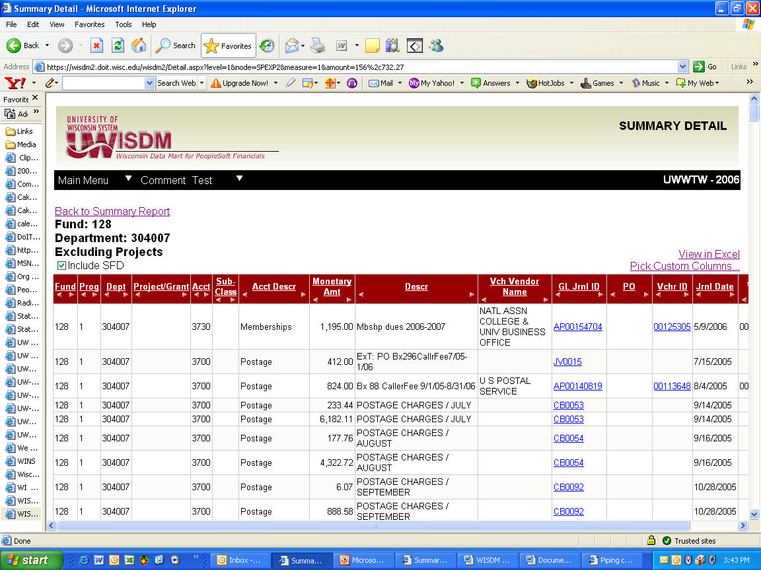

Information in the drilldown screen can be customized to provide the detail in the way you want to view it. You can sort column information in ascending (one click) or descending (two clicks) order by clicking on the underlined heading name of the column. You can also change the way the information is presented by moving or hiding columns.

To move columns to the right or left, click on the left and right arrows below the column heading. To customize the screen view of transactions, select **Pick Custom Columns** in the upper right.

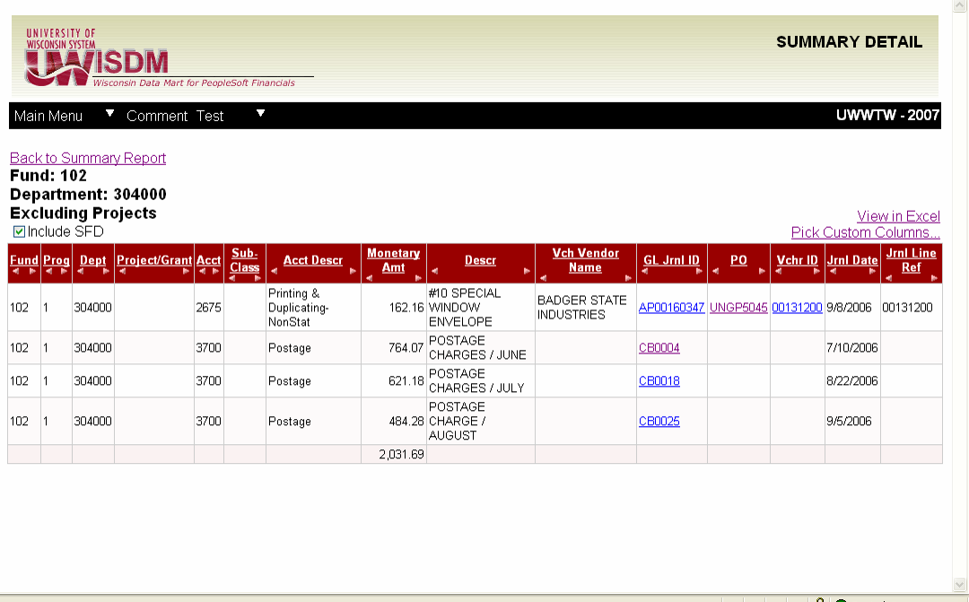

The **Pick Custom Columns** option will take you to a screen in which you can select the columns to display as shown in the next screen. If you make changes, click on the **Update** button on the bottom of the screen.

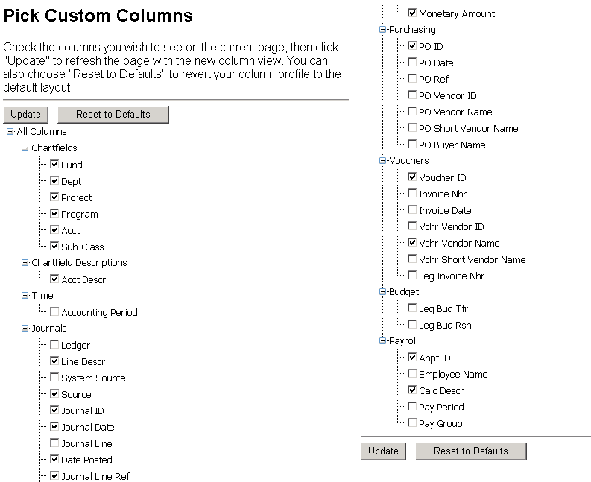

The system will take you back to the previous screen of transaction information with the changes you made. Any changes you made will be saved, so the next time you use WISDM, the view will be the same as the customized screen you left. If you don’t want to save the changes, go back to the original detail screen using the Back button at the top left of your screen.

To view or copy information into an Excel spreadsheet, simply click on **View in Excel** in the upper right corner of the screen. You can save the information in excel to your computer or network drive just as you save any other file.

# Department Rollup

The **Rollup** function enables you to combine account information for different departments and funds. To use the rollup function, from the Navigation menu, click on **Department** and then **Rollup**. The following screen will be displayed:

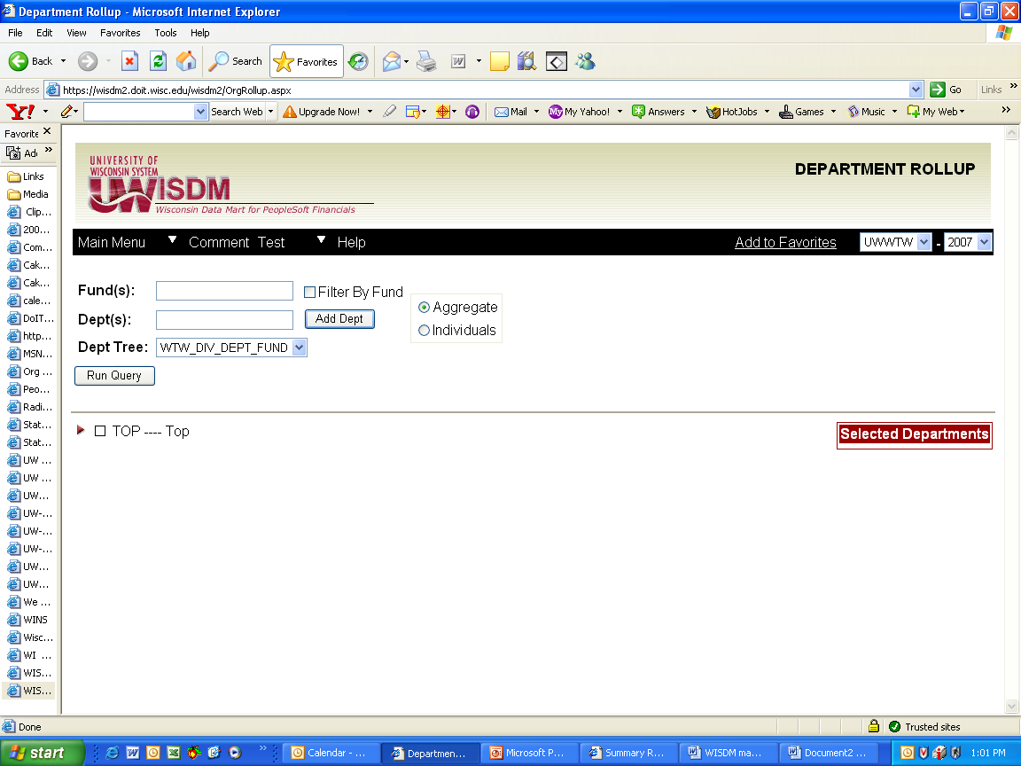

This is a very powerful summary function. It allows roll ups across funds, programs, divisions, and multiple dept levels. A number of different options are available using this function depending on what you are looking for.

**Steps to perform a query:**

1. Choose a Dept Tree to select the type of role up you want to do. Because details roll up in different ways for each of these trees, it may take a little playing with this to get what you are looking for. Each tree will display different roll up options in the section that shows the selected departments in the screen above. Press the arrow next to “Top” to open more detailed levels.

AUXALL – rolls up to auxiliary funds only

DIVFUND – rolls funds up by division, can select funds within a division

FUNDPROG – rolls programs up by fund, can select program, orgs within programs

WTW\_DEPT\_TREE – this is the default and will accommodate most user needs

INTDIST – rolls up fund 128 depts that receive interest distribution by division

WTW\_DIV\_DEPT\_FUND – rolls up by fund, by department, by division

1. Type in a Fund number. For multiple funds, type in one fund number, a comma and the next fund number. If you want all funds rolled up for a group of departments, type in “all”.
2. The rest of the query selection can be done in one of two ways, by typing in each dept code, or by selecting from the tree.

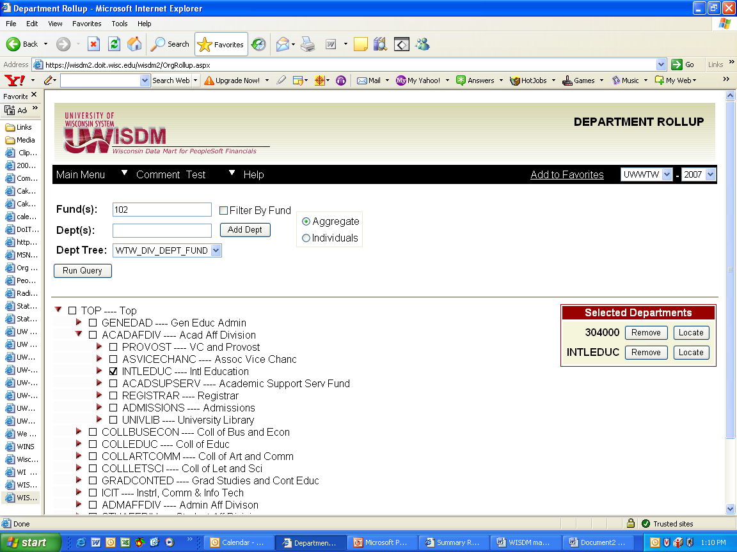

Typing in depts: If you know the departments you want to roll up, you can enter each department code and click on Add dept. A list will display on the right side of the screen below the header “Selected Departments”. You can add as many Depts as you want by typing in the Dept number and then clicking on the Add Dept button.



To remove a Dept from the list, click on the Remove button to the right of the Dept number. Clicking on the Locate button will show you where the selected Dept is in the tree.

Selecting from the tree: Each sideways arrow can be pressed to display groups or depts that are rolled up to that level. You can select the group, or keep pressing the sideways arrows to get to the specific dept or fund you are looking for. Groups of depts can be selected by checking the box in front of the item to be included in the query.

1. If this is a query you need to do regularly, you can save it by pressing the Add to Favorites bar.



Once pressed it will take you to the favorites section, and you will be able to name the query and place it in a folder. See the favorites section for how to set up folders.

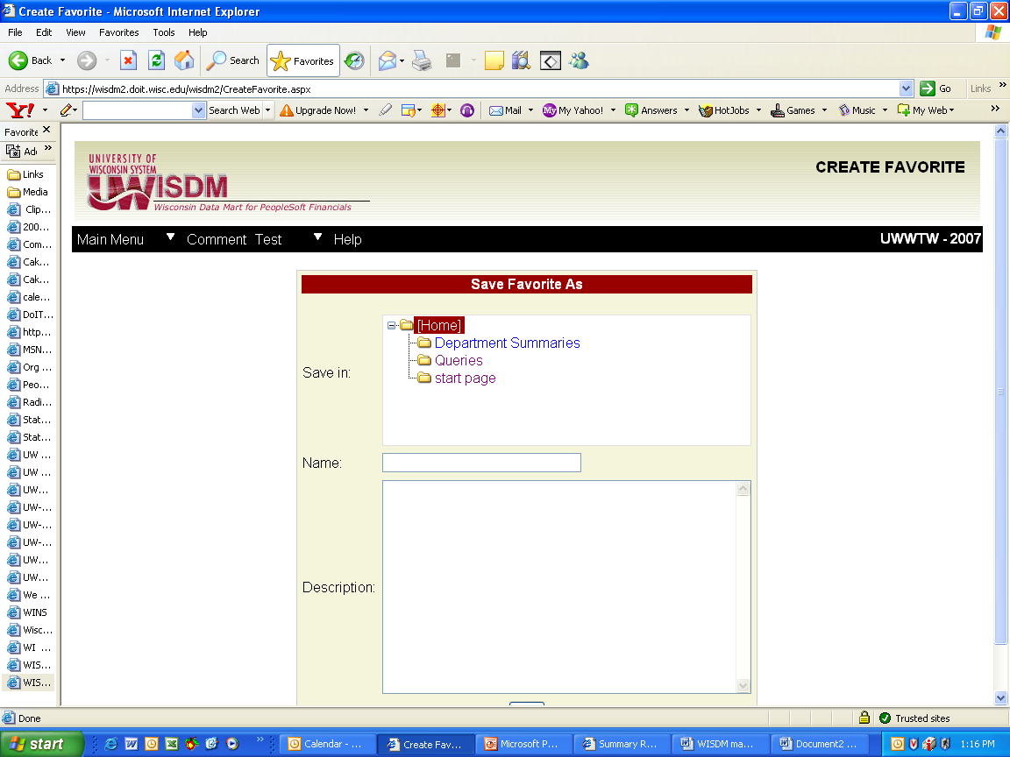

1. Run the query by clicking the Run Query button. The query will run and bring up the Summary Report screen. The previous page roll-up was run and is shown as it would display below. Note the departments selected are indicated on the report.

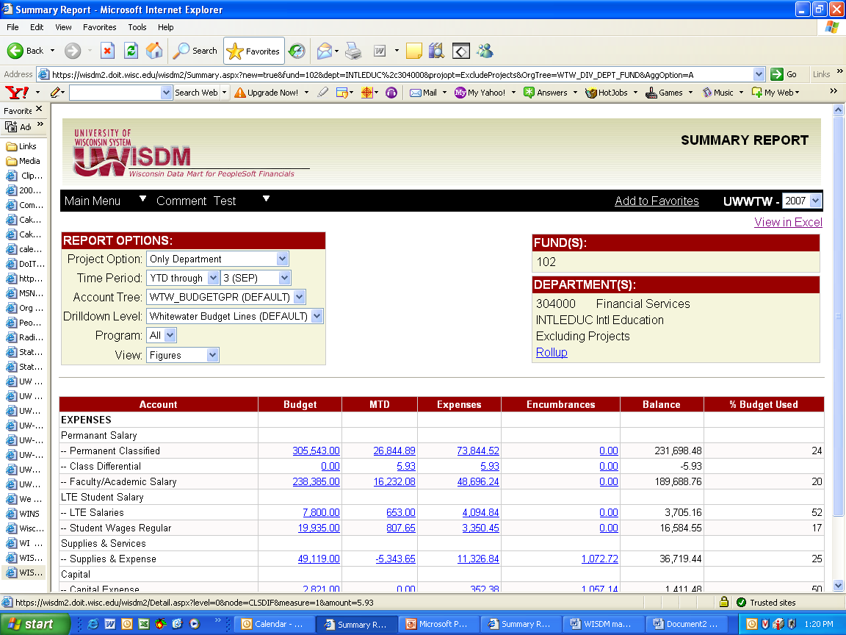

**Project Search**

To search for a particular project, select the **Project Search** option under **Project** of the navigation menu. At the following screen enter information criteria and click on the Submit button.

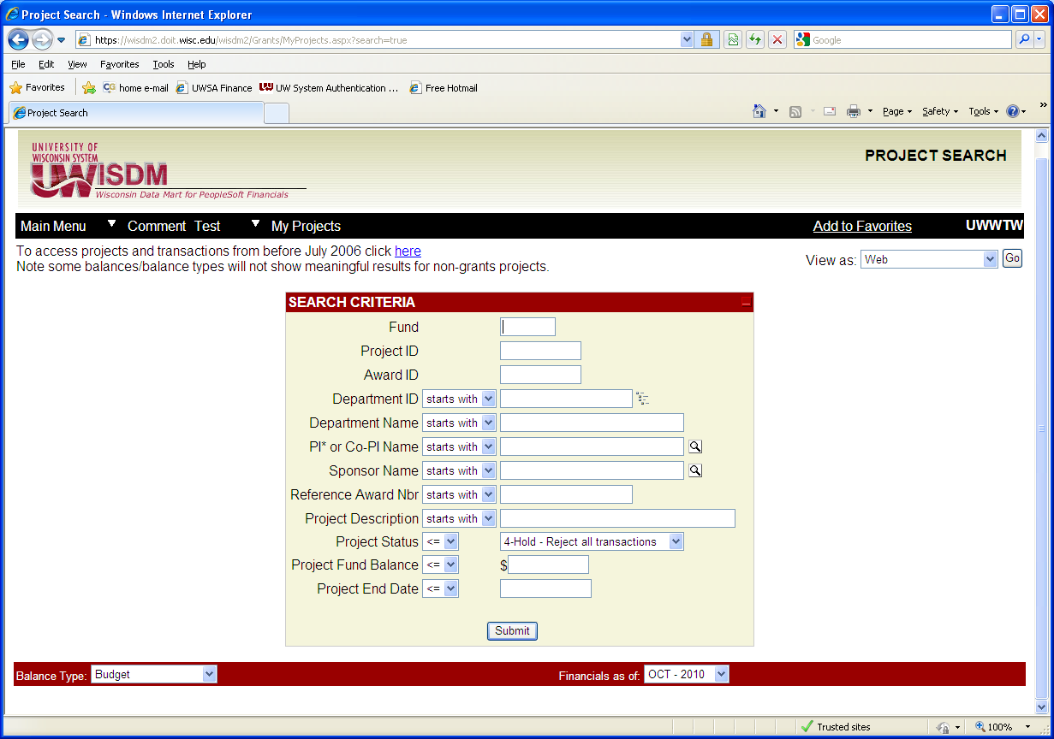

In the next screen you will see the result from a search of projects from before 2006, using the fund and the division, selected using the icon on the right of the Department field. Because we did not select a specific project number, rather a division, the list appeared showing projects that met the criteria. From here we can select the project Summary Report, or award information – both are blue and underlined. If you enter a project number in the regular project search screen shown above and it doesn’t display, the project may have been created before 2006 and you will need to use this screen to find it.

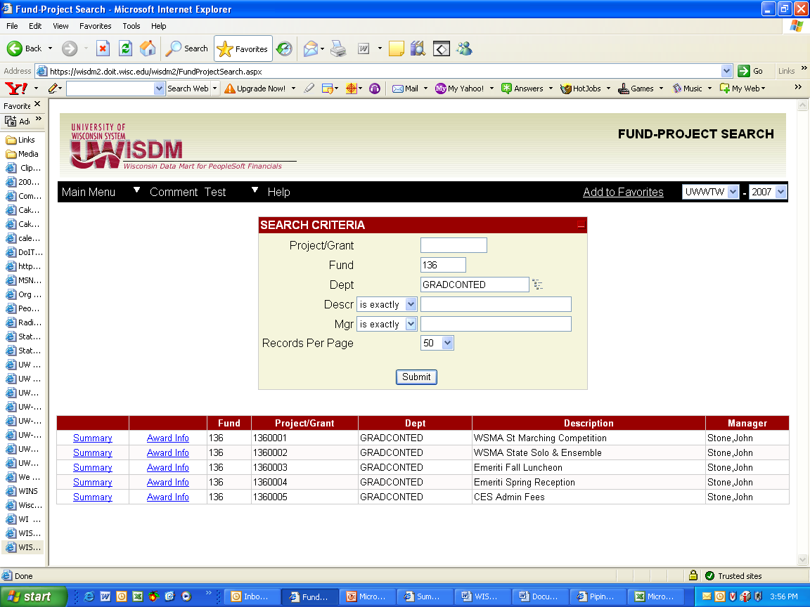

All Projects are assigned to a department code. If you are looking at the department Summary Report, you can also look at the project Summary Report, by selecting the project from the drop down screen. This will show the activity for all projects assigned to that department.

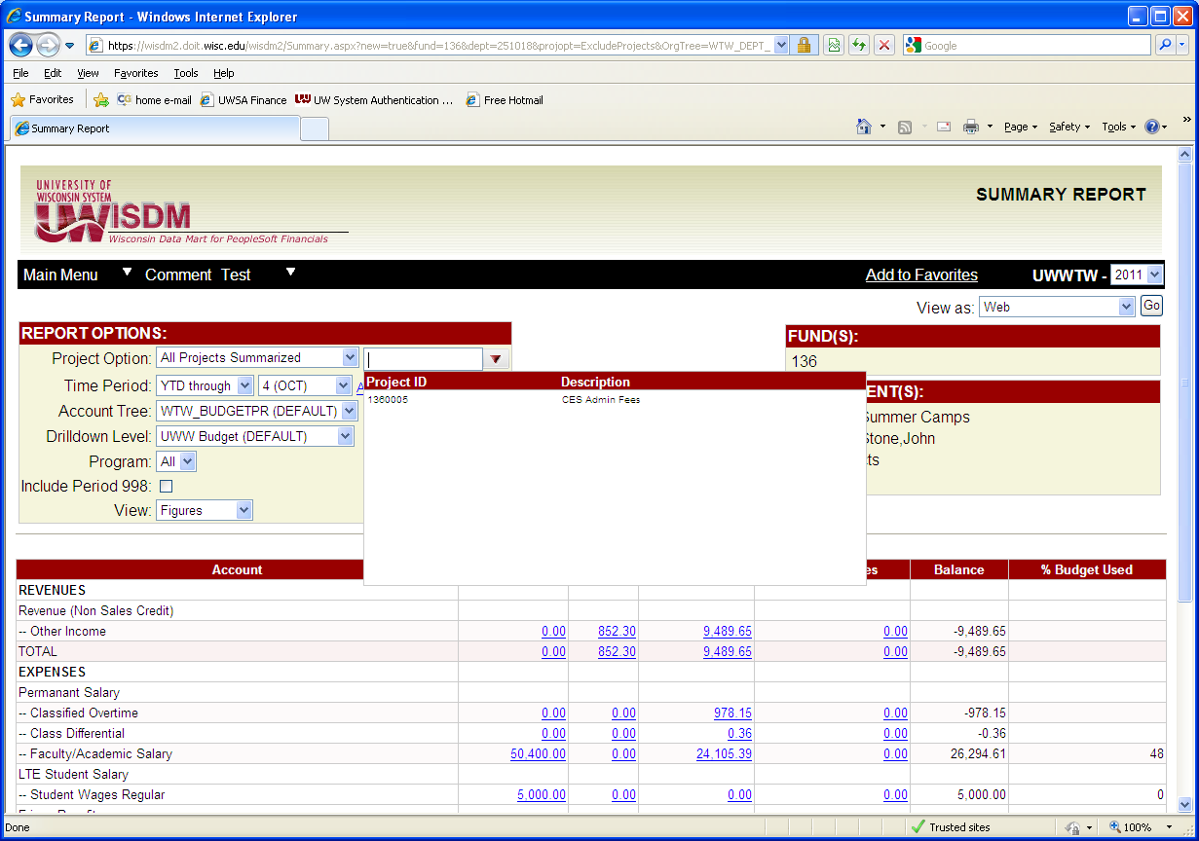

UW System has implemented a grants reporting module with enhanced project reporting capabilities. UW-Whitewater has implemented the module, but has fewer reporting capabilities than the full module used at the large campuses. Feel free to look at any of your projects in the **Project Search** function. The next screen shows a project search for a grant. You will notice that you can see the overall budget, a description of the project, the faculty PI, the status, the department to which it is assigned, the project dates, and indirect cost rate for the grant in addition to the summary report. The old project search just gives the summary report.

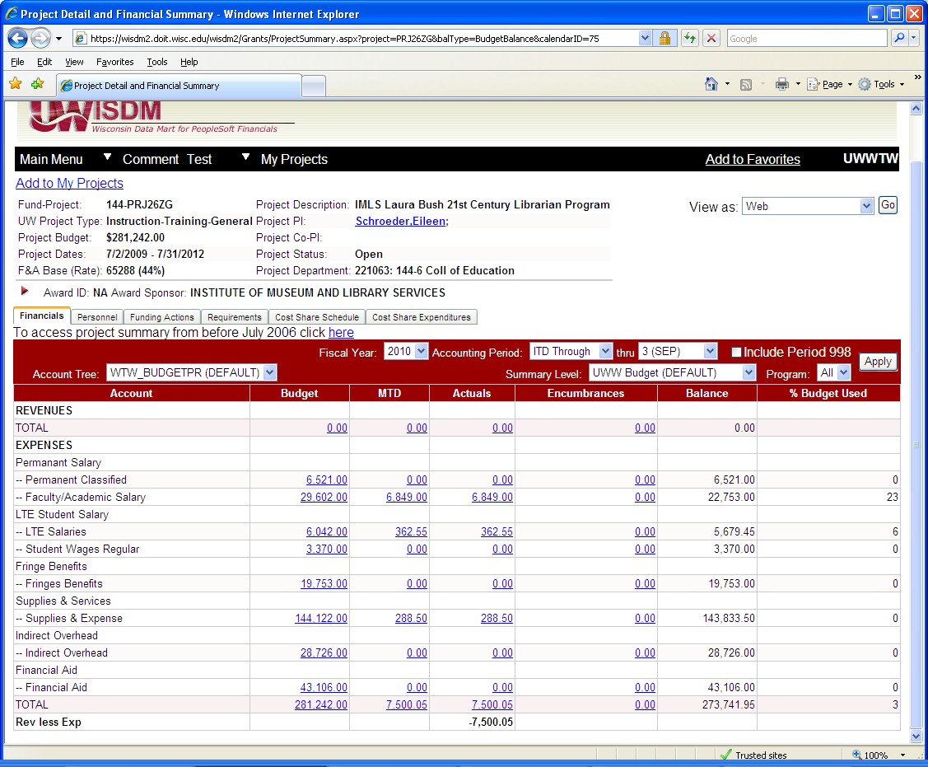**Purchase Order Search**

Clicking on **PO** under the **AP/PO Search** section from the Navigation menu allows you to view details relating to a Purchase Order. Using the PO number, the PO date, or the Vendor Name, you can access PO details including line description information, accounting distributions, and invoices if any payments have been made against the PO.

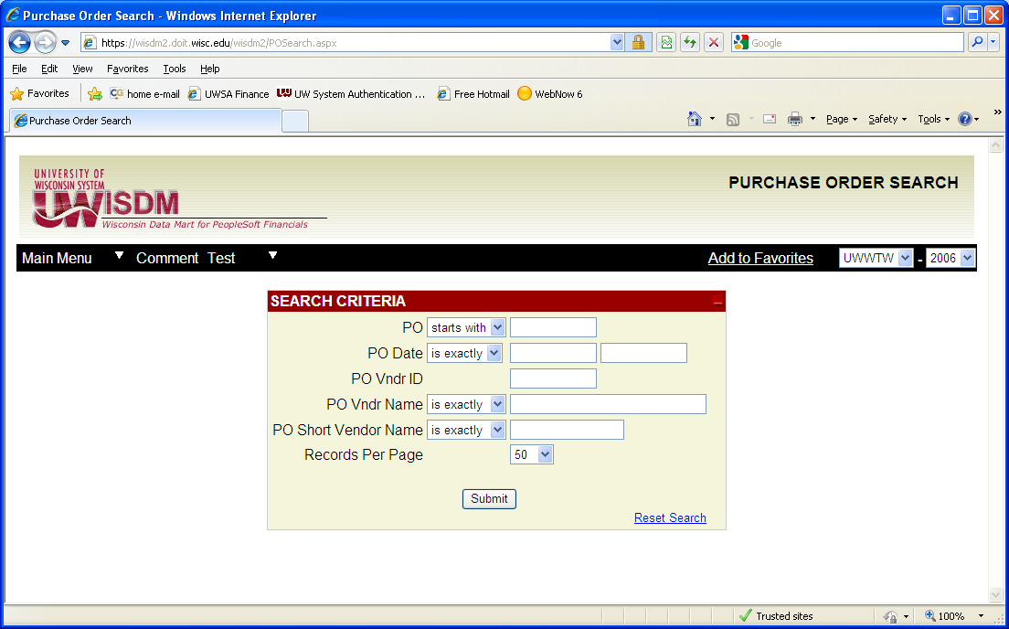

Enter the criteria you would like to search on and click the Submit button. You will be brought to a screen similar to the following:

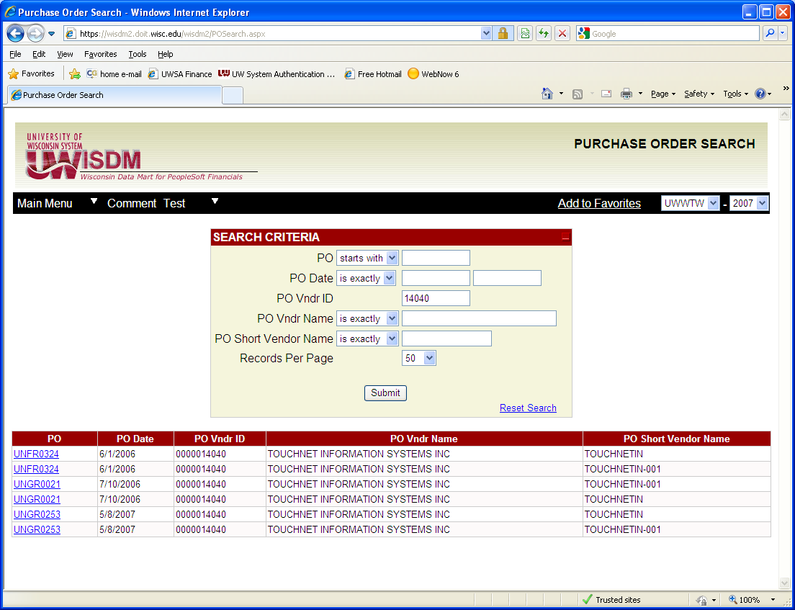

If you click on the blue underlined purchase order number, you will see the details of the purchase order as shown in the next screen.

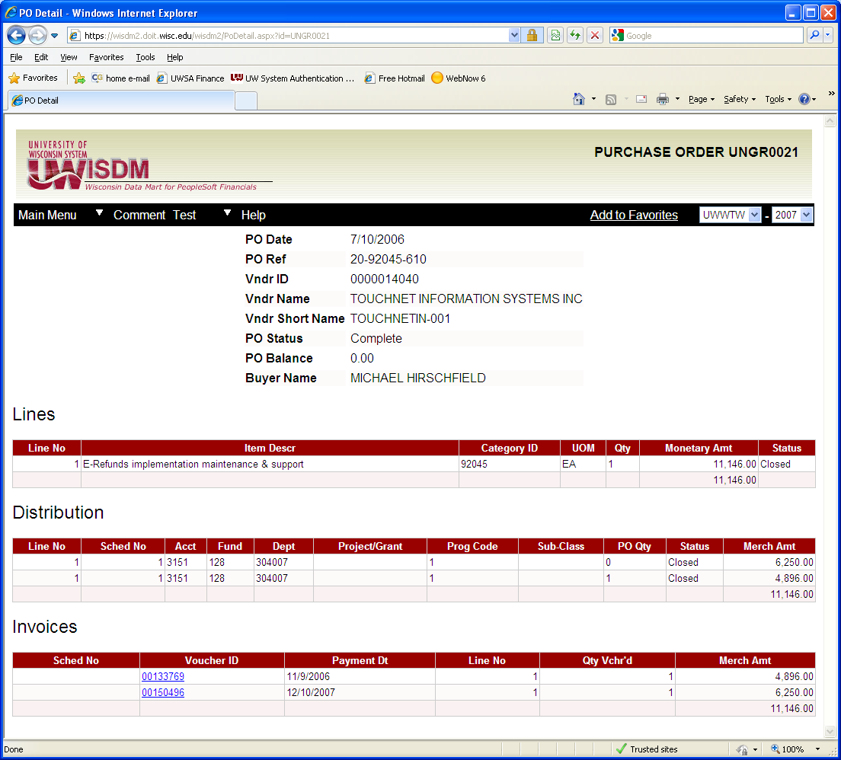

From here you can drill on the blue underline information to see what was paid for each voucher.**Encumbrance Search**

Clicking on **Encumbrance Search** under the **AP/PO Search** section of the navigation menu allows you to find encumbrance information. You may search by a number of features such as Department, Purchase Order, or Vendor Name. The Vendor Name has a pull-down menu, which allows you to search on only a portion of the name by choosing “starts with” or if you know the exact name you chose “is exactly”. The fiscal year can be changed on the screen in the upper right hand corner. Once all search criteria is entered, click on the Submit button.

**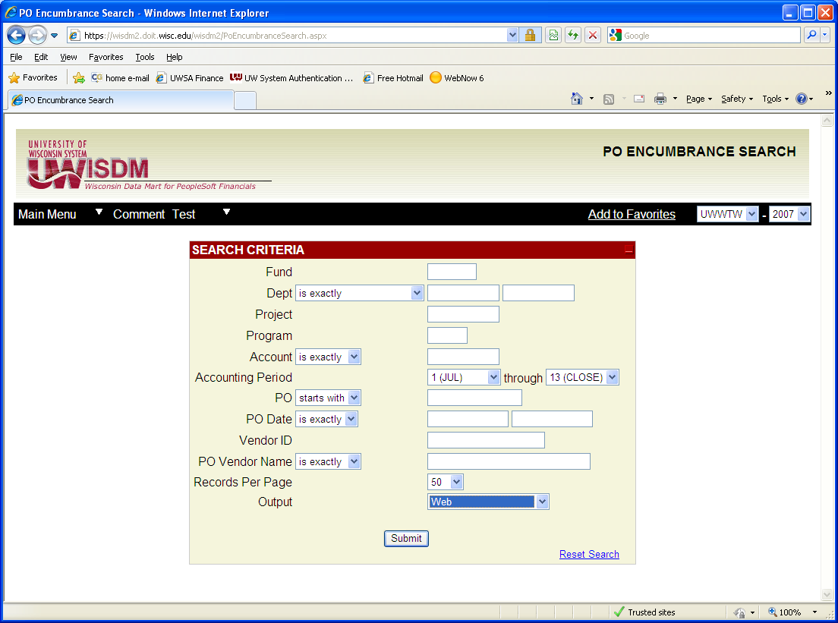**

The system will bring back a list depending on the selections. In the next screen it shows a list of payments made on a purchase order, as the purchase order number was used for the search. Any item in blue and underlined can be drilled down on to get more information.

You could also enter a department number and fund to get the list of encumbrances that make up the year-end encumbrance balance. If the balance is one PO, using the drilldown in the summary will get you to what it is. But if the balance is made up of a number of POs, using this function will help you identify how much is open on each PO.

**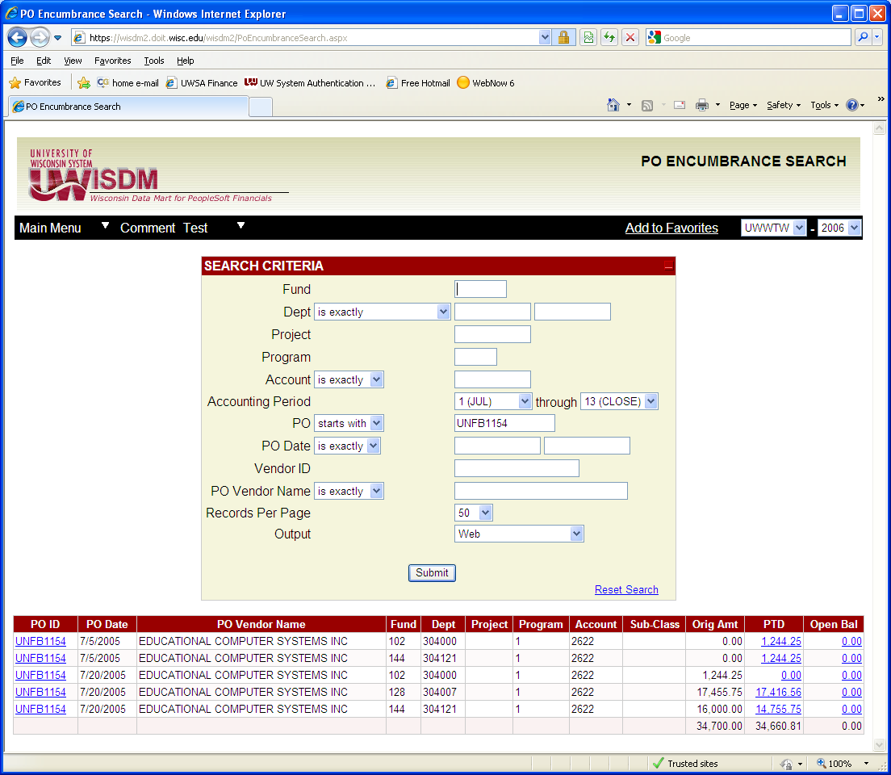**

The next screen shows the results of the drilldown on the third item “Open Bal” field from the screen above.

**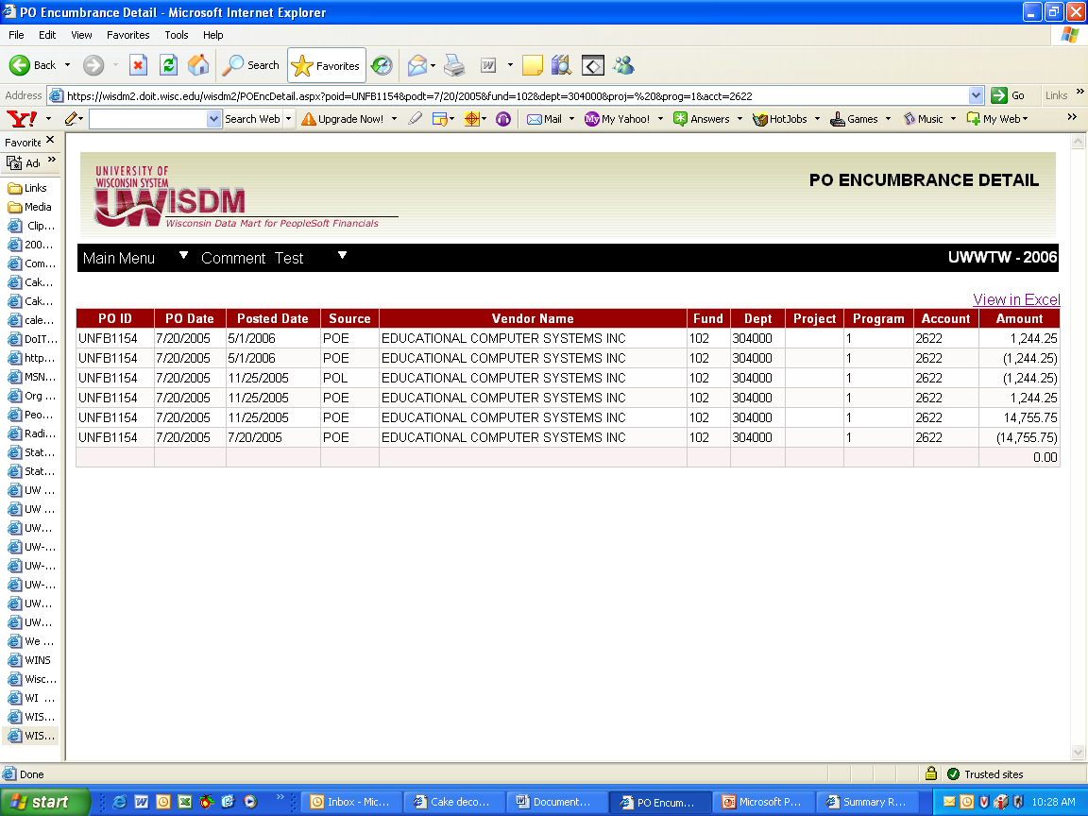**

**Voucher Search**

Clicking on **Voucher** under the **AP/PO Search** section of the navigation menu allows you to find voucher information. You may search by Voucher ID, Invoice Date, Vendor ID, Vendor Name or any of the information you know. The Vendor Name has a pull-down menu, which allows you to search on only a portion of the name by choosing “starts with” or if you know the exact name you chose “is exactly”. The fiscal year can be changed on the screen in the upper right hand corner. Once all search criteria is entered, click on the Submit button.

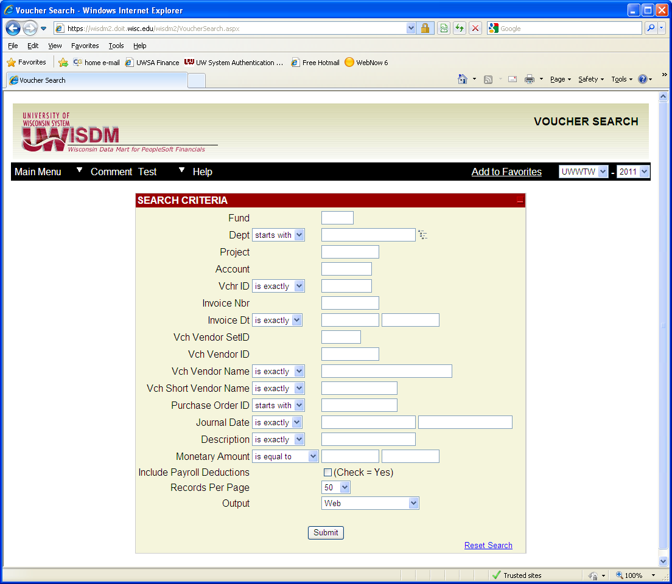

**Search by Vendor Name:**

If you are searching by Vendor Name, you will retrieve a list of vouchers paid to a specific vendor. This list will appear at the bottom of the vendor search screen.

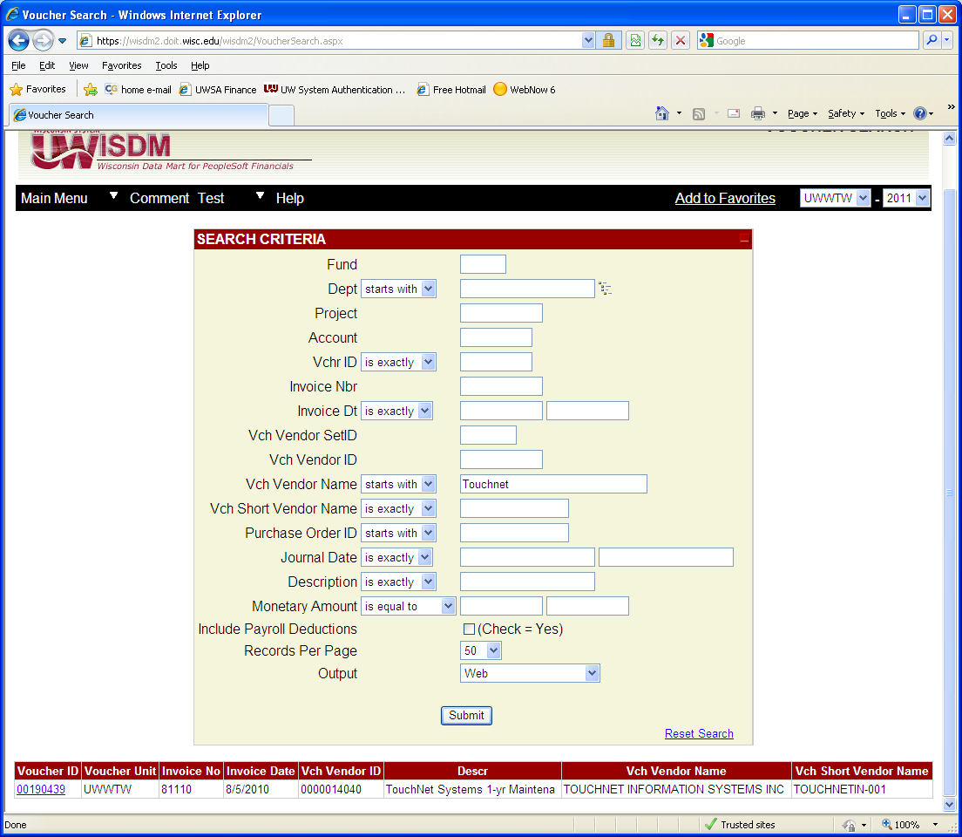

Each voucher number will appear as a link, and by clicking on a voucher number, you will get information about that voucher. You will also see detail on Account, Dept and Amount paid under “Distribution” and you will get the check number (under Payment Reference) and the amount paid under “Payments”.

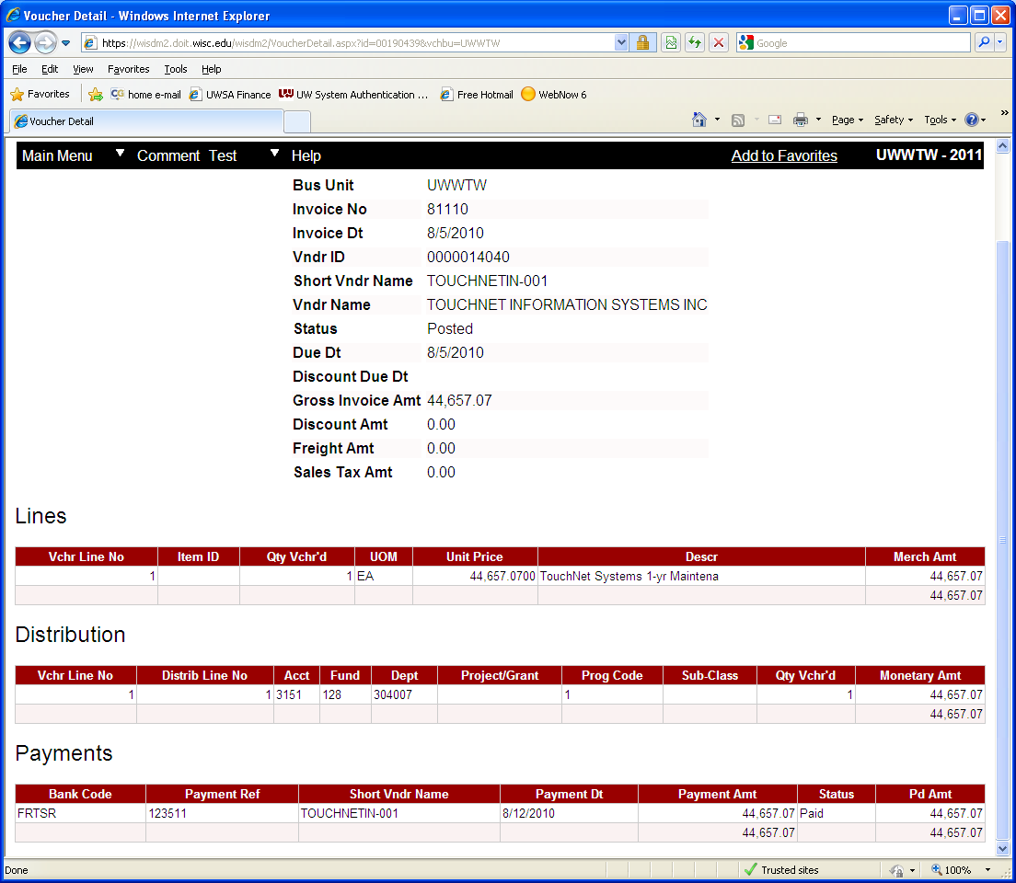

**Searching by Voucher Number:**

If you are searching by Voucher Number, you will retrieve one voucher, which appears at the bottom of the screen as a link. By clicking on the voucher number, you will see details described above.

**Vendor Search**

Clicking on **Vendor** under the **AP/PO Searches** section of the navigation menu allows you to view details relating to a specific vendor. You can search by Vendor ID# or by Vendor name. If you don’t know the vendor’s full name you can indicate, using the pull-down menu, that the vendor name “contains” some part of the vendor name. This search will give you all vouchers and PO’s that are issued to a specific vendor. Then links will be displayed so you can drilldown on a specific voucher or PO to get additional information.

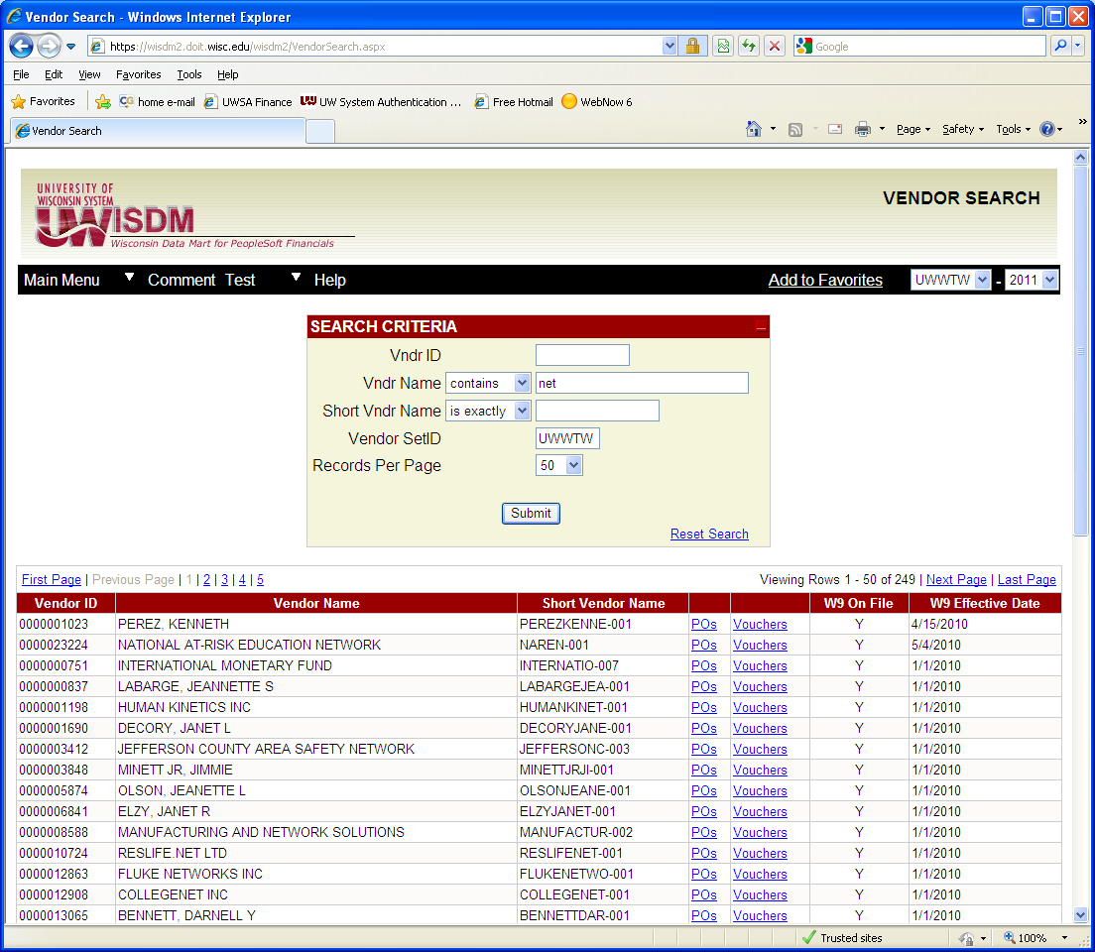

**Payroll Encumbrance Search**

Clicking on **Encumbrance Search** under the **Payroll** section of the navigation menu allows you to search for employee encumbrances for payroll. This search allows you to select all encumbrances by dept, fund, project account, and employee specific information. You can select the employee name from a drop down list if you start typing the name. Once an employee is selected, click on submit, and the system will bring back information about all payments for that employee by funding source and account.

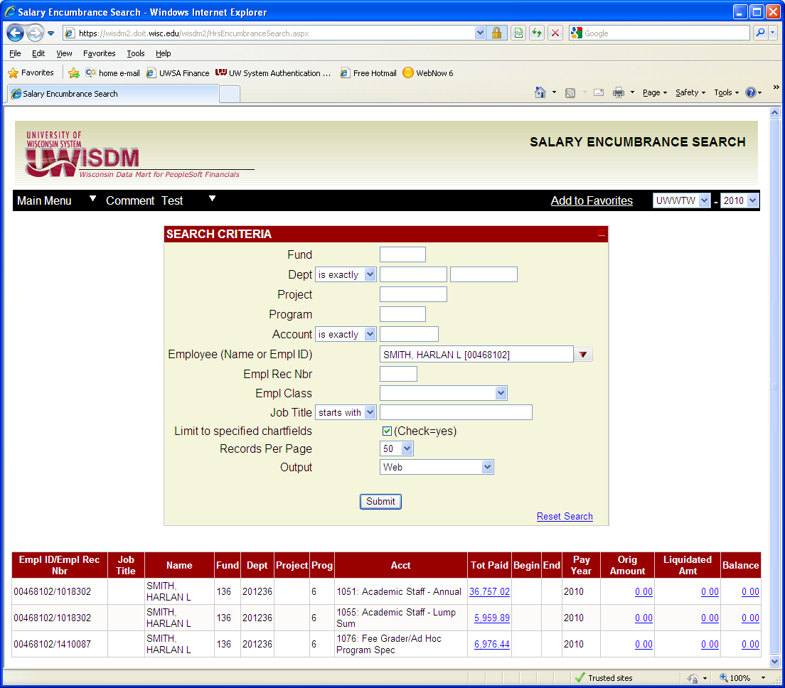

The encumbrance search using your department code, fund and starting account code is a good way to review the staff being charged to your department. You should use the starting account code to avoid pulling in student payrolls, as these are not encumbered, and clutter the screen if pulled in. See the next screen for department 304000, fund 128, and account codes starting with 15.

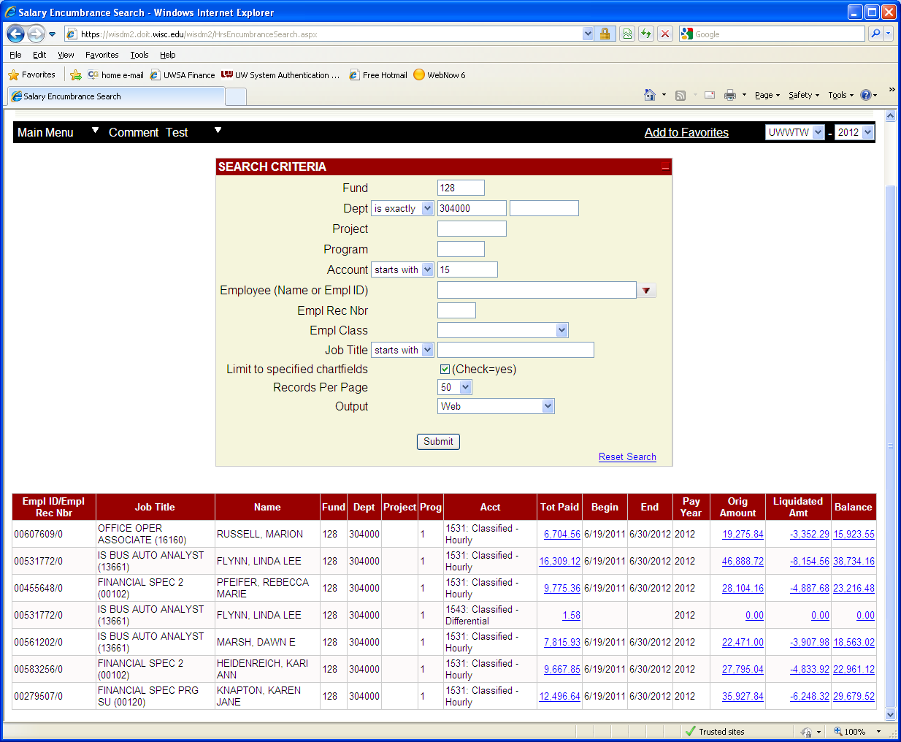

**Salary/Fringe Search**

The **Salary/Fringe Search** works in a similar way to the encumbrance search, but will bring back salary payments and fringes, without the encumbrance information. You can select salary only, fringe only, or both. In the next screen both was selected.

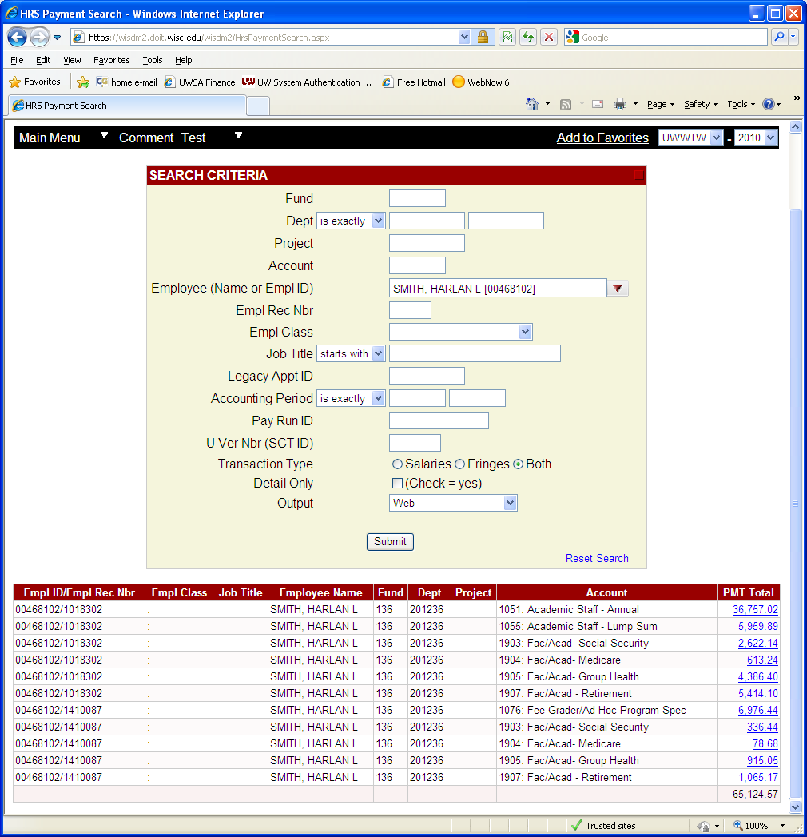

**Journal Search**

Clicking on **Journal** under the **Other Searches** section of the navigation menu allows you to search for a specific journal, which would include all entries on the journal. This search allows you to search by Journal ID or Journal date with the ability to narrow it down to Ledger, Source, Accounting Period, Voucher ID or Purchase Order. The fiscal year can also be changed on the screen in the upper right hand corner. You have a choice to take this information directly into excel, by selecting that option in the search criteria. Once all search criteria is entered click Submit. The journal will then be shown below the criteria entered or in excel if that was selected.

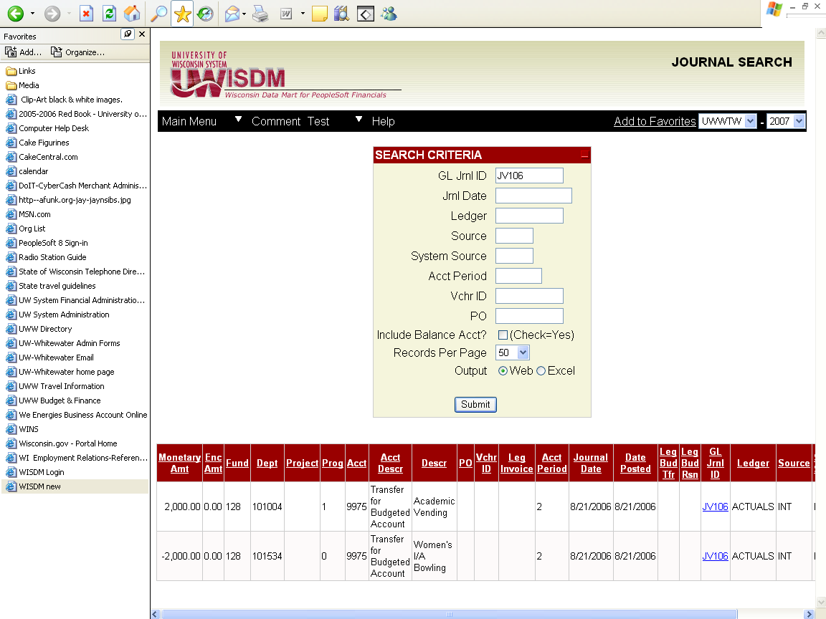

**Transaction Search**

Clicking on **Transaction** under the **Other Searches** section of the navigation menu allows you to search for transactions meeting specific criteria such as Fund, Dept, Program, Account, Date, Description, Monetary Amount or a combination of these criteria. Some of the criteria have pull-down menus that give you a choice of commands and can be changed by clicking on the arrow and selecting the appropriate choice. This search requires that you enter something in at least one field such as the fund, department, program or account. The more specific you can be, the faster the search will run. The fiscal year can also be changed in the upper right hand corner. After filling in your criteria, click Submit.

If you enter only a fund and submit, you will get transactions for all departments in that fund, which will be a lot of information. If you enter a dept and submit, you will get all transactions for a specific dept. If you enter a dept and account you can narrow your search to one specific account.

You also have the ability to take your search directly into excel, by clicking that box, which can be very helpful if you are looking for limited information, such as the detail for a JV that has hundreds of lines. You can select which columns you wish to see from this screen by clicking on the **Pick Custom Columns.**

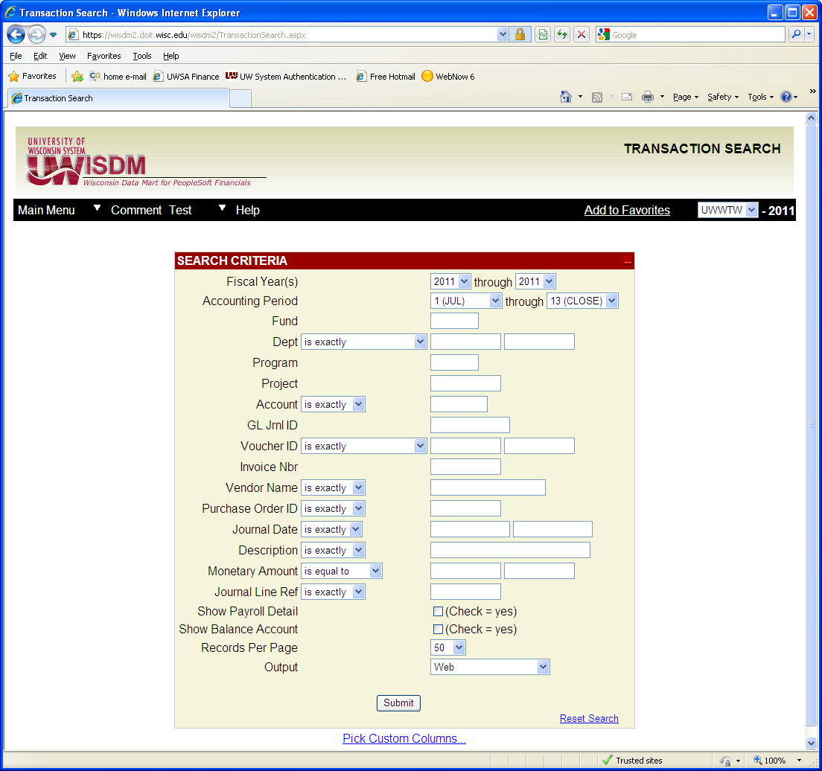

**WISER**

WISER is a new tool within WISDM. When you click on WISER, you will go through a login and come to this screen. From here you can enter a department, select a year or select from the drop down of the organizational structure.

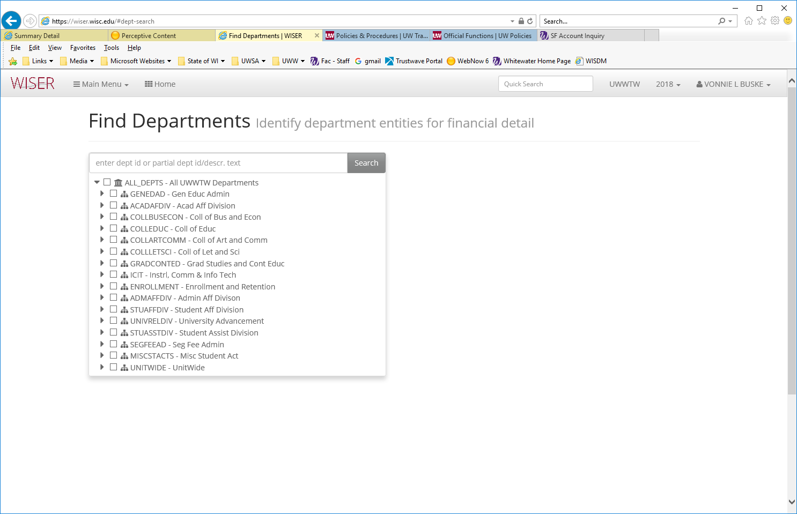

Once you select a department, you can then select the fund(s) related to that department if there are more than one, and run the query.

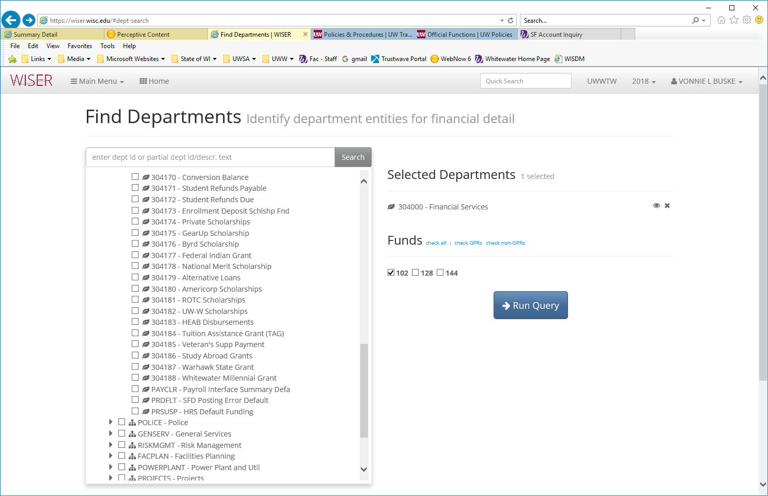

The report will look much like the Summary Report screen, but there are a few new options. Once in the report, you can choose to add a fund, or switch to a different fund. You can select to see multiple years on the screen. Note: multiple years will show the same time of the FY for each year displayed. So if it is September, it will show through end of month of September for each year. The screen below shows dept 304000, fund 102 for multiple years.

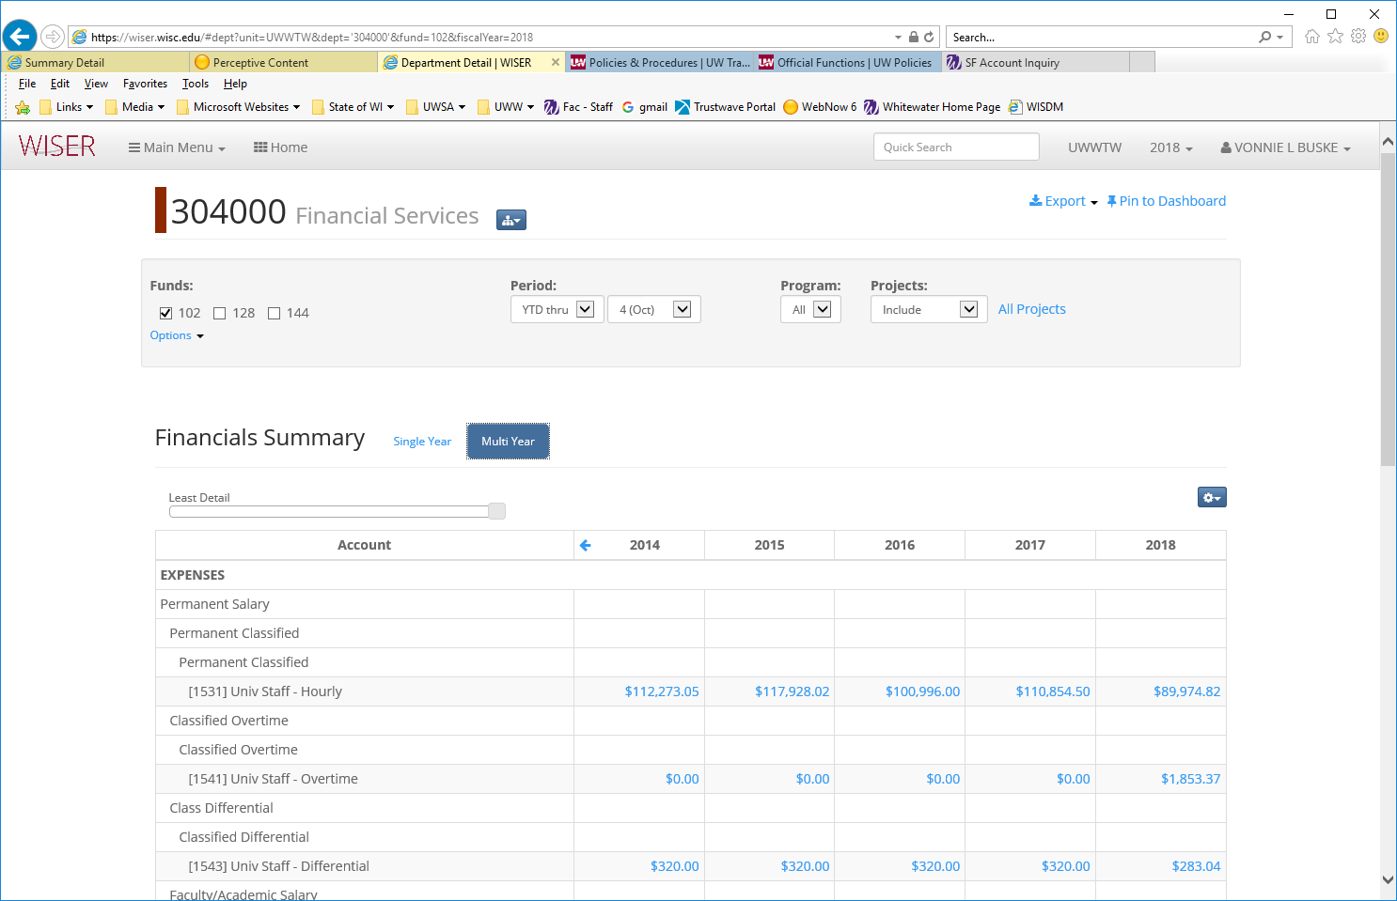

Notice the Detail bar, that can be adjusted to show more or less detail, like we used the dropdown levels of detail in WISDM. Also like WISDM, if its blue it is drillable. See the detail of the Postage amount below.

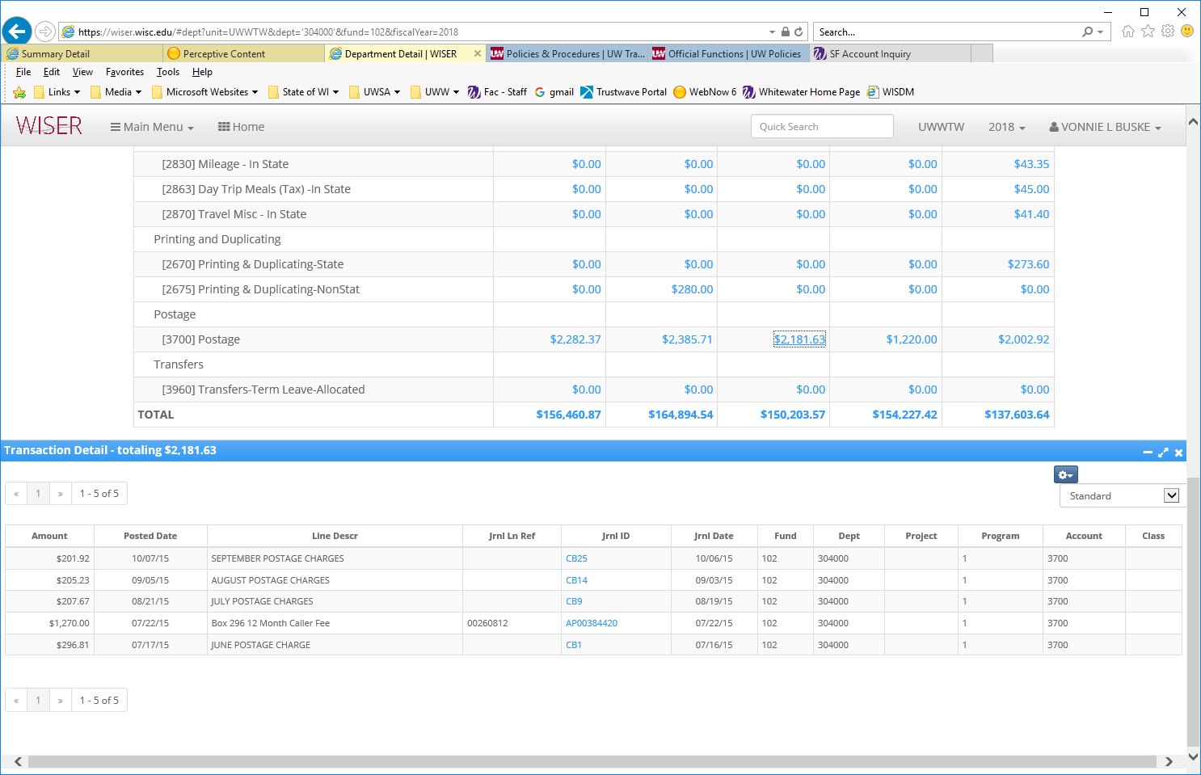

Below the summary you will also find categorizations of the expenses in the summary report, so if you want to see more detail of a specific expenditure type, you can click to drill to a deeper level. The detail will be the current year, so to look at a different year, select that year from the bar at the top. In this screen you can see FY2017 Expense Reports detail.

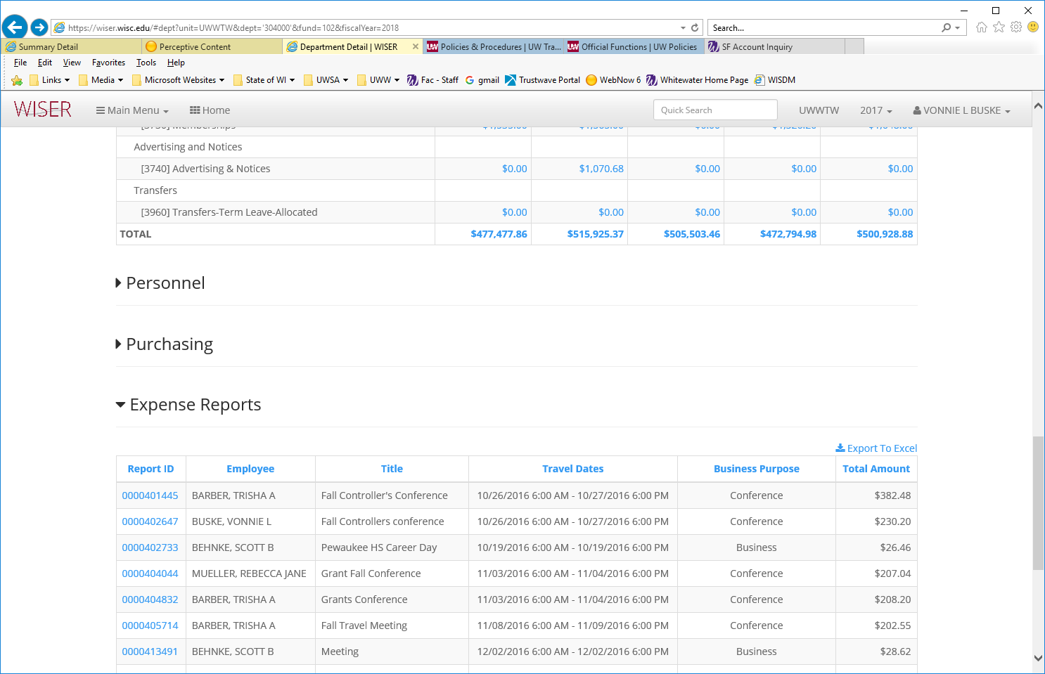

To see the entire paid expense report, click on the Report ID at the left, and the information below is displayed. If an item was not paid, it will not display.

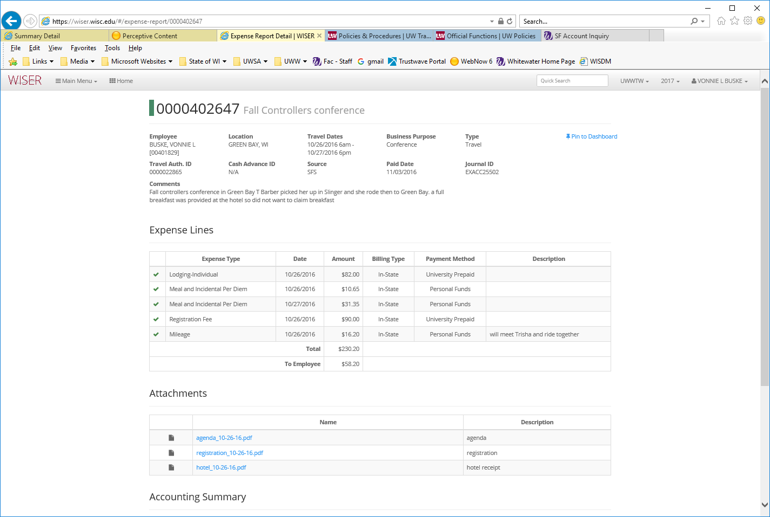

**Favorites**

You have the ability to set up favorites to enable you to go to a particular screen or page. You can set up folders in the favorites area to hold reports that you run regularly. Select **My Favorites** from the navigation menu.

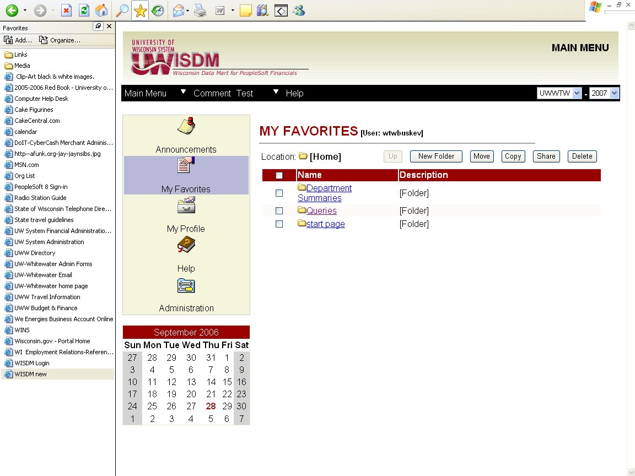

* **Up: To go back to previous folder.**
* **New Folder: Use to create a new folder.**
* **Move: To move selected folders or favorites to a new location.**
* **Copy: To make a copy of selected folders or favorites to a new location**
* **Share: To share selected favorites with another WISDM user.**
* **Delete: To delete selected favorites or folders.**

**My Profile**

Your profile allows you to set the account tree levels for your reports or to change your password.

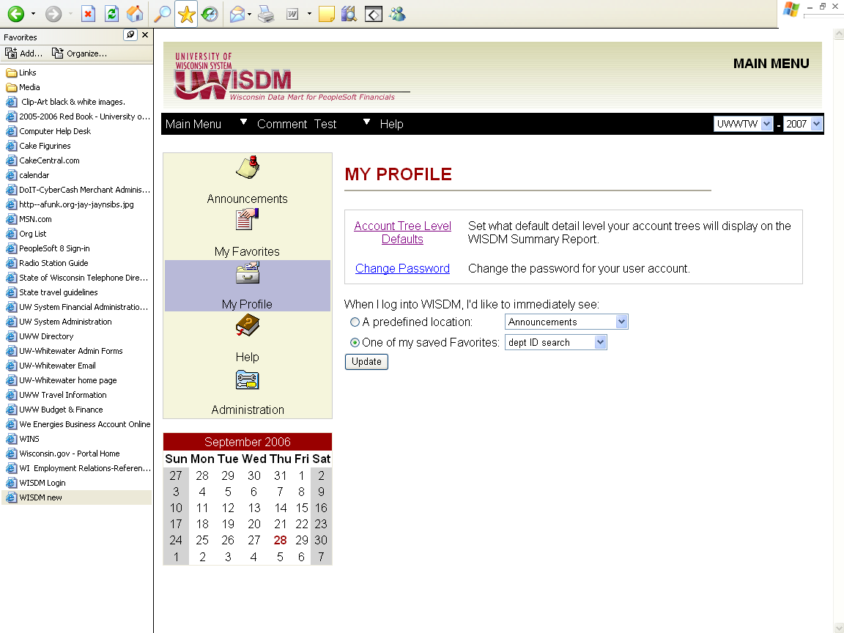

**To change your Account tree level:**

Click on Account Tree Level Defaults to see the default settings. Account tree levels determine how much detail you see in your Summary Reports. You can either select most or least detail for all reports, or you can set up the default for each tree used to generate a report if you want different levels of detail. The screen below displays the current default. If you want the least detail (summary numbers to start with) for all reports, simply select least from the drop down menu in the **Default for unlisted trees** field. This will apply to all reports.

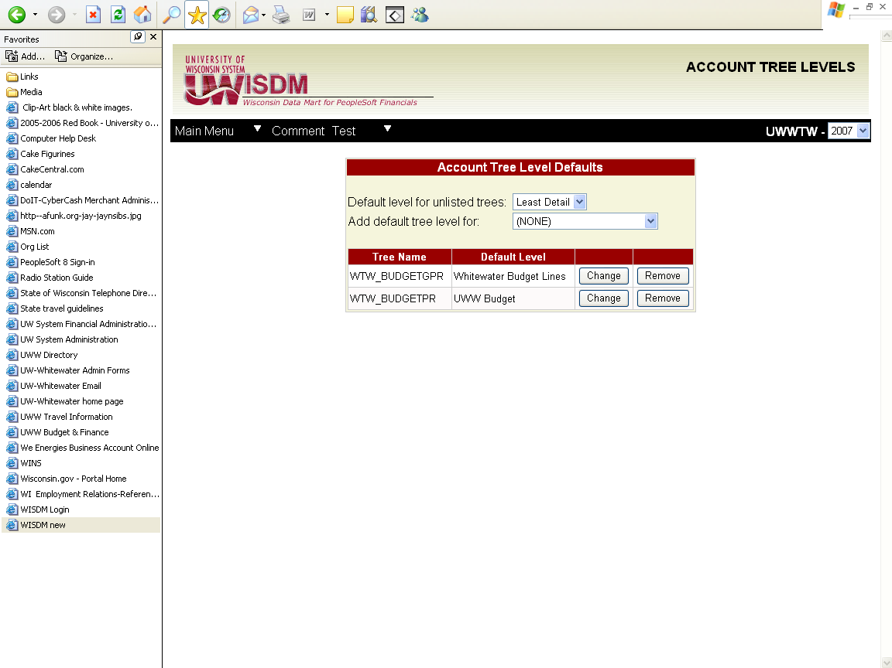

To change the level of detail that will show upon opening a Summary Report, click on “Change” for the one you want to change.

Click on the dropdown list, and select which level of detail you want from the list. Redbook Budget will give you the highest roll up, least detail in your Summary Report. Detail values will give you account code detail on the Summary Report. Most of the defaults are UW Whitewater Budget level.

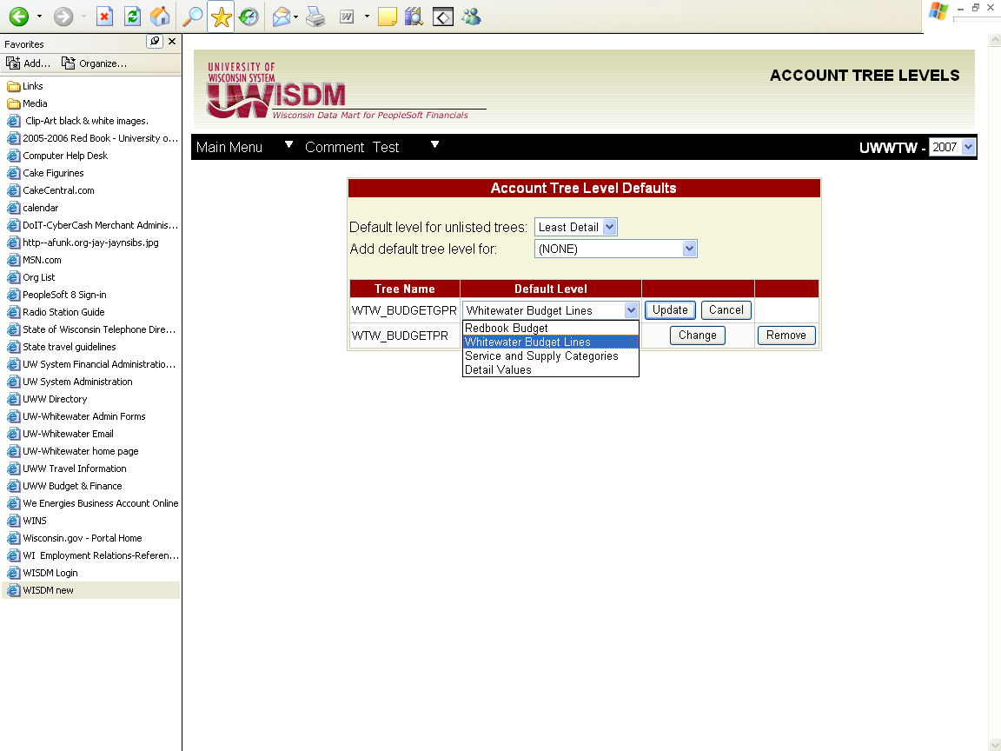

You do not need to change these unless you always want a different detail level to show up in your Summary Reports. When you are in the Summary Report, you can still select a different detail level by clicking on the detail level dropdown shown in the Summary Report in the next screen.

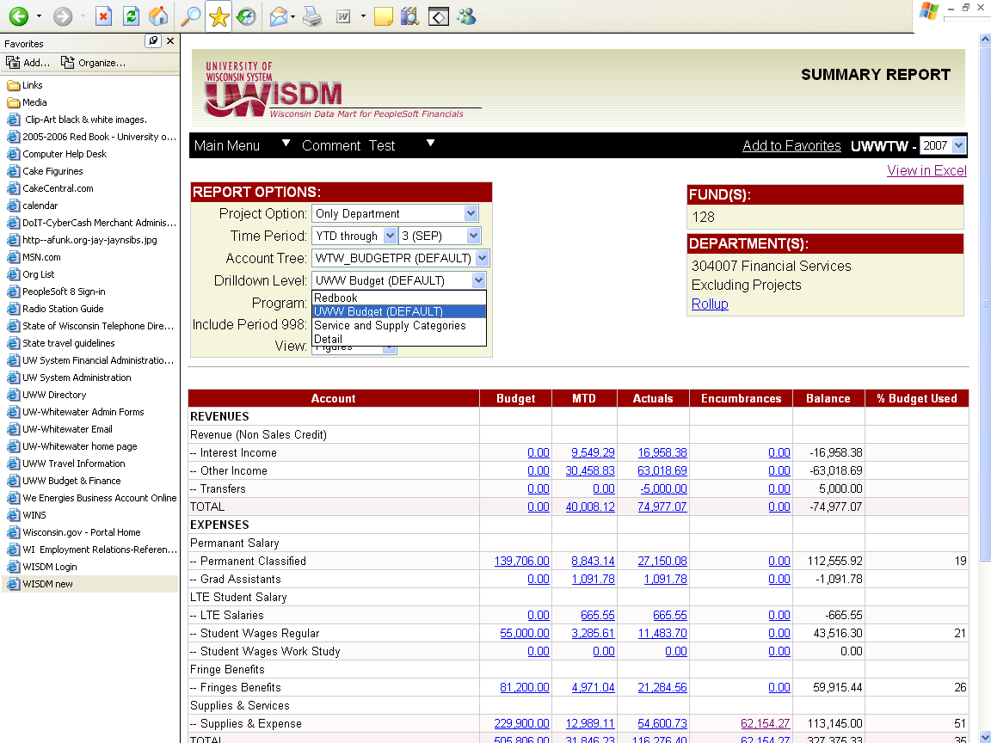

**Help**

Help can be accessed from anywhere in the system. You can look for help from the navigation menu or from any other screen that has a Help icon. The main page is shown here:

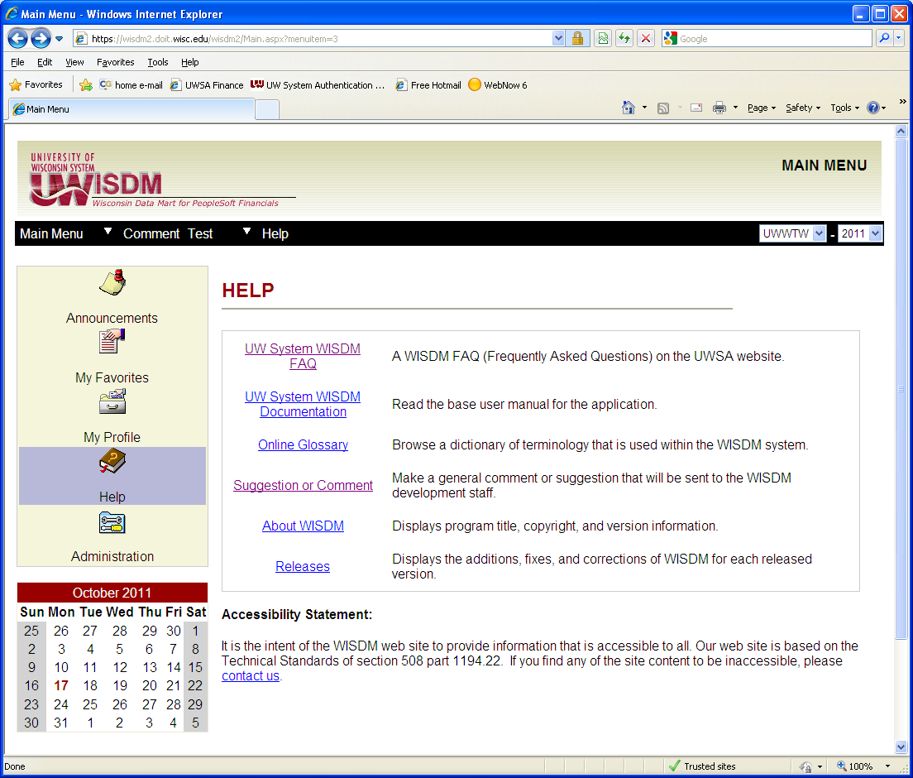

Below is the help screen accessed using the help icon while in the department search screen. The information should help answer any questions you have while in this screen.

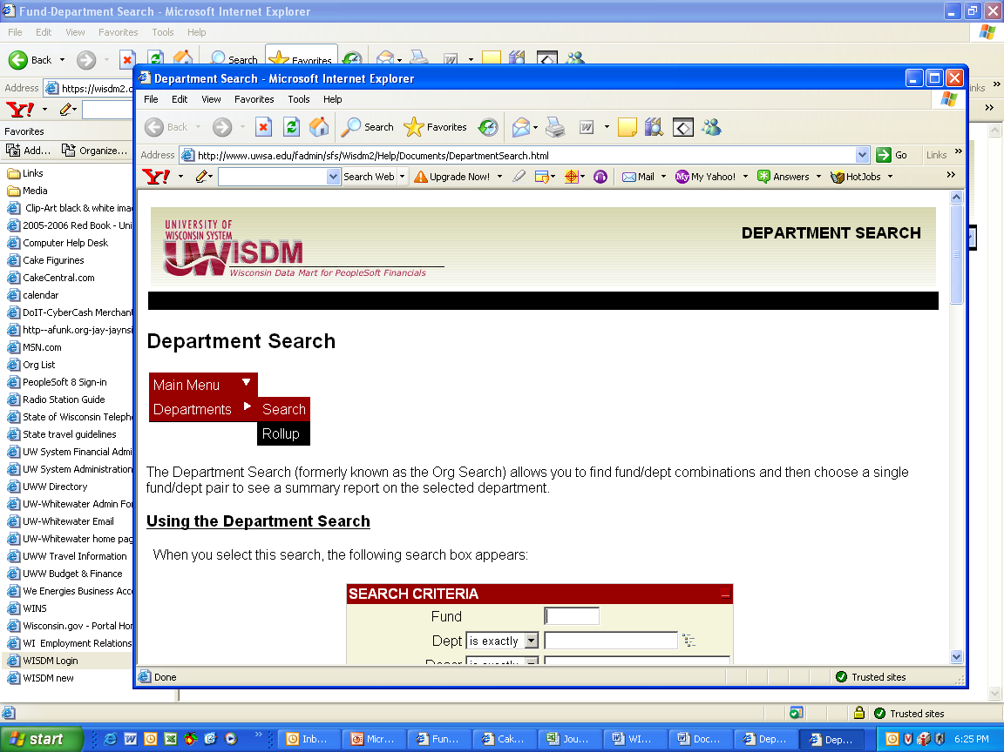

A Glossary contains many of the terms used with the system.

