Cost Transfer Workflow Tool – Approving Non-Salary Transfers

September 2020
Table of Contents
Cost Transfer Tool Overview 3
What is it? 3
Features 3
Salary Cost Transfers (SCT) vs. Non-Salary Cost Transfers (NSCT) 3
Resources 3
Roles 3
Instructions for Division Approvers 4
Approving the Transfer Request 4
Logging in 4
Viewing the Details of a Cost Transfer 4
Documentation Tab 5
Justification for Transfers 90 Days After Date of Original Transaction 5
Signature Error! Bookmark not defined.
History of the Transfer 6
Delegating Signature Authority 6
Searching for Transfers 7
Workflow After Submitted 8
Person Resolution 8
Other Aspects to Workflow and Approval 8

Cost Transfer Tool Overview

What is it?
- The Cost Transfer Tool is designed to make a balanced transfer of accounting from one funding source to another.

Features
- Gives the user the ability to search WISER to select transaction(s) that need to be transferred.
  - This step also eliminates tedious entry
- Validations are performed to ensure the data is clean and valid when going to the General Ledger (GL).
- Provides a custom workflow that requests signatures for approval based on the content of the transfer
- Provides search features so users can find transfers they have made in the past.
- Integrates to WISER so that when looking at a transaction in WISER, a transfer can be initiated right from the reporting system.

Salary Cost Transfers (SCT) vs. Non-Salary Cost Transfers (NSCT)
Cost transfers are divided into two forms – salary and non-salary. Each cost transfer has a transfer number which acts like a unique business key. Salary transfers begin with “S” and non-salary begins with “N”, followed by a unique sequence number. This document only goes over non-salary transfers.

Resources
There are several resources available to help you progress through the Cost Transfer Workflow Tool that you can use when you encounter problems, have specific questions, or desire to provide feedback:
- Help Icon: for immediate assistance, click on the help icon found on most screens within the Cost Transfer Workflow Tool itself. Many of your questions may be answered right here.
- Cost Transfer Support: Each institution has SFS users who are more familiar with the process and procedures for doing Cost Transfers. Find your institutional support contact on this website: https://www.wisconsin.edu/sfs/institutional-support-contacts/.
- SFS Documentation and Training Page: The SFS group at UWSA maintains documentation on how the SFS Cost Transfer Tool functions. You can find it by following this link, to the SFS web page. Cost Transfer Tool documents can be found under the “GL – General Ledger” subsection.
- Send a Comment/Support: Click on this link at the bottom of your screen to provide feedback or seek assistance from SFS Problemsolvers.

Roles
The tool has different roles for different users. All users have the Preparer role. In addition to the preparer, sponsored projects have PIs, Project/Program Investigator.
Role | Processing allowed | Comments
Preparer | - Create Transfers | All employees in institutions that use the Cost Transfer Tool can create a transfer.
Division Submitter/Approver | - Create Transfers  - Approve Transfers to Submit to SFS  - Delegate Approval Authority (to another user with the same role to cover absences)  - Manage Division Users | These Approvers must be designated by the Division Business Representatives via an email request to SFS Problemsolvers.  This is the same approvers as e-reimbursements

Instructions for Division Approvers

Approving the Transfer Request

Logging in
- Login to the Cost Transfer Tool
- Under the main menu in your dashboard
  - This is the main screen or landing page from which Approvers begin – think of this as the main menu/home screen.
  - Work List Headers that apply to you will appear.
Work List Headers:
Transfers I need to Sign: transfers requiring your review and approval
Transfers Routed to Me: transfers needing your review and comments, these would normally be routed back to the preparer
Open Transfers I am Tracking: transfers in the approval process
Recently Completed Transfers: only displays transfers that you have prepared
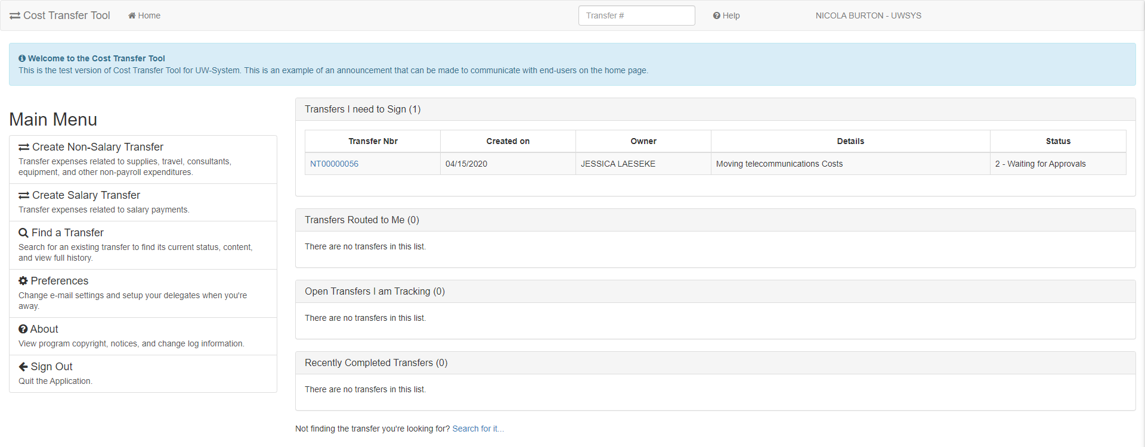

Viewing the Details of a Cost Transfer
- Click on the link from the Work List
  - This brings you to the Details tab showing the “From” and “To”
    - The approver can review the Details of Transfer and the accuracy of the account coding associated with the cost transfer
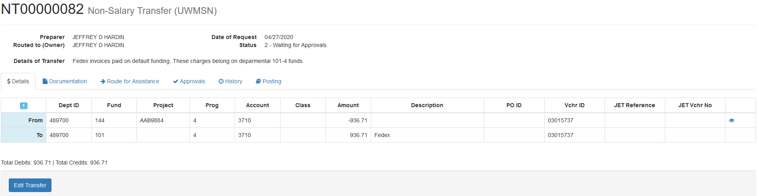

Documentation Tab
- Click on the Documentation Tab
  - Click on Attachments and view all, if any, attachments
    - Note: WISER documentation is NOT REQUIRED, as the tool validates the authenticity of the From.
  - Click Comments and view all, if any, attachments
    - Note: Comments that are included with routing and rejections are stored here
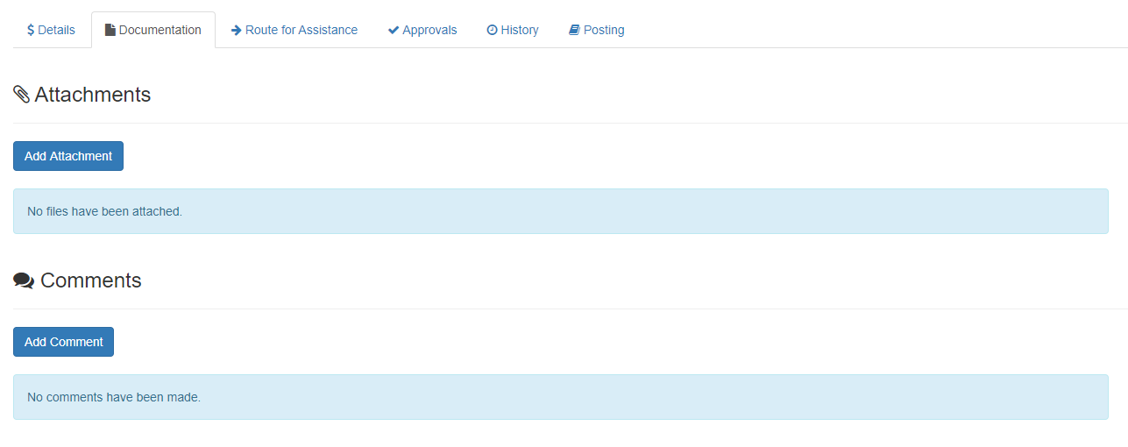

Justification for Transfers 90 Days After Date of Original Transaction
- In the Documentation Tab, if the transfer is over 90 days, the preparer will be automatically be required to fill out the justification.
  - 90 Day period is technically 90 days from the end of the month a transaction is posted.

Approvals
- Click on the Approvals Tab
- If all looks good, click Approve
  - This captures your signature on the transfer, no further action is required
- If the accounting or justification needs more work:
  - Click Send back to Preparer
    - If you send back the transfer, please include a comment telling the Preparer the revisions you are asking them to perform.
  - OR enter correction mode by clicking Correct to make the correction(s) yourself
    - After clicking Correct, edit what needs to be fixed
    - Click Submit for Approvals
    - Click Approve in the approval tab
- The Cost Transfer Workflow tool will automatically determine the next required approval
  - Email Notification to Approvers That a Cost Transfer Requires Approval
*** Original intended recipients: ERIC J STEBERL, SHERRI VOIGT ***
Transfer NT00000063 requires approval from you for Sponsored Programs Accountant.
Please review the transfer by following this link: https://www.ct.sfs.services.wisc.edu/nsct/63
Transfer Synopsis:
Created by: JACQUELINE MILSKI
Created on: 4/20/2020
Details of transfer:
Test AAG7746 - ability for UWMSN PI to approve UWSYS transfer

Note: a direct link to the transfer record within the Cost Transfer Workflow Tool is embedded in the email.
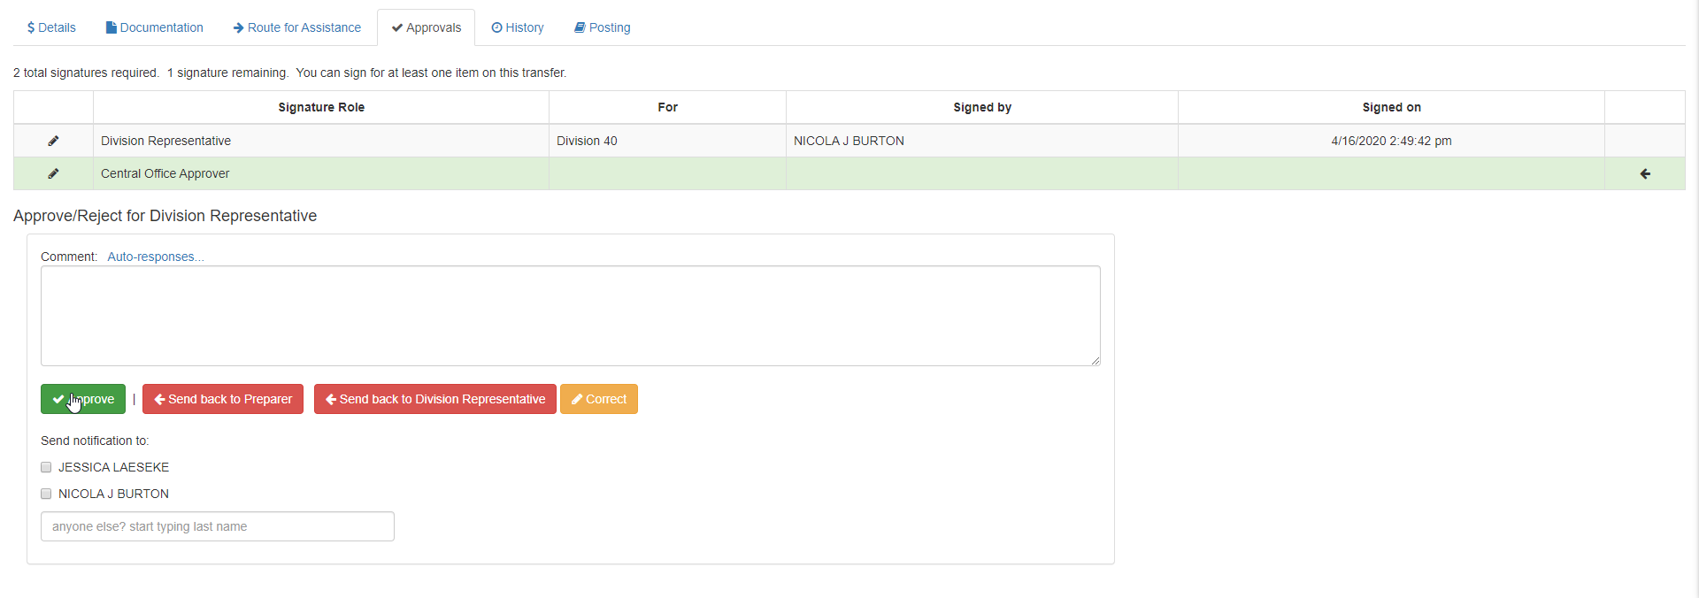

History of the Transfer
- Check the History tab to see all major events, which are captured and retained here
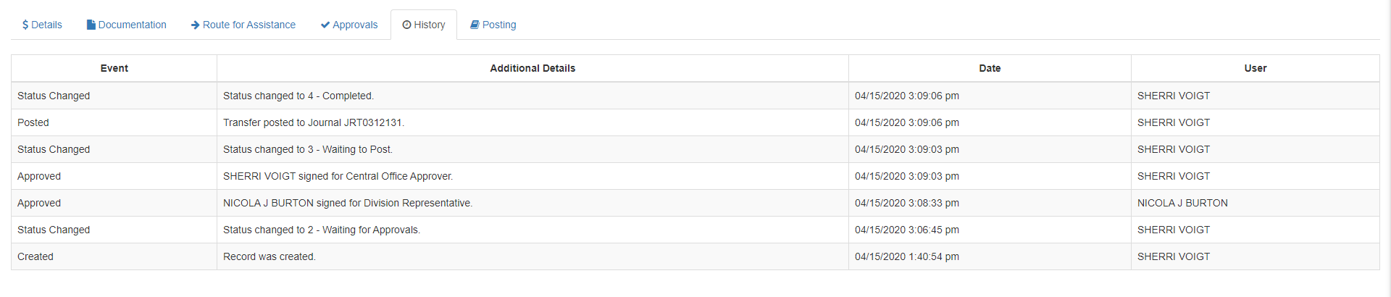

Delegating Signature Authority
This allows you to designate another user to approve transfers on your behalf. This can be a co-worker who will approve for you during an absence or a permanent delegation.
- Click on Preferences
- Under Delegates add their name as well as the effective dates they should be the delegate for
- Click Add
- Click Save Preferences
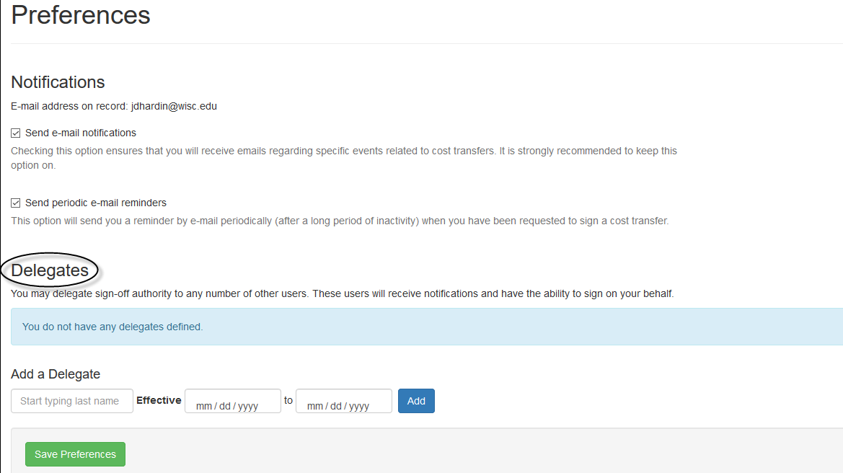

Searching for Transfers
- Click on Find a Transfer while in the Dashboard
- On the “Find a Transfer Screen” users:
  - Can search for completed transfers
  - Can search for transfers in process
  - Can use multiple filtering options (e.g. Project ID)
  - Can search for any transfer, not just transfers prepared by you, and view comments, documents, preparer, approvers, etc.…
** Eliminates the need to print a copy for your file **
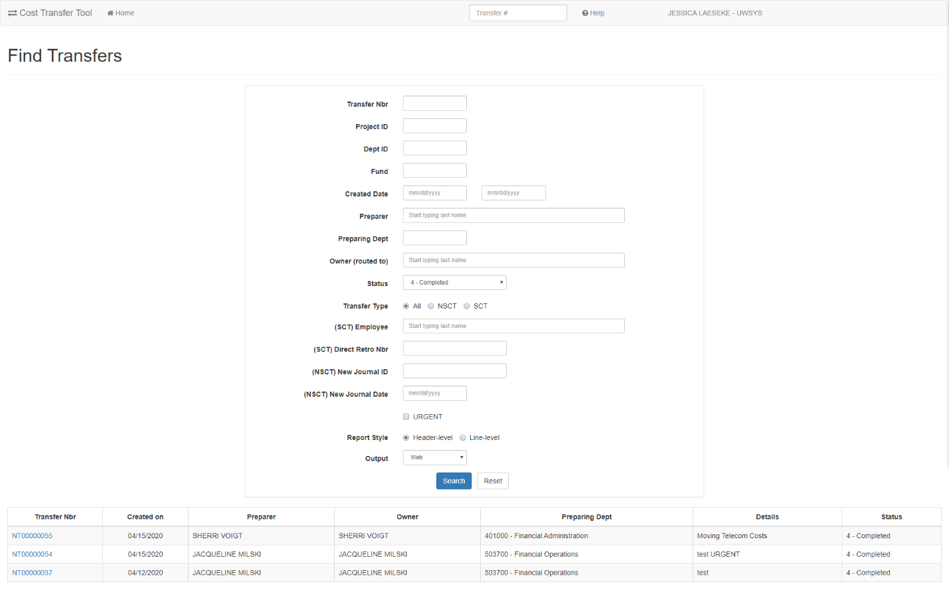

Workflow After Submitted
- Once the transfer completes all entry and passes validations, it then moves on to the next step – review and approval by a person.
  - User Entry Wait for Approvals Pending Posting Posted/Complete
- The record can be returned to the preparer any point to be revised or deleted
- The approvals process is dynamic and depends on the content of the transfer itself.
- One core concept in Cost Transfer workflow is the idea of an approval “tier”.
  - Tiers are ordered so that the first tier must be fulfilled before the second tier, and that must be fulfilled before the third and so on. This ensures that the next level tier does not see the transfer on their work lists until it is ready for them to sign.
  - Upon a rejection, the rejection usually goes to the previous tier where it must be corrected or deleted by the preparer.

Person Resolution
The final component of the workflow process is person resolution. This refers to the process that the tool uses to resolve who can sign on a given approval item. It is important to note that when each new tier opens, the resolution process runs. This means that the approval item is not tied to a specific person until they sign. The person or persons that are determined to sign is delayed until the last possible moment and is not computed at the time the transfer is submitted.

Other Aspects to Workflow and Approval
- When a record is rejected and goes back to be edited, upon submission a second time, existing signatures made prior to rejection are preserved. The system “fast-forwards” to the highest, unsigned tier at that time.
- It is possible for a division approver to make their own transfer and sign it as well. There is no conflict of interest considered.
- In some cases, PI tier becomes stuck because a PI that must sign has left the University. In this case, a new PI must be assigned in SFS and extracted to WISER. The record then must be put back in edit mode and re-submitted.

