SUPERVISOR APPROVAL OF FURLOUGH REQUESTS

1. NINE-MONTH, ACADEMIC-YEAR INSTRUCTIONAL EMPLOYEES:

A. The nine-month, academic-year instructional employees will submit furlough as absence requests, by selecting COVID FURLOUGH as the absence name and entering the quantity of hours.
B. COVID FURLOUGH requests will appear in the list of absences needing approval, along
with all other absence requests (sick leave, etc.).

2. TWELVE-MONTH ANNUAL NON-INSTRUCTIONAL EMPLOYEES:

A. Annual non-instructional employees will submit furlough on the biweekly timesheet.
B. The furlough entries (FURLM) will run through the Time Administration process, which occurs every day at approximately 6:15 a.m. for monthly-paid employees. The process takes about an hour.
C. Once processed through Time Admin, the furlough entries will appear in the "Payable Time Approvals" section of the Manager Self Service Dashboard for approval.
D. Check the dates to be sure you are seeing all the entries for the full month. The default dates on the Manager Self Service Dashboard (MSS) are for the current biweekly pay period. Change the start and/or end dates to include the full month.

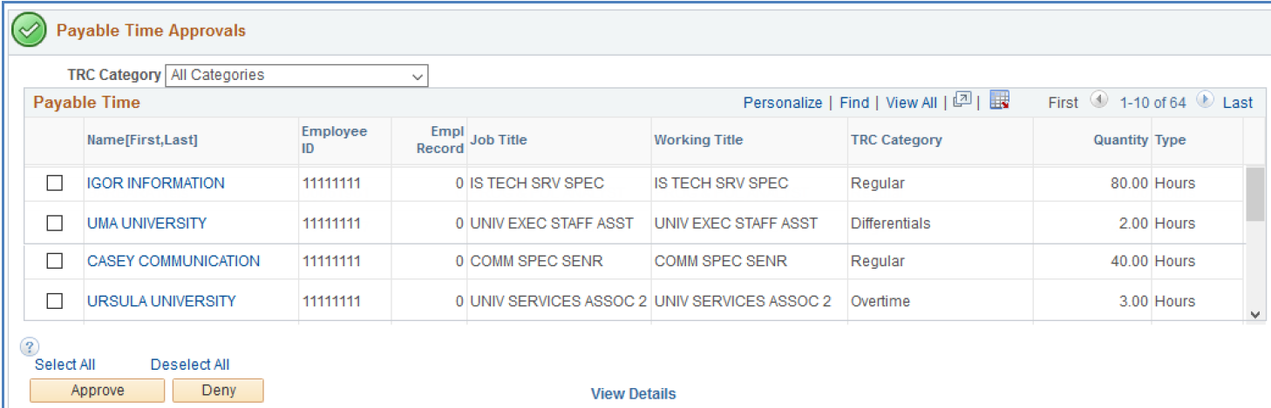

E. Please note how many lines of approvals are needed. To see everything, click "View All."
F. The "Quantity" column on the right indicates the total number of hours to be approved for each employee. Click on the employee's name to see the detail of those hours.
G. Click on the box next to each employee's name, or, click "Select All" to select all hours for all employees, even the ones not showing on the screen. Click the "Approve" button.
H. Approving furlough entries for annual, non-instructional employees, is the same process
as approving the biweekly timesheet hours and furlough for UNIVERSITY STAFF and student employees. All of the hours will be in the "Payable Time Approvals" section of the Manager Self Service Dashboard (MSS).

