**HRS/TAM**

**Search Committee**

**Guide**

Updated August 30, 2018

**HRS/TAM Recruiting User Guide**

**TA and Chair Members**

**Things to know before accessing HRS/TAM2**

What is TAM?2

How to Sign In2

Enabling Pop-Ups2

Troubleshooting/Assistance2

**Accessing TAM3**

**Searching Job Openings/Applicants4-5**

**Viewing Application Materials6-7**

**References8**

**In System Navigation 8**

**Corresponding with Applicants9-11**

**Viewing Applicant Correspondence12**

**Candidates Disposition13**

Changing Disposition13-14

**Attaching Additional Documents15-18**

To Candidate’s File15-16

To Job Posting17-18

**Printing Applicant Documents19**

**Appendix20-23**

Sample Emails21-22

Disposition Flow Chart23

**THINGS TO KNOW BEFORE ACCESSING HRS/TAM**

**WHAT IS TAM?** TAM (Talent Acquisition Manager) is housed within the Human Resources System (HRS). The program allows for candidates to apply, committee members to screen, and Human Resources to hire all in one program.

**1**

**2**

**HOW TO SIGN IN** HRS/TAM will work utilizing the Net Id Username and Password that you use to access your email or MyUWW.

**ENABLE POP-UPS** To allow for applicant’s attachments to be viewed, please enable pop-ups. Additional information on enabling pop-ups can be found at the following link: <https://kb.wisc.edu/helpdesk/page.php?id=15047>

**HRS/TAM is compatible with:**

* Internet Explorer Versions 7-11 (page 2-3)
* Mozilla Firefox (page 4)
* Google Chrome (page 5-6)
* Safari (page 7)
* iPad (page 8)

**3**

**UW-Whitewater TAM HelpDesk**

Contact UW-W Human Resources at 262/472-1072 or [hrstudent@uww.edu](mailto:hrstudent@uww.edu)

**HAVING TROUBLE ACCESSING HRS/TAM?**

See Page 3 troubleshooting guide, or

Contact the TAM Helpdesk at 262/472-1072 (x1072) or [hrstudent@uww.edu](mailto:hrstudent@uww.edu)

**ACCESSING TAM**

* 1. Use the link: <https://kb.wisc.edu/hrs/> to access TAM
  2. Click on ‘Log in to HRS’ on the left menu

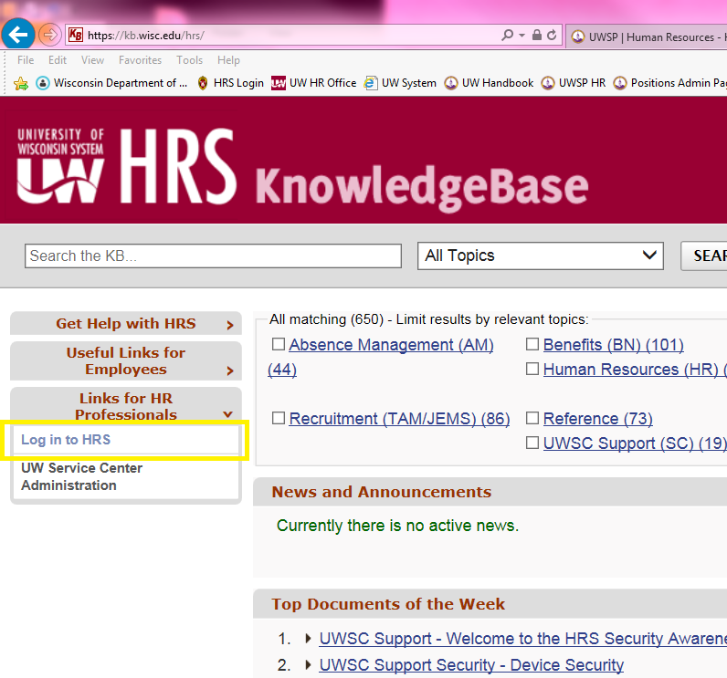

* 1. Sign in using your standard UW-W NetID and password

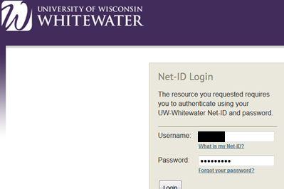

**SEARCHING JOB OPENINGS/APPLICANTS**

1. The Oracle Menu will appear, click on Recruiting.

2. On the next menu choice, click on Search Job Openings.

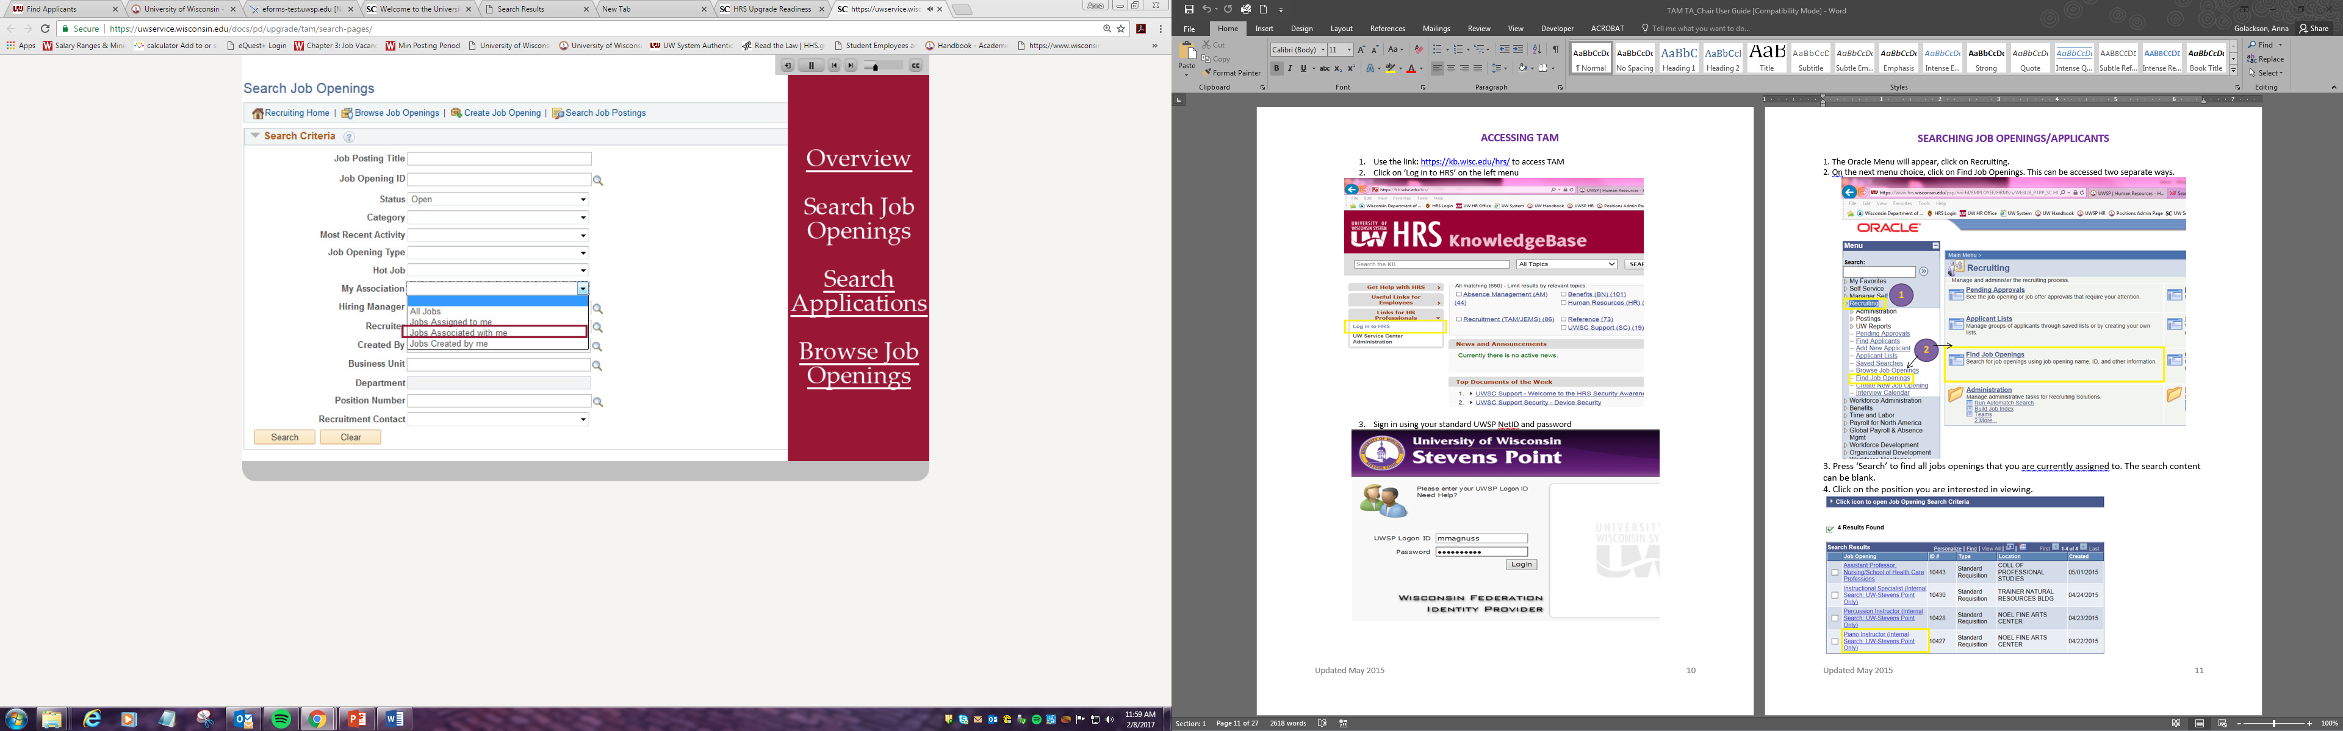

3. Clear the “Status” Box. Press ‘Search’ to find all jobs openings with which you are currently associated.

4. Click on the position you are interested in viewing.

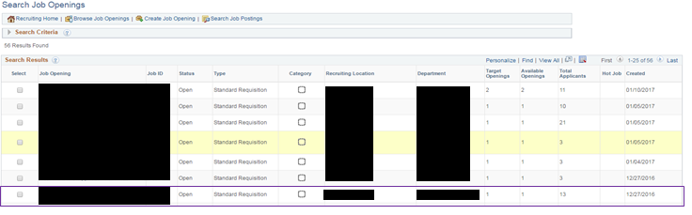

1. Once clicking on the position, you will find a list of all applicants who have applied. At times, the list may seem abbreviated, as the system will only display the first 20 applicants. You can manually change this setting by selecting ‘View All’ or by flipping the page, by using the arrow.



1. To view the candidate details, including Resume, Cover letter and references the application icon, which will take you to all the attachments, applicant information, and job opening information.

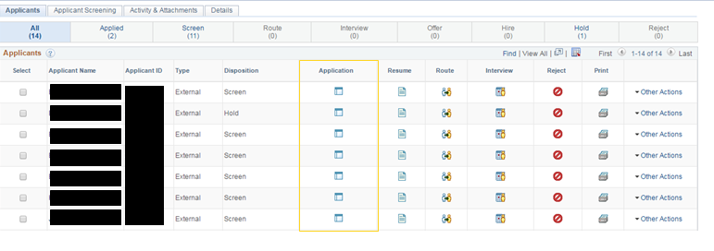

**VIEWING APPLICATION MATERIAL**

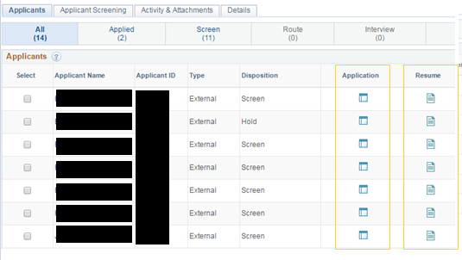

* 1. To view the application materials select the application icon. To view only the resume, select the resume icon.
  2. The next page (Application Icon) will provide the screening committee with a lot of information, and can look overwhelming. The most pertinent information will be housed at the top of the screen, and in the attachments section.

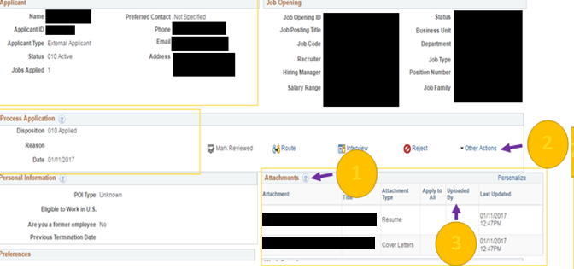

The attachments section houses all of the documents an applicant submits. All documents will be shown without any additional action, and will be grouped.

**2**

**1**

In the ‘Other Actions’ drop down, select ‘Recruiting Actions’ and then ‘Edit Application Details’. This will redirect you to a new page that appears as below.

**3**

Once candidates click ‘Submit’ they are unable to update or include additional attachments. Applicants may reach out to the chair/TA Coordinator to include attachments. This is done by the steps included in ‘2’ above.

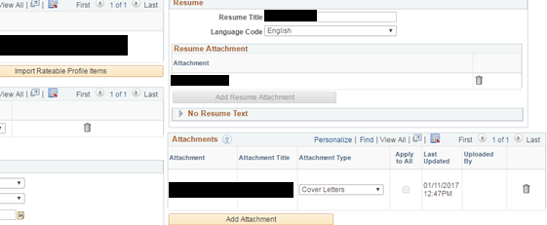

**REFERENCES**

References can be found in 3 separate locations: Applicants may include them in their **resume**, as a separate attachment in the attachments section/references as shown on pages 15 of this guide, or under ‘Applicant Data’ and ‘References’ in the screenshot below. All of these methods are acceptable in the application process.

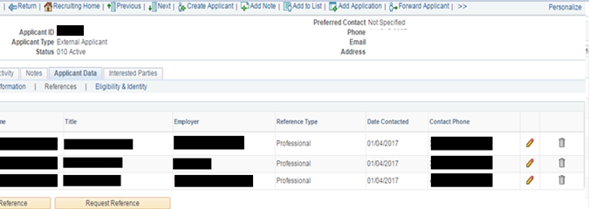

**IN SYSTEM NAVIGATION**

TAM offers great in-system navigation. Below are two examples of what the system navigation looks like. Select the ‘Previous or Next’ button to view their specific information or ‘Return’ to return to the previous screen. You can also select ‘Manage Job Opening’ in the ribbon at the top of the screen to return to the job opening general page. This method will make finding information in TAM easier and more efficient.

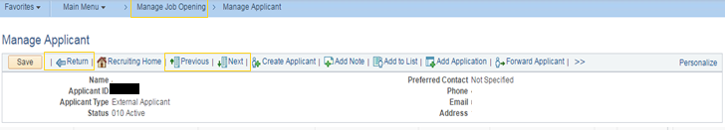

**CORRESPONDING WITH APPLICANTS**

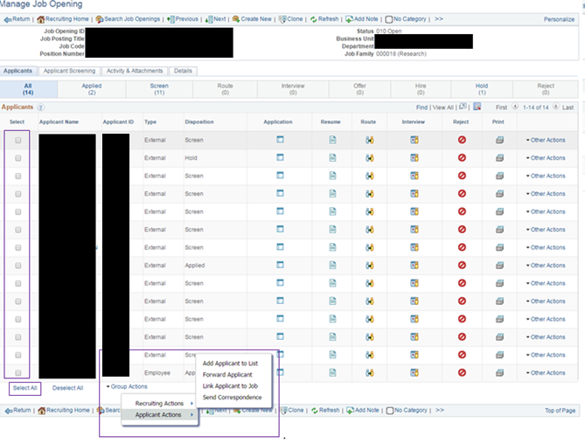On the applicant list (refer to page 11) click the check box or choose ‘Select All’ to create communication between the hiring committee and applicants. Select ‘Group Actions’, then ‘Applicant Actions’, then ‘Send Correspondence’ and click okay.

The selected applicant(s) will appear in the ‘To’ line. It is important to note that applicants will only see their name when corresponding with multiples. Your name (as the sender) will automatically be filled in the ‘Carbon Copy’ line.

A subject will need to be included prior to sending the message.

**A great subject line is, “UW-Whitewater Position _________”**

Access: Public vs Private

Private allows only the person sending to view the notes, public allows all committee members to view the correspondence. **It is required to use the Public Setting.**

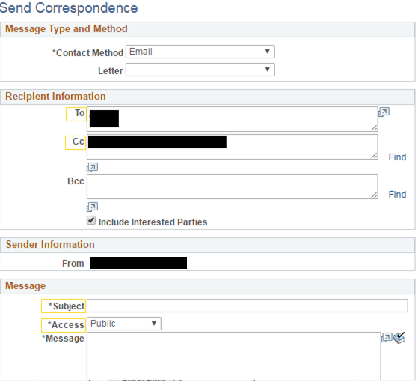

**Please note: Do not select the ‘Letter’ or Mail Merge function. TAM has trouble syncing and editing the information that is merged, instead copy and paste the message into the body of the email.**

**SAMPLE EMAIL MESSAGES**

A complete list of acceptable correspondence can be found at: <https://kb.wisc.edu/hrs/page.php?id=21486> or in the Appendix

**Application Materials Received Message:**

Subject: Acknowledgement of Receipt of Application

Dear (Name),

Thank you for submitting your application to the University of Wisconsin-Whitewater, for [position title and number]. All of your application materials have been submitted successfully.

Your materials will be reviewed by our staff to determine if your qualifications are commensurate with the posting requirements. Should review of your application result in a decision to pursue your candidacy, you will be contacted.

Once again, thank you for your interest.

Regards,

Name

Search and Screen Committee Chair

**Application Materials Missing Message:**

Subject: Acknowledgement of Receipt of Application

Dear (Name),

Thank you for submitting your application to the University of Wisconsin-Whitewater, for [position title and number]. All of your application materials have been submitted except [missing materials]. To guarantee consideration your application must be complete, which includes the required documents as noted in the position announcement, by [Date Due]. Please attach the missing document(s) and email to [email address]. Your application will be complete once we receive these missing documents. We sincerely appreciate your interest in this position and thank you for the time you invested in submitting your application.

Regards,

Name

Search and Screen Committee Chair

Copy and Paste the appropriate message into the body of the email. Click ‘Preview’ to view what the candidate will see. Click ‘Send’ to deliver to all candidates who were previously checked.

Messages are not sent to candidates automatically when dispositions are changed, instead they must be entered manually.

**WHEN SHOULD MESSAGES BE SENT?**

Messages should be sent to keep candidates in the loop with the hiring process. Minimally, this includes: when the candidates applies, regarding a complete application, or missing materials and if the candidate has not been chosen.

**VIEWING CORRESPONDENCE WITH CANDIDATES**

All correspondence is directly saved to the applicant’s contact notes. If the message is made public (required) it can be viewed by all committee members by following the steps below.

Click on the applicant’s name and then click on the tab entitled ‘Notes’. This will display all correspondence with the committee and chair. While messages can be deleted, they should be saved for record.

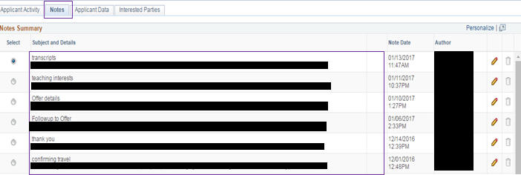

The full message can be viewed by clicking on the Edit Note Icon (pencil). You can also see who sent the message under the ‘Author’ column, often this is the Committee Chair or TA Coordinator

**CANDIDATE DISPOSITION**

A candidate’s disposition refers to the status the candidate is currently in. Most often the hiring committee will see: Applied, Screen, Hold. The committee members should only view those listed in the ‘Screen’ status.

|  |  |  |  |
| --- | --- | --- | --- |
| **Disposition** | | **Meaning** | **Phase of Search** |
| Applied | The Candidate has submitted their application, but the chair/ TA coordinator has yet to determine if all application materials are complete. | | Initial Screening |
| Screen | The candidate has a completed application and can be viewed by the chair/TA coordinator. | | Initial Screening |
| Hold | The candidate is missing application materials and therefore is on hold. The Chair/TA coordinator should communicate the missing materials via TAM email. The candidate should not be reviewed until in ‘Screen’ disp. | | Initial Screening |
| Under Review | The team is moving forward with reviewing the candidate’s qualifications | | Initial Screening |
| Does Not Meet Minimum Qualifications | As the title implies, the group will not be moving forward because the required qualifications are not met. | | Throughout Search |
| Consider for Interview | The candidate is a front-runner for an in person interview, and is likely participating in a phone interview. | | Phone/In-Person Interview |
| Interview | Candidate will come to campus for in-person interview | | In-Person Interview |

**CHANGING CANDIDATE DISPOSITION**

A candidate’s disposition is accessible in two ways:

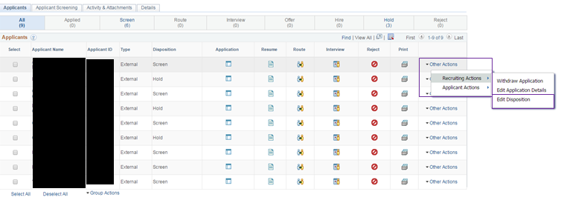 (1) On the applicant list, you can click on the ‘Other Actions’ drop-down associated with the candidate’s name, then ‘Recruiting Actions’, then ‘Edit Disposition’ as show below:

(2) On the applicant list, you can click on the applicant’s name, and then select ‘Other Actions’ drop-down associated with the candidate’s name, then ‘Recruiting Actions’, then ‘Edit Disposition’ as show below:

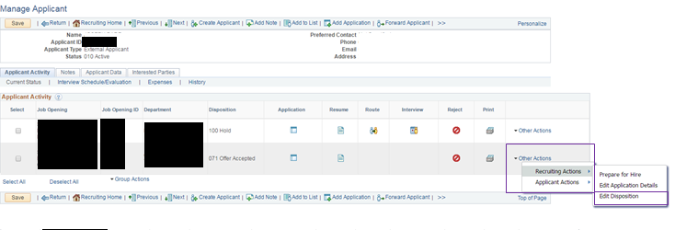

As shown in the example above, a candidate may have applied for more than one position. In that case, ensure you are change the disposition for the appropriate position.

A dialogue box will then appear where you change the disposition in the ‘*New Disposition’ drop down menu. Click ‘Save’ once you have chosen the appropriate new disposition.

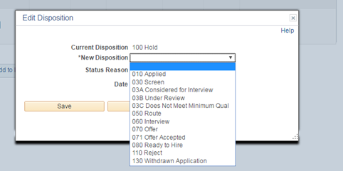

Regardless of the page from which you access the ‘Edit Disposition’ option, the new disposition will show in the ‘Disposition’ column.

**ATTACHING ADDITIONAL DOCUMENTS TO CANDIDATE FILE**

Additional documents, including updated resume, references, teaching philosophy, etc. can be added by accessing the candidate information.

Click on the candidate’s name or the application icon on the applicant list. In the ‘Process Application’ section, click the ‘Other Actions’ drop down menu, then ‘Recruiting Action’ and ‘Edit Application Details’.

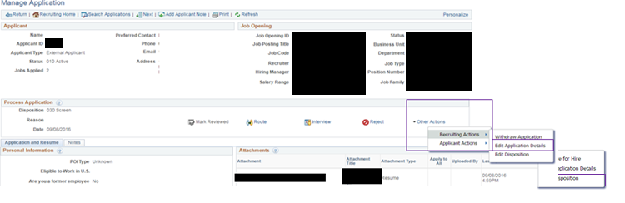

Then, under the ‘Attachments’ section, click the ‘Add Attachment’ button

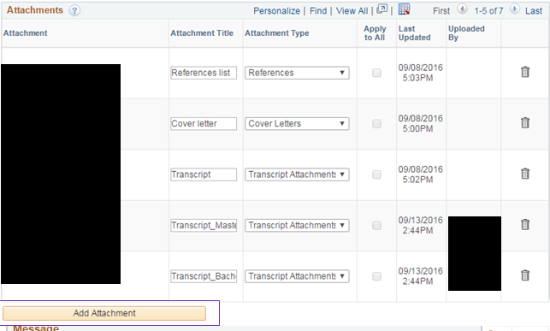

This will open a new box to browse save files. Choose the file you would like to include and select ‘Upload’. Please remember that attachments should only be deleted if you are updating/replacing a document.

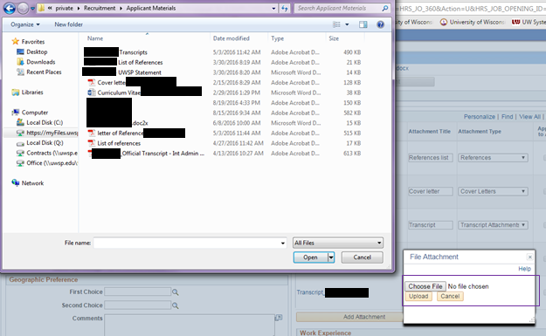

You will then need to click the ‘Save’ button in the upper left-hand corner before returning to the posting.



**ATTACHING ADDITIONAL DOCUMENTS TO THE JOB POSTINGS**

Find the Job Opening and click ‘Activity & Attachments’. The default tab that is open is entitled ‘Applicants’.

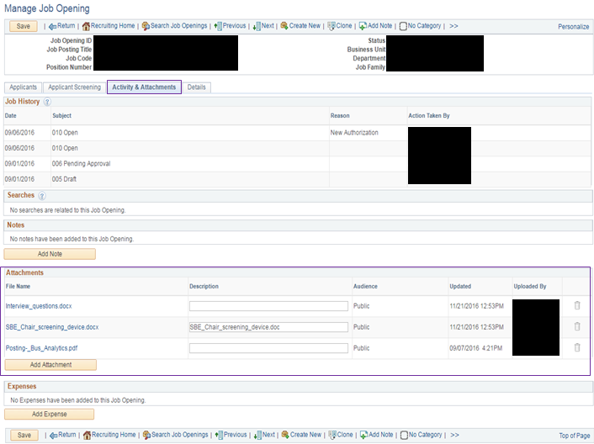

Click ‘Add Attachment’ at the bottom of the ‘Attachments section’. This will prompt a new dialogue box. Select ‘Choose File’ and once a document is selcted, click the ‘Upload’ button.

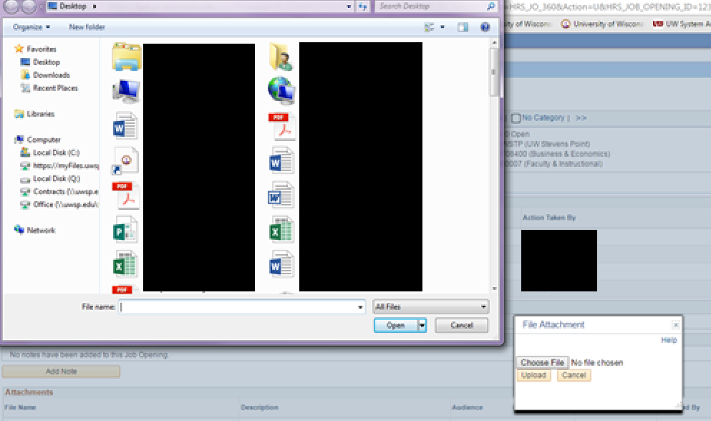

Choose the ‘Public’ from the drop-down menu in the ‘Audience’ column for the material that is being posted. Press ‘Save’ and ‘Refresh’ to view the new document.

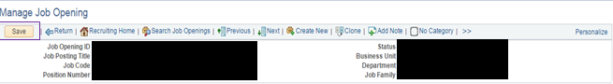

**PRINTING APPLICANT DATA**

Under the applicant click the application icon, select the attachment that requires printing, and then print from the browser.

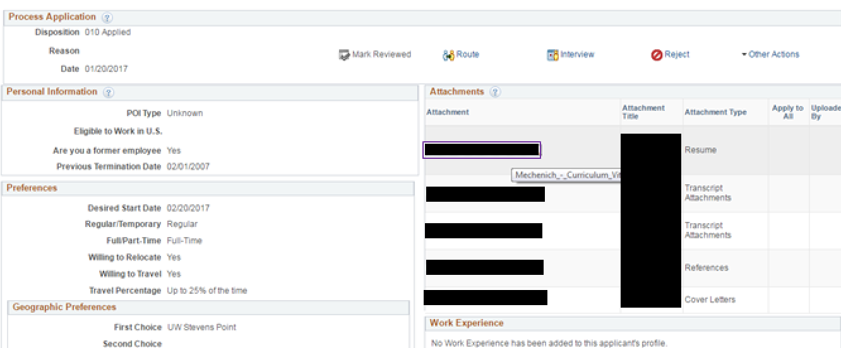

****If the document is a Word document, then you will likely need to ‘Click Enable Editing’ to view and print the document. If an error message is prompted you will have to save the document to your desktop to view and print.

**Appendix**

**SAMPLE EMAILS**

|  |  |  |
| --- | --- | --- |
| **Situation** | **Subject** | **Email** |
| To candidates in the Applied Status | Acknowledgement of Receipt of Application | Dear (Name),  I am pleased you have applied for the position of (Position Title) at the University of Wisconsin-Whitewater. Your application packet was complete OR Your application packet was missing XYZ. The screening of applications begins (date) (and only completed applications as of (date) will be considered).  On behalf of my committee colleagues, we sincerely appreciate your interest in this position and thank you for your application. Please contact me if you have any questions regarding our position.  Regards,  (Contact Name)  (Chair or TA Coordinator), Search Committee-(Position) |
| To candidates who apply after the rolling deadline date has passed | Acknowledgement of Receipt of Application | Dear (Name),  I am pleased you have applied for the position of (Position Title) at the University of Wisconsin-Whitewater.  On behalf of my committee colleagues, we sincerely appreciate your interest in this position and thank you for your application. Please contact me if you have any questions regarding our position.  Regards,  (Contact Name)  (Chair or TA Coordinator), Search Committee-(Position) |
| To candidates letting them know the position deadline has been extended | UW-Whitewater (Position Title) Position Update | Greetings,  As a courtesy, you are receiving this communication to notify you the application deadline for the position of (position title) at UW- Whitewater has been extended to (extended deadline date). At that time, all application materials will be reviewed. Thank you for your interest in this position.  Regards,  (Contact Name)  (Chair or TA Coordinator), Search Committee-(Position) |
| To pool candidates indicating the department is not hiring at this time (adjunct) | Acknowledgement of Receipt of Application | Dear (Name),  Thank you for submitting your application for the position of (Title) at the University of Wisconsin-Whitewater. We are not currently hiring for this department, but should an opening occur, your application materials will be reviewed.  On behalf of my committee colleagues, we sincerely appreciate your interest in this position and thank you for your application. Please contact me if you have any questions regarding our position.  Regards,  (Contact Name)  (Chair or TA Coordinator), Search Committee-(Position) |

|  |  |  |
| --- | --- | --- |
| **Situation** | **Subject** | **Email** |
| To candidates submitting application materials via e-mail or not through TAM | Acknowledgement of Receipt of Application | (Name),  Thank you for your interest in the (Position Title) position at the University of Wisconsin-Whitewater. In order to be considered for the position we need you to submit your application through the TAM portal.  If you do not have an account created in the TAM portal, you can create an account at this link: <https://www.careers.wisconsin.edu/>  Once you have created an account you can search for the position by its position number. The position number for the position you are currently interested in is (position number).  At that point, you will be able to upload your cover letters, resume, transcripts, and all other required application documents.  A Frequently Asked Question document to assist you in applying can be found here: https://kb.wisc.edu/hrs/page.php?id=21900  I hope this helps you get started. I look forward to receiving your application in our TAM portal.  Regards,  (Contact Name)  (Chair or TA Coordinator), Search Committee-(Position) |
| To candidates who did not get the position | (UW- Whitewater (Position Title) Position Update | Thank you for your interest in the (Position Title) position at the University of Wisconsin-Whitewater. Many qualified applicants applied for this job opening. However, after review of the applications, yours was not selected for further consideration.  We wish you success with your job search in the future and invite you to explore <https://www.careers.wisconsin.edu> for further employment opportunities.  Regards,  (Contact Name)  (Chair or TA Coordinator), Search Committee-(Position) |

**DISPOSITION FLOW CHART**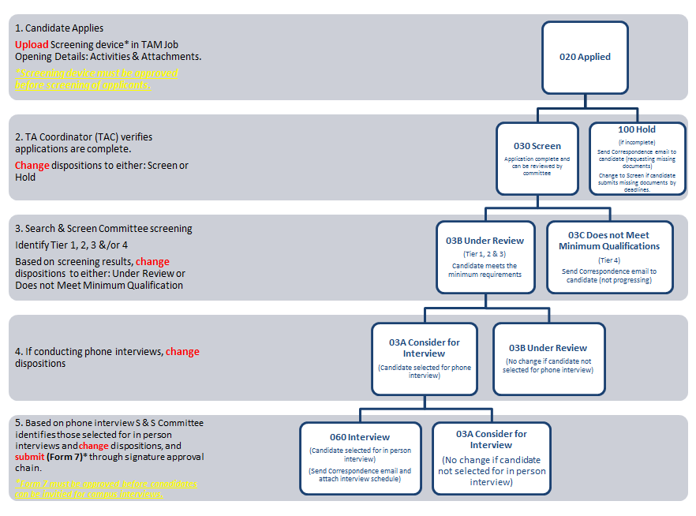

WITHDRAW NOTE: If a candidate withdraws at any step in the process, record this notification in the Applicants’ Contact Notes:

1. Date UW- Whitewater was notified
2. How UW- Whitewater was notified (phone, email etc.)
3. Who the applicant notified
4. If any specific reasons were provided by the applicant – please include.
5. Change their disposition status to: **120 Withdrawn**