Temporary Handbook for COVID-19
Summer 2020
SESSION B
(UPDATED 6/18/20)
Changes from Session A are highlighted
Hello Families and Staff,
We are happy to be welcoming you back to the Children’s Center. In response to the current COVID-19 pandemic, we have taken careful consideration of our operating procedures and adjusted these in order to provide the safest environment for you child and our staff at this time. This handbook outlines current changes to policies and procedures until it is determined that these extra measures are no longer needed. Please read this handbook carefully prior to returning.
Changes to Daily Operations:
- HOURS OF OPERATION are 8:00am – 5:00pm. Our staff will be using extra time before and after hours to do extra cleaning and sanitizing. The shortened operating hours also allow us to stay in compliance with the restrictions of the number of staff we are allowed to have on site according to the temporary rules from the Wisconsin Department of Children and Families (10 at a time).
- Please limit traffic in the office. If you need to speak with Erica or Peggy, please try to send an email or call rather than coming directly into the office.
- Arrival Procedures for the morning 8:00-9:00am:
- Please see the attached map for your classroom’s assigned entrance. We are carefully directing the traffic flow in / out of the building to reduce the risk of exposures to children, families, and staff.
- Only one adult at a time per child shall enter the Roseman building to drop off a child
- If waiting behind another family, maintain 6-foot distance (see markings on floor to guide you)
- Temperature Checks – will be done for all children upon arrival at the Center and mid-day.
- Complete the health screening questions.
- Once cleared for entry, UWW-CC staff will take your child to their classroom and sign them in for the day.
- If you arrive after 9:00, please wait at the table and call the office. We will send a staff member out to check your child in for the day.
- All family members should refrain from entering the classrooms. Only children and assigned staff are permitted in the classrooms. Family ID cards will be activated for outdoor entrances from 7:30am – 10:00am and will not be activated for room access during this session.
- Helpful Tip: Explain the drop-off procedures to the child ahead of time.
  - Use the walk/drive to school to as your "goodbye time."
  - If you have any drop-off routines/rituals, talk about how those will be different, and ask for suggestions from your child.
  - Make sure they understand that you will be staying in the hallway and that a teacher will be taking their temperature and bringing them to their room.
  - Say good-bye in a loving and confident way. You can reassure them that you will pick them up after rest and snack time.

- Pick-up Procedures at the end of the day 3:30-4:00pm:
- Please call the classroom to let the staff know that you are at the Center and ready to pick up your child. Your teacher will instruct you where to wait for them to deliver your child to you. If there is not answer, please call the office.
- PHONE NUMBERS:
Children’s Center Office | 262.472.1768
Robin Room Classroom | 262.472.1894
Robin Room Cell Phone | 262.903.3203
Mallard Room Classroom | 262.472.1898
Mallard Room Cell Phone | 262.903.3206
Crane Room Classroom | 262.472.1896
Crane Room Classroom | 262.903.3208
** DO NOT LEAVE MESSAGES / VOICEMAILS ON ANY OF THE CLASSROOM PHONES. IF CLASSROOM STAFF DOES NOT ANSWER PHONE, PLEASE CALL THE OFFICE

- UWW-CC staff will bring your child out to you. Please avoid gathering near other families waiting for their children.
Additional Operational Precautions:
- No Drop-in Care or additional days will be added to children’s schedules this summer beyond our current enrollment. We need to limit the amount of children in each of the groups as much as possible.

- Separate Groups: Classes will remain separate throughout our hours of operation. There will be no combining or comingling of groups at any time of the day. In addition, staff will only be assigned to work with one group of children and will not enter the other classrooms within a given day. TA’s will only be allowed to work in different classrooms in extreme circumstances and should be approved by the director to do so.

- PERSONAL BELONGINGS: All extra items (toys from home, car seats, strollers, etc. should NOT be brought into the center).

Health and Illness Policies:
Children, family members who are bringing children to school and staff should all abide by the following health recommendations:
If a child or anyone in their household are exhibiting any of these symptoms, please DO NOT come to the Children’s Center:
- Fever over 100.4
- Persistent cough
- Runny Nose
- Sore Throat
- Body aches
- New loss of taste or smell
- Other symptoms of COVID related illness in children are: red eyes, blotchy rash, abdominal pain

- If you are calling your child in sick for the day, please report any of these symptoms (or possible exposure to someone that has these symptoms) to help us track illnesses.

- Please consider being tested for COVID to either confirm or rule out that illness related to the listed symptoms.

- If your child is exposed to a person who tests positive for COVID-19 or has a presumptive case of COVID-19, the family shall notify the Director. The Director will notify all employees and families of their possible exposure (confidentiality will be maintained at all times). The Director will work with the Walworth County Health Department and the Wisconsin Department of Children and Families to follow appropriate protocol for the entire center at that time.
  - A child who has a confirmed case or has been exposed to someone who has a confirmed or presumptive case of COVID-19 must quarantine for 14 days with no symptoms – this is the time it takes to see if symptoms arise (incubation period). The child can return to attending the UWW-CC when:
  - No fever for at least 72 hours (3 full days without the use of fever reducing medication)
  - AND…other symptoms have improved (cough, shortness of breath, etc.)
  - AND…at least 7 days have passed since symptoms first appeared.
  - OR a written statement from a medical professional clears the child to return to childcare.

IMPORTANT DEFINITIONS
• “Presumptive case of COVID-19”: when you have been exposed to someone with a positive coronavirus test AND you have symptoms of cough, fever, or shortness of breath.
• “Quarantine”: when you stay away from other people for a period of time when you may become sick with an infection, even if you have no symptoms.
• “Fever free”: A temperature less than 100.4° Fahrenheit AND not using fever-reducing medicine (e.g. Tylenol).

- If a child gets sick during the day, the child will be brought to the UWW-CC office. The family will be notified and requested to pick up their child ASAP. The child should remain home until the symptoms have cleared for at least 24 hours, but depending on the severity of the symptoms, the UWW-CC staff reserves the right to ask a family to keep their child home for up to 72 hours symptom free.

- Travel Guidelines - please keep us informed when you travel to other areas that may impact your exposure levels. Travel will be assessed according to the current information provided by the Wisconsin Department of Health Services. The UWW-CC reserves the right to exclude you from our program for up to 14 days (the incubation period for COVID) based on risk related to the area of travel.
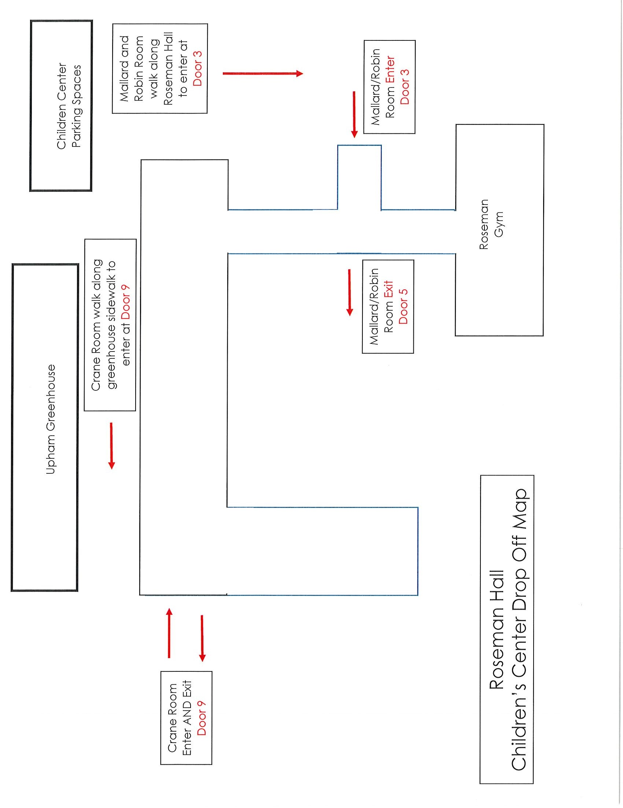
Staff / Employee Policies:
- ENTERING / EXITING the Roseman Building – please see the attached map which show the designated entrances for all staff and families. We ask that you ONLY use these doors.

- Health Screening - All Staff (Lead Teachers and TA’s) will complete a health screening including taking their temperature upon arrival at the Center each day.

- Staff members should not come to work if they or anyone living in their household are exhibiting the following symptoms:
    - *Fever over 100
    - *Persistent cough
    - *Runny Nose
    - *Sore Throat
    - *Body aches

- If you are calling in sick for the day, please report any of these symptoms (or possible exposure to someone that has these symptoms) to help us track illnesses.

- Please consider being tested for COVID to either confirm or rule out that illness related to the listed symptoms.

- If an employee is confirmed to have COVID-19 infection, the employee shall notify their supervisor. The employer will notify all other employees and families of their possible exposure (confidentiality will be maintained at all times). The employer will work with the Walworth County Health Department and the Wisconsin Department of Children and Families to follow appropriate protocol for the entire center at that time.

  - An employee who has a confirmed case or has been exposed to someone who has a confirmed or presumptive case of COVID-19 Must quarantine for 14 days with no symptoms – this is the time it takes to see if symptoms arise (incubation period) and can return to work at the UWW-CC when:
  - No fever for at least 72 hours (3 full days without the use of fever reducing medication)
  - AND…other symptoms have improved (cough, shortness of breath, etc.)
  - AND…at least 7 days have passed since symptoms first appeared.
  - OR a written statement from a medical professional clears you to return to work.

- Travel Guidelines – please keep us informed when you travel to other areas that may affect your exposure levels. Travel will be assessed according to the current information provided by the Wisconsin Department of Health Services. The UWW-CC reserves the right to exclude you from our program for up to 14 days (the incubation period for COVID) based on risk related to the area of travel.

- TA’s should punch in / out for their shifts on the classroom ipads or phone. Please avoid congregating in the Children’s Center office.

- Lockers - TA’s will be assigned an office locker to use for the summer. Please be sure to use disinfecting wipes to wipe down the inside and outside of your locker at the end of each of your shifts.

- Multiple changes of clothing – we suggest that you have an extra set of clothes (or two that you keep in your locker, so that you can change in the middle of your shift should you have any bodily secretions from children that get on your clothes – especially infant / toddler teachers). You might also consider wearing an oversized button down shirt, apron, scrub shirt, or other kind of “smock” type clothing over your regular clothes that could be easily changed at different times of the day if needed. We recommend these items be laundered and kept at the CC for this specific use.

- Masks / Face coverings: Disposable masks will be available for staff to wear while working. This is optional while in the classroom. All staff who are interacting with families at drop-off or pick-up times shall wear a mask.

- Breaks / Break Room – Please limit “gathering” in this small space. 1-2 people may use this space at a time. Please use the oxivir spray to sanitize the area used both BEFORE and AFTER you are done eating.

- Serving Meals – We will be suspending our family-style dining procedures. One teacher will wear gloves and plate all food for children. Serving containers shall remain on the classroom counters. Classroom serving containers will be prepared in the kitchen by our kitchen staff. Kitchen staff will deliver the serving containers to a table outside of the classroom door.

- Dishes – The kitchen staff will do breakfast and lunch dishes. Dish carts should be placed in the hallway when the meal service is completed, so that the kitchen staff can collect the dishes without entering the classroom.

- Cots – All cots will be sprayed with oxivir after rest time, before stacking them in the storage area. Please be sure that children only sit on their own cots. Ideally, cots should be 6 ft. apart during rest times. This may not be possible in all classrooms, so use as much space as possible between cots (2-6 ft.). Another strategy is to make sure children lay “head to toe” on cots that might be in closer proximity.

- Laundry Procedures – Wear gloves when handling dirty laundry. Do not shake dirty laundry. Clean and disinfect hampers after removing dirty laundry. Enter the laundry room from the outside door (do not walk through the classroom).

- Core staff shall clean and disinfect their personal office workspace daily.
Healthy Hand Hygiene: All children, staff, and volunteers should engage in hand hygiene at the following times:
- Arrival to the facility and after breaks
- Before and after applying sunscreen and / or bug spray to children
- After coming in contact with bodily fluid
- After handling animals or cleaning up animal waste
- After playing outdoors or in sand
- After handling garbage
- After using shared equipment like toys, computers, ipads, pens, scissors, etc.
- Infant / toddler teachers should wash their hands, neck, and anywhere touched by a child’s secretions after feeding or holding.
- Teachers should wash their hands before and after handling infant bottles prepared at home or prepared in the facility. Bottles, bottle caps, nipples, and other equipment used for bottle-feeding should be thoroughly cleaned after each use by washing in a dishwasher or by washing with a bottlebrush, soap, and water.
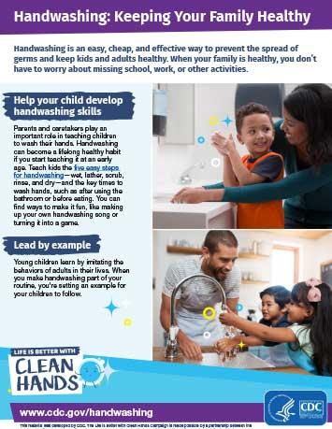
Child Drop-off Screening Form

Child Name: __________________________ Date: ___________ Drop-off Person Name:____________________________

What time will the child be picked up today? ___________ Who will be the pick-up person? __________________
Child Health Screening:
Please check off all that apply:
❏ This child has not had a fever (temperature of 100.4° or higher) within the past 72 hours.

❏ This child has not had potential symptoms of COVID-19, such as shortness of breath or persistent dry cough, within the past 72 hours.

❏ This child has not taken any fever reducing medications like acetaminophen or ibuprofen in the past 24 hours.

❏ This child is free of symptoms of other communicable illness, and is healthy enough to engage in daily activities including outdoor play.

❏ This child or a family member living with this child has traveled outside the state of WI in the past 7 days.

Current Temperature Reading: __________

Anyone with a current temperature of 100.4° or greater will not be admitted to the center.
Children must meet all these conditions in order to be admitted to the center.

Dropoff Person Signature: ______________________________

Child Name: __________________________ Date: ___________ Drop-off Person Name:____________________________

What time will the child be picked up today? ___________ Who will be the pick-up person? __________________
Child Health Screening:
Please check off all that apply:
❏ This child has not had a fever (temperature of 100.4° or higher) within the past 72 hours.

❏ This child has not had potential symptoms of COVID-19, such as shortness of breath or persistent dry cough, within the past 72 hours.

❏ This child has not taken any fever reducing medications like acetaminophen or ibuprofen in the past 24 hours.

❏ This child is free of symptoms of other communicable illness, and is healthy enough to engage in daily activities including outdoor play.

❏ This child or a family member living with this child has traveled outside the state of WI in the past 7 days.

Current Temperature Reading: __________

Anyone with a current temperature of 100.4° or greater will not be admitted to the center.
Children must meet all these conditions in order to be admitted to the center.

Dropoff Person Signature: ______________________________
Family Agreement for Summer Session B

Dear UWW-CC Families,
In order to reopen as safely as possible our program has had to establish new policies and procedures. These policies are effective beginning on July 6, 2020 and will be in place until we determine it is safe to discontinue. Understand that while we can take care to limit the potential of your child being exposed to COVID-19 while at The Children’s Center, we cannot guarantee it. Please read each item below, sign, and return to the Children’s Center office on your first day at attendance.

I, _______________________________, parent of __________________________ wish to have my child begin attending the UW-Whitewater Children’s Center on July 6, 2020.
- Drop-off will take place at the designated health screening station in the Roseman Building. Please try to bring your own pen for this purpose.
- I will wait for my child to be screened for signs of illness upon arrival daily.
- I will not bring unnecessary personal items into the program. This includes the storing of car seats and strollers in the center.
- I will call upon arrival for picking up my child and will wait outside for the UWW-CC staff to bring my child out to me.
- I will not enter the classrooms, except for preauthorized circumstances as defined by the program Director.
- I will only bring my child to the UWW-CC when everyone in our home is healthy and symptom free, with no known exposure to COVID19.
- Fever reducers (ibuprofen or acetaminophen) will not be given to my child on any day of attendance.
- If my child shows signs of illness during care, I, or another authorized person, will retrieve my child within 60 minutes of being notified.
- I will wait my turn to enter the program, and practice proper social distancing while on program premises.
- I will wear a mask when interacting with the UWWCC staff at drop-off and pick-up times.
- I will thoroughly wash my and my child’s hands before dropping off, prior to picking up, and as soon as we return home.
- Only one adult guardian per family is permitted at drop off at pick up.
- I understand this situation is fluid and subject to change per state, other local authority, and program needs.
- I understand failure to follow these new safety guidelines may result in termination.

_____________________________________ ___________
Family / Parent/Guardian signature Date

