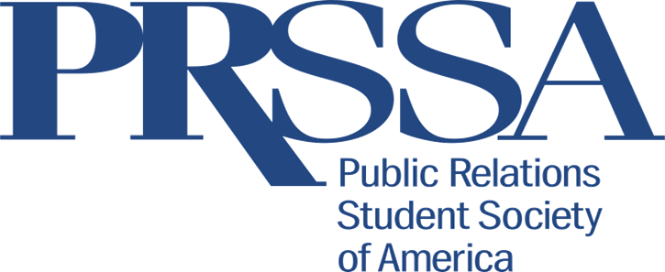

Why Join?
Enhance Your Education
- Add to your resume by joining PRSSA.
- PRSA offers scholarships and awards to recognize student accomplishments.
- Gain leadership experience!
Broaden Your Network
- Throughout the year, we invite public relations and related professional to speak at our general member meetings to give guidance, allow members to ask questions, and offer possible internship opportunities.
- PRSSA offers member the opportunity to go on agency crawls and other tours of public relations and marketing companies and departments.
- There are numerous conferences and events you can attend at a low cost for being a PRSSA member such as the National Conference, Regional Conference, PRSA Chapter Socials, and much more.
Gain Professional Skills
- PRSSA offers workshops to help students build their professional skillset such as resume building, Adobe Suite Shop training, and much more!
Launch Your Career
- By becoming a PRSSA member, you are also a PRSA member which allows you access to the PRSSA Job and Internship Center which gives you professional tips and updated internship opportunities.

Want to Become a Member or Want More Information?
Contact Lysianne Peacock at peacocklk28@uww.edu.

