Notifying Instructors of Accommodations

- Sign on to ARP (use the “ARP” square, then “Sign In to ARP”)
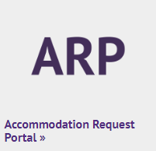

- Scroll down until you see your classes (it will be below your “To Do” list, in a section titled “Select Accommodations for Your Class”)
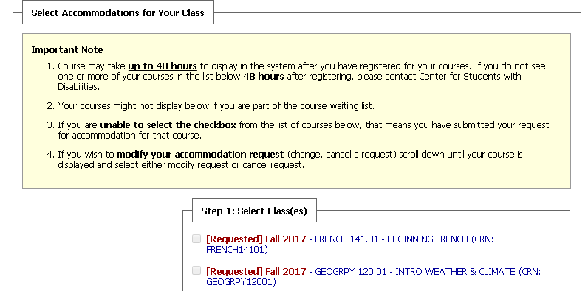
  - Alternatively, you can click on “List Accommodations” on the left side
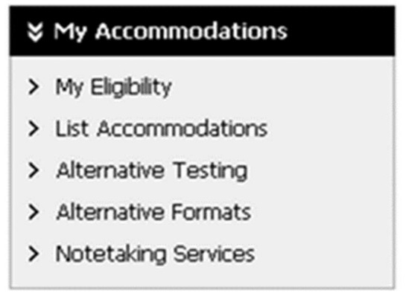

- Select any classes for which you would like accommodations

- Click “Step 2 – Continue to Customize Your Accommodations”

- Your classes will be listed by their course code (e.g., “COMM 110”, “MATH 141”), and will also have information about the course below the course name
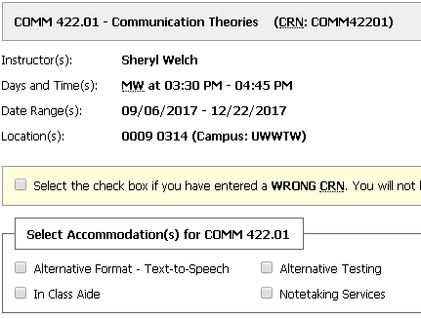

- Select the accommodations you want for each course

- Review and check off the “I understand…” statement for EACH COURSE
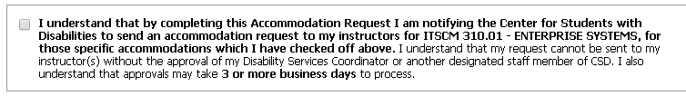

- Click “Submit Your Accommodation Requests”

Modifying Accommodation Requests

- Log on to ARP

- Scroll down below your classes until you see your accommodation requests
  - Alternatively, click on “List Accommodations” on the left side
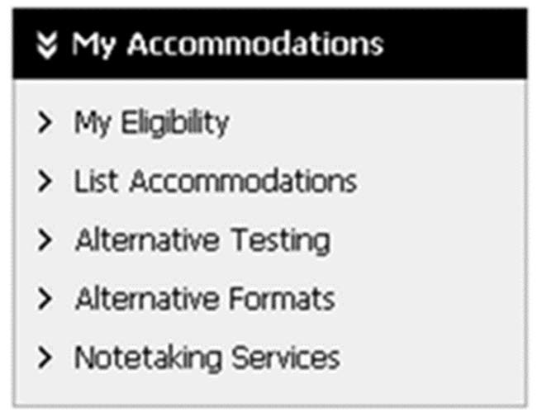

- Click on “Modify Request” on the right side of the class for which you want to modify your accommodations
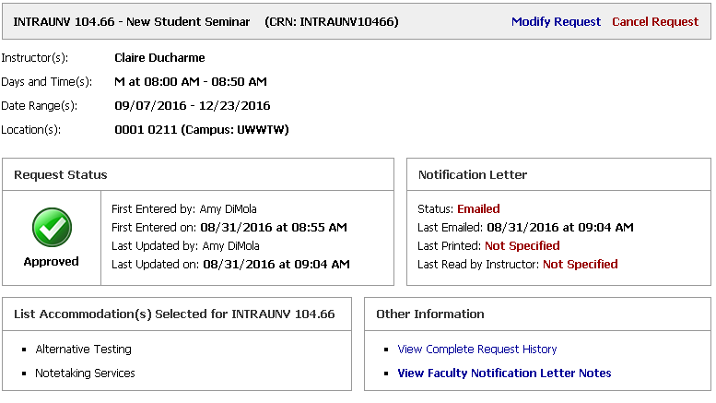

- Select, or de-select, your accommodations

- Click “Update Request”

