Instructions for installing Kurzweil’s Read-the-Web extension in Chrome & Firefox (does not work in IE or Safari):

Read-the-Web browser extension (Web License and Standalone)
- Chrome –
  - Open a web page in Chrome
  - Click on the Apps Icon
  - Click on Web Store
  - Search for Kurzweil
  - Add “Read The Web” to your browser

- Firefox –
  - Load this extension using the link below instead of through Mozilla.
  - https://www.kurzweiledu.com/products/software-updates.html

- Usage -
  - The extensions function identically
  - A Kurzweil icon is stored to the right of the address bar.
    - Will be gray when not in use

  - Activate the extension by clicking on the icon.

  - Use your Kurzweil login to access the extension.
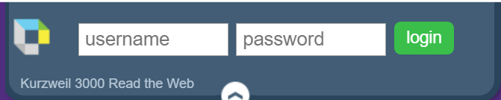
  - The login bar will turn into your tool bar, with controls similar to those in the online version of Kurzweil (Firefly)
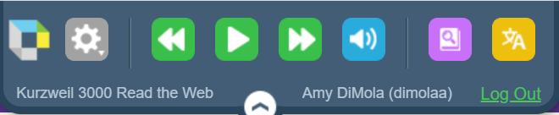
  - Clicking on the webpage will cause a cursor to appear
  - Clicking on the cog wheel will bring up your customization options
