How to Submit an Alternative Media E-Request

- From the Whitewater homepage, click on the link “Disability Services (CSD)” under Warhawk Life, or go to www.uww.edu/csd.
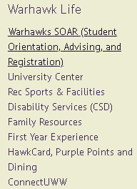

- Click on the square labeled Alternative Media
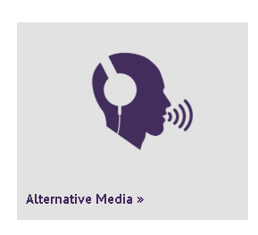

- Click on the link “SUBMIT A REQUEST” or the “Alt Media Request” icon with the stack of books at the bottom of the page.

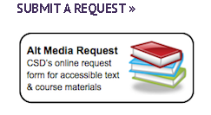

- Log on with your Net-ID and password.
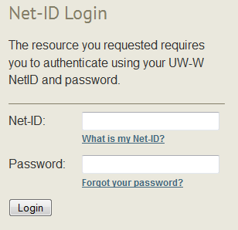

- Fill out the form by selecting correct career, subject, class, section, and primary instructor from the drop down menus.

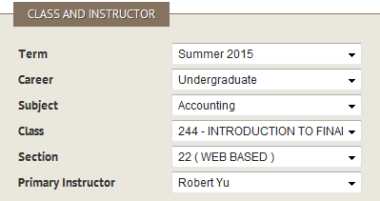

- Read the copyright acknowledgement and check the box to indicate you understand and agree to the terms of the agreement.
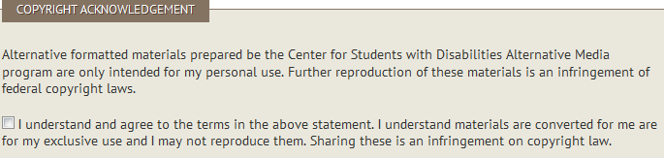

- Now, fill in as much information as you can about each text being requested.
- If the text is purchased, you will need to provide a copy of the receipt. You can upload an electronic version of the copy using the “receipt file” section or deliver a physical copy to Alternative Media.
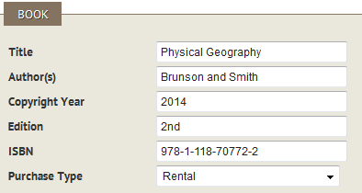

- Select your preferred format for the text conversion. If you select “other,” please note what format you prefer.
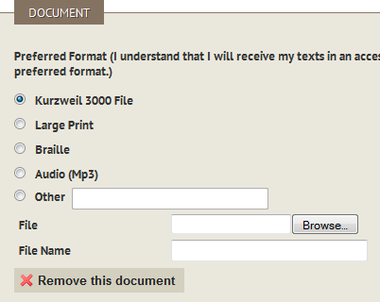

- If you have multiple books for the same class, click “Add a book” and repeat steps 6 and 7.

- If you would like to request a PDF, Word file, or other document for conversion, upload these files using the “browse” button under the heading “Additional Documents.” You can add multiple files by using the “Add a document” button.
- If you do not have additional documents to upload, you must click the “remove this document” button.
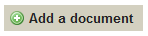

- Click the “Submit” button after double checking that all of your information is correct.
- You may be prompted to provide information for important fields that are blank. Please indicate “information needed” if you would like to continue to process the request with the missing information.

