.

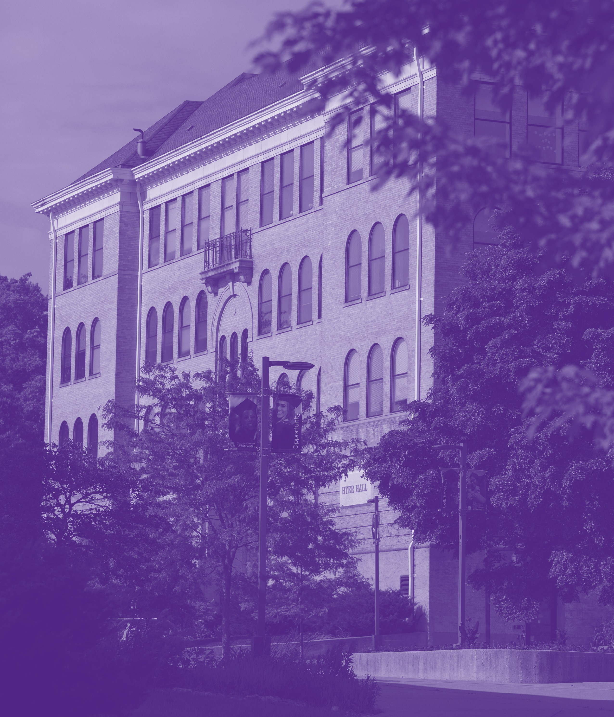

ANNUAL REPORT

2024-2025

**Prepared By:**

Tonya Schmidt   
  
Assistant Vice Chancellor for Student Affairs and Dean of Students

Executive Summary:

The Dean of Students Office’s goal is to help students make sense of all their opportunities so that they can achieve their highest potential at the University of Wisconsin-Whitewater. We do this through support, challenge, and advocacy. We address concerns, questions, and complaints. Common concerns include class absence, faculty grievance, medical withdrawal questions and other attendance issues.

We are committed to helping students be academically successful while navigating their Warhawk experience through authentic outreach and services.

Key Strategic Priorities (aligned with University Strategic Plan & Institutional Priorities)

* Expand services of Fostering Success and Independence (FSI).
* Seamless transition with Warhawk Emergency Fund (WEF).
* Hiring key positions – Dean of Students and Community Standards Coordinator.
* Create a UWS Chapter 14 Canvas course to support instructors in the academic misconduct process.

Key Accomplishments:

* Expanded services through offering scholarships to FSI students during the Spring 2025 semester. FSI collaborated with campus partners, such as Warhawk Pantry, One Stop/Success Coaches, UHCS, Career Services, and the Financial Literacy Center to aid in awareness of services and hosting events.
* Transitioned Warhawk Emergency Fund to the Dean of Students Office.
* Hired a Community Standards Coordinator and Dean of Students.
* UWS Chapter 14 Canvas course created in July 2025 and will be rolled out to instructors August 26, 2025.

Data/Metrics (aligned with Key Accomplishments):

**Fostering Success and Independence:**

* The average GPA of 25 FSI students for Fall 2024 was 3.0. The average GPA of 25 FSI students for Spring 2025 was 2.9.
* 88% of students were in good academic standing at the end of the Fall 2024 term. 84% of students were in good academic standing at the end of the Spring 2025 term.
* Two FSI students graduated in Spring 2025.

**Warhawk Emergency Fund:**

* WEF provided $52,522 to students in need.
* $24,865 or 46% of funds were provided to cover students’ housing insecurities .
* An additional $15, 850 was provided to students to meet their basic needs (food and gas).

**Conduct and Community Standards:**

* Academic and non-academic conduct cases continue to increase; academic by 84% and non-academic by 12%.
  + Academic conduct cases increase due in large part to unauthorized artificial intelligence (AI) use. Of the 170 academic cases, 62% were related to AI.
* Dean of Students office functioned with only one full time conduct coordinator for Fall Semester and onboarded a new community standards coordinator in January 2025 while continuing to manage the increased conduct case load.

Data Analysis/Summary/Takeaways

**Non-Academic Misconduct Cases**

|  |  |  |
| --- | --- | --- |
| **2024-2025** | 2023-2024 | 2022-2023 |
| **379** | 338 | 276 |
|  | | |

**Academic Misconduct Cases**

|  |  |  |  |  |
| --- | --- | --- | --- | --- |
| **2024-2025** | 2023-2024 | 2022-2023 | 2019-2020 |  |
| **170** | 92 | 107 | 31 |  |

**CARE Team**

|  |  |  |  |  |
| --- | --- | --- | --- | --- |
| **CARE Team Data: 2024-2025**  **(07.01.2024-06.30.2025)** |  |  | **CARE Team Data: 2023-2024**  **(07.01.2023-06.30.2024)** |  |
| Mental Health | 269 |  | Mental Health | 229 |
| Suicide Threat | 41 |  | Suicide Threat | 39 |
| Suicide Attempt | 13 |  | Suicide Attempt | 12 |
| Self-Injury | 13 |  | Self-Injury | 17 |
| Illness or Injury | 56 |  | Illness or Injury | 74 |
| Death of Family/Friend | 58 |  | Death of Family/Friend | 56 |
| Academic Concern | 56 |  | Academic Concern | 50 |
| Academic Disruption | 0 |  | Academic Disruption | 6 |
| AODA Concern | 6 |  | AODA Concern | 4 |
| Threat to Others | 2 |  | Threat to Others | 5 |
| Threat Assessment | 4 |  | Threat Assessment | 0 |
| Moved to Separate University Process | 41 |  | Moved to Separate University Process | 8 |
| Misc | 14 |  | Misc | 40 |
| **Total** | **573** |  | **Total** | **540** |

**Medical Withdrawal**

|  |  |  |  |  |
| --- | --- | --- | --- | --- |
| **Medical Withdrawal Data: 2024-2025**  **(07.01.2024-06.30.2025)** |  |  | **Medical Withdrawal Data: 2023-2024**  **(07.01.2023-06.30.2024)** |  |
| Approved | 95 |  | Approved | 59 |
| Denied | 1 |  | Denied | 1 |
| Incomplete | 1 |  | Incomplete | 1 |
| In progress | 24 |  | In progress | 4 |
| **Total** | **121** |  | **Total** | **65** |

Key Strategic Priorities for 2025-2026 (aligned with University Strategic Plan & Institutional Priorities)

* Continue to evaluate Warhawk Emergency Fund criteria and consider expansion of eligibility to increase retention of additional students in need.
* Partner with University Health and Counseling Services to raise awareness of resources (folder initiative) and encourage participation in Recognize, Respond and Refer online course.

*Folder initiative – Chancellor’s Mental Health Committee sub-group that is bringing back the resource folder to be distributed to 1500 UWW staff/faculty.

Appendix

Appendix

**Dean of Students Office**

**Student Misconduct**

**Academic Year 2025**

**07/01/2024 – 06/30/2025**

|  |  |  |  |
| --- | --- | --- | --- |
| **NON-ACADEMIC MISCONDUCT**  **HEARINGS** | **2024-2025** | 2023-2024 | 2022-2023 |
| **TOTAL HEARINGS HELD** | 5 | 13 | 8 |
| **Student Requested** | **0** | 0 | 3 |
| **Other** | **4** | 13 | 1 |
| **Violation – Decision Upheld** | **1** | 9 | 5 |
| **Violation – Decision Overturned** | **0** | 1 | 0 |
| **Settlement Agreement** | **4** | 3 | 3 |

**NON-ACADEMIC MISCONDUCT CASES**

|  |  |  |
| --- | --- | --- |
| **2024-2025** | 2023-2024 | 2022-2023 |
| **379** | 338 | 276 |
|  | | |

|  |  |  |  |
| --- | --- | --- | --- |
|  | **2024-2025** | 2023-2024 | 2022-2023 |
| **TOTAL CHARGES** |  |  |  |
|  | | | |
| **Responsible** | **591** | 499 | 513 |
| **Not responsible** | **39** | 126 | 104 |
| **Warnings** | **76** | 72 | 14 |
| **No Findings Entered** | **3** | 38 | 43 |
| **Restorative Justice** | **3** | 0 | 0 |
| **17.09(01) Dangerous Conduct** | **274** | 256 | 243 |
| **17.151(02) Sexual Assault** |  | 0 | 1 |
| **17.09(04) Harassment** | **5** | 13 | 5 |
| **17.09(05) Hazing** |  | 2 | 2 |
| **17.09(14) Violation of UWS 18** | **9** | 26 | 20 |
| **17.09(15) Violations of Univ. rules** | **65** | 73 | 79 |
| **17.09(07) Unauthorized use of or damage to to property** | **56** | 42 | 28 |
| **17.09(09) Forgery or falsification** | **38** | 63 | 31 |
| **17.09(06) Illegal use, possession of alcohol or controlled substances** | **214** | 200 | 189 |
| **17.09(10) Misuse of computing resources** | **7** | 4 | 6 |
| **17.09(13) Serious and repeated violations of municipal law** | **3** | 6 | 3 |
| **17.09(11) False statement or refusal to comply re. university matter** | **10** | 14 | 21 |

*1Single cases can result in multiple charges.*

*This chart only shows common charges and not an inclusive list of charges.*

*\*17.09(02) Sexual Assault cases are reflected in Title IX reporting.*

|  |  |  |  |
| --- | --- | --- | --- |
| **SANCTIONS** | **2024-2025** | 2023-2024 | 2022-2023 |
| **Expulsion** | **1** | 1 | 0 |
| **Supervised university disciplinary probation** | **0** | 11 | 4 |
| **Suspension** | **3** | 12 | 3 |
| **University disciplinary probation** | **225** | 169 | 190 |
| **University Warning** | **42** | 56 | 14 |
| **Alcohol - Under the Influence/Alcohol edu** | **119** | 76 | 92 |
| **Alcohol & Marijuana Awareness Workshop** | **40** | 59 | 35 |
| **AODA Evaluation - DOS** | **13** | 13 | 10 |
| **Marijuana 101 - DOS** | **1** | 8 | 26 |
| **Apology letter** | **9** | 4 | 11 |
| **Building ban** | **11** | 7 | 4 |
| **Community Service - DOS** | **0** | 8 | 2 |
| **Restitution - DOS** | **7** | 2 | 1 |
| **Paper - Alcohol and Liability** | **9** | 5 | 9 |
| **Paper - Operating Under the Influence** | **6** | 5 | 14 |
| **Paper - Personal Life Plan** | **3** | 5 | **13** |
| **Paper - Reflection Paper/Responsibility** | **55** | 30 | **37** |
| **Additional Sanctions/Stipulations** | **34** | 49 | **49** |
| **Educational Reflection Meeting** | **70** | 66 | 62 |

*1Single cases can result in multiple sanctions.*

*This chart only shows common sanctions and not an inclusive list of sanctions.*

|  |  |  |  |  |  |  |
| --- | --- | --- | --- | --- | --- | --- |
| **PERCENTAGE OF RECITIVISAM** | **2024-2025** | | 2023-2024 | | 2022-2023 | |
| **Chap 17 Illegal use, possession, manufacture, or distribution of alcohol or controlled substances** | **17** | **9.5** | 21 | 14.9 | 27 | 16.5 |
| **Chap 17 Violation of University rules** | **7** | **14.6** | 7 | 14.6 | 3 | 5.5 |
| **Chap 17 Violation of Criminal Law** | **0** | **0** | 0 | 0 | 0 | 0 |
| **Chap 14 Plagiarism** | **4** | **11.1** | 2 | 5.9 | 2 | 3.9 |
| **Chap 14 Uses unauthorized materials or fabricated data** | **10** | **9.0** | 8 | 13.3 | 4 | 5.9 |

|  |  |  |  |
| --- | --- | --- | --- |
| **SEXUAL MISCONDUCT CASES & Support Services** | **2024-2025** | 2023-2024 | 2022-2023 |
| **ASSIGNED CASES INVESTIGATED** | **0** | **2** | **14** |
| Title IX Sexual Misconduct | 0 | 1 | 5 |
| DOS Sexual Misconduct | 0 |  | 8 |
| Employee – Investigation only/HR holds outcome | 0 | 1 | 1 |
| Support services provided by DOS Office |  |  |  |
|  |  |  |  |
| **STUDENT ORG INVESTIGATIONS** | **2024-2025** | 2023-2024 | 2022-2023 |
| **TOTAL INVESTIGATIONS** | **2** |  |  |
| Responsible | 1 |  |  |
| Not Responsible | 1 |  |  |

**ACADEMIC MISCONDUCT CASES**

|  |  |  |  |  |
| --- | --- | --- | --- | --- |
| **2024-2025** | 2023-2024 | 2022-2023 | 2019-2020 |  |
| **170** | 92 | 107 | 31 |  |

|  |  |  |  |
| --- | --- | --- | --- |
|  | **2024-2025** | 2023-2024 | 2022-2023 |
| **TOTAL CASES** | **170** | 92 | 107 |
| **TYPES OF CHARGES** | | | |
| **Plagiarism** | **42** | 37 | 52 |
| **Unauthorized collaboration** | **13** | 8 | 7 |
| **Copying on exam** | **1** | 1 | 1 |
| **Assisting another student w/academic misconduct** | **10** | 3 | 5 |
| **Uses unauthorized materials or fabricated data** | **125** | 70 | 72 |
| **Other** | **21** | 6 | 17 |
| |  | | --- | | **TYPES OF SANCTIONS** | | | | |
| **Assignment to repeat work** | **2** | 7 | 4 |
| **Assignment to repeat work with a lowered grade** | **8** | 11 | 5 |
| **Lowered grade on assignment** | **40** | 21 | 39 |
| **Lowered grade in class** | **4** | 2 | 0 |
| **Failing in course** | **7** | 4 | 4 |
| **Failing grade on assignment** | **93** | 48 | 47 |
| **Additional sanctions** | **12** | 10 | 4 |
| **TOTAL HEARINGS** |  |  |  |
| **Student Requested** | **3** | 3 | 5 |
| **Violation / Decision Upheld** | **3** | 3 | 4 |
| **Violation/Decision Overturned** | **0** | 0 | 1 |
| **Violation – Decision Overturned** | **0** | 1 | 1 |