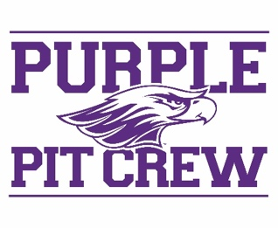
2024 Purple Pit Crew
Position Description

First Year Experience: Transition • Connection • Integration • Development

Responsibilities:
- Assist with orientation check-in process as well as the implementation of all Warhawk Welcome events, particularly R U Purple and Hawk Fest. Please note: physical labor is involved.
- Create a welcoming and inclusive atmosphere for all students and families: UW-Whitewater is an institution which values diversity of thought and background, seeks to create a better world for all, and strives to be welcoming and inclusive of everyone with consideration for such aspects as race, ethnicity, gender, sexual orientation, disability, religion or other differences.
- Work collaboratively and respectfully with all university personnel (i.e. faculty, staff, administration, etc.). Use appropriate language and behavior throughout all forms of communication (in person, via email, on social media, etc.).
- Adhere to all campus policies and state/federal laws. Failure to abide by University policies and/or state law may be cause for removal from the position.
- Represent UW-Whitewater and the Office of the First Year Experience in a professional manner and with a positive attitude. Exhibit pride for First Year Experience and the UW-Whitewater campus.
- HAVE FUN!

Qualifications:
- Full-time student in good academic standing.
  - Must be a current student at UWW for at least one semester
- Desire to help new students transition to UW-Whitewater.
- Ability to serve as a positive role model and to be approachable.
- Be detail oriented and self-motivated.
- Serve as an inclusive leader: one who is welcoming and affirming of all students and families.

Required Dates:
- August 30: Hawk Squad and PPC training, 9am-4pm
- August 31: Warhawk Welcome (all day, exact hours TBA)
- September 1: Warhawk Welcome (all day, exact hours TBA)
- September 2: Warhawk Welcome (all day, exact hours TBA)

Compensation & Benefits
- Paid $9 per hour for training and position responsibilities during Warhawk Welcome.
- Gear: two Purple Pit Crew shirts, water bottle, drawstring bag
- Opportunity to move into the residence halls early
- Gain leadership experience and skills while working with a team!

