How to register for
Warhawks SOAR

Warhawks SOAR registration opens as follows:
March 1 for students starting in September
October 1 for students starting in January
- Log into WINS:
  - From uww.edu, click on “WINS” at the top.

  - Log-in:
    - Username: enter your NetID which is your last name (the first 8-9 characters), your first initial, middle initial, and the two digit day you were born (i.e. May 4= 04): https://my.uww.edu/NetId.aspx.
    - Password: the first time you log in your password is your 7 digit student ID number. This number can be found in your admit letter. If you are unable to locate your ID number, call the Admissions Office at 262.472.1440.

- In WINS, from “Student Home”, click on the Warhawks SOAR tile:
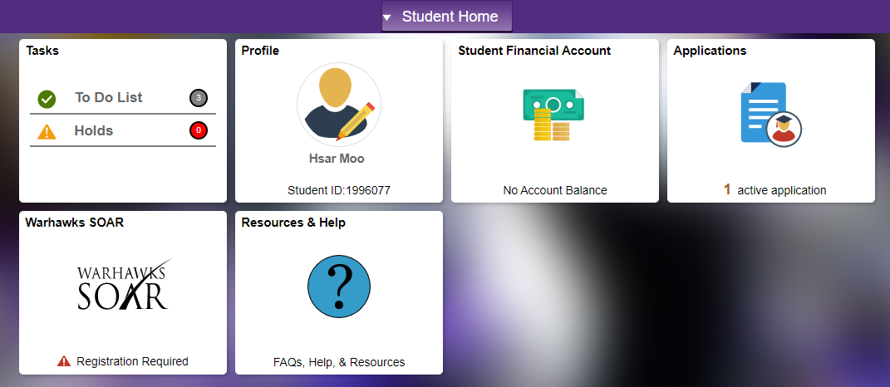

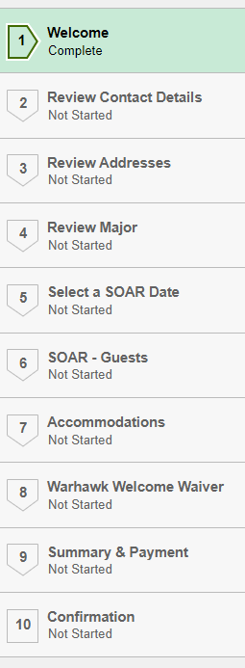
- Complete the 10 step registration process:

Please note: to complete your reservation, payment of the $100 enrollment deposit is required. The “Summary & Payment” screen will have a “Click To Pay” button to submit payment. There is not an option to defer these fees.
The new student fee ($90 for freshmen, $50 for transfers), Warhawks SOAR guest fees ($15 per guest) will be added to the student's first semester bill.
Questions? Please contact the First Year Experience Office at
262-472-3205 or fye@uww.edu.

