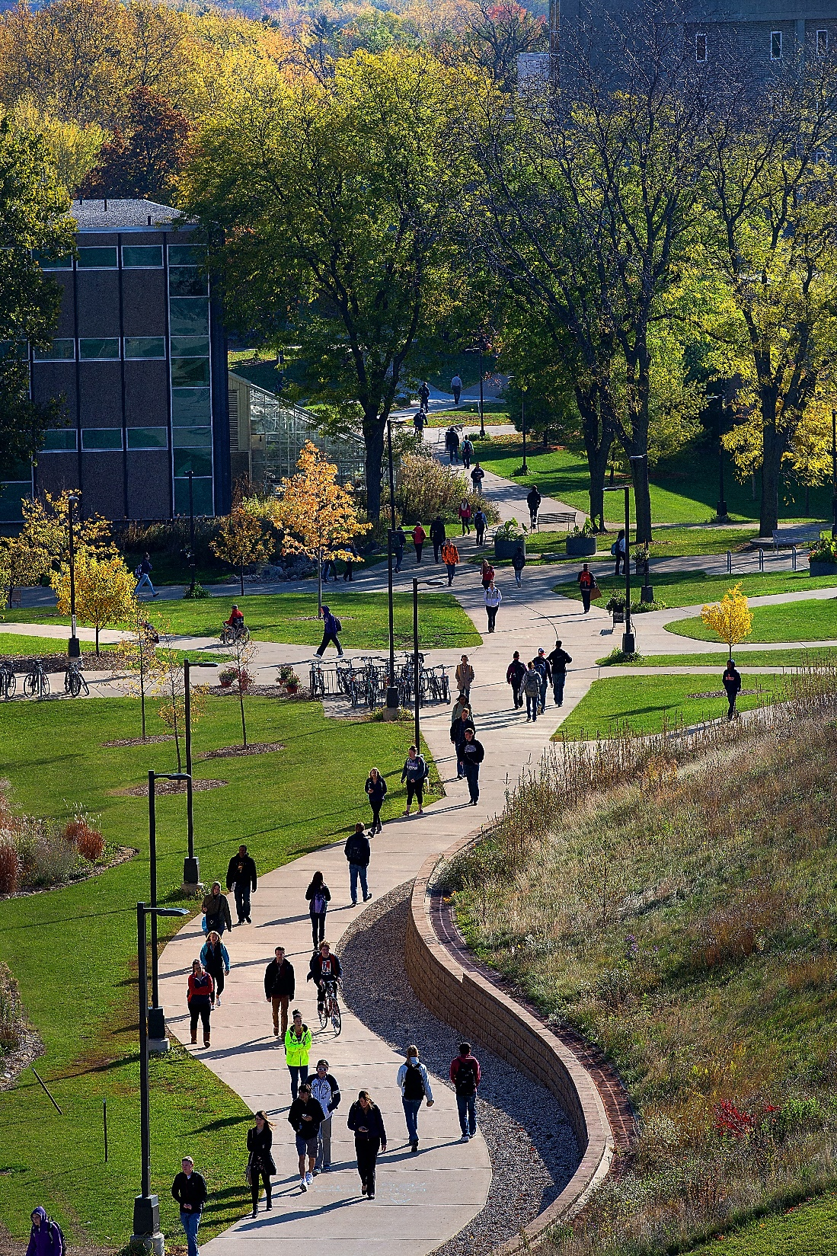
2021-2022
Fact Sheet

Table of Contents

General Information | 3
Nomination and Application | 4
Post-Admission | 7
Academic Information | 8
Campus Life | 9
In and Around Whitewater | 10

Location
General Information
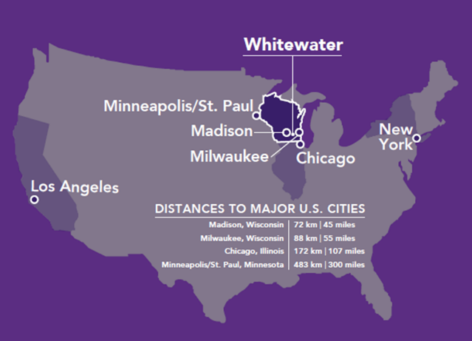
UWW is located in the city of Whitewater. The city’s population is about 14 000, which makes it a tight-knit community that values peace and cordiality. Whitewater is an ideal, quiet place to concentrate on one’s studies.
The city of Whitewater has all the advantages of a small town, while also being strategically located an hour’s drive from Madison the capital of the state of Wisconsin, and Milwaukee, the biggest city in Wisconsin. It is also 2-hour drive from the third largest city in the US, Chicago.

General Background
Enjoying robust undergraduate enrollment of around 12,000 students UWW offers undergraduate and graduate programs in over 75 areas of study, as well as a residential Intensive English curriculum. Students learn from the experts: no courses at UWW are taught by teaching assistants or graduate students, but instead by instructors with the highest degrees in their fields. A small student-faculty ratio (21:1) allows faculty to get to know each student and encourage individual success in the classroom and through research, internships and mentoring.
Academic Offer
University of Wisconsin Whitewater offers a wide range of courses across 5 academic departments:
College of Arts and Communication
College of Letters and Sciences
College of Business and Economics
College of Education and Professional Studies
School of Graduate Studies

Contact Information
Incoming exchange students to UW-W; application documents, visa, insurance, course registration, housing: Office of Admissions – Shia Lee and Jodi Simek | Tel: +1 262-472-1440  Email: lees08@uww.edu  Website: http://www.uww.edu/international/future/exchange
Outgoing exchange students from UW-W, balances:  Office of Global Experiences – Shia Lee and Dan Colleran | Tel: +1 262-472-5379  Email: studyabroad@uww.edu  Website: https://www.uww.edu/international/globalexperiences

Nomination
Nomination and Application
- Students must be nominated by their home university
- Students must have completed at least one year of university studies prior to the beginning of exchange studies at UW-Whitewater
- Student must be in good academic standing at their home university
- Exchange coordinators should send their nominations to lees08@uww.edu
- Nominations should include the student name, email address, major field(s) of study, academic level (undergraduate or graduate), and term(s) of study at UW-Whitewater
Application
After nomination we will reach out to each nominee with the coordinator in copy explaining their next steps. We encourage student to complete the application and submit the supporting materials by the deadline. However, we can consider applicants even past the deadline depending on class availability and visa processing times.
To be considered for exchange admission to UWW we require the nominees to submit the following:
- Online application as a Special (non-degree student)
- Exchange Student Application Supplement
- English Proficiency Results (or attestation of English proficiency)
- Official academic transcript (in English, or with an English translation)
- Copy of Passport
- Certification of Finances Form
- Bank Statement issued within the past 6 months
- Course Selection Form*

All of the above should be sent electronically either by the exchange coordinator or by the applicants themselves to lees08@uww.edu
Online Application
Exchange students (both graduate and undergraduate) should submit an electronic application here: https://apply.wisconsin.edu/. The application is free. After submission applicants are redirected to a payment page which they should ignore.
Detailed instructions on eApp submission are available on our website.
Exchange Student Application Supplement
This document contains the release statement that when signed allows us to release the student’s final transcript to the home university in compliance with FERPA regulations.
The second page should be used as a checklist to make sure that all the necessarily documents are provided.

English Proficiency Results (or attestation of English proficiency)

According to US exchange regulations (22 CFR 62.10(a)), incoming exchange students must possess enough proficiency in English to successfully participate in their studies and function on a day-to-day basis. The same regulation requires accepting institutions to check this proficiency by either a test, an attestation or an interview.
Applicants can demonstrate it by
- submitting a corresponding score from this list. Please note that the scores can come electronically. We do not require official results to be mailed to us.
- submitting a UWW Attestation of English Proficiency Form.
- submitting other English proficiency documentation if it stipulated in the exchange agreement
Please note that we have to collect one of the above for any exchange applicant even those who come from English-speaking counties.
Official academic transcript (in English, or with an English translation)

Some UWW courses, especially upper division ones, require certain prior knowledge, having transcripts for applicants allows our advisors to define if the students are ready to take those classes.
The transcripts should be sent electronically. If they are not issued in English, please also send the English translation.
Copy of Passport

US exchange regulations also require us to issue documents in the official legal name of the student. To do that we need a scan of the biographical page of passport.
Student’s legal name is only used for the admission and immigration documents. They can set a preferred name in their account at UWW after arrival.
Certification of Finances
According to US exchange regulations (22 CFR 62.12(b)(1)), exchange students must show “adequate financial resources to participate in and complete his or her exchange visitor program”. This is usually done through a bank statement. That bank statement could come from a sponsor as well as the student themselves. To connect the sponsor and the student we need the Certification of Finances form.
After the form is completed and signed by both the student and their sponsor it should be emailed to lees08@uww.edu If the student is providing their own bank statement, the Certification is not required.
Bank Statement issued within the past 6 months

The statement should name a specific amount. We cannot accept bank letters attesting to “sufficient finances”. Statements should be issued within the past six months.
Specific amounts are available on our website. The amounts stated are estimates.
Please refer to our partnership agreement to find which of the 3 models applies to you (Tuition Only, Tuition, Room and Board or Wisconsin-Hessen Agreement).
All incoming exchange participants are required to have the UW System insurance. We cannot provide waivers for that. The charge will be applied to the student’s account. More information here.
Course Selection Form*
Although Course selection is stated as a part of the application packet, it is not always possible to submit it at the time of application.
Course schedule release dates are usually after the application deadlines so we will consider an applicant if we receive all the materials apart from the Course Selection.
Students can submit the selection after the schedule is posted. Due to high demand we recommend starting the selection immediately after the classes are available.
We will notify the students when they can start the selection. If a student is applying after the class registration is open, we will require the course selection as part of the application.
Fall schedule is usually available in early April. Spring schedule is usually available in October.

Next Steps
Post-admission
After the student is admitted we will notify them via email. The email will also include a link to their Next Steps.
The page contains information on setting up UWW email address. That email will be the University’s official communication channel with the student. Username and NetID required for setting up will be stated in the admission email.
Applying for Housing
Students should submit housing application here. The application is available on a year-long basis. If a student is studying at UWW for one semester, they should still submit the year-long application. They will not be charged for the second semester.
Part of the application is the deposit payment page. The students should print the form out, sign it and send a scan of it to lees08@uww.edu. No payment is required at that stage. We will use the form to reserve accommodation. A charge of $25 will be put on student’s account when they arrive on campus.
Exchange students are not required to live on campus. However, if students are interested in off-campus housing, they will need to arrange it themselves.
Register for Orientation
All incoming exchange students must attend International Student Orientation. Representatives from vital offices such as Student Accounts, the Registrar and International Office provide valuable information to students.
As part of orientation, the students will also meet with academic advisors.
UWW charges all exchange students an Orientation Fee ($170* at time of this writing) and International Activities fee per semester ($125 at the time of writing) for the mandatory, pre-term international student orientation program and international student portal. Fees may change without notice.
*Subject to change without notice.
Apply for J-1 visa
All exchange students must obtain a J-1 visa prior to arriving in the USA. After admission UWW issues Form DS-2019 which we send along with the admission letter to the student via FedEx.
Upon receipt of DS-2019 the students should schedule an appointment with their nearest US embassy or consulate.
Students must bring original DS-2019 along with the passport with the J-1 visa when entering the USA.
Students are required to arrive prior to the orientation, however, they are allowed to enter the US 30 prior to that date.

A Course Selection Form must be submitted so that our academic advisors can pre-register students for their courses. The Course Selection Form can be submitted only one time. If any changes are necessary, they can be made upon arrival, subject to course availability and approval. Therefore, students should complete the form carefully and submit it only after they have obtained approval from their home university. Enrollment in courses is subject to availability, course schedules, and approval by UW-W’s academic advising coordinators. UW-W will endeavor to successfully place students in courses who meet the requirements as space in these courses allows.
Academic Information
Students can find the courses offered for their intended semester under “WINS Guest Course Search”.
The link above has the schedule, course description and method of delivery for every course offered during that semester. If posted, students can also find syllabi here (requires log-in).
Academic load
J-1 visa regulations require undergraduate students to be enrolled in at least 12 credits of face-to-face classes per semester (9 credits of face-to-face classes for graduate students). When selecting classes, students should pay special attention to the mode of delivery to make sure the class is face-to-face. Students can only select online courses if they are already enrolled in 12 (9 for graduate) on-campus credits. However, online classes are not covered under tuition waiver and if selected, students will have to pay online class tuition themselves. Graduate students are permitted to take undergraduate courses. However, undergraduate students cannot take graduate-level classes. Instructions on course selection can be found on our website.
Hybrid and 8-week
Some courses (especially in our MBA programme) are offered on hybrid and/or 8-week basis.
Hybrid classes are a combination of face-to-face and online study. Exchange students are permitted to take hybrid courses only if they are already enrolled in 12 (9 for graduate) on-campus credits.
Typical semester lasts about 16 weeks. 8-week classes are offered for the first and second 8 weeks of the semester. Exchange students are permitted to take 8-week classes as long as they maintain full time enrollment throughout the semester. For example, a graduate student can take two first 8-week classes (3 credits each) and one second 8-week class (for 3 credits). Students cannot enroll in 9 credits of all first 8 week classes and not study during the second 8 weeks.
UWW Academic Calendar can be found here (Check all the boxes for “Academic&Administrative”)
UW-W uses an A-F grading scale and honor points on a 4.00 scale. One official transcript will be mailed to each student’s home university upon completion of the exchange period to assist in the transfer of credits. Students may request additional copies of their transcript from the Registrar’s Office for a small fee.

Housing
Campus Life
UWW has 13 Residence Halls. Each has a live-in Residence Assistant, student staff member who help facilitate positive learning communities in the residence halls. Every residence hall floor has at least one RA who is available to serve as a resource for residents, to offer individual assistance, and to promote community development by interacting individually with students and encouraging group interactions.
Most international exchange students are placed in either Wells East or Starin Halls. Housing assignment could be changed upon request but is subject to availability.
Dining
UWW is served by two dining halls and several cafes across campus. Students can purchase a meal plan ranging from 10 to 24 meals per week in the dining halls. Meal plan will be loaded onto the student’s UWW ID card. Students can then just swipe the card to get into the dining halls or purchase food on campus.
Please note that unless specified in the exchange agreement, meal plans fees are not waived.
Safety
UWW has been named as the safest campus in Wisconsin. We strive to maintain student safety through a 24/7 police department on campus, emergency call towers located near parking lots and via text emergency notification system.
Facilities
In addition to excellent academic facilities UWW can also purchase access to state-of-the-art recreation center with an indoor track, weight room and swimming pool.
Students can take advantage of free tutoring at the brand new Chrisman Success Center.
Activities
Our International Students and Scholar Services organize several trips throughout Fall and Spring semesters. Recently our students visited: Milwaukee Bucks basketball game, Skyzone Trampoline Park in Madison, Haunted House/Corn Maze at Schuster’s Farm and had a hiking trip to Devil’s Lake. Some of the trips are free and some require a small payment to cover entry and transportation fees.
Work
J-1 exchange students are allowed to work on campus in job providing services to the students. Workload is limited to 20 hours per week. Students must find employment on campus first. Admitted students can view campus jobs on our website. Students must report initial and any changes in employment to our International Students and Scholar Services.

In Whitewater
In and Around Whitewater

Whitewater is a historic town with many restaurants, a supermarket, and several pharmacies. Two emergency medicine centers are located in the city. The nearest hospital is a 15-minute drive from campus.
The climate of Whitewater is mild with average temperatures of +28C in July and -3C in January which offers many recreational opportunities.
Transport
There is no direct bus service from Whitewater to nearest cities. Students can take advantage of the University’s free shuttle bus running between our main and Rock County campus. The shuttle stops at Van Galder JTS Bus Station in Janesville, WI.
Students can also use Uber, Lyft or rent cars to get around.
Around Whitewater
From Janesville students can take busses to
- Madison, Wisconsin’s capital of about 255,000 inhabitants;
- Milwaukee, Wisconsin’s biggest city of 595,000;
- Chicago’s O’Hara International Airport. Airport is connected to the city of Chicago via a metro line.
The state of Wisconsin is a great place for hiking with Kettle Moraine Ice Trail located about 15 minutes outside Whitewater. Other places of interest include
- Wisconsin Dells
- Lake Geneva
- House on the Rock

