- After creating an account this question will appear on screen, click continue. 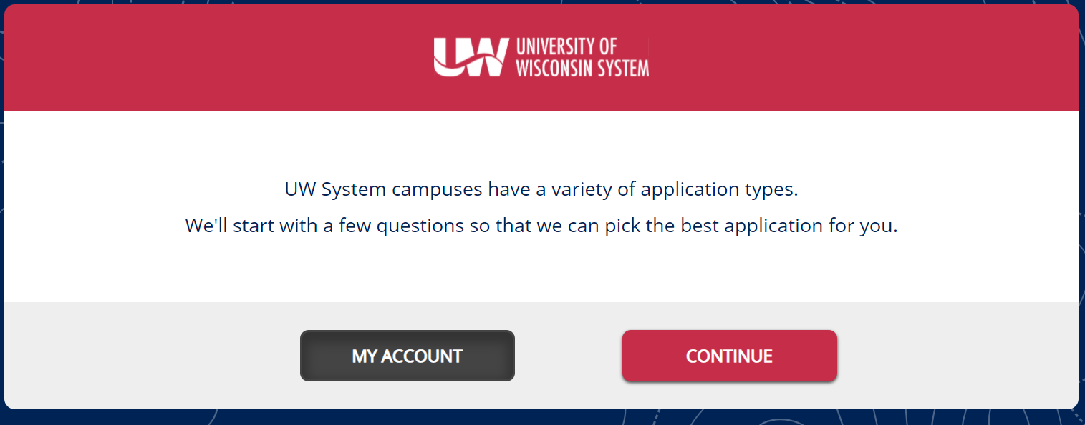
- Select a few courses.
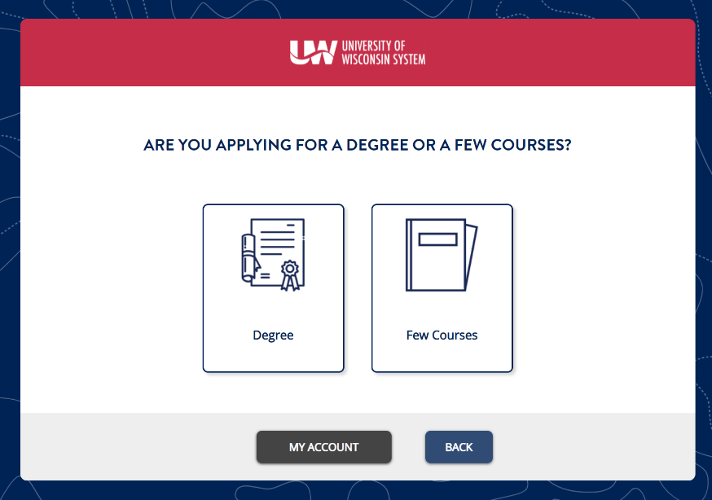

- You will be asked whether you are a U.S. Citizen or not. If you select No go to step four, yes go to step five.
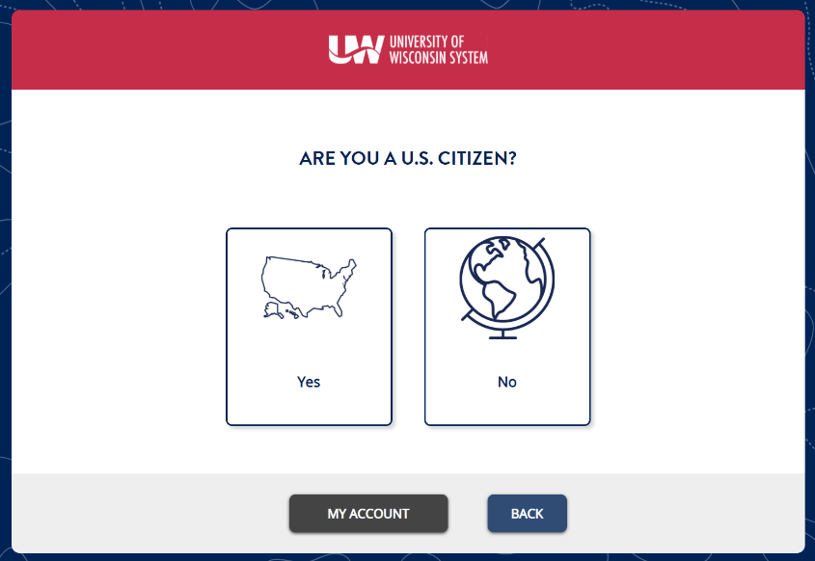
- Selecting no will bring you to an additional question, U.S. Residency Status, select one. Proceed to step five.
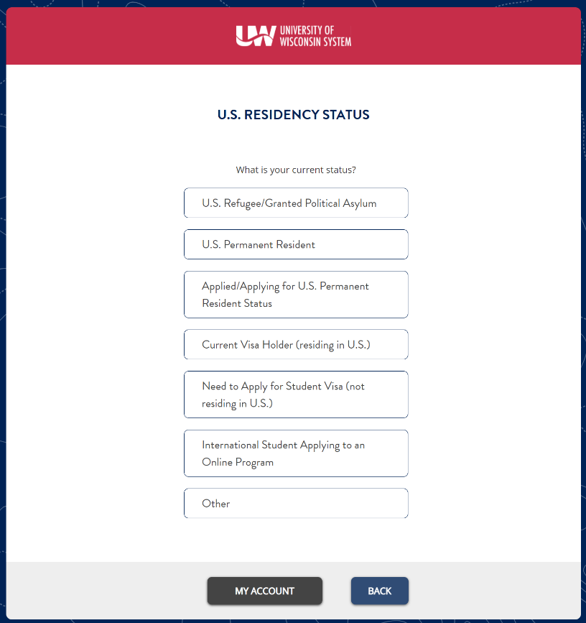

- Select yes.
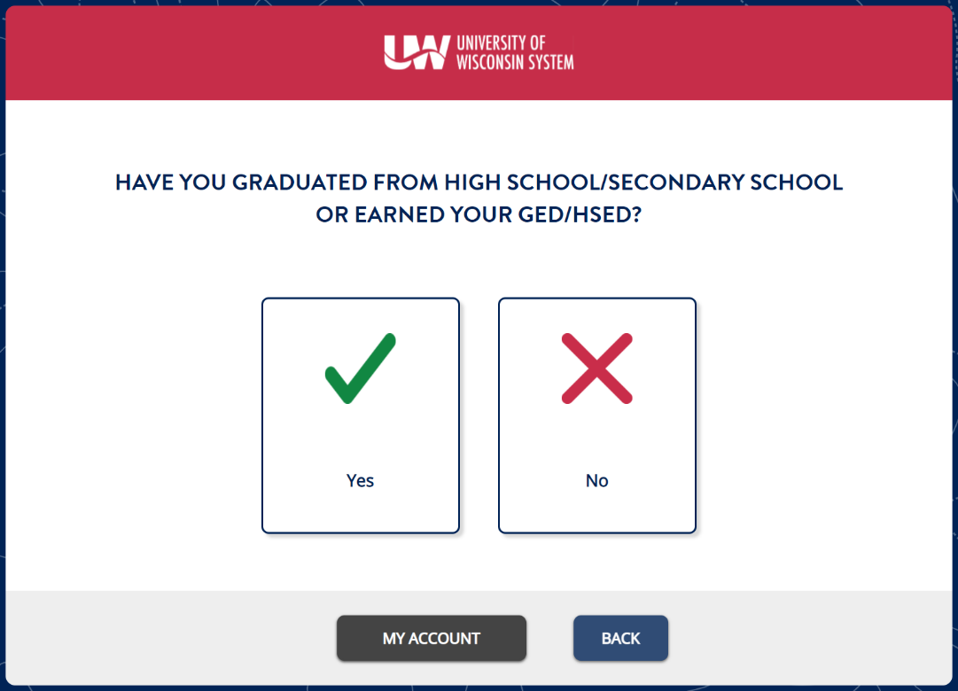

- Select Graduate.
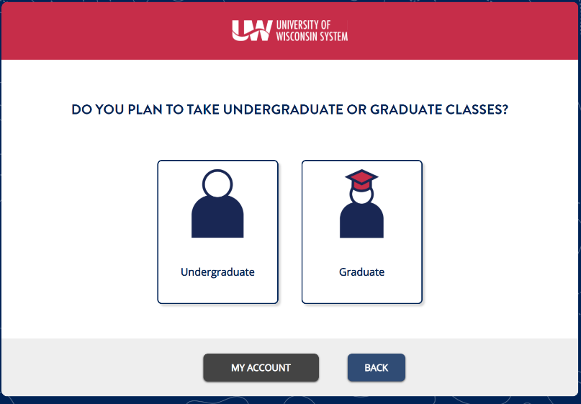

- Select yes.
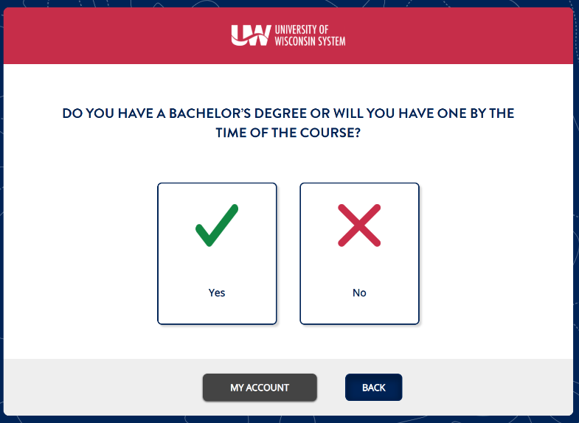

- It will say you are a graduate non-degree applicant, click continue.
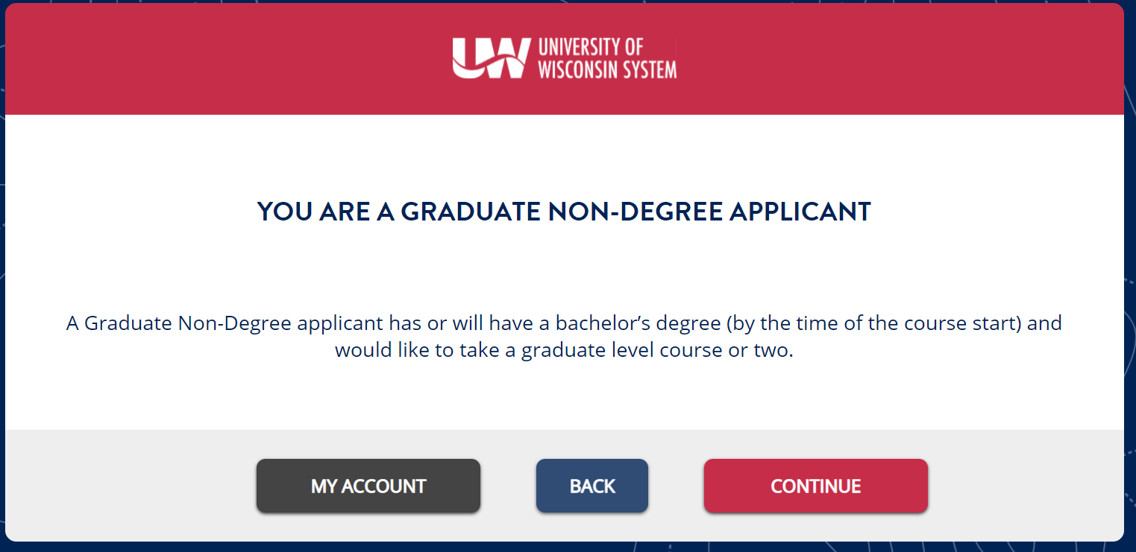
- Select UW-WHITEWATER and press save and continue.

- Then you may select the program you wish to apply for.
