CITI TRAINING INSTRUCTIONS

These instructions will help you set up an account and enter the site for the required training needed to do Human Subjects Research and Animal Research at UW-Whitewater. The Office of Research and Sponsored Programs covers the cost of the training module. There is an option for continuing education credits but the cost must be paid by the individual.

- Click on the CITI Training logo on our home page or training page.

- You will now be on the home page for CITI.
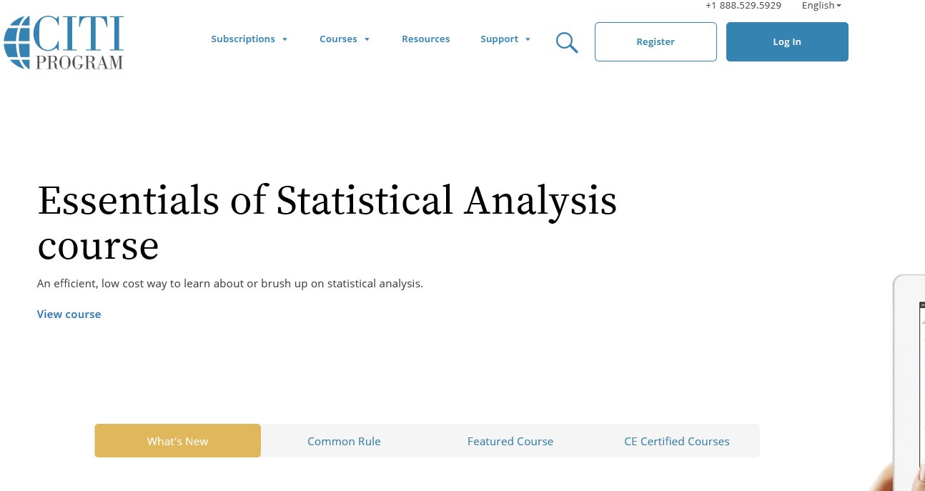

3. Click on the “Log In” button. This will take you to where you can log in or register to set up an account.

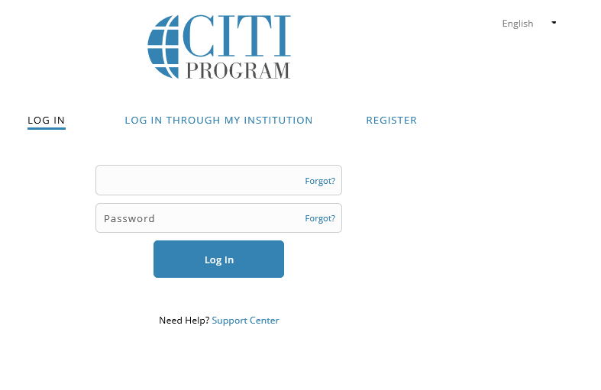
4. If you have forgotten your account information, you will get the following error message:
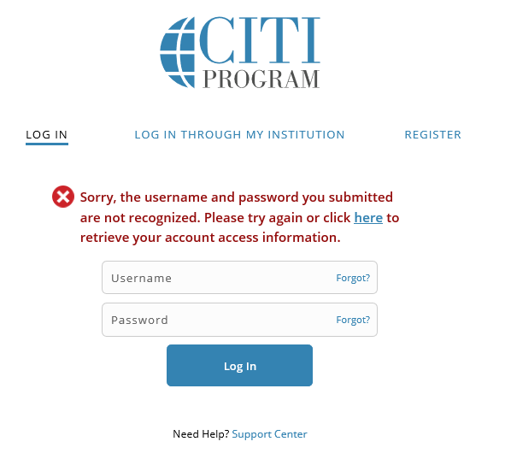
5. You will then be able to retrieve your username or reset your password.
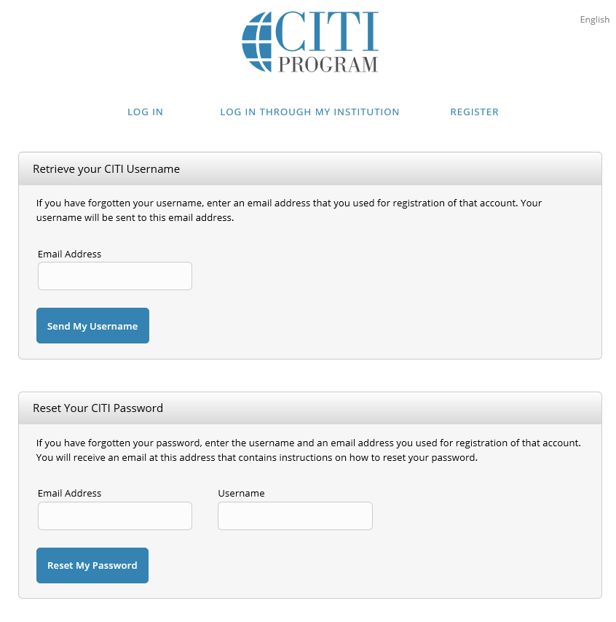
6. Once logged in, you can click on courses and see the following screen:
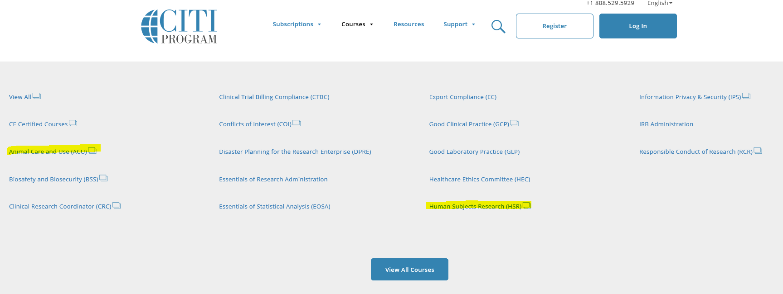
7. The highlighted areas are the only ones needed for research. Click on “Human Subjects Research” and scroll down the page to the Basic Courses section. The highlighted course is the one required.
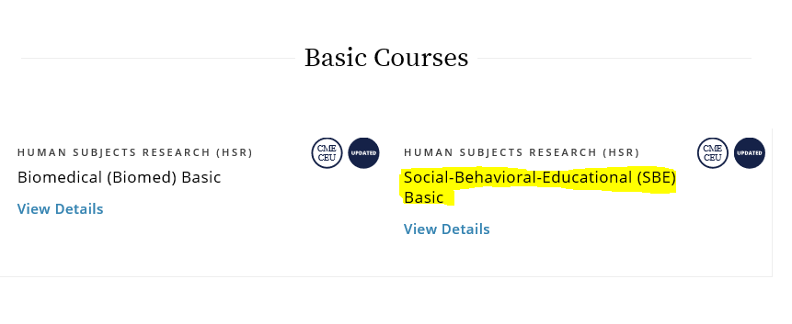
8. If you are doing animal research, you will go to the Animal Care and Use area and scroll to the basic courses. The highlighted course is one of the required courses.
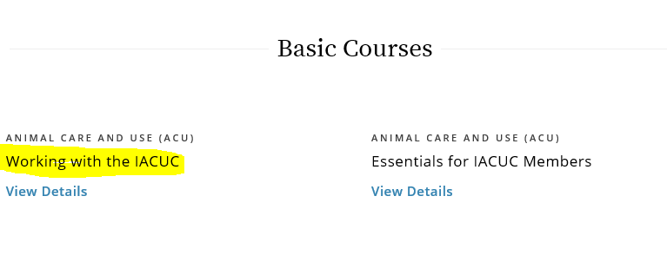

9. You will also need one of the animal specific courses based on the type of animal you are working with. (Below is a sample of the types of animals and does not include all of them.)
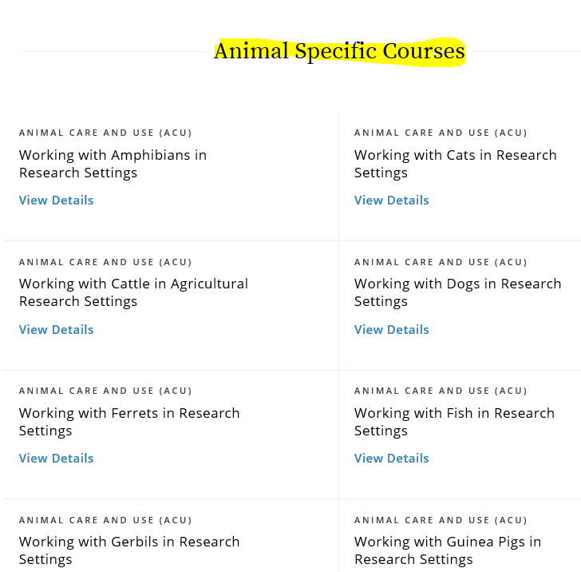
10. Once you register and pick your courses, you will be able to log in anytime and see your courses that you have signed up for or started. This will be your new home page.
