- Policy Purpose

This establishes a grievance procedure as a problem-solving mechanism for University Staff with an expectation of continued employment who wish to appeal working conditions, discipline, layoff, or dismissal. This policy applies to all permanent university staff employees.

- Background

The UW-Whitewater grievance policy establishes a dispute resolution process for University Staff. UW-Whitewater has developed formal grievance procedures in accordance with Wis. Stat. § 36.115(4) (which requires the Board of Regents to develop personnel systems that are separate and distinct from the personnel systems under Wis. Stat. Chapter 230), and with UW System Administrative Policy 1233: Grievance Procedures. Effective July 1, 2015, the grievance procedures found at Chapter ER 46 of the Wisconsin Administrative Code and any procedures established by the Office of State Employment Relations are no longer applicable to current UW System University Staff employees. Therefore, this policy and these procedures provide grievance procedures for University Staff employees that hold positions with an expectation of continued employment at UW-Whitewater. For employees hired before July 1, 2015, an additional option is available pursuant to Wisconsin Employment Relations Commission (WERC). See 7. Grievance Procedure, Step Two B for more information.

- Definitions

Chancellor’s Designee: an administrative officer with the authority to hear and adjust personnel and policy actions when they have been grieved through this policy. At UW-Whitewater, the Chancellor’s designee for University Staff grievances is the Chief Human Resources Officer.

Discipline: any action taken by UW-Whitewater with respect to a University Staff member with an expectation of continued employment, which has the effect, in whole or in part, of a correction or a penalty.

Disciplinary Actions: include written reprimands, suspension, demotion, or termination.

Dismissal: separation from employment for disciplinary or performance reasons.

Grievance: a request for a specific action to solve a problem or redress an action resulting from working conditions, discipline, layoff, or dismissal.

Grievance procedure: the process through which certain working conditions, discipline, layoff, or dismissal of a UW System University Staff member can be appealed. All University Staff with an expectation of continued employment at UW-Whitewater are eligible to file a grievance through this provision.

HR&D: UW-Whitewater Department of Human Resources & Diversity.

Impartial Hearing Officer: a grievance review committee Chair (University Staff Grievance Subcommittee Chair or designee) established through the University Staff Council, an arbitrator from a roster developed by UW System Administration of arbitrators, an arbitrator from the Wisconsin Employment Relations Commission (WERC) roster of neutral decision makers not employed by the WERC, or an arbitrator employed by the Wisconsin Employment Relations Commission.

Just Cause: a standard that is applied to determine the appropriateness of a disciplinary action. The elements of determining whether just cause exists include:

- Whether the employee had notice of reasonable workplace expectations and the potential consequences if those expectations were not met;
- Whether the workplace expectations were reasonably related to business efficiency and performance the employer might reasonably expect from the employee;
- Whether a full, fair, and complete investigation was undertaken by the employer before discipline or discharge to determine whether the employee violated expectations;
- Whether the employer obtained substantial evidence of the employee's guilt;
- Whether workplace expectations were applied equitably and without discrimination; and
- Whether the degree of discipline imposed was reasonably related to the seriousness of the employee's offense and the employee's past record.

Layoff: separation from employment for reasons of budget or due to the discontinuance, curtailment, modification, or redirection of a program.

Preponderance: the preponderance standard, burden of proof is met when the party with the burden convinces the fact-finder when there is greater than 50% chance that the claim is true.

Working Conditions: the working environment and all existing circumstances affecting labor in the workplace including, but not limited to, work hours, physical aspects of the job, and assignment of duties outside the employee’s job description.

Workplace Safety: the maintenance of occupational health and safety standards and for the promotion of workplace health and safety.

University Staff: are members of the university workforce that contribute in a broad array of positions in support of the university’s mission.

University Staff Grievance Subcommittee: A standing subcommittee of the University Staff Council, consisting of University Staff employee representatives appointed to University Staff Council. Some members shall carry “replacement status” for hearing grievances in the event of an absence or conflict of interest of one of the standing subcommittee members. Service on the University Staff Grievance Subcommittee will be conducted without loss of pay, and subcommittee members will be released from their regular duties to participate. Additionally, there shall be no adverse repercussions from serving on the University Staff Grievance Subcommittee.

- Grievable Subjects

University Staff with an expectation of continued employment may file a formal grievance contesting layoffs and disciplinary actions if the employee alleges that the action was taken without just cause. These grievances may be moved through the steps of the grievance procedure as follows:

- Grievable subjects for University staff with an expectation of continued employment:
  - Written Reprimand: Step One only
  - Other Disciplinary Actions: Begin at Step One and may proceed through Step Two (A or B)
  - Layoff: Begin at Step One and may proceed through than Step Two (A or B)
  - Dismissal: Begin at Step Two (A or B) and may proceed through Step Three

University Staff may file a formal grievance regarding working conditions if the employee alleges that the employer failed to comply with an applicable policy, rule, or procedure. Such a grievance may allege that the University failed to provide safe working conditions. These grievances may be moved through the steps of the grievance procedure as follows:

- Grievable subjects for all University Staff employees:
  - Working Conditions/Workplace Safety: Step One only

- Non-Grievable Subjects

Actions not grievable under this policy include the following:
- Verbal warning or verbal reprimand
- Termination of an appointment for temporary employment
- Release from probation
- Performance evaluations
- Any matter alleging sexual harassment or matters alleging harassment and/or discrimination on the basis of protected class (e.g. age, race, creed, color, sex, marital status, disability, sexual orientation, national origin, or arrest and conviction record) whose complaints are appropriate for the procedures of the UW-Whitewater Department of Human Resources & Diversity, and other state and federal laws.
- Activities falling under management rights are not grievable. Management rights include, but are not limited to:
  - Utilizing personnel, methods, and means in the most appropriate and efficient manner possible as determined by management
  - Managing and directing employees
  - Determining the size and composition of the work force
  - Determining the content of written policies and procedures
  - Managing the job evaluation system, which includes position classification, the establishment of position qualification standards, and the allocation of positions to classifications.
  - Hiring, promoting, assigning, or retaining employees
  - Establishing reasonable work expectations
- Wisconsin Retirement System (WRS) benefits and health insurance matters
- Any other matter which UW-Whitewater has no authority to resolve disputes

- Right to Representation

A grievant may designate a representative of their choosing to be present at any grievance meeting and/or hearing. Prior to a grievance meeting and/or hearing, all communications regarding a grievance will be with the university staff employee unless the employee states in writing all communication must go through their designated representative. During the meeting and/or hearing, the representative has the right to observe and take notes, ask clarifying questions, serve as an advisor to the employee, explain significance of points made by the employee or employer, and speak about practices at the work site. The representative has no right to speak for the employee in response to questions. If a representative and/or advisor is selected by an employee who is an attorney, the employee must provide HR&D with notice at least 48 hours in advance of the meeting.

- Grievance Procedure

Prior to filing a formal grievance, University Staff employees are encouraged to first seek resolution of their grievances through informal discussions with their immediate supervisors. The Department of Human Resources & Diversity may serve as a resource to mediating a resolution. If such a discussion does not resolve the matter, an employee may file a formal grievance following the procedures set forth in this policy.

University Staff serving a probationary period do not have the right to file grievances on dismissal, discipline, or layoff.

Temporary and project employees may grieve working conditions or workplace safety issues only. Process timelines are established to enable review and resolution within a reasonable time after the problem occurred.

Discipline or dismissal of a University Staff member with an expectation of continued employment may be imposed only for just cause.

The University Staff Grievance Subcommittee will be provided with copies of letters of discipline issued to University Staff employees.

Grievances shall be submitted on a form provided by the employer (Exhibit I). Only one subject matter may be covered in any one grievance. Each grievance shall describe the facts upon which the grievance is based, and the relief sought by the employee.

The employee and the appropriate grievance step respondent may agree in writing to extend the time limits in any step of the grievance procedure. Parties are strongly encouraged to resolve situations prior to a grievance being filed, but upon filing, parties are encouraged to resolve grievances at early stages of grievance procedures.

UW-Whitewater is prohibited from retaliating against a grievant for filing a grievance or against a representative or witness who participates, or is scheduled to participate, in grievance proceedings.

At any stage of the process, the employee may choose to submit a written statement in lieu of participating in a grievance hearing. The written statement will be considered in the same manner as an in-person hearing.

The grievant has the burden of proving his/her case by a preponderance of the evidence, except in the case of a discipline or dismissal, for which the University will have the burden of proving just cause by a preponderance of the evidence.

If an employee fails to observe any grievance procedures time limit, the grievance will be considered resolved. Time limits may be extended only by mutual agreement between the grievant and a UW-Whitewater management designee.

Grievances shall be pursued in accordance with the following steps and time limits.

Pre-file:

  - Prior to any grievance being filed, the employee and the employee’s representative (if applicable) must first meet with the supervisor and a representative from HR&D in an effort to resolve the issue.
  - If the grievance being filed is against the employee’s supervisor, the employee and the employee’s representative (if applicable) must first meet with a representative from HR&D in an effort to resolve the issue.
  - This meeting must take place within the first 20 days of the occurrence or when the employee should have been aware or become aware of the occurrence. If employees are not able to meet with their supervisor, they must contact HR&D for assistance.
  - The University will make a good faith effort to informally resolve a problem brought to management’s attention through discussion and open communication with the department or unit involved along with other University officials.
  - If there is no agreed upon resolution, the employee should move to Step One in the grievance process.

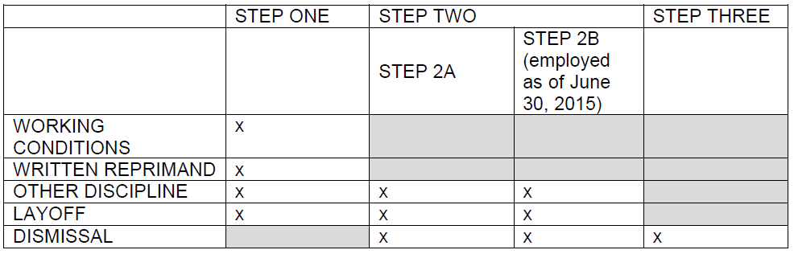

Step One:

If informal attempts to resolve a matter through discussion between an employee and supervisor and/or HR&D are not successful, a grievance may be filed.
      - Grievances shall be submitted using the UW-Whitewater Employee Grievance Form (see Exhibit 1). On the form, circle Grievance Step “1”. One grievance per form. Each grievance shall describe the facts upon which the grievance is based and the relief sought.
      - Grievances shall be filed with the employee’s supervisor or with an HR&D representative no later than ten (10) calendar days from the date the grievant received a response from the pre-file notification.
      - Within thirty (30) calendar days of receipt of the written grievance, a representative from HR&D will meet with the grievant to hear the grievance.
      - The grievant shall receive a written decision no later than seven (7) calendar days after this meeting.
      - If the subject of the grievance is not discipline or layoff, there will be no further opportunity for appeal.

Step Two A (Standard Procedure):

Appeal a discipline decision (not including written reprimands) or layoff decision from Step One, or appeal a dismissal.
            - Appeals shall be submitted using the UW-Whitewater Employee Grievance Form (see Exhibit 1). On the form, circle Grievance Step “2A”. One grievance per form. Each grievance shall describe the facts upon which the grievance is based and the relief sought.
            - File the appeal with HR&D as follows:
              - Discipline/Layoff – appeals must be filed within ten (10) calendar days from receipt of the decision in Step One.
              - Dismissal – appeals dismissal must be filed within twenty (20) calendar days of the date of written notice of dismissal.
            - HR&D will review the options for an impartial hearing officer with the employee. The employee must then select which impartial hearing officer will hear the case at the time the appeal is filed.
            - At issue before the impartial hearing officer will be whether just cause for the discipline or discharge exists. For cases involving layoff, the issue before the impartial hearing officer will be whether the applicable layoff procedure was followed.
            - The impartial hearing officer may refuse to hear a grievance for lack of timeliness or because the attempted grievance involves a non-grievable issue.
            - The impartial hearing officer will be charged with hearing the case within thirty (30) calendar days of the filing and responding within fourteen (14) calendar days of the hearing. The deadlines may be extended by mutual agreement. Hearings may be recorded. The hearing shall be closed unless it is opened by mutual consent.
            - The impartial hearing officer will make a report and recommendations to the Chancellor or Chancellor’s designee within fourteen (14) calendar days of the hearing.
            - Within twenty (20) calendar days of receipt of the report and recommendations, the Chancellor or Chancellor’s designee shall issue a statement accepting or rejecting the findings of the impartial hearing officer and explaining how the recommendations will be implemented.

Step Two B (Grandfathered Procedure for Certain University Staff):

An employee who held permanent status in State employment prior to July 1, 2015 and according to the provisions of Wis. Stat. § 36.115(6) retains Wisconsin Statute Chapter 230 appeal rights, and may appeal a disciplinary action, layoff or discharge directly to the Wisconsin Employment Relations Commission (WERC). Note: Employees hired prior to July 1, 2015, may choose an appeal route under Step Two A OR Step Two B.
  - The grievant may appeal directly to the WERC under Wis. Stat. § 230.44(1)(c) within 30 calendar days.
  - If an appeal to WERC is filed, no further steps in the grievance process will apply. The decision of the WERC may be subject to judicial review, but an appeal to the Board of Regents is not available using this procedure.
  - No grievances pertaining to working conditions may be appealed to the WERC.

Step Three – UW Board of Regents Review:

For cases of dismissal only, a grievant that is dissatisfied with the Step Two A (Standard Procedure) decision may appeal the decision to the UW Board of Regents.

- The appeal must be filed within 30 calendar days of receipt of the decision. Appeals shall be submitted using the UW-Whitewater Employee Grievance Form (see Exhibit 1). On the form, circle Grievance Step “3”. One grievance per form. Each grievance shall describe the facts upon which the grievance is based and the relief sought.
- The Board of Regents Personnel Matters Review Committee will conduct a review based on the record of the matter created by the impartial hearing officer and will prepare recommended findings and a decision and transmit them to the full Board for final action. No further appeal shall be available to the parties.
- Appeals taken to the WERC (Step Two B) may not be appealed to the Board of Regents.

A flow chart of the grievance steps can be found in Exhibit 2.

For information about the operation of the grievance procedure or how to appeal an action, contact UW-Whitewater Department of Human Resources & Diversity at 262-472-1024 or hr@uww.edu.

For concerns or issues during the grievance process, please contact usc@uww.edu or contact the current University Staff Council Chairperson directly. See the University Staff Council webpage for a list of current USC representatives.

- Related Documents

UW System Administrative Policy 1233: Grievance Procedures
UW System Administrative Policy 1277: Compensation
Wis. Stat. § 36.115(4)
Wis. Stat. § 36.115(6)
Wis. Stat. § Chapter 230
Wis. Stat. § 230.44(1)(c)
UW-Whitewater Employee Grievance Form

- Policy History

April 12, 2016: Links, contact information updated (phone number added), and formatting to align with UWW policy formatting.

April 20, 2017: University Staff Council revisions to revise University Staff Grievance “Committee” to “Subcommittee,” clarify membership of the University Staff Grievance Subcommittee, and clarify “days” as “calendar days.”

December 5, 2019: Updated the definition of the Impartial Hearing Officer from the entire US Grievance Subcommittee to US Grievance Subcommittee Chair to be in compliance with LAB audit.

March 11, 2020: Links, department name, grammatical, and inclusive pronoun language updated.

November 4, 2021: USC approved updated policy to include adding links to UW System policies and Wisconsin Statutes, rearranging policy layout and format, and adding additional wording to make it more user-friendly.

Future update to do: UW-Whitewater University Staff Disciplinary Policy and Procedures document is currently under development by HR&D. Once finalized, USC will incorporate reference to this document into this policy.

University Staff Personnel Rules: Employee Grievance Policy, 01 OCTOber 2021 VERSION:

Approved by University Staff Council: November 4, 2021
Effective Date: January 1, 2022

ACCEPTED AND APPROVED ON BEHALF OF THE UNIVERSITY

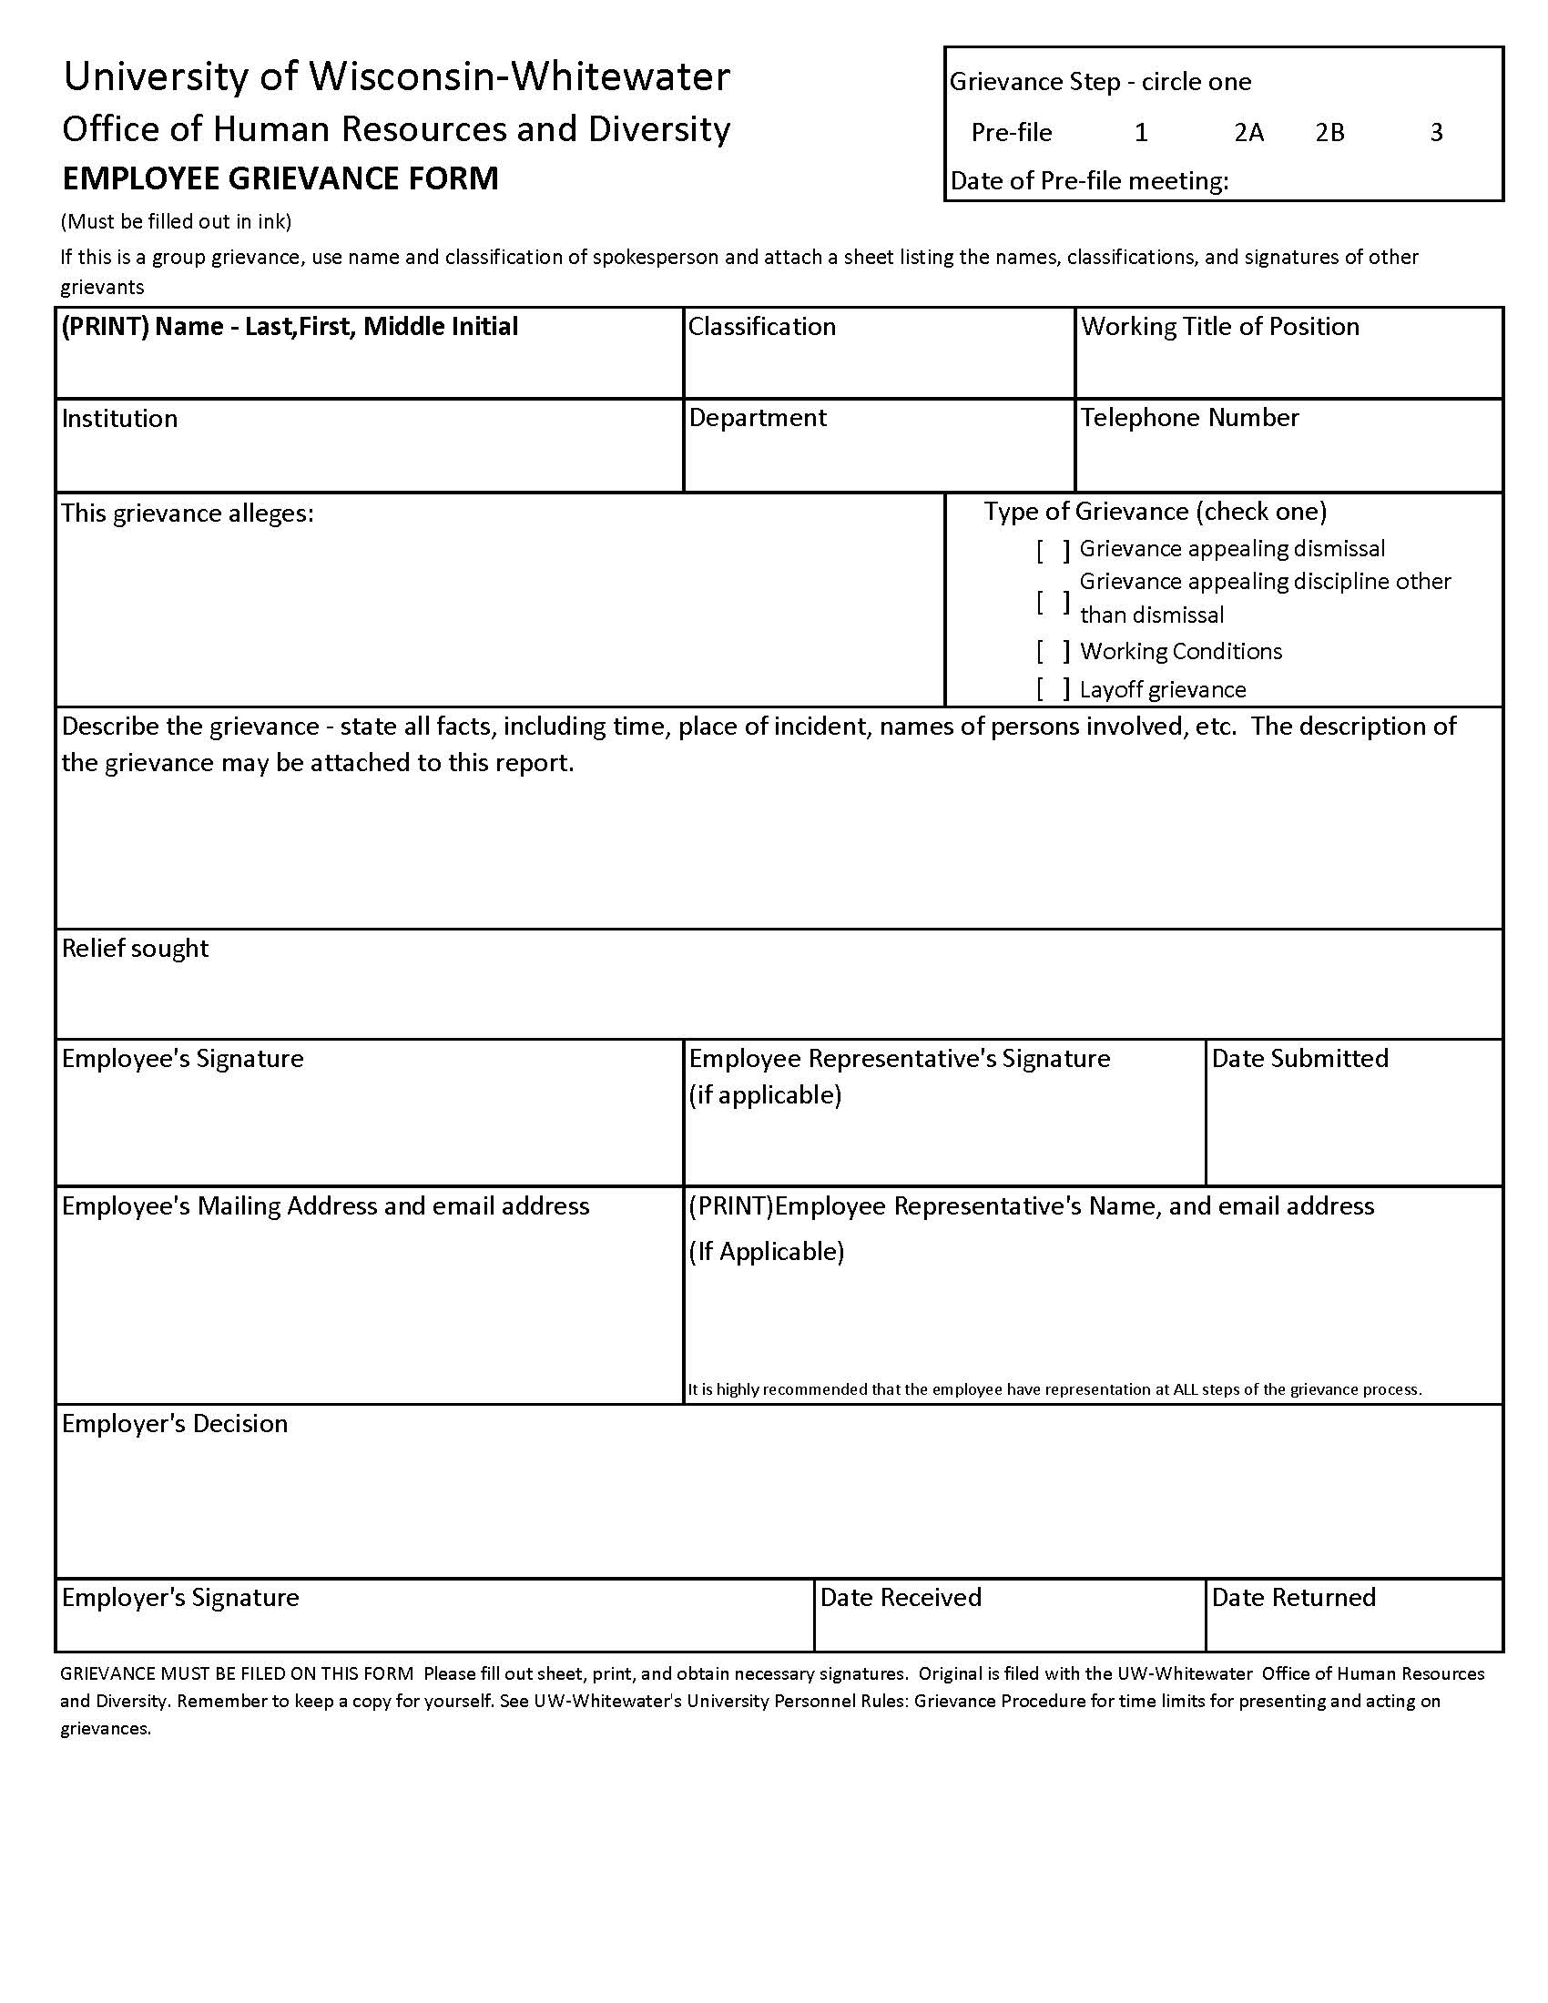
Exhibit 1
Exhibit 2

