Poster Instructions
*PowerPoint works best and we recommend it.
PowerPoint only does posters up to 56x42 inches; we recommend 40x40 inches.

Landscape Print

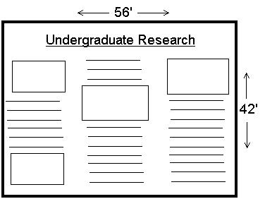-In page setup:
Custom size: Width: 56 in.
Height: 42 in.
Orientation: landscape

- Under Print Properties:
Paper Size: Postscript custom Page size: Width: 42 in.
Height: 56 in.
Orientation: Portrait
Rotate: Off Page Order: Front to Back

Portrait Print
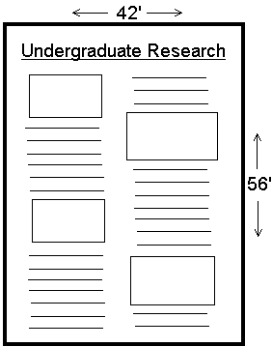
-In page setup:
Custom size: Width: 42 in.
Height: 56 in.
Orientation: Portrait

- Under Print Properties:
Paper Size: Postscript custom
Page size: Width: 42 in.
Height: 56 in.
Orientation: Portrait
Rotate: Off
Page Order: Front to Back

Additional Tips:
- In PowerPoint, avoid modifying backgrounds through “Slide Design”. This sometimes creates problems.
- For figures, use jpegs, not uncompressed formats. Import the smallest file that is suitable. Large PowerPoint files can print VERY slowly.
- Preview your poster carefully before you print—differences in fonts can sometimes change formatting.

Other Programs:
- Avoid PDFs!
- Adobe Photoshop files usually print OK but avoid very large files (over about 10 megs).

