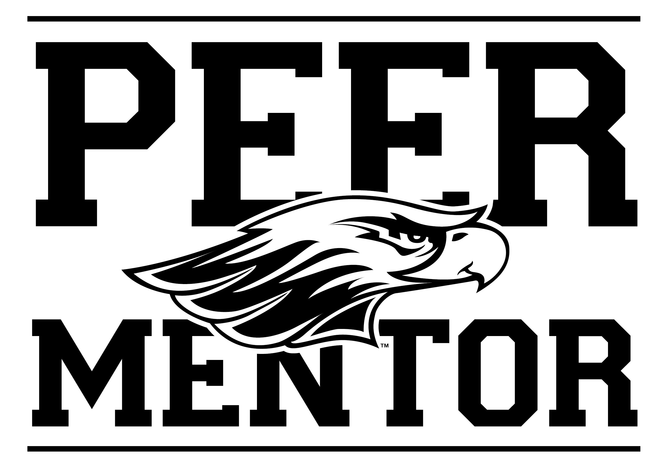
2024 Peer Mentor
Position Description

First Year Experience: Transition • Connection • Integration • Development

The Mentor program plays an active role in the University’s overall retention efforts. Peer Mentors assist new students with the transition to UW-Whitewater by serving as a role model and guiding students through their first semester on the UW-Whitewater campus.

Benefits & Outcomes
As a Peer Mentor you will develop your leadership skills, professional communication, group facilitation skills, and have the opportunity to work with a diverse population of students, faculty, and staff. Gain valuable work experience for any major.

Peer Mentors can make up to $900 in the fall semester.

Peer Mentor Responsibilities:
- Serve as a positive role model and resource to all new students.
- Lead a group of new students through fall orientation, Warhawk Welcome.
- Aid with the facilitation of a New Student Seminar section. Attend class each week in the fall semester, work collaboratively with assigned New Student Seminar Instructor, provide the student perspective on various class topics, and assist with classroom discussion & activities.
- Develop and maintain a connection with your assigned group of new students. Contact & support students outside of New Student Seminar weekly (i.e. email, texting, social media, in person, WebEx, etc.).
- Follow-up with mentees who need additional support or connection to resources as highlighted through the New Student Assessment.
- Complete all Mentor Program training sessions in August.
- Attend all Mentor staff meetings occurring twice each month throughout the fall semester.
- Complete required paperwork by the given deadlines (recording hours, contact reports, evaluations, Navigate case notes, etc.).
- Represent UW-Whitewater and the Office of the First Year Experience in a professional manner and with a positive attitude.
- Adhere to all campus policies and state/federal laws. Failure to abide by University policies and/or state law may be cause for removal from the position. (Conduct checks will be done through the Dean of Students Office and University Housing to ensure you are in good standing, and that you are not on probation for university or residence hall violations.)
- Perform other duties as assigned by the Mentor Program Manager, Graduate Assistant for Mentor Programs, or other staff members from the First Year Experience Office.

Qualifications:
- Full-time UW-W main campus student in good University conduct standing, academic standing, and cumulative Whitewater GPA of 2.8 or higher. (Grade checks will be completed each semester)
- Must have been a UW-Whitewater main campus student for at least two semesters by Fall 2024.
- Desire to help new students transition to college and adjust to UW-Whitewater.
- Ability to serve as a positive role model and be approachable.
- Demonstrate leadership abilities including involvement in extra-curricular activities.
- Ability to balance academics with other responsibilities, involvement, and personal life.
- Possess strong communication skills, pay attention to detail, and self-motivated.
- Serve as an inclusive leader: one who is welcoming and affirming of all students.

2024 Peer Mentor Position Description Continued

2024 Required Dates:
Peer Mentors are required to attend the following trainings and meetings.
- TBD: Mentor Program Pre-Fall Training
- August 28-30, all day: Mentor Program Fall Training
- September 1-2, all day and evening: Warhawk Welcome
- September-December: Fridays, 12:00-1pm|Mentor meetings: 6 meetings throughout the semester:

  - September 13
  - September 27
  - October 11
  - November 1
  - November 15
  - December 6

- September-December: New Student Seminar (50 minutes each week)
- October/November: Participate and assist with the implementation of Mentor sponsored events including but not limited to: the Fall Diversity Forum, Boxes & Walls, & Homecoming activities. (details provided in training)

Selection Process:
Those interested in the Peer Mentor position can anticipate the following selection process:
- Complete the online Peer Mentor application via the FYE website starting January 12, 2024: http://www.uww.edu/fye/freshmen/peer-mentor
  - Applications due by Monday, February 12, 2024 by 4:30pm.
- Have one UW-Whitewater professional reference – name & email. Your reference must be a part of the UW-Whitewater community. This can include a faculty member, professional staff member, a current supervisor for an on-campus position, your Resident Assistant or other hall staff, your Peer Mentor, someone you work with in a student organization, an advisor, etc.
- Those who meet requirements of the position will be invited to an individual interview.
- Offers made via email by Friday, March 22, 2024.
- Offers must be accepted by Wednesday April 3, 2024.

Questions? Please contact:

Brittany Franson
Manager of Mentor Programs
Office of the First Year Experience
University Center Room 245
fransonb@uww.edu, 262.472.1938

