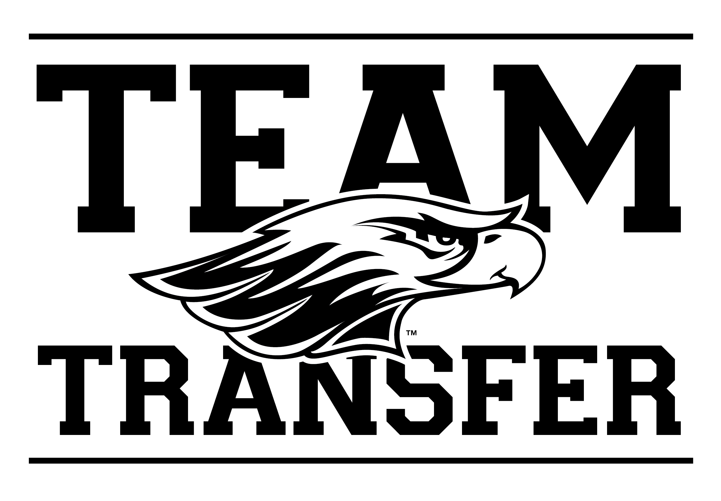
2024 Transfer Peer Mentor
Position Description

First Year Experience: Transition • Connection • Integration • Development

The Mentor program plays an active role in the University’s overall retention efforts. Transfer Peer Mentors assist new transfer students with the transition to UW-Whitewater by serving as a role model guiding students through their first semester on the UW-Whitewater campus.

Benefits & Outcomes
As a Transfer Peer Mentor you will develop your leadership skills, professional communication, group facilitation skills, and have the opportunity to work with a diverse population of students, faculty, and staff. Gain valuable work experience for any major.

Transfer Peer Mentors can make up to $900 in the fall semester.

Transfer Peer Mentor Responsibilities:
- Serve as a role model and resource to all new students.
- Lead a group of new transfer students through fall orientation, Warhawk Welcome.
- Aid with the facilitation of a New Student Seminar section (attend class twice each week throughout the first 8 weeks of the semester), work collaboratively with assigned New Student Seminar Instructor, provide the student perspective on various class topics and assist with classroom discussion & activities.
- Develop and maintain a connection with your assigned group of transfer students. Contact & support students outside of New Student Seminar weekly (i.e. email, texting, social media, in person, WebEx, etc.).
- Complete all Mentor Program training sessions in August.
- Attend all Mentor staff meetings occurring twice each month throughout the fall semester.
- Complete required paperwork by the given deadlines (recording hours, contact reports, evaluations, Navigate case notes, etc.).
- Represent UW-Whitewater and the Office of the First Year Experience in a professional manner and with a positive attitude.
- Adhere to all campus policies and state/federal laws. Failure to abide by University policies and/or state law may be cause for removal from the position. (Conduct checks will be done through the Dean of Students Office and University Housing to ensure you are in good standing, and that you are not on probation for university or residence hall violations.)
- Perform other duties as assigned by the Graduate Assistant for Mentor Programs, the Mentor Program Manager, or other staff members from the First Year Experience Office.

Qualifications:
- Full-time student in good University conduct standing, academic standing, and cumulative Whitewater GPA of 2.8 or higher. (Grade checks will be completed each semester)
- Have transferred to UW-Whitewater and been a UW-Whitewater student for at least one semester.
- Desire to help new transfer students transition to UW-Whitewater.
- Ability to serve as a positive role model and to be approachable.
- Demonstrated leadership abilities including involvement in extra-curricular activities.
- Ability to balance academics with other responsibilities, involvement, and personal life.
- Possess strong communication skills, pay attention to detail, and is self-motivated.
- Serve as an inclusive leader: one who is welcoming and affirming of all students.

2024 Transfer Peer Mentor Position Description Continued

2024 Required Dates:
Peer Mentors are required to attend the following trainings and meetings.
- TBD: Mentor Program Pre-Fall Training
- August 28-30, all day: Mentor Program Fall Training
- September 1-2, all day and evening: Warhawk Welcome
- September-December: Fridays, 12:00-1pm|Mentor meetings: 6 meetings throughout the semester:

  - September 13
  - September 27
  - October 11
  - November 1
  - November 15
  - December 6

- September-December: New Student Seminar (50 minutes, twice each week for the first 8 weeks of the semester, then continue checking in with mentees and attending mentor meetings the second half of the semester)
- October/November: Participate and assist with the implementation of Mentor sponsored events including but not limited to: the Fall Diversity Forum, Boxes & Walls, & Homecoming activities. (details provided in training)

Selection Process:
Those interested in the Transfer Peer Mentor position can anticipate the following selection process:
- Complete the online Team Transfer application via the FYE website starting January 12, 2024: https://www.uww.edu/fye/transfer/team-transfer
  - Applications due by Monday, February 12, 2024 by 4:30pm.
- Have one UW-Whitewater professional reference – name & email. Your reference must be a part of the UW-Whitewater community. This can include a faculty member, professional staff member, a current supervisor for an on-campus position, your Resident Assistant or other hall staff, your Peer Mentor, someone you work with in a student organization, an advisor, etc.
- Those who meet requirements of the position will be invited to an individual interview.
- Offers made via email by Friday, March 22, 2024.
- Offers must be accepted by Wednesday April 3, 2024.

Questions? Please contact:

Brittany Franson
Manager of Mentor Programs
Office of the First Year Experience
University Center Room 245
fransonb@uww.edu, 262.472.1938

