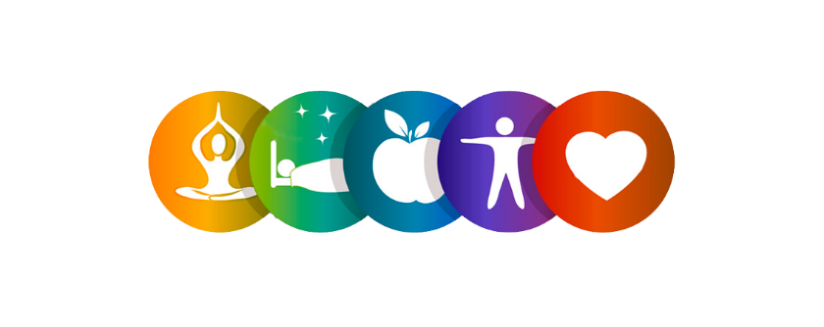

**2022 Employee Wellness & Benefits Events**

**WELLNESS EVENTS**

* **ZACH MERCURIO- Creating a Culture Where Everyone Matters**

***“Human beings thrive when they know that they matter- the belief that we are noticed and seen and relied on...” – Zach Mercurio; WCWI Conference September 21, 2021.***

Zach will be speaking on “Reframing Wellbeing through a Culture Where Everyone Matters”. Zach is an author, researcher, and consultant specializing in purposeful leadership, meaningful work, mattering, and positive organizational development.

Open to Faculty, Staff, Students, and Community.

* + **August 24th from 10:00am-11:30am in the Young Auditorium**.
* **KEPRO Workshops**
  + **How to Speak with Your Physician**

This seminar is necessary due to all of the changes happening in healthcare today. Doctors have very little time to spend with patients, thus, every minute you spend with a physician truly counts. This seminar is designed to give patients a set of specific tools to optimize visits, including pre-appointment preparation and communication during and after an appointment

Date: 8/24/2022

Time: 12:00 PM, America/Chicago

Visit the Worksite Wellness page for more information to attend: <https://www.uww.edu/worksitewellness>

* **BLOOD DRIVE** 
  + Wednesday, November 16, 2022 from 12:00PM- 6:00PM in the UC Old Main Ballroom
* **Upcoming KEPRO Workshops and Past Recordings** 
  + Visit the Worksite Wellness page for more information to attend:

[**https://www.uww.edu/worksitewellness**](https://www.uww.edu/worksitewellness)

**BENEFIT EVENTS**

* **TIAA ON CAMPUS**
  + **August 11, 2022**

By appointment only – Register for an appointment at [www.TIAA.org/schedulenow](http://www.TIAA.org/schedulenow) or by calling 800-732-8353.

* **SUICIDE PREVENTION WEEK**

September 4, 2022 - September 10, 2022

* **BIOMETRIC SCREENING**
  + **Wednesday, September 21, 2022** at the Community Engagement Center: Room 108 &109. – Visit the Worksite Wellness page for more information:

<https://www.uww.edu/worksitewellness/hra>

* **OPEN ENROLLMENT/ ABE**
  + September 26, 2022 - October 21, 2022
* **BENEFIT FAIR**

Wednesday, October 12, 2022

10am – 2pm

UC275 Old Main Ballroom

* **FLU SHOT CLINIC**

October 26, 2022

9AM-12PM UC 68A&B

By appointment only

* **ETF (Employee Trust Fund) Webinars on retirement/annuity options/WRS and more!**
  + <https://www.uww.edu/documents/adminaffairs/HR%20Diversity/Upcoming%20ETF%20Webinars.pdf>

Revised: 6/17