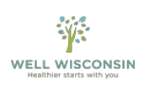
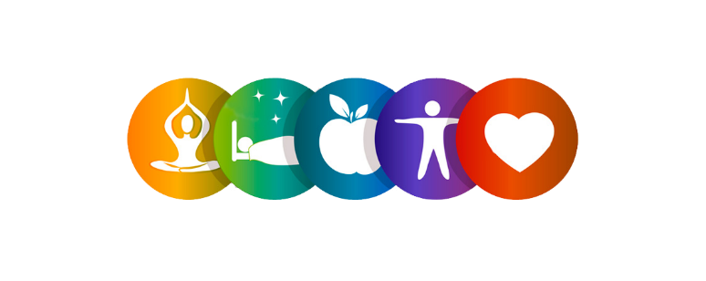

Earn a $150 Wellness Reward
Employees,
If you are eligible, you can receive a $150 Wellness Incentive. You must complete these steps by October 14th, 2022:
To receive your $150 incentive:
1. Create a StayWell account and/or log-in to your existing account at https://wellwisconsin.staywell.com.
2. Register for an appointment for your biometric health screening. Follow this quick guide for instructions. Results will auto-upload in your StayWell portal within 2 weeks of appointment date.
The Screening location is held at:
UW Whitewater: James R. Connor University Center
Hamilton Room 164
800 W Main Street
Whitewater, WI 53190
UW-W 2022 Screening Dates
- 09/21/2022 8:30a - 12:30p
Biometric Screening Poster - How to Register
3. Complete the online StayWell health assessment.
4. Complete a StayWell well-being activity of your choice.
For questions on earning your incentive or how to use the StayWell portal, contact StayWell help line at 1-800-821-6591 or wellwisconsin@staywell.com.
*All wellness incentives paid to participants of the State of Wisconsin Group Health Insurance Programs by StayWell are considered taxable income to the group health plan subscriber and are reported to your employer for tax purposes. Health information, including responses to the health assessment, are protected by federal law and will never be shared with ETC, the Group health Insurance Program or your employer.
*This event is voluntary. It does not take the place of your doctor’s care. The health-screening and health assessment do not diagnose problems or recommend treatments.

